# What's your cough telling you?



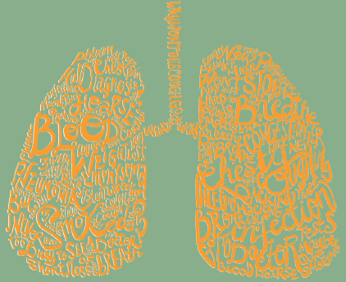

With more than **11,000** people diagnosed with lung cancer in Australia each year, it's important to know what your cough is telling you.

Do you have:

* a new cough that has persisted for **3** weeks or more
* a changed cough
* coughing up blood
* a chest infection that won't go away?

These symptoms may be due to other conditions, however it's important to see your GP or healthcare worker to be sure.

[**canceraustralia.gov.au**](http://www.canceraustralia.gov.au)