**Can c er A ustra li a**

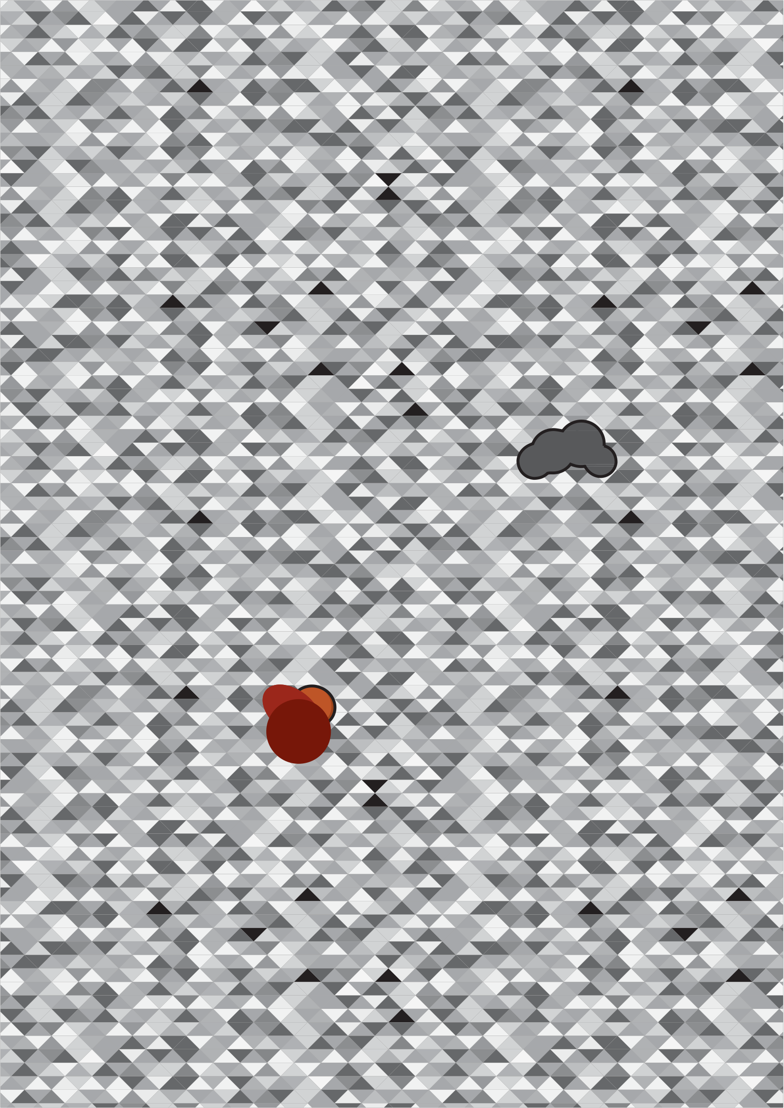

**LEARNER’S**

**guide**

Providing information and support to Aboriginal and

Torres Strait Islander women with breast cancer

**LEARNER’S Guide**



Providing information and support to Aboriginal and

Torres Strait Islander women with breast cancer

**••••••••••••••••••••••••••••••••••••••••••••••••••••••••••••••••••••••••**

The *Learner’s Guide* was prepared and produced by Cancer Australia.

Cancer Australia

Locked Bag 3 Strawberry Hills NSW 2012 Australia

Tel: +61 2 9357 9400

Fax: +61 2 9357 9477

Freecall: 1800 624 973

Website: [www.canceraustralia.gov.au](http://www.canceraustralia.gov.au/)

© Cancer Australia 2012

ISBN Print: 978-1-74127-183-6

ISBN Online: 978-1-74127-200-0

Design and illustration by Alex Tyers.

Paper-based publications

This work is copyright. You may reproduce the whole or part of this work in unaltered form for your own personal use or, if you are part of an organisation, for internal use within your organisation, but only if you or your organisation do not use the reproduction for any commercial purpose and retain this copyright notice and all disclaimer notices as part of that reproduction. Apart from rights to use as permitted by the *Copyright Act 1968* or allowed by this copyright notice, all other rights are reserved and you are not allowed to reproduce the whole or any part of this work in any way (electronic or otherwise) without first being given the specific written permission from Cancer Australia to do so. Requests and inquiries concerning reproduction and rights are to be sent to the Publications and Copyright contact officer, Cancer Australia, Locked Bag 3, Strawberry Hills, NSW 2012.

Internet sites

This work is copyright. You may download, display, print and reproduce the whole or part of this work in unaltered form for your own personal use or, if you are part of an organisation, for internal use within your organisation, but only if you or your organisation do not use the reproduction for any commercial purpose and retain this copyright notice and all disclaimer notices as part of that reproduction. Apart from rights to use as permitted by the *Copyright Act 1968* or allowed by this copyright notice, all other rights are reserved and you are not allowed to reproduce the whole or any part of this work in any way (electronic or otherwise) without first being given the specific written permission from Cancer Australia to do so. Requests and inquiries concerning reproduction and rights are to be sent to the Publications and Copyright contact officer, Cancer Australia, Locked Bag 3, Strawberry Hills, NSW 2012. Copies of the *Learner’s Guide* can be downloaded from the Cancer Australia w[ebsite: www.canceraustralia.gov.a](http://www.canceraustralia.gov.au/)u or ordered by telephone: 1800 624 973.

Disclaimer

Cancer Australia does not accept any liability for any injury, loss or damage incurred by use of or reliance on the information. Cancer Australia develops material based on the best available evidence, however it cannot guarantee and assumes no legal liability or responsibility for the currency or completeness of the information.

Recommended citation

Cancer Australia. Learner’s Guide. Cancer Australia, Surry Hills, NSW, 2012.

Contents

Acknowledgements 2

7. Psychosocial issues and support 19

Activity 20 19

Overview of guide 3

Activity 21 20

Introduction 4

Activity 1 4

Activity 22 20

Activity 23 21

Activity 24 21

1. Breast cancer: the facts 5

Activity 2 5

Activity 3 5

Activity 4 6

Activity 5 6

2. Early breast cancer journey 7



Activity 6 7

3. Awareness and early detection 8

Activity 7 8

Activity 8 9

Activity 9 9

Activity 10 10

4. Investigation and diagnosis of breast cancer 11

Activity 11 11

Activity 12 12

5. Treatment options for breast cancer 13

Activity 13 13

Activity 14 14

Activity 15 15

Activity 16 16

Activity 17 16

6. Breast cancer follow-up care 17

Activity 18 17

Activity 19 18

8. Multidisciplinary team approach 22

Activity 25 22

**1**

**Acknowledgements**

Cancer Australia* gratefully acknowledges the Aboriginal and Torres Strait

Islander women who participated in the review of this document.

Cancer Australia Staff

The following staff were involved in the development of this resource:

• Hannah Nancarrow, *Senior Project Officer*

• Caroline Nehill, *Manager*

• Ornella Care, *Manager*

Funding

Funding for the development of this resource was provided by the Australian Government

Department of Health and Ageing.

Contact us

If you have any queries please contact Cancer Australia directly on 02 9357 9400.



GUIDE

*On 30 June 2011, National Breast and Ovarian Cancer Centre (NBOCC ) amalgamated with Cancer Australia to form a single national agency, Cancer Australia, to provide leadership in cancer control and improve outcomes for Australians affected by cancer.

learner’s GUIDE • Overview of guide

**Overview of guide**

The *Learner’s Guide* is part of a suite of resources developed by Cancer Australia to support implementation of the unit of competency HLTAHW431A *Provide information and support to women with breast cancer for* Aboriginal and

Torres Strait Islander Health Workers.

Supporting resources

The Cancer Australia supporting resources include:

*•• Learner’s Resource: Providing information and support to Aboriginal and Torres Strait*

*Islander women with breast cancer* - Handbook.

*• Learner’s Guide: Providing information and support to Aboriginal and Torres Strait Islander women with breast cancer -* Activities and assessments.

*•• Facilitator’s Guide: Providing information and support to Aboriginal and Torres Strait*

*Islander women with breast cancer* - Facilitator’s notes.

Aim

The *Learner’s Guide* provides Aboriginal and/or Torres Strait Islander Health Workers with activities and assessments to support learning on providing information and support to Aboriginal and Torres Strait Islander women through their breast cancer journey following a diagnosis of early breast cancer.

Outcomes

Together with the *Learner’s Resource,* the *Learner’s Guide* covers the knowledge and skills required for the unit of competency *Provide information and support to Aboriginal and Torres Strait Islander women with breast cancer.*

Essential outcomes of the *Learner’s Resource* and *Learner’s Guide* are to:

• promote awareness and early detection of breast cancer

• provide information and support to clients being investigated for a breast cancer symptom

• provide information and support to clients being treated for early breast cancer

• provide information and support to clients to complete breast cancer follow-up care.

**3**

**Introduction**

Activity 1

What are your learning goals? (What do you hope to get from completing this course?)

|  |
| --- |
| Goal 1 |
|  |
|  |
|  |
|  |
|  |
|  |

|  |
| --- |
| Goal 2 |
|  |
|  |
|  |
|  |
|  |
|  |

|  |
| --- |
| Goal 3 |
|  |
|  |
|  |
|  |
|  |
|  |

learner’s GUIDE • Breast cancer: the facts

1. **Breast cancer: the facts**

Activity 2

In a large group discuss the nature of cancer, using words that you think of, have heard of, know of or associate with the word ‘cancer’.

*During this exercise, some myths may come up – treat other people with respect, whilst dispelling the myth. Get some of the myths out there and write them up on the board for participants to look at and reflect upon. Are there any other things you have heard community members or doctors say that you want to clarify?*

Write down the top five key points discussed about the nature of cancer:

1.

2.

3.

4.

5.

Activity 3

In your own words describe what breast cancer is, as if you were telling a group of women in your community:

**5**

learner’s GUIDE • Breast cancer: the facts

Activity 4

In a small group discuss the differences between ductal carcinoma in situ (DCIS), early and secondary breast cancer. Make any notes below.

Activity 5

In small groups search through *Breast Cancer in Australia - An overview, 2012* and summarise the evidence into meaningful information of incidence, mortality and survival rates of Aboriginal and Torres Strait Islander women with breast cancer in 1-2 sentences:

Incidence

Mortality

Survival

learner’s GUIDE • Early breast cancer journey

2. **Early breast cancer journey**



Activity 6

Consider Mrs Rose, a 57 year old woman from your community. She has been referred to you from the local GP.

She is the primary carer of her grandchildren.

Before you go to see Mrs Rose you want to have a good idea of what the journey may look like for her as she is treated for breast cancer.

Think about where Mrs Rose needs to go for each step in the breast cancer journey and highlight some of the issues that may arise considering her life circumstances. Note any questions you have about this process.

Work through individually then discuss in small groups.

3. **Awareness and early detection**

Activity 7

In a small group discuss the six moderate-strong risk factors for breast cancer in the context of cultural and community, family and individual issues. Present back to the larger group.

**Context**

**Risk factor** Cultural & community Family Individual

1.

|  |  |  |  |
| --- | --- | --- | --- |
|  |  |  |  |
|  |  |  |  |
|  |  |  |  |
|  |  |  |  |

2.

|  |  |  |  |
| --- | --- | --- | --- |
|  |  |  |  |
|  |  |  |  |
|  |  |  |  |
|  |  |  |  |

3.

|  |  |  |  |
| --- | --- | --- | --- |
|  |  |  |  |
|  |  |  |  |
|  |  |  |  |
|  |  |  |  |

4.

|  |  |  |  |
| --- | --- | --- | --- |
|  |  |  |  |
|  |  |  |  |
|  |  |  |  |
|  |  |  |  |

5.

|  |  |  |  |
| --- | --- | --- | --- |
|  |  |  |  |
|  |  |  |  |
|  |  |  |  |
|  |  |  |  |

6.

|  |  |  |  |
| --- | --- | --- | --- |
|  |  |  |  |
|  |  |  |  |
|  |  |  |  |
|  |  |  |  |

learner’s GUIDE • Awareness and early detection



Activity 8

Belinda is 34 years old and overweight. Belinda lives in the city and has a 30 minute walk to work at a local school each day. She drinks every weekend and some week

nights, usually four cans of rum and coke mix and smokes whenever she drinks.

What is Belinda doing that is helping reduce her risk of developing breast cancer?

What lifestyle advice would you give to Belinda to reduce her risk of developing breast cancer?

Activity 9

In a small group discuss the five main signs of breast cancer:

1.

2.

3.

4.

5.

And the main symptom of breast cancer:

6.

Activity 10

Imagine there are low screening rates for breast cancer amongst Aboriginal and Torres Strait Islander women in your community. Generally Aboriginal and Torres Strait Islander women do not see their local health service/doctor with a breast cancer symptom until it’s too late. Breast cancer is not talked about even though you know one or two women who have breast cancer.

What are the two things you need to promote in your community?

1.

2.

In small groups focus on one group member’s community and plan a strategy to improve early detection and awareness of breast cancer. Write on butcher’s paper and present to the larger group.

Planning cancer control questions to discuss in the group

Where are we now? What is happening in the community?

Is there access to screening in the community? If so, are these screening services appropriate?

Is there a women’s health service?

Where do we want to be? Who are the target group?

What are the targets to achieve (short and long term)?

How do we get there? What can we do to bridge the gaps?

What has worked in the past?



4. **Investigation and diagnosis of breast cancer**

Activity 11

*Refer back to Activity 6 with Mrs Rose.*

Mrs Rose’s GP, Dr Smith, said he found a lump on clinical examination and explained the steps to her to properly diagnose breast cancer. Dr Smith is concerned she did not understand his explanation. You have gone to see Mrs Rose to discuss what will happen to diagnose her with breast cancer.

What would be your explanation?

Mrs Rose’s results are back. In small groups explain the following results from Mrs Rose’s tests in a way she will understand.

Scenario 1

The lump in the breast was found to be oestrogen and progesterone receptor positive (hormone receptors), HER2-negative with one axillary node metastasis.

Explanation:

Scenario 2

The lump in the breast is less than 4 cm and is hormone receptor negative with no node metastasis.

Explanation:

Choose three of the following organisations:

• Cancer Australia

• National Breast Cancer Foundation

• McGrath Foundation

• Breast Cancer Network Australia

• BreastScreen

• Cancer Council

Research and briefly outline their role and summarise the interrelationships between the organisations. Summarise the broad scope of their activities as they relate to your local area with regard to service provision for clients in the context of breast cancer care issues.

Organisation

Role in breast cancer/

cancer control

Broad scope of their activities as they relate to local area

5. **Treatment options for breast cancer**



Activity 13

List and briefly describe the five most common types of treatment for breast cancer, highlighting the adjuvant therapies.

Treatment 1

Treatment 2

Treatment 3

Treatment 4

Treatment 5

Desiree, a 42 year old woman has been referred to you by BreastScreen.

Desiree has been diagnosed with Stage IIB carcinoma and told she should have a lumpectomy (breast conserving surgery). She is uncertain as she thinks she should just remove the whole breast (mastectomy).

Discuss in small groups what key message and information could you provide Desiree with to help her with this decision between the two types of surgery.

Make any notes below:

Desiree also needs to have a sentinel node biopsy.

In your own words explain what this is:

Desiree has undergone the sentinel node biopsy and has been told she needs to have her lymph nodes removed from her armpit.

Why would this be so?

1.

2.

3.

Activity 15

In small groups discuss radiotherapy, chemotherapy, hormonal therapy and targeted therapy. Comment on the positives and negatives of each type of adjuvant therapy, including side effects. Present back to the larger group.

therapy p ositives negatives

What advice would you give to a client experiencing side effects of cancer treatment?

Activity 17

What is the difference between ‘complementary’ and ‘alternative’ therapies?

Complementary

Alternative

What advice would you give to a client considering bush medicine or other types of complementary/

alternative therapies in their cancer treatment?

6. **Breast cancer follow-up care**

Activity 18

Kerry is a 38 year old Indigenous woman from northern New South Wales (NSW ). She has lived in Sydney for over five years and has two children, aged 14 and 18, who live with their grandmother in Kempsey NSW.

Kerry had a right mastectomy and axillary clearance. Six months after surgery Kerry noticed a feeling of ‘heaviness’ in her right arm. She ignored the problem as she was just trying to cope with her cancer treatment. It was not until her 12 month check-up with her surgeon that a 2.5 cm forearm difference in limb size was discovered. Kerry is also overweight and taking medication for hypertension.

Kerry’s surgeon referred her to a lymphoedema clinic at the hospital. The lymphoedema practitioner planned a treatment strategy which included massage and the fitting of a compression garment. Kerry did not like wearing her compression garment and experienced recurrent cellulitis.

What were Kerry’s risk factors for developing lymphoedema?

**•**

**•**

**•**

What are the early warning signs of secondary lymphoedema?

1.

2.

3.

4.

5.

What can you do to help Kerry better manage her lymphoedema?



Consider Aunty Barb, a 62 year old woman from a remote community in Western Australia ( WA). Aunty Barb:

• underwent treatment in Perth where she stayed for eight weeks

• had a left mastectomy and breast reconstruction followed by six cycles of chemotherapy

• had a tumour that is ER positive

• is postmenopausal, and

• completed treatment 12 months ago and is on tamoxifen.

Aunty Barb does not show up to her first follow-up appointment at the nearest medical centre

(3 hours drive from her home) and so you go out to see her.

In small groups discuss what barriers and/or challenges might prevent her from attending?

Make any notes below:

Explain to Aunty Barb what follow-up for breast cancer treatment involves:

1.

2.

3.

Why is follow-up treatment important for Aunty Barb?

7. **Psychosocial issues and support**

Activity 20

Meet Pauline.

Pauline is a 61 year-old married woman who

• was diagnosed with breast cancer after she presented to your Aboriginal Medical Service with a lump

• has had a mastectomy with a lot of complications, *and*

• has since had lymphoedema.

Family history

• Pauline has lost three family members to cancer and more to other chronic diseases.

Her social context

• Married to Bill.

• Pauline’s daughter and three grandchildren live with her.

What are the four main types of psychosocial issues Pauline may experience? Provide an example of each:

1.

*Example:*

2.

*Example:*

3.

*Example:*

4.

*Example:*

What is likely to be helpful for Pauline?

What signs do you need to look out for that may show Pauline is experiencing psychological issues that require special treatment?

Activity 22

What communication skills would you use when talking with Pauline?

Activity 23

Pauline is the main carer for her grandchildren. When Pauline went away for treatment the children stayed behind and the separation affected them in a traumatic way. Pauline hasn’t sat down with them and discussed the situation clearly.

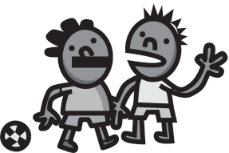

How would you advise Pauline and her husband in relation to talking to their three grandchildren about Pauline’s breast cancer?

Activity 24

Pauline presents at the local Aboriginal Medical Service and she looks depressed, and admits that she is finding everything an effort. You decide you need to refer Pauline to receive more support and assistance.

Identify three clients you have worked with recently whom you have referred to outside agencies

for further support and assistance. Which agencies did you use and for what reasons? Make a list of factors that helped and factors that hindered the referral process including your own strengths and weaknesses in making appropriate referrals. Identify strategies you could use to effect improvement.

**client 1 client 2 client 3**

agency

reason

Factors that helped the referral process

Factors that hindered

the referral process

Suggested strategies

8. **Multidisciplinary team approach**



Activity 25

On the following table list some of the people you interact with at work. Classify them according to whether they are in a vertical relationship (employer/leader) or in a lateral or horizontal relationship (fellow workers/ peers) with you. Say why and in what ways you interact with these people.

person relationship/role why and how you interact

What are some of the new relationships you could make, to work effectively in a multidisciplinary team, to support Aboriginal and Torres Strait Islander women with breast cancer?

person benefits of this relationship/role

**Notes**

**canceraustralia.gov.au**

ro Ca ncer Aust ralia 2 012 LGIBC