# INVESTIGATING SYMPTOMS OF LUNG CANCER: A GUIDE FOR ALL HEALTH PROFESSIONALS

# May 2020

**This guide has been developed to assist all health professionals to investigate symptomatic people with suspected lung cancer and support their early and rapid referral into the diagnostic pathway. This is a general guide to appropriate practice to be followed subject to the clinician’s judgment in each individual case. The guide is based on the best available evidence and expert consensus.**

***Investigating symptoms of lung cancer: a guide for all health professionals has been officially recognised as an Accepted Clinical Resource by The Royal Australian College of General Practitioners***



**Endorsed by**

|  |  |  |  |  |  |
| --- | --- | --- | --- | --- | --- |
| Australian College of Rural & Remote Medicine (ACRRM) Logo | Australian Primary Health Care Nurses Association (APNA) endorsed logo | | Cancer Nurses Society of Australia (CNSA) logo | | Consumers Health Forum of Australia (CHF) logo |
| CRANAplus logo | | Lung Foundation Australia logo | | National Aboriginal and Torres Strait Islander Health Worker Association (NATSIHWA) logo | |
| **Royal Australasian College of Surgeons (RACS) logo** | **Royal Australasian College of Physicians (RACP) logo** | | **The Royal Australian and New Zealand College of Radiologists (RANZCR)** | | **The Thoracic Society of Australia & New Zealand (TSANZ) logo** |

**Lung cancer is the leading cause of cancer death in Australia. Symptoms of lung cancer can often be non-specific which may hinder early diagnosis and treatment.**

## Risk factors for lung cancer

### Lifestyle factors

* current or former tobacco smoking

### Environmental factors

* passive smoking
* occupational exposures e.g. radon, asbestos, diesel exhaust, silica
* air pollution

### Personal factors

* increasing age
* family history of lung cancer
* chronic lung disease e.g. chronic obstructive pulmonary disease (COPD), pulmonary fibrosis
* personal history of cancer e.g. lung cancer, head and neck cancer, bladder cancer

## Risk of lung cancer in different populations

* While smoking is the largest single cause of lung cancer, **people who have never smoked may also be diagnosed with lung cancer**. About 90% of lung cancer in males and 65% in females is estimated to be a result of tobacco smoking.1
* Aboriginal and Torres Strait Islander people are twice as likely to be diagnosed with and die from lung cancer2 and have lower 5-year survival3 compared with non-Indigenous Australians.
* Incidence and mortality increase with remoteness and are highest for those living in lower socioeconomic areas.3
* The association of lung cancer with smoking can lead to lung cancer patients feeling stigmatised, contributing to delays in help-seeking for symptoms4,5 and psychological distress.6

## Symptoms and signs of lung cancer

* Symptoms can present in a similar manner to other conditions such as COPD, chronic heart failure and coronary heart disease.7
* Please refer to the flow chart overleaf for symptoms and signs of lung cancer, recommended investigations and referrals, and timeframes for referral.

## Early detection and diagnosis of lung cancer improves chances of survival8

Health professionals working in primary care are integral to early detection, as the majority of patients with cancer first present to primary care settings.9 In the three months leading up to diagnosis, patients often see a GP ≥ 4 times before a diagnosis of lung cancer is made.10

## Stage at diagnosis and 5-year survival of lung cancer11,12

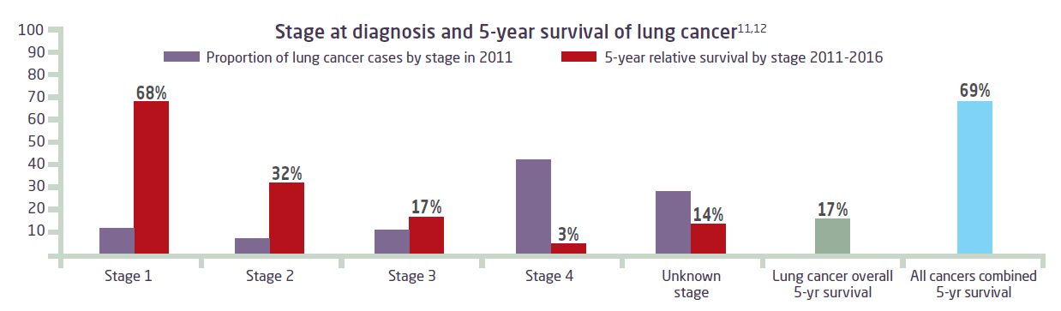

## Optimal imaging modalities for lung cancer

* Chest CT scans should be offered when there is a strong clinical suspicion of lung cancer. They should be delivered with contrast unless contraindicated.
* Low-dose CT (LDCT) scans have a lower radiation dose compared to conventional chest CT scans, provide good clinical information and are more sensitive than chest X-ray in the diagnosis of lung cancer.13
* There is ongoing national and international research into the role of LDCT screening for lung cancer in asymptomatic people. For more information on the potential role of screening for asymptomatic patients, visit [Cancer Australia’s lung cancer screening enquiry information centre](https://canceraustralia.gov.au/about-us/lung-cancer-screening-enquiry).

## Multidisciplinary care is the best practice approach to providing evidence-based care14

* All patients with suspected lung cancer should be referred to a specialist with expertise in lung cancer who is affiliated with a multidisciplinary team (MDT).
* Ensure referrals are made in a timely manner; the first specialist appointment should take place within two weeks of referral.
* Lung Foundation Australia’s MDT directory provides useful information about MDTs with expertise in lung cancer, visit [lungfoundation.com.au/lung-cancer-mdt/](https://lungfoundation.com.au/lung-cancer-mdt/)

**For the full recommendations, the evidence underpinning this guide and reference list, visit** [**canceraustralia.gov.au**](canceraustralia.gov.au/ISLCReport)

**Investigating symptoms of lung cancer – a guide for all health professionals**

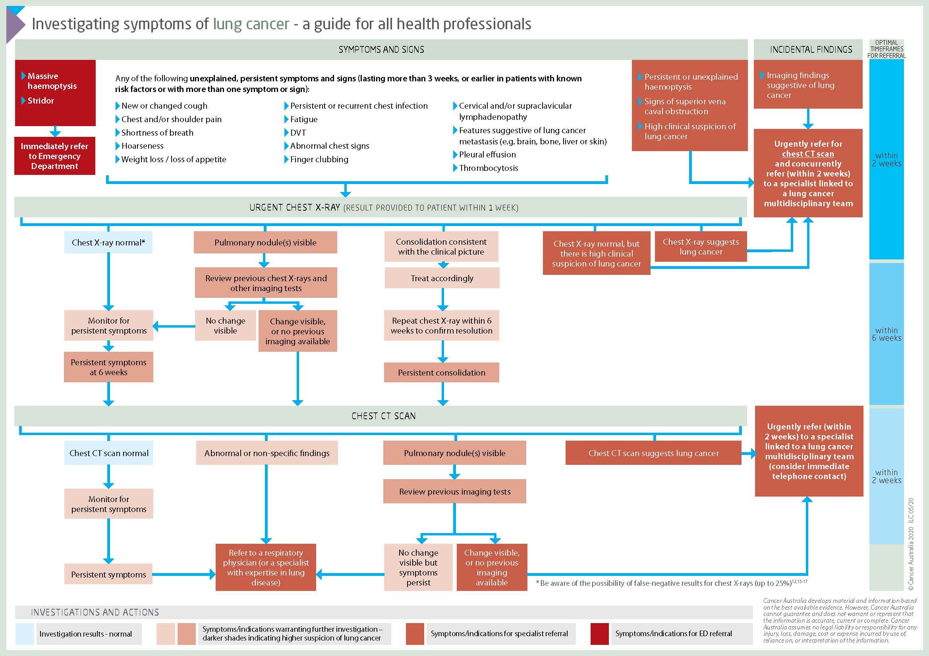

© Cancer Australia 2020 ILC 05/20