The impact of COVID-19 on cancer-related medical services and procedures in Australia in 2020

Examination of MBS claims data for 2020, nationally and by jurisdiction

September 2021

*The impact of COVID-19 on cancer-related medical services and procedures in Australia in 2020: Examination of MBS claims data for 2020, nationally and by jurisdiction* was prepared and produced by:

Cancer Australia  
Locked Bag 3 Strawberry Hills NSW 2012 Australia  
Tel: +61 2 9357 9400 Fax: +61 2 9357 9477  
[canceraustralia.gov.au](http://www.canceraustralia.gov.au)

© Cancer Australia 2021.

ISBN Online: 978-1-74127-010-5

**Recommended citation**

Cancer Australia, 2021. *The impact of COVID-19 on cancer-related medical services and procedures in Australia in 2020: Examination of MBS claims data for 2020, nationally and by jurisdiction*, Cancer Australia, Surry Hills, NSW.

*The impact of COVID-19 on cancer-related medical services and procedures in Australia in 2020: Examination of MBS claims data for 2020, nationally and by jurisdiction* can be downloaded from the Cancer Australia website: [canceraustralia.gov.au](http://www.canceraustralia.gov.au) or ordered by telephone: 1800 624 973.

**Copyright statements**

**Paper-based publications**This work is copyright. You may reproduce the whole or part of this work in unaltered form for your own personal use or, if you are part of an organisation, for internal use within your organisation, but only if you or your organisation do not use the reproduction for any commercial purpose and retain this copyright notice and all disclaimer notices as part of that reproduction. Apart from rights to use as permitted by the *Copyright Act 1968* or allowed by this copyright notice, all other rights are reserved and you are not allowed to reproduce the whole or any part of this work in any way (electronic or otherwise) without first being given the specific written permission from Cancer Australia to do so. Requests and inquiries concerning reproduction and rights are to be sent to the Publications and Copyright contact officer, Cancer Australia, Locked Bag 3, Strawberry Hills, NSW 2012.

**Internet sites**This work is copyright. You may download, display, print and reproduce the whole or part of this work in unaltered form for your own personal use or, if you are part of an organisation, for internal use within your organisation, but only if you or your organisation do not use the reproduction for any commercial purpose and retain this copyright notice and all disclaimer notices as part of that reproduction. Apart from rights to use as permitted by the *Copyright Act 1968* or allowed by this copyright notice, all other rights are reserved and you are not allowed to reproduce the whole or any part of this work in any way (electronic or otherwise) without first being given the specific written permission from Cancer Australia to do so. Requests and inquiries concerning reproduction and rights are to be sent to the Publications and Copyright contact officer, Cancer Australia,   
Locked Bag 3, Strawberry Hills, NSW 2012.

**Disclaimer**

Cancer Australia does not accept any liability for any injury, loss or damage incurred by use of or reliance on the information. Cancer Australia develops material based on the best available evidence, however it cannot guarantee and assumes no legal liability or responsibility for the currency or completeness of the information.

Contents

Acknowledgements vi

Key Findings vii

1 Approach 1

2 Methodology 3

3 Diagnostic procedures 4

3.1 Breast cancer 5

3.2 Colorectal cancer 6

3.3 Kidney cancer 7

3.4 Liver cancer 8

3.5 Lung cancer 9

3.6 Prostate cancer 10

3.7 Stomach and pancreatic cancer 11

3.8 Uterine cancer 13

4 Surgical and non-surgical therapeutic procedures 14

4.1 Breast cancer 15

4.2 Colorectal cancer 16

4.3 Kidney cancer 17

4.4 Liver cancer 18

4.5 Lung cancer 19

4.6 Melanoma of the skin 20

4.7 Prostate cancer 21

4.8 Pancreatic cancer 24

4.9 Stomach cancer 25

4.10 Gynaecological cancers 26

Appendix A 28

Appendix B 30

References 35

Tables

Table 1 Annual observed and expected services for cancer-related diagnostic procedures in 2020, by cancer type 4

Table 2 Annual observed and expected services for cancer-related therapeutic procedures in 2020, by cancer type 14

Table A1 MBS item codes for cancer-related diagnostic procedures 28

Table A2 MBS item codes for cancer-related surgical and non-surgical therapeutic procedures 28

Table B1 Annual observed and expected services for cancer-related diagnostic procedures in 2020, by jurisdiction 30

Table B2 Annual observed and expected services for cancer-related therapeutic procedures in 2020, by jurisdiction 32

Figures

Figure 1 Ratio of the observed to expected number of services for selected cancer-related diagnostic procedures for 2020, by cancer type 5

Figure 1.1 Annual observed and expected number of services for breast cancer-related diagnostic procedures in 2020, by jurisdiction 6

Figure 1.2 Annual observed and expected number of services for colorectal cancer-related diagnostic procedures in 2020, by jurisdiction 7

Figure 1.3 Annual observed and expected number of services for kidney cancer-related diagnostic procedures in 2020, by jurisdiction 8

Figure 1.4 Annual observed and expected number of services for liver cancer-related diagnostic procedures in 2020, by jurisdiction 9

Figure 1.5 Annual observed and expected number of services for lung cancer-related diagnostic procedures in 2020, by jurisdiction 10

Figure 1.6 Annual observed and expected number of services for prostate cancer-related diagnostic procedures in 2020, by jurisdiction 11

Figure 1.7 Annual observed and expected number of services for stomach and pancreatic cancer-related diagnostic procedures in 2020, by jurisdiction 12

Figure 1.8 Annual observed and expected number of services for uterine cancer-related diagnostic procedures in 2020, by jurisdiction 13

Figure 2 Ratio of the observed number of services to expected number of services for selected cancer-related therapeutic procedures for 2020, by cancer type 15

Figure 2.1 Annual observed and expected number of services for breast cancer-related therapeutic procedures in 2020, by jurisdiction 16

Figure 2.2 Annual observed and expected number of services for colorectal cancer-related therapeutic procedures in 2020, by jurisdiction 17

Figure 2.3 Annual observed and expected number of services for kidney cancer-related therapeutic procedures in 2020, by jurisdiction 18

Figure 2.4 Annual observed and expected number of services for liver cancer-related therapeutic procedures in 2020, by jurisdiction 19

Figure 2.5 Annual observed and expected number of services for lung cancer-related therapeutic procedures in 2020, by jurisdiction 20

Figure 2.6 Annual observed and expected number of services for melanoma of the skin related therapeutic procedures in 2020, by jurisdiction 21

Figure 2.7-a Annual observed and expected number of services for prostate cancer-related therapeutic procedures in 2020, by jurisdiction 23

Figure 2.7-b Annual observed and expected number of services for prostate cancer-related monitoring procedures in 2020, by jurisdiction 24

Figure 2.8 Annual observed and expected number of services for pancreatic cancer-related therapeutic procedures in 2020, by jurisdiction 25

Figure 2.9 Annual observed and expected number of services for stomach cancer-related therapeutic procedures in 2020, by jurisdiction 26

Figure 2.10 Annual observed and expected number of services for gynaecological cancer-related therapeutic procedures in 2020, by jurisdiction 27

Acknowledgements

Cancer Australia acknowledges the expertise of Professor David Roder in his advice and guidance on Cancer Australia’s work in analysing the impact of COVID-19 on cancer-related services. Cancer Australia also acknowledges Ms Anh-Minh Nguyen and the team from the Cancer Epidemiology and Population Health Research Group, University of South Australia in undertaking the analysis and contribution to the development of the report, *The impact of COVID-19 on cancer-related medical services and procedures in Australia in 2020: Examination of MBS claims data for 2020, nationally and by jurisdiction*.

Key Findings

Substantial reductions in procedures relating to cancer-related investigations and treatment were reported in 2020 by service providers in Australia as a result of the COVID-19 pandemic.1-4 Medicare Benefits Schedule (MBS) claims data were examined for January to December 2020 as a marker of cancer control activity to investigate the impact of COVID-19 on cancer-related medical services and procedures in Australia.

There were reductions in the observed compared to expected number of MBS services in Australia in 2020 for diagnostic and therapeutic procedures related to the following 14 cancer types: breast, colorectal, lung, prostate, melanoma of the skin, stomach, kidney, pancreatic, liver, uterine, ovarian, cervical, vaginal, and vulval cancers.

When compared to the number of services expected, the sum of services examined across all cancer types observed nationally for 2020 for selected cancer-related diagnostic procedures[1] was 8% lower (163,595 fewer services) than expected.

The impact varied by cancer type with the observed number of services in 2020:

* at least 5% lower than expected for colorectal cancer (13% lower; 87,293 fewer services), liver cancer (12% lower; 488 fewer services), lung cancer (9% lower; 3,884 fewer services), prostate cancer (7% lower; 50,618 fewer services), and stomach and pancreatic cancers combined[2] (6% lower; 870 fewer services).
* similar to expected (i.e. less than 5% difference) for breast cancer (4% lower; 20,672 fewer services) and uterine cancer (2% higher; 144 more services).
* higher than expected for kidney cancer (5% higher; 86 more services).

When compared to the number of services expected, the sum of services examined across all cancer types observed nationally for 2020 for selected cancer-related surgical and non-surgical therapeutic procedures was 9% lower (14,600 fewer services) than expected.

The impact varied by cancer type with the observed number of services in 2020:

* at least 5% lower than expected for breast cancer (6% lower; 1,001 fewer services), melanoma skin cancers[3] (14% lower; 11,245 fewer services), pancreatic cancer (7% lower; 352 fewer services), and gynaecological cancers, cervical, ovarian, uterine, vaginal, and vulval combined (8% lower; 1,372 fewer services).
* similar to that expected i.e. less than 5% difference for lung cancer (2% higher; 68 more services), liver cancer (4% higher; 53 more services), prostate cancer (2% lower; 536 fewer services), kidney cancer (3% lower; 67 fewer services), stomach cancer (1% higher; 5 more services), and colorectal cancer (1% lower; 151 fewer services).

Similar patterns of differences between observed and expected services were generally observed across the states and territories for each cancer type, although with some variation by jurisdiction.

Similar patterns to those observed nationally were observed when examined by age, sex, remoteness of residence, and socioeconomic status areas. No notable differences were observed between subgroups within each of these sociodemographic groups.

Although differences between the observed and expected number of MBS claims for diagnostic and therapeutic cancer-related services for a number of cancers in Australia in 2020 may be due to factors other than COVID-19, it is plausible that COVID-19 played an important role.

Any potential delays in diagnoses and treatment in response to these reductions in services may lead to more cancers being diagnosed at a later stage and poorer patient outcomes.

# Approach

Substantial reductions in procedures relating to cancer-related investigations and treatment were reported in 2020 by service providers in Australia as a result of the COVID-19 pandemic.1-4 Any potential delays in diagnoses and treatment in response to these reductions in services may lead to more advanced stage of cancer at diagnosis and poorer patient outcomes.5

The extent of these impacts were previously examined by Cancer Australia for the top five incident cancers – breast, colorectal, lung, prostate and skin cancer – through analysis of Medicare Benefits Schedule (MBS) claims data for cancer-related medical services and procedures in Australia.1-3, 6, 7 Service providers claim reimbursement using MBS item codes for various services, including professional attendances and procedures, and these were used as a proxy measure for estimating the impact on cancer-related diagnostic and surgical and non-surgical therapeutic services across the health system. The MBS data that provided the basis of the report applies to health services provided to the Australian public in non-inpatient settings, private outpatient clinics and to private inpatients of public and private hospitals. They do not include services provided by hospital doctors to public patients in public hospitals or services that qualify for a benefit under the Department of Veterans' Affairs National Treatment Account.

Cancer Australia’s previous analyses of MBS data for the first three quarters of 2020 showed notable reductions in the number of services claimed for a range of diagnostic and surgical and non-surgical therapeutic procedures for the five highest incidence cancers. These reductions occurred during the initial COVID-19 period between March and May 2020, with many service types showing partial or full recovery in the monthly number of services by September 2020.3, 6, 7

This report builds on the previous analyses by examining the cumulative number of services observed for January to December 2020[4], compared to the expected number of services expected from trends in historical numbers for the period 2017–2019. As with Cancer Australia’s previous analyses, MBS data were examined for services related to the highest incidence cancers (breast, colorectal, lung, melanoma of the skin and prostate cancers). In addition, cancer-related diagnostic and surgical and non-surgical therapeutic procedures were identified and data examined for cervical, kidney, liver, pancreatic, ovarian, stomach, uterine, vaginal, and vulval cancers. Non-surgical procedures may include radiotherapy for some cancers including both external beam radiotherapy (EBRT) delivery via linear accelerators (LINAC) and brachytherapy, however, monitoring of changes to EBRT LINAC delivery is outside the scope of this report[5].

In some cases, procedures may relate to more than one cancer type. Where necessary cancer groupings were applied for ease of presentation and analysis of the data. Accordingly, identified MBS diagnostic procedures for stomach cancer and pancreatic cancer overlap in their specificity and these data are presented together in the grouping ‘stomach and pancreatic cancer’[6]. Surgical and non-surgical therapeutic procedures data for cervical, ovarian, uterine, vaginal, and vulval cancers also overlap to some degree and are presented as the grouping ‘gynaecological cancers’.

The number of services for each of the cancer types were examined for two high-level categories: diagnostic procedures and therapeutic procedures. Analyses focused on MBS claims data for diagnostic and therapeutic procedures known to be related to malignancies/ cancer and for the management of pre-cancerous conditions.6, 7 MBS data for screening procedures for cancers of the breast, bowel, and cervix, and complementary services undertaken within the public sector, were not included in these analyses.

# Methodology

The MBS items included in these analyses were selected as markers of cancer control activity during the COVID-19 pandemic.

Services were selected for each of the cancer types for two high-level categories: diagnostic procedures and surgical and non-surgical therapeutic procedures. The MBS data analysed in this report do not include screening mammograms for breast cancer, faecal occult blood test (FOBT) screening for colorectal cancer, or human papillomavirus (HPV) cervical screening tests for cervical cancer or complementary diagnostic and treatment services undertaken within the public sector.

Analyses focused on MBS claims data for procedures known to be related to specified cancer types, suspected malignancies/ cancer or management of pre-cancerous conditions in consultation with cancer registry and specialist clinician expertise in the relevant cancer field. As principal diagnoses are not routinely recorded alongside MBS claims, clinical judgement was required for this process including weighing the likely sensitivity and specificity of an MBS item relating to a particular cancer type.

The numbers of claims in 2020 for these cancer-related services were compared with the expected number of services for 2020, derived by linear projection of trends in claims across 2017-2019. To be eligible, claims for respective MBS items needed to have consistent scope and criteria for use from 2017 so that expected values for 2020 could be projected using the same procedure codes. In some instances, where the criteria for making claims had changed from 2017-2018, numbers of claims for 2019 were used as the expected values. This applied to a minority of MBS items which have been identified in Appendix A alongside respective Observed/Expected (O/E) ratios. To accommodate annual growth, wherever feasible, linear projections of annual claims across 2017-2019 were the preferred approach for calculating expected values for 2020.

For reporting of changes in the number of services, a difference threshold of 5 or more percentage points was used to describe changes in the observed number of services provided nationally in 2020 compared to the expected number of services (Refer to Tables 1 & 2).

For some procedures, the number of services for some states and territories were provided as aggregated data through the Medicare Statistics online portal, with the following groupings: New South Wales and the Australian Capital Territory (NSW/ACT); Victoria and Tasmania (VIC/TAS); and South Australia and the Northern Territory (SA/NT). For consistency throughout the report, data for these states and territories are grouped for all of the procedures examined when presented as jurisdictional breakdowns for each category.

Aggregate data for procedure groupings within the diagnostic and therapeutic categories for the cancer types analysed were examined for sociodemographic factors including age, sex, remoteness of residence, and socioeconomic status areas. No notable differences between population subgroups were observed.

# Diagnostic procedures

The observed number of services for the selected diagnostic procedures[7] in 2020 for all cancer types examined was 8% lower than the expected number of services based on analysis of data over the period 2017−2019 (Table 1, below).

Table Annual observed and expected services for cancer-related diagnostic procedures in 2020, by cancer type

|  |  |  |  |  |  |
| --- | --- | --- | --- | --- | --- |
| **Cancer type** | **Observed** | **Expected**[8] | **O/E Ratio** | **Difference** | |
| **Number of services** | **% difference** |
| **Breast cancer** | 520,613 | 541,285 | 0.96 | - 20,672 | - 4% |
| **Colorectal cancer[9]** | 609,645 | 696,938 | 0.87 | - 87,293 | - 13% |
| **Kidney cancer** | 1,940 | 1,854 | 1.05 | + 86 | + 5% |
| **Liver cancer** | 3,446 | 3,934 | 0.88 | - 488 | - 12% |
| **Lung cancer** | 40,562 | 44,446 | 0.91 | - 3,884 | - 9% |
| **Prostate cancer[10]** | 713,998 | 764,617 | 0.93 | - 50,619 | - 7% |
| **Stomach and pancreatic cancers[11][12]** | 12,990 | 13,860 | 0.94 | - 870 | - 6% |
| **Uterine cancer[13]** | 9,348 | 9,204 | 1.02 | + 144 | + 2% |
| **Total diagnostic procedures** | **1,912,542** | **2,076,137** | **0.92** | **- 163,595** | **- 8%** |

Figure 1 Ratio of the observed to expected number of services for selected cancer-related diagnostic procedures for 2020, by cancer type

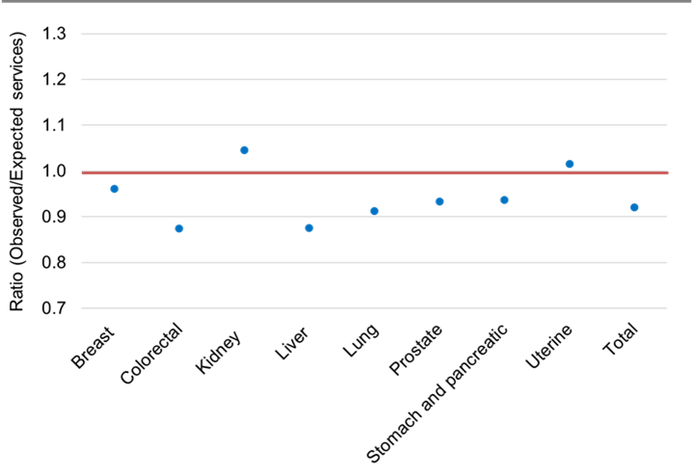

## Breast cancer

Diagnostic procedures for the detection of breast cancer include imaging and surgical procedures. MBS data examined for these analyses included diagnostic mammography and 3D-tomosynthesis where malignancy is suspected, magnetic resonance imaging (MRI) for breast cancer, and surgical biopsy procedures. The latter include solid tumour breast biopsies and fine needle aspiration procedures and associated lymph node procedures, such as sentinel lymph node biopsy.

In 2020, the observed number of services nationally for breast cancer-related diagnostic procedures was similar to expected, that is, less than 5% difference (4% lower, with 20,672 fewer services; 520,613 services observed versus 541,285 services expected) [Table 1; Figure 1].

The observed number of services for 2020 was 14% lower than expected for SA/NT and 6% lower than expected for QLD. The observed number of services was similar to expected for NSW/ACT (3% lower), VIC/TAS (2% lower) and WA (4% higher) [Table B1; Figure 1.1]. For each state/territory:

* The observed number of services was 14% lower than expected for SA/NT, with 6,295 fewer services (37,956 services observed versus 44,251 services expected); and 6% lower than expected for QLD, with 6,796 fewer services (105,964 services observed versus 112,760 services expected). The observed number of services was similar to expected for WA (4% higher), with 1,630 more services (40,531 services observed versus 42,161 services expected); NSW/ACT (3% lower), with 6,688 fewer services (202,034 services observed versus 208,722 services expected); and VIC/TAS (2% lower), with 2,523 fewer services (132,498 services observed versus 135,021 services expected) [Table B1; Figure 1.1].

The observed and expected number of diagnostic services related to breast cancer for 2020 for each state and territory are provided in Appendix Table B1.

Figure 1.1 Annual observed and expected number of services for breast cancer-related diagnostic procedures in 2020, by jurisdiction

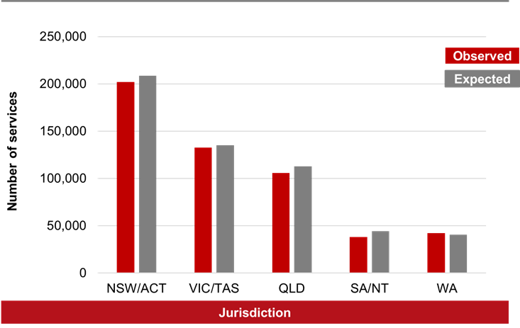

## Colorectal cancer

Diagnostic procedures for the detection of colorectal cancers that were examined for these analyses include colonoscopies and sigmoidoscopies with or without removal of polyp procedures[14][15]. Some pre-cancerous polyps and some early stage malignant polyps can be removed during the colonoscopy/ sigmoidoscopy procedure and may not require further/ extended surgical procedures in relation to treatment of colorectal cancer.  Therefore, use of these item codes by service providers may represent both a diagnostic procedure as well as a treatment procedure for early stage colorectal cancers[16].

In 2020, the observed number of services nationally for diagnostic procedures related to colorectal cancers was 13% lower than expected, with 87,293 fewer services (609,645 services observed versus 696,938 services expected) [Table 1; Figure 1].

The observed number of services for 2020 was lower than expected for most jurisdictions. The observed number of services was 22% lower than expected for VIC/TAS and 10–12% lower for NSW/ACT, SA/NT, and WA. The observed number of services was similar to expected, that is, less than 5% difference, for QLD (4% lower) [Table B1; Figure 1.2]. For each state/territory:

* The observed number of services was 22% lower than expected for VIC/TAS, with 42,118 fewer services (151,578 services observed versus 193,696 services expected); 12% lower than expected for NSW/ACT, with 26,855 fewer services (206,093 services observed versus 232,948 services expected); 11% lower than expected for SA/NT, with 6,237 fewer services (52,616 services observed versus 58,853 services expected); and 10% lower than expected for WA, with 5,924 fewer services (54,921 services observed versus 60,845 services expected). The observed number of services was similar to expected for QLD (4% lower), with 6,160 fewer services (144,437 services observed versus 150,597 services expected) [Table B1; Figure 1.2].

The observed and expected number of diagnostic services related to colorectal cancers for 2020 for each state and territory are provided in Appendix Table B1.

Figure 1.2 Annual observed and expected number of services for colorectal cancer-related diagnostic procedures in 2020, by jurisdiction

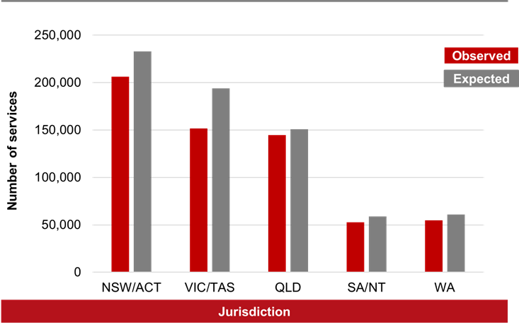

## Kidney cancer

The diagnostic procedure examined for these analyses for kidney cancer was surgical renal biopsy (closed) procedures.

In 2020, the observed number of services nationally for kidney cancer-related diagnostic procedures was 5% higher than expected, with 86 more services (1,940 services observed versus 1,854 services expected) [Table 1; Figure 1].

The observed number of services for 2020 was 11% lower than expected for WA and 25% higher than expected for VIC/TAS. The observed number of services was similar to expected, that is, less than 5% difference, for NSW/ACT (2% higher) and QLD (4% higher). Due to the small number of services for SA/NT (i.e. less than 5 services), any difference in observed and expected numbers of services should be interpreted with caution [Table B1; Figure 1.3]. For each state/territory:

* The observed number of services was 11% lower than expected for WA, with 17 fewer services (142 services observed versus 159 services expected); and 25% higher than expected for VIC/TAS, with 70 more services (351 services observed versus 281 services expected). The observed number of services was similar to expected for QLD (4% higher), with 10 more services (260 services observed versus 250 services expected) [Table B1; Figure 1.3].

The observed and expected number of diagnostic services related to kidney cancer for 2020 for each state and territory are provided in Appendix Table B1.

Figure 1.3 Annual observed and expected number of services for kidney cancer-related diagnostic procedures in 2020, by jurisdiction

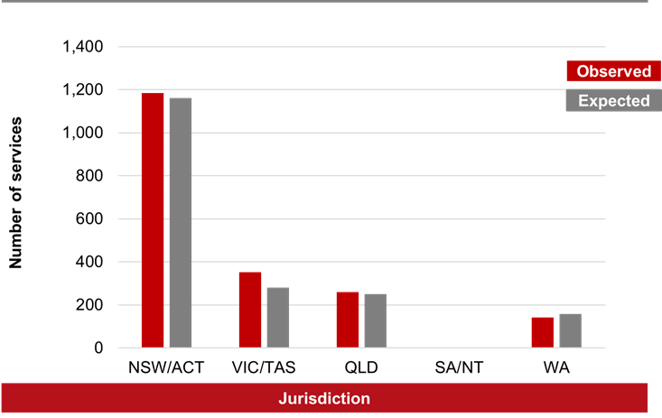

## Liver cancer

The diagnostic procedure examined for this cancer type in these analyses was surgical biopsy of the liver.

In 2020, the observed number of services nationally for liver cancer-related diagnostic procedures was 12% lower than expected, with 488 fewer services (3,446 services observed versus 3,934 services expected) [Table 1; Figure 1].

The observed number of services for 2020 was lower than expected for most jurisdictions. The number of observed services was 27% lower than expected for SA/NT and 8-16% lower than expected for NSW/ACT, VIC/TAS, and QLD. The observed number of services was similar to expected, that is, less than 5% difference, for WA (4% lower) [Table B1; Figure 1.4]. For each state/territory:

* The observed number of services was 27% lower than expected for SA/NT, with 79 fewer services (218 services observed versus 297 services expected); 16% lower than expected for VIC/TAS, with 213 fewer services (1,125 services observed versus 1,338 services expected); 12% lower than expected for QLD, with 73 fewer services (562 services observed versus 635 services expected); and 8% lower than expected for NSW/ACT, with 110 fewer services (1,217 services observed versus 1,327 services expected). The observed number of services was similar to expected for WA (4% lower), with 13 fewer services (324 services observed versus 337 services expected) [Table B1; Figure 1.4].

The observed and expected number of diagnostic services related to liver cancer for 2020 for each state and territory are provided in Appendix Table B1.

Figure 1.4 Annual observed and expected number of services for liver cancer-related diagnostic procedures in 2020, by jurisdiction

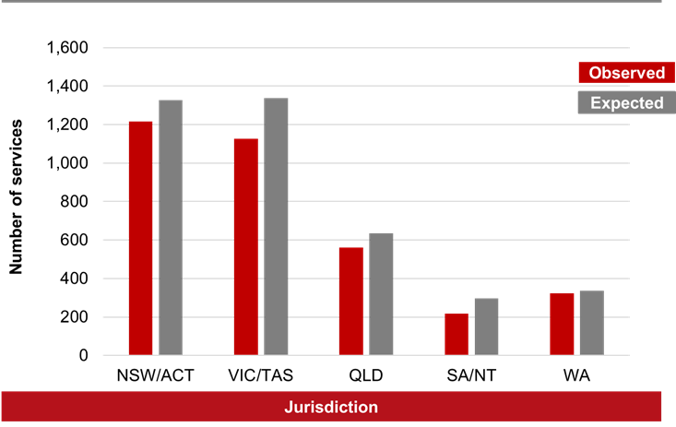

## Lung cancer

Diagnostic procedures for the detection of lung cancer examined for these analyses included Positron Emission Tomography (PET) studies for evaluation of lung nodules, needle biopsies (percutaneous, endoscopic, or by bronchoscopy), and thoracoscopy and thoracotomy procedures with or without biopsies.

In 2020, the observed number of services nationally for lung cancer-related diagnostic procedures was 9% lower than expected, with 3,884 fewer services (40,562 services observed versus 44,446 service sexpected) [Table 1; Figure 1].

The number of observed services for 2020 was lower than expected for most jurisdictions. The number of services was 6–12% lower than expected for NSW/ACT, VIC/TAS, SA/NT and WA. The observed number of services was similar to expected, that is, less than 5% difference, for QLD (2% lower) [Table B1; Figure 1.5]. For each state/territory:

* The observed number of services was 12% lower than expected for NSW/ACT, with 2,014 fewer services (15,077 services observed versus 17,091 services expected); 11% lower than expected for SA/NT, with 500 fewer services (4,036 services observed versus 4,526 services expected); 8% lower than expected for VIC/TAS, with 948 fewer services (10,540 services observed versus 11,488 services expected) and 6% lower than expected for WA, with 273 fewer services (3,929 services observed versus 4,202 services expected). The observed number of services was similar to expected for QLD (2% lower), with 150 fewer services (6,980 services observed versus 7,130 services expected) [Table B1; Figure 1.5].

The observed and expected number of diagnostic services related to lung cancer for 2020 for each state and territory are provided in Appendix Table B1.

Figure 1.5 Annual observed and expected number of services for lung cancer-related diagnostic procedures in 2020, by jurisdiction

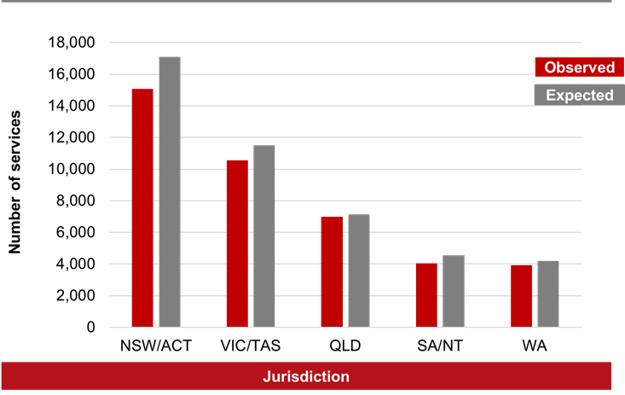

## Prostate cancer

Quantitation of circulating Prostate Specific Antigen (PSA) levels (also known as a PSA blood test) is an initial investigative procedure to inform the diagnosis of prostatic disease including prostate cancer. PSA tests are usually undertaken in conjunction with other preliminary diagnostic procedures such as digital rectal examination (DRE) of the prostate[17], and prostatic ultrasound[18]. An individual MBS item code (66655) exists for PSA testing available once in a 12-month period.

Where necessary, these preliminary investigations are then followed by more specific procedures including imaging and biopsies of the prostate gland itself.

Diagnostic procedures for suspected prostate cancer examined for these analyses were PSA testing (annual), magnetic resonance imaging (MRI) procedures and biopsy procedures of the prostate gland.

In 2020, the observed number of services nationally for prostate cancer-related diagnostic procedures was 7% lower than expected, with 50,619 fewer services (713,998 services observed versus 764,617 services expected) [Table 1; Figure 1].

The observed number of services for 2020 was lower than expected for most jurisdictions. The number of observed services was 5–9% lower than expected for NSW/ACT, VIC/TAS, QLD, and WA. The observed number of services was similar to expected, that is, less than 5% difference, for SA/NT (2% lower) [Table B1; Figure 1.6]. For each state/territory:

* The observed number of services was 9% lower than expected for VIC/TAS, with 19,953 fewer services (191,289 services observed versus 211,242 services expected); 7% lower than expected for WA, with 6,849 fewer services (87,061 services observed versus 93,910 services expected); 6% lower than expected for NSW/ACT, with 14,475 fewer services (222,797 services observed versus 237,272 services expected); and 5% lower than expected for QLD, with 7,758 fewer services (149,285 services observed versus 157,043 services expected). The observed number of services was similar to expected for SA/NT (2% lower), with 1,584 fewer services (63,566 services observed versus 65,150 services expected) [Table B1; Figure 1.6].

The observed and expected number of diagnostic services related to prostate cancer for 2020 for each state and territory are provided in Appendix Table B1.

Figure 1.6 Annual observed and expected number of services for prostate cancer-related diagnostic procedures in 2020, by jurisdiction

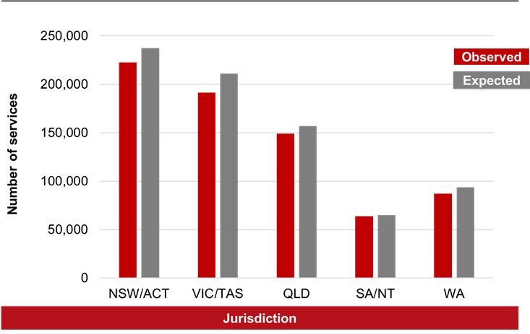

## Stomach and pancreatic cancer

Diagnostic procedures used for the detection of stomach and pancreatic cancers examined in the report include endoscopic ultrasound procedures (endoscopy with ultrasound imaging), with or without biopsy; oesophagoscopy with biopsy procedures and whole body (68Ga‑DOTA‑peptide) Positron Emission Tomography (PET) studies. Some of these diagnostic procedures may also be used for diagnosing oesophageal cancer.

In 2020, the observed number of services nationally for diagnostic procedures related to stomach and pancreatic cancers was 6% lower than expected, with 870 fewer services (12,990 services observed versus 13,860 services expected) [Table 1; Figure 1].

The observed number of services for 2020 was lower than expected for most jurisdictions. The number of observed services was 5-14% lower than expected for NSW/ACT, VIC/TAS, and WA. The observed number of services was 13% higher than expected for QLD, and similar to expected that is, less than 5% difference, for SA/NT (3% higher), [Table B1; Figure 1.7]. For each state/territory:

* The observed number of services was 14% lower than expected for NSW/ACT, with 842 fewer services (5,292 services observed versus 6,134 services expected); 13% higher than expected for QLD, with 291 more services (2,548 services observed versus 2,257 services expected); 10% lower than expected for VIC/TAS, with 308 fewer services (2,842 services observed versus 3,150 services expected); 5% lower than expected for WA, with 48 fewer services (978 services observed versus 1,026 services expected). The observed number of services was similar to expected for SA/NT (3% higher), with 36 more services (1,330 services observed versus 1,294 services expected) [Table B1; Figure 1.7].

The observed and expected number of diagnostic services related to stomach and pancreatic cancers for 2020 for each state and territory are provided in Appendix Table B1.

Figure 1.7 Annual observed and expected number of services for stomach and pancreatic cancer-related diagnostic procedures in 2020, by jurisdiction

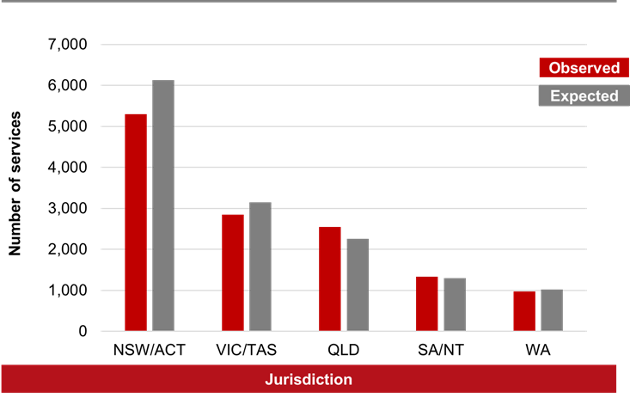

## Uterine cancer

The diagnostic procedure examined in these analyses was endometrial biopsy for suspected malignancy. This procedure is predominantly used for diagnosis of uterine cancers; however, this procedure may also be used for diagnosing other gynaecological cancers.

In 2020, the observed number of services nationally for uterine cancer-related diagnostic procedures was similar to expected, that is, less than 5% difference (2% higher, with 144 more services; 9,348 services observed versus 9,204 services expected) [Table 1; Figure 1].

The observed number of services for 2020 was similar to that expected for most jurisdictions, except for SA/NT, where the observed number of services was 11% higher than expected [Table B1; Figure 1.8]. For each state/territory:

* The observed number of services was 11% higher than expected for SA/NT, with 64 more services (650 services observed versus 586 services expected). The observed number of services was similar to expected for VIC/TAS (4% lower), with 86 fewer services (2,231 services observed versus 2,317 services expected); NSW/ACT (3% higher), with 74 more services (2,644 services observed versus 2,570 services expected); QLD (3% higher), with 10 more services (260 services observed versus 250 services expected); and WA (1% higher), with 12 more services (1,427 services observed versus 1,415 services expected) [Table B1; Figure 1.8].

The observed and expected number of diagnostic services related to uterine cancer for 2020 for each state and territory are provided in Appendix Table B1.

Figure 1.8 Annual observed and expected number of services for uterine cancer-related diagnostic procedures in 2020, by jurisdiction

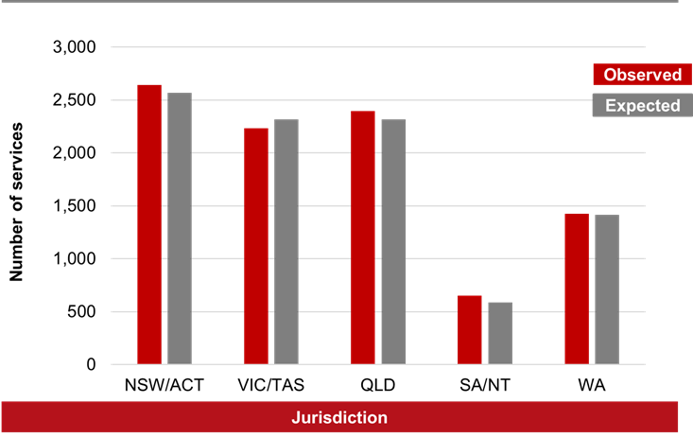

# Surgical and non-surgical therapeutic procedures

The observed number of services for the selected surgical and non-surgical therapeutic procedures in 2020 for all cancer types examined was 9% lower than the expected number of services based on analysis of data over the period 2017−2019 (Table 2, below).

Table Annual observed and expected services for cancer-related therapeutic procedures in 2020, by cancer type

|  |  |  |  |  |  |
| --- | --- | --- | --- | --- | --- |
| **Cancer type** | **Observed** | **Expected**[19] | **O/E Ratio** | **Difference** | |
| **Number of services** | **% difference** |
| Breast cancer | 15,865 | 16,866 | 0.94 | - 1,001 | - 6% |
| Colorectal cancer | 11,505 | 11,656 | 0.99 | - 151 | - 1% |
| Kidney cancer | 2,451 | 2,518 | 0.97 | - 67 | - 3% |
| Liver cancer | 1,507 | 1,454 | 1.04 | + 53 | + 4% |
| Lung cancer | 3,696 | 3,628 | 1.02 | + 68 | + 2% |
| Melanoma of the skin[20] | 68,131 | 79,376 | 0.86 | - 11,245 | - 14% |
| Prostate cancer | 21,662 | 22,198 | 0.98 | - 536 | - 2% |
| Pancreatic cancer | 4,942 | 5,294 | 0.93 | - 352 | - 7% |
| Stomach cancer | 1,004 | 1,000 | 1.00 | + 4 | 0% |
| Gynaecological cancers**[21]** | 16,575 | 17,947 | 0.92 | - 1,372 | - 8% |
| **Total therapeutic procedures** | **147,338** | **161,937** | **0.91** | **- 14,599** | **- 9%** |

Figure 2 Ratio of the observed number of services to expected number of services for selected cancer-related therapeutic procedures for 2020, by cancer type

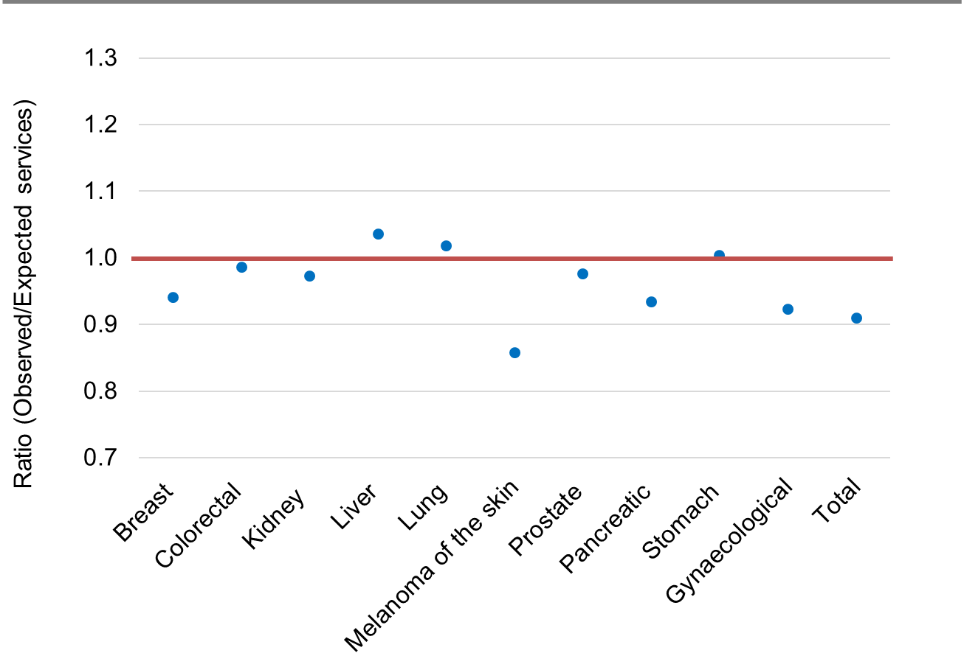

## Breast cancer

For treatment of breast cancer, surgical therapeutic procedures examined in these analyses included surgical excision of breast lesions and mastectomies.

In 2020, the observed number of services nationally for breast cancer-related surgical therapeutic procedures was 6% lower than expected, with 1,001 fewer services (15,865 services observed versus 16,866 services expected) [Table 2; Figure 2].

The observed number of services for 2020 was lower than expected for most jurisdictions. The number of observed services was 5–16% lower than expected for NSW/ACT, VIC/TAS, and SA/NT. The observed number of services was similar to those expected, that is, less than 5% difference, for QLD (3% higher) and WA (0% difference) [Table B2; Figure 2.1]. For each state/territory:

* The observed number of services was 16% lower than expected for VIC/TAS, with 694 fewer services (3,762 services observed versus 4,456 services expected); 5% lower than expected in NSW/ACT, with 314 fewer services (5,551 services observed versus 5,865 services expected); and 5% lower than expected for SA/NT, with 79 fewer services (1,389 services observed versus 1,468 services expected). The observed number of services was similar to expected for QLD (3% higher), with 86 more services (3,350 services observed versus 3,264 services expected); and WA (0% lower), with 1 fewer service (1,813 services observed versus 1,814 services expected) [Table B2; Figure 2.1].

The observed and expected number of surgical therapeutic services related to breast cancer for 2020 for each state and territory are provided in Appendix Table B2.

Figure 2.1 Annual observed and expected number of services for breast cancer-related therapeutic procedures in 2020, by jurisdiction

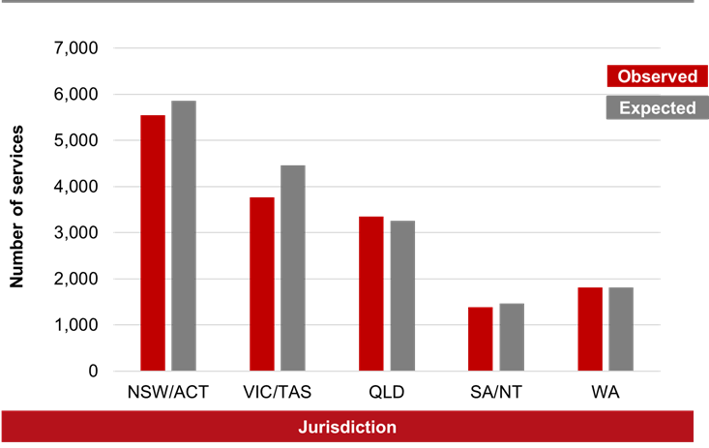

## Colorectal cancer

A range of surgical therapeutic procedures are utilised for treatment of colorectal cancer and were examined in these analyses including resection of lesions, colectomy and hemicolectomy procedures, as well as abdominoperineal resections and anterior resections of the bowel. As indicated in section 1.2, some early stage malignant polyps can be removed during the colonoscopy/ sigmoidoscopy procedure and may not require further or extended surgical procedures in relation to treatment of colorectal cancer, thus representing both a diagnostic procedure as well as a treatment procedure for early stage colorectal cancers[22].

In 2020, the observed number of services nationally for surgical procedures for colorectal cancer was similar to expected, that is, less than 5% difference (1% lower, with 151 fewer services; 11,505 services observed versus 11,656 services expected) [Table 2; Figure 2].

The observed number of services for 2020 was 11% lower than expected for WA and 5-6% higher than expected for SA/NT and QLD. The observed number of services was similar to expected for NSW/ACT (3% lower) and VIC/TAS (2% lower) [Table B2; Figure 2.2]. For each state/territory:

* The observed number of services was 11% lower than expected for WA, with 128 fewer services (1,006 services observed versus 1,134 services expected); 6% higher than expected in QLD, with 141 more services (2,590 services observed versus 2,449 services expected); and 5% higher than expected in SA/NT, with 45 more services (923 services observed versus 878 services expected). The observed number of services was similar to expected for NSW/ACT (3% lower), with 131 fewer services (3,868 services observed versus 3,999 services expected); and VIC/TAS (2% lower), with 78 fewer services (3,118 services observed versus 3,196 services expected) [Table B2; Figure 2.2].

The observed and expected number of surgical procedures related to colorectal cancers for 2020 for each state and territory are provided in Appendix Table B2.

Figure 2.2 Annual observed and expected number of services for colorectal cancer-related therapeutic procedures in 2020, by jurisdiction

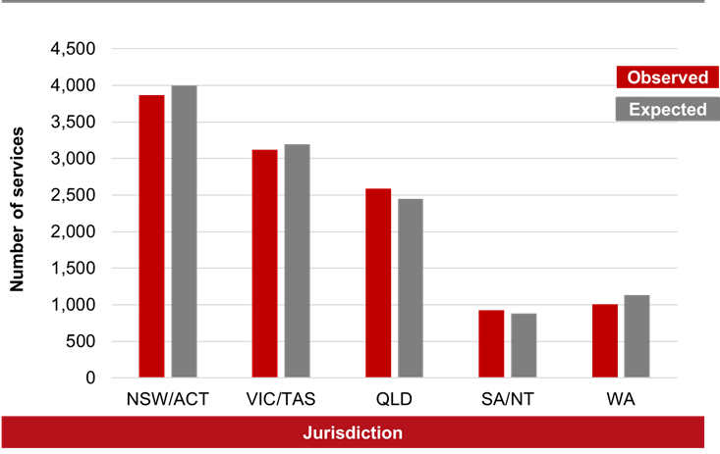

## Kidney cancer

Surgical procedures for the treatment of kidney cancers examined in these analyses included partial, complete or radical nephrectomy surgeries with *en bloc* lymph node dissections (with or without adrenalectomy) and nephro-ureterectomy procedures.

In 2020, the observed number of services nationally for kidney cancer-related surgical procedures was similar to expected, that is, less than 5% difference (3% lower, with 67 fewer services; 2,451 services observed versus 2,518 services expected) [Table 2; Figure 2].

The observed number of services for 2020 were 11% lower than expected for VIC/TAS and 6% higher than expected for QLD. The observed number of services was similar to that expected for NSW/ACT (3% lower), SA/NT (1% higher) and WA (1% higher) [Table B2; Figure 2.3]. For each state/territory:

* The observed number of services was 11% lower than expected for VIC/TAS, with 73 fewer services (619 services observed versus 692 services expected); and 6% higher than expected for QLD, with 27 more services (461 services observed versus 434 services expected). The observed number of services was similar to expected for NSW/ACT (3% lower), with 27 fewer services (848 services observed versus 875 services expected); SA/NT (1% higher), with 2 more services (223 services observed versus 221 services expected); and WA (1% higher), with 4 more services (300 services observed versus 296 services expected) [Table B2; Figure 2.3].

The observed and expected number of therapeutic services related to kidney cancer for 2020 for each state and territory are provided in Appendix Table B2Table .

Figure 2.3 Annual observed and expected number of services for kidney cancer-related therapeutic procedures in 2020, by jurisdiction

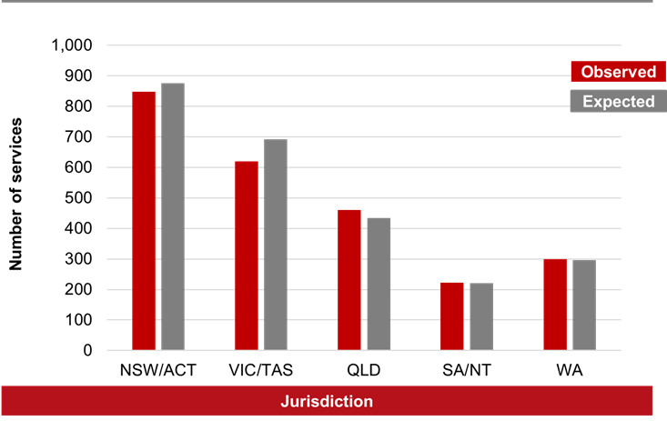

## Liver cancer

A range of procedures is used in the treatment of liver cancer, including both surgical and non-surgical procedures (including ablative procedures). Liver cancer-related surgical procedures examined in these analyses included lobectomy (i.e. removal of a lobe of the liver), or segmental/ subsegmental liver resection procedures as well liver ablation procedures, which encompasses radiofrequency or microwave ablation of unresectable liver tumours.

In 2020, the observed number of services nationally for liver cancer-related therapeutic procedures was similar to expected, that is, less than 5% difference (4% higher, with 53 more services; 1,507 services observed versus 1,454 services expected) [Table 2; Figure 2].

The observed number of services for 2020 was higher than expected for most jurisdictions. The observed number of services was 11–22% higher than expected for VIC/TAS, SA/NT and WA. The observed number of services was similar to those expected for NSW/ACT (4% lower) and QLD (4% lower) [Table B2; Figure 2.4]. For each state/territory:

* The observed number of services was 22% higher than expected for WA, with 28 more services (155 services observed versus 127 services expected); 13% higher than expected for VIC/TAS, with 50 more services (430 services observed versus 380 services expected); and 11% higher than expected for SA/NT, with 11 more services (110 services observed versus 99 services expected). The observed number of services was similar to expected for NSW/ACT (4% lower), with 27 fewer services (580 services observed versus 607 services expected); and QLD (4% lower), with 9 fewer services (232 services observed versus 241 services expected) [Table B2; Figure 2.4].

The observed and expected number of therapeutic services related to liver cancer for 2020 for each state and territory are provided in Appendix Table B2.

Figure 2.4 Annual observed and expected number of services for liver cancer-related therapeutic procedures in 2020, by jurisdiction

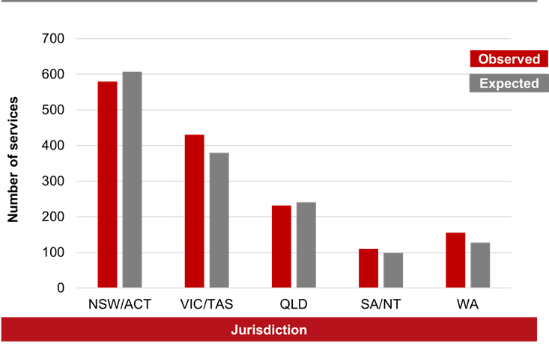

## Lung cancer

A range of lung-cancer related surgical procedures are utilised for treatment of lung cancer and were examined in theses analyses including lobectomies, segmentectomies, wedge resections, pneumonectomies and endobronchial laser resection procedures.

In 2020, the observed number of services nationally for lung cancer-related surgeries was similar to expected, that is, less than 5% difference (2% higher, with 68 more services; 3,696 services observed versus 3,628 services expected) [Table 2; Figure 2].

The observed number of services for 2020 in some jurisdictions was higher than expected. The number of observed services was 22% higher than expected for SA/NT and 9% higher than expected for VIC/TAS. The observed number of services was 25% lower than expected for QLD and similar to that expected for NSW/ACT (4% higher) and WA (1% higher) [Table B2; Figure 2.5]. For each state/territory:

* The observed number of services was 25% lower than expected for QLD, with 146 fewer services (444 services observed versus 590 services expected); 22% higher than expected for SA/NT, with 53 more services (292 services observed versus 239 services expected) and 9% higher than expected for VIC/TAS, with 112 more services (1,336 services observed versus 1,224 services expected). The observed number of services was similar to expected for NSW/ACT (4% higher), with 42 more services (1,107 services observed versus 1,065 services expected); and WA (1% higher), with 7 more services (517services observed versus 510 services expected) [Table B2; Figure 2.5].

The observed and expected number of therapeutic services related to lung cancer for 2020 for each state and territory are provided in Appendix Table B2.

Figure 2.5 Annual observed and expected number of services for lung cancer-related therapeutic procedures in 2020, by jurisdiction

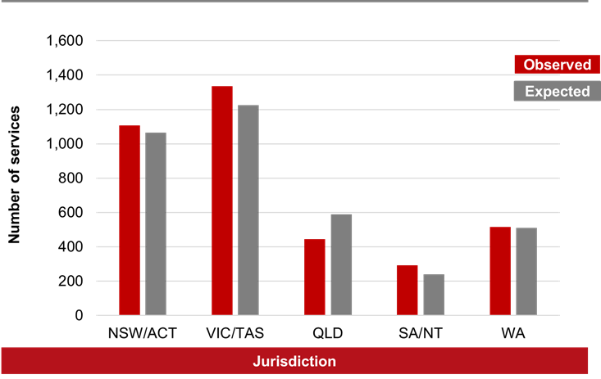

## Melanoma of the skin

The surgical therapeutic procedures for melanoma of the skin in these analyses were definitive surgical excisions for confirmed melanoma-related skin cancers[23]. This encompasses procedures where treatment is by definitive surgical excision and suture, for a range of excision sites and tumour diameters. These procedures are reimbursed where “*the excised specimen is sent for histological examination; and malignancy is confirmed from the excised specimen or previous biopsy*”. Therefore, use of these item codes by service providers represent confirmed diagnosis and treatment procedures for these cancer types.

In 2020, the observed number of services nationally for therapeutic procedures related to melanoma of the skin was 14% lower than expected, with 11,245 fewer services (68,131 services observed versus 79,376 services expected) [Table 2; Figure 2].

The observed number of services for 2020 was 11–17% lower than expected for each jurisdiction [Table B2; Figure 2.6]. For each state/territory:

* The observed number of services was 17% lower than expected for QLD, with 4,024 fewer services (19,975 services observed versus 23,999 services expected); 16% lower than expected for WA, with 1,294 fewer services (7,045 services observed versus 8,339 services expected); 15% lower than expected for SA/NT, with 650 fewer services (3,619 services observed versus 4,269 services expected); 13% lower than expected for NSW/ACT, with 3,704 fewer services (25,296 services observed versus 29,000 services expected); and 11% lower than expected for VIC/TAS, with 1,574 fewer services (12,196 services observed versus 13,770 services expected) [Table B2; Figure 2.6].

The observed and expected number of therapeutic services related to melanoma of the skin for 2020 for each state and territory are provided in Appendix Table B2.

Figure 2.6 Annual observed and expected number of services for melanoma of the skin related therapeutic procedures in 2020, by jurisdiction

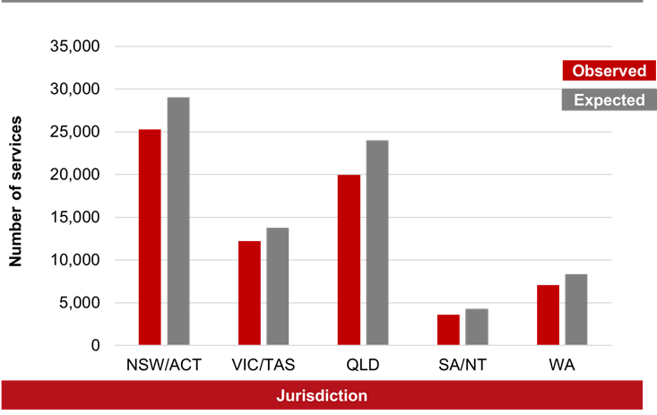

## Prostate cancer

Definitive curative treatment options for localised or locally advanced prostate cancer include surgery (radical prostatectomy), and radiation therapy by external beam radiotherapy (EBRT) or brachytherapy. Treatment options for some earlier stage cancers may also involve the monitoring of key indicators of progression of disease and undergoing regular testing to monitor the requirement to progress to active treatment if necessary, also known as active surveillance.

Treatment options for some earlier stage cancers may also involve the monitoring of key indicators of progression of disease and undergoing regular testing to monitor the requirement to progress to active treatment if necessary, also known as active surveillance.8, 9

In addition to their role in initial diagnosis, the procedures of PSA[24] testing and MRI scans of the prostate may also be employed as part of active surveillance to monitor the progress of the disease and determine if further treatment may be indicated. For more advanced cancers, these procedures may also be employed as part of watchful waiting strategies to monitor the need for palliative treatments. Within the context of the current analyses utilising MBS claims data, separate item codes are used to indicate that these procedures were for the monitoring/ assessment of previously diagnosed disease.

#### Surgical therapeutic procedures

A range of procedures is used in the treatment of prostate cancer, including both surgical and non-surgical procedures (including ablative procedures and external beam radiotherapy and brachytherapy). Prostate cancer-related surgical procedures are largely prostatectomy procedures (i.e. removal of the prostate), and options may include both endoscopic and open procedures, and radical prostatectomy which may include pelvic lymphadenectomy.

A second grouping of prostate cancer-related procedures includes prostate ablation, which encompasses transurethral radiofrequency needle ablation (TUNA), endoscopic laser ablation procedures and transurethral microwave thermotherapy procedures. These procedures are used in the treatment of prostatic disease, although predominantly for treatment of benign disease i.e. benign prostate hyperplasia (BPH).

Treatment options for radiotherapy for prostate cancer include both external beam radiotherapy (EBRT) delivery via linear accelerators (LINAC) and brachytherapy. Monitoring of changes to EBRT LINAC delivery is outside the scope of this report[25]. Brachytherapy delivery procedures include implantation of catheters and radioactive seeds for high dose rate (HDR) and low dose rate (LDR) brachytherapy, respectively.

Definitive therapeutic procedures examined in these analyses included prostatectomy surgeries, prostate ablation procedures and brachytherapy delivery procedures.

In 2020, the observed number of services nationally for prostate cancer-related surgical and non-surgical therapeutic procedures was similar to expected, that is, less than 5% difference (2% lower, 535 fewer services; 21,662 services observed versus 22,197 services expected) [Table 2; Figure 2].

The observed number of services for 2020 was 6% lower than expected for VIC/TAS. The observed number of services was similar to expected for NSW/ACT, QLD, SA/NT and WA [Table B2; Figure 2.7-a]. For each state/territory:

* The observed number of services was 6% lower than expected for VIC/TAS, with 453 fewer services (6,749 services observed versus 7,202 services expected). The observed number of services was similar to expected for WA (3% lower), with 73 fewer services (2,203 services observed versus 2,276 services expected); NSW/ACT (1% lower), with 55 fewer services (7,078 services observed versus 7,133 services expected); QLD (1% higher), with 45 more services (3,886 services observed versus 3,841 services expected); and SA/NT (0% difference), with 1 more service (1,746 services observed versus 1,745 services expected) [Table B2; Figure 2.7-a].

The observed and expected number of therapeutic services related to prostate cancer for 2020 for each state and territory are provided in Appendix Table B2.

Figure 2.7-a Annual observed and expected number of services for prostate cancer-related therapeutic procedures in 2020, by jurisdiction

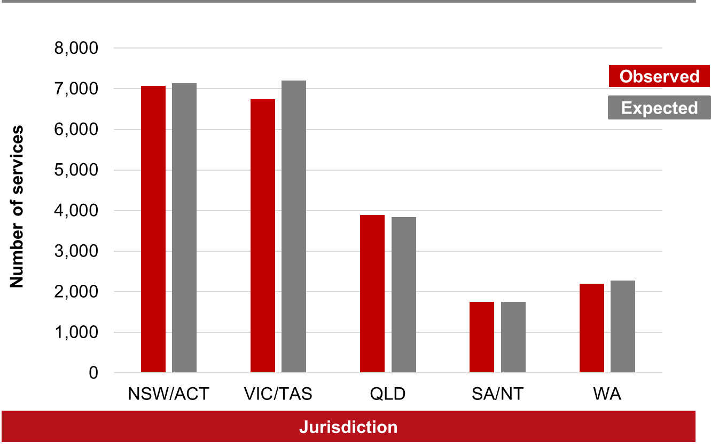

#### Monitoring procedures for previously diagnosed disease

Monitoring procedures examined in these analyses included Multiparametric MRI scan for assessment of prostate cancer2; and quantitation of PSA levels for previously diagnosed prostatic disease.

In 2020, the observed number of services nationally for prostate cancer monitoring procedures was similar to expected, that is, less than 5% difference (2% higher, with 17,989 more services; 1,025,495 services observed versus 1,007,506 services expected).

The observed number of services for 2020 was similar to those expected for most jurisdictions. The number of observed services was 10% higher than expected for WA. The observed number of services was similar to expected for NSW/ACT (4% higher), VIC/TAS (2% lower), QLD (0% difference), and SA/NT (1% higher) [Table B2; Figure 2.7-b]. For each state/territory:

* The observed number of services was 10% higher than expected for WA, with 8,986 more services (103,837 services observed versus 94,851 services expected). The observed number of services was similar to expected for NSW/ACT (4% higher), with 14,311 more services (370,754 services observed versus 356,443 services expected); VIC/TAS (2% lower), with 5,346 fewer services (273,244 services observed versus 278,590 services expected); SA/NT (1% higher), with 463 more services (70,162 services observed versus 69,699 services expected); and QLD (0% difference), with 426 fewer services (207,498 services observed versus 207,924 services expected) [Table B2; Figure 2.7-b].

The observed and expected number of monitoring services related to prostate cancer for 2020 for each state and territory are provided in Appendix Table B2.

Figure 2.7-b Annual observed and expected number of services for prostate cancer-related monitoring procedures in 2020, by jurisdiction

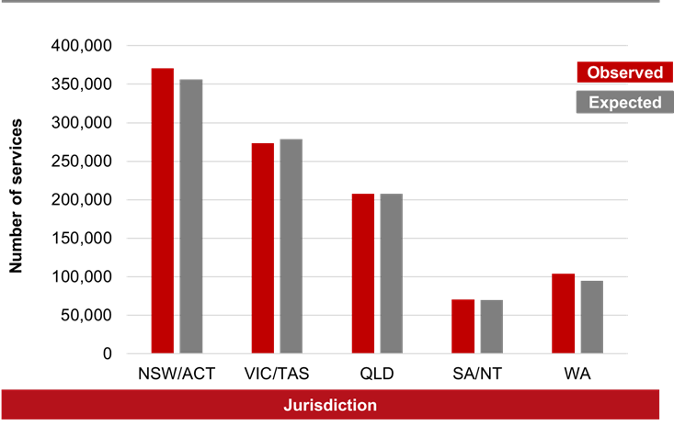

## Pancreatic cancer

Surgical procedures for the treatment of pancreatic cancer examined in these analyses included local excision of pancreatic/ duodenal tumours, pancreatectomy procedures including near, total or distal pancreatectomies, Whipple’s procedures, and endoscopic stenting procedures of bile ducts.

In 2020, the observed number of services nationally for pancreatic cancer-related surgical procedures was 7% lower than expected, with 352 fewer services (4,942 services observed versus 5,294 services expected) [Table 2; Figure 2].

The observed number of services for 2020 was lower than expected for most jurisdictions. The number of observed services was 5–19% lower than expected for NSW/ACT, VIC/TAS, and SA/NT. The observed number of services was 11% higher than expected for QLD and similar to that expected, that is, less than 5% difference, for WA (1% lower) [Table B2; Figure 2.8]. For each state/territory:

* The observed number of services was 19% lower than expected for VIC/TAS, with 254 fewer services (1,073 services observed versus 1,327 services expected); 11% lower than expected for SA/NT, with 63 fewer services (524 services observed versus 587 services expected); 11% higher than expected for QLD, with 86 more services (892 services observed versus 806 services expected); and 5% lower than expected for NSW/ACT, with 116 fewer services (2,076 services observed versus 2,192 services expected). The observed number of services was similar to expected for WA (1% lower), with 4 fewer services (377 services observed versus 381 services expected) [Table B2; Figure 2.8].

The observed and expected number of therapeutic services related to pancreatic cancer for 2020 for each state and territory are provided in Appendix Table B2.

Figure 2.8 Annual observed and expected number of services for pancreatic cancer-related therapeutic procedures in 2020, by jurisdiction

The figure is a column graph depicting the number of therapeutic procedures related to pancreatic cancer for each jurisdiction in 2020. Two bars are shown for each jurisdiction, one for the number of observed services and one for the number of expected services. The column bar for observed services is lower than the column bar for expected services for jurisdictions including NSW and ACT combined, VIC and TAS combined, and SA and NT combined. The column bar for observed services is higher than the column bar for expected services for QLD. The observed and expected number of services are considered similar for WA.
 


## Stomach cancer

Surgical procedures used for the treatment of stomach cancer examined in these analyses were local excision of gastric tumours and partial or total gastrectomy procedures.

In 2020, the observed number of services nationally for stomach cancer-related therapeutic procedures was similar to expected, that is, less than 5% difference (0% difference, with 4 more services; 1,004 services observed versus 1,000 services expected) [Table 2; Figure 2].

The observed number of services for 2020 was 7% lower than expected for NSW/ACT and 22% higher than expected for QLD. The observed number of services were similar to that expected for VIC/TAS (3% lower). Due to the smaller number of services for SA/NT and WA, any differences in observed and expected numbers of annual services should be interpreted with caution [Table B2; Figure 2.9]. For each state/territory:

* The observed number of services was 23% higher than expected for SA/NT, with 8 more services (43 services observed versus 35 services expected); 22% higher than expected for QLD, with 31 more services (172 services observed versus 141 services expected); 11% higher than expected for WA, with 10 more services (100 services observed versus 90 services expected); and 7% lower than expected for NSW/ACT, with 37 fewer services (462 services observed versus 499 services expected). The observed number of services was similar to expected for VIC/TAS (3% lower), with 8 fewer services (227 services observed versus 235 services expected) [Table B2; Figure 2.9].

The observed and expected number of therapeutic services related to stomach cancer for 2020 for each state and territory are provided in Appendix Table B2.

Figure 2.9 Annual observed and expected number of services for stomach cancer-related therapeutic procedures in 2020, by jurisdiction

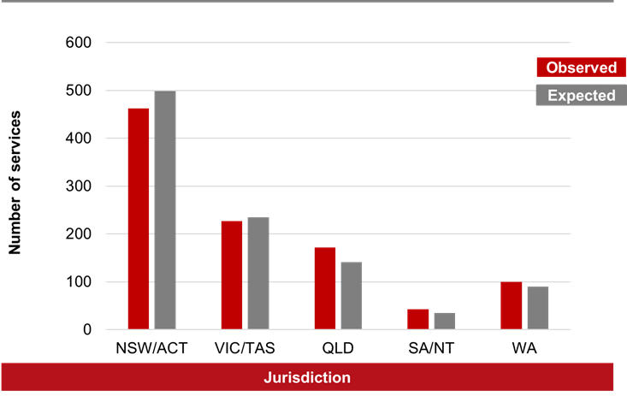

## Gynaecological cancers

Therapeutic procedures for gynaecological cancers including uterine, ovarian, cervical, vaginal and vulval cancers encompass both surgical and non-surgical procedures. In some cases, the same procedure type may be used in the treatment of more than one type of gynaecological cancer, in particular for advanced disease; or may be grouped together for the purposes of reimbursement through the MBS. Therefore, analyses for all treatment procedures examined in the report are presented as a gynaecological cancer grouping.

Surgical procedures examined in the report include oophorectomy, salpingectomy or salpingo-oophorectomy laparotomy procedures; partial, complete or radical vaginectomy procedures for proven malignancy; excision of vulva or vulvectomy procedures for suspected or proven malignancy; colposcopy and large loop excisions for previously confirmed intraepithelial neoplastic changes and radical or debulking operations for advanced gynaecological malignancy. Non-surgical procedures examined in the report include intrauterine and/ or intravaginal brachytherapy procedures.

In 2020, the observed number of services nationally for gynaecological cancer-related therapeutic procedures was 8% lower than expected, or 1,372 fewer services (16,575 services observed versus 17,947 services expected) [Table 2; Figure 2].

The observed number of services for 2020 was lower than expected for most jurisdictions. The number of observed services was 10–13% lower than expected for VIC/TAS, QLD and SA/NT. The observed number of services was similar to expected, that is, less than 5% difference, for NSW/ACT (3% lower) and WA (3% lower), [Table B2; Figure 2.10]. For each state/territory:

* The observed number of services was 13% lower than expected for VIC/TAS, with 525 fewer services (3,515 services observed versus 4,040 services expected); 11% lower than expected for QLD, with 430 fewer services (3,375 services observed versus 3,805 services expected); and 10% lower than expected for SA/NT, with 175 fewer services (1,654 services observed versus 1,829 services expected). The observed number of services was similar to expected for NSW/ACT (3% lower), with 185 fewer services (6,182 services observed versus 6,367 services expected); and WA (3% lower), with 57 fewer services (1,849 services observed versus 1,906 services expected) [Table B2; Figure 2.10].

The observed and expected number of therapeutic services related to gynaecological cancers for 2020 for each state and territory are provided in Appendix Table B2.

Figure 2.10 Annual observed and expected number of services for gynaecological cancer-related therapeutic procedures in 2020, by jurisdiction

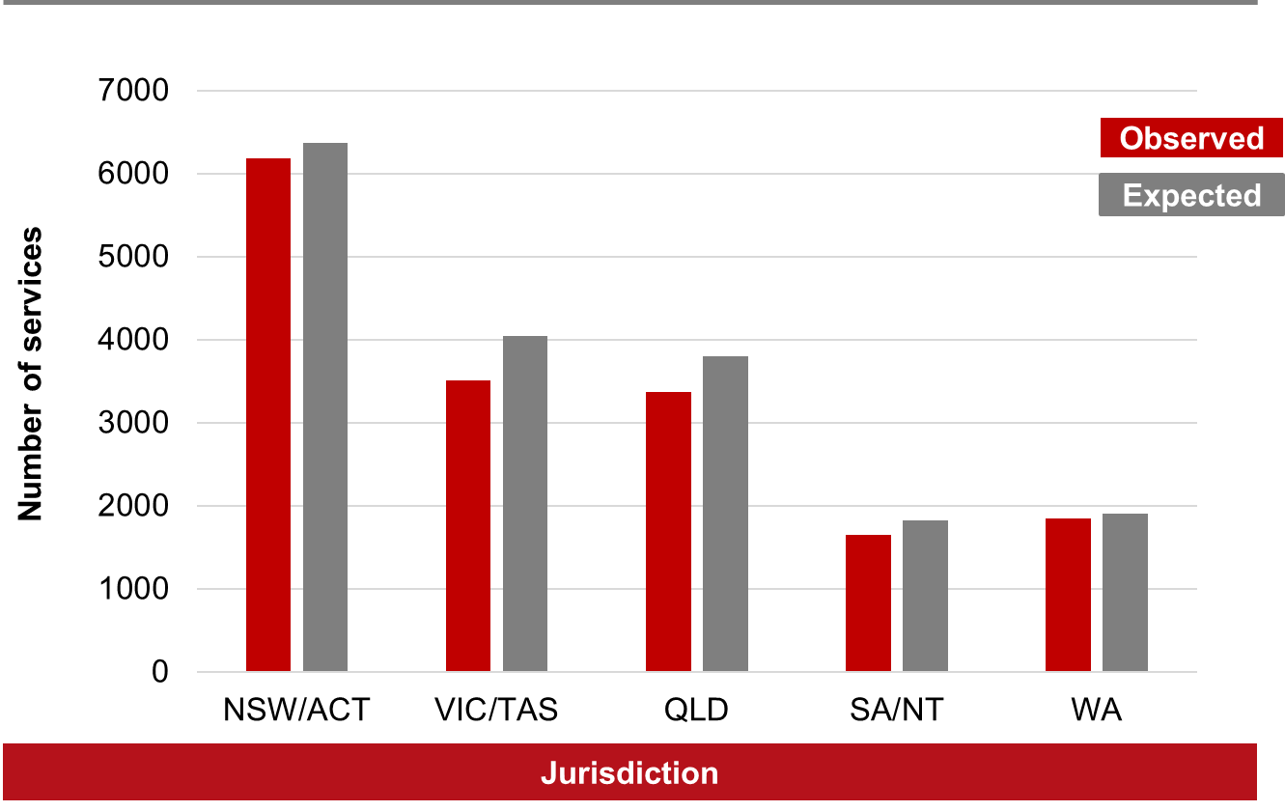

Appendix A

Table A1 MBS item codes for cancer-related diagnostic procedures[26]

| **Cancer type** | **MBS Item code** |
| --- | --- |
| **Breast cancer** | 59300, 59301, 59302, 59303, 59304, 59305, 63458, 63467, 63487, 63488, 63531, 63532, 63533, 63534, 31506, 31509, 31530, 31533, 31536, 31539, 31545, 31548, 63489, 63490, 30299, 30300, 30302, 30303 |
| **Colorectal cancers** | 32072, 32075, 32084, 32087, 32096, 32222, 32223, 32224, 32225, 32226, 32227, 32228, 32088*, 32089*, 32090*, 32093* |
| **Kidney cancer** | 36561 |
| **Liver cancer** | 30409, 30411,30412 |
| **Lung cancer** | 30696, 30710, 38418, 38812, 38436, 38448, 41892, 41898, 61523 |
| **Prostate cancer** | 63541, 63542, 37212, 37215, 37218, 37219, 37226, 66655 |
| **Stomach and pancreatic cancers[27]** | 30688, 30690, 30692, 30694, 61647, 41822 |
| **Uterine cancers[28]** | 35620 |

Table A2 MBS item codes for cancer-related surgical and non-surgical therapeutic procedures

| **Cancer type** | **MBS Item code** |
| --- | --- |
| **Breast cancer** | 31512, 31515, 31516, 31519, 31524 |
| **Colorectal cancers[29]** | 32000, 32003, 32004, 32005, 32006, 32009, 32012, 32024, 32025, 32026, 32028, 32039, 32042, 32045, 32046, 32099, 32102, 32103, 32104, 32105, 32106, 32108, 32015, 32018, 32021, 32023, 32030, 32047, 32051, 32054, 32057 |
| **Kidney cancer** | 36516, 36519, 36522, 36525, 36526, 36527, 36528, 36529, 36531, 36532, 36533, 43984, 43987 |
| **Liver cancer** | 30414, 30415, 30418, 30421, 50950, 50952 |
| **Lung cancer** | 38438, 38440, 38441, 41901 |
| **Melanoma skin cancers[30]** | 31371, 31372, 31373, 31374, 31375, 31376, 31300*, 31305*, 31310*, 31315*, 31320*, 31325*, 31330*, 31335* |
| **Prostate cancer (definitive treatment)** | 15338, 37220, 37227, 37200, 37203, 37206, 37209, 37210, 37211, 37201, 37202, 37207, 37208, 37224, 37230, 37233 |
| **Prostate cancer (monitoring of previously diagnosed disease)** | 63543, 63544, 66656, 66659, 66660 |
| **Pancreatic cancer** | 30578, 30580, 30583, 30584, 30593, 30491 |
| **Stomach cancer** | 30518, 30520, 30523, 30524, 30526 |
| **Gynaecological cancers** | 35664, 35667, 15308, 15316, 15324, 35720, 35713, 35717, 35536, 35548, 35557, 35560, 35561, 35562, 35564, 35644,35645, 35646, 35647, 35648 |

Appendix B

Table B1 Annual observed and expected services for cancer-related diagnostic procedures[31] in 2020, by jurisdiction

| **Cancer type** | **Observed** | **Expected[32]** | **Ratio** | **Difference** | | |
| --- | --- | --- | --- | --- | --- | --- |
| **Number of services** | **% difference** |
| **Breast cancer** | | | | | | | |
| **NSW/ACT** | 202,034 | 208,722 | 0.97 | -6,688 | -3% |
| **VIC/TAS** | 132,498 | 135,021 | 0.98 | -2,523 | -2% |
| **QLD** | 105,964 | 112,760 | 0.94 | -6,796 | -6% |
| **SA/NT** | 37,956 | 44,251 | 0.86 | -6,295 | -14% |
| **WA** | 42,161 | 40,531 | 1.04 | 1,630 | 4% |
| **Total** | **520,613** | **541,285** | **0.96** | **-20,672** | **-4%** |
| **Colorectal cancers[33]** | | | | | | | |
| **NSW/ACT** | 206,093 | 232,948 | 0.88 | -26,855 | -12% |
| **VIC/TAS** | 151,578 | 193,696 | 0.78 | -42,118 | -22% |
| **QLD** | 144,437 | 150,597 | 0.96 | -6,160 | -4% |
| **SA/NT** | 52,616 | 58,853 | 0.89 | -6,237 | -11% |
| **WA** | 54,921 | 60,845 | 0.90 | -5,924 | -10% |
| **Total** | **609,645** | **696,938** | **0.87** | **-87,293** | **-13%** |
| **Kidney cancer** | | | | | | | |
| **NSW/ACT** | 1,185 | 1,161 | 1.02 | 24 | 2% |
| **VIC/TAS** | 351 | 281 | 1.25 | 70 | 25% |
| **QLD** | 260 | 250 | 1.04 | 10 | 4% |
| **SA/NT** | 2 | - | - | - | - |
| **WA** | 142 | 159 | 0.89 | -17 | -11% |
| **Total** | **1,940** | **1,854** | **1.05** | **86** | **5%** |
| **Liver cancer** | | | | | | | |
| **NSW/ACT** | 1,217 | 1,327 | 0.92 | -110 | -8% |
| **VIC/TAS** | 1,125 | 1,338 | 0.84 | -213 | -16% |
| **QLD** | 562 | 635 | 0.88 | -73 | -12% |
| **SA/NT** | 218 | 297 | 0.73 | -79 | -27% |
| **WA** | 324 | 337 | 0.96 | -13 | -4% |
| **Total** | **3,446** | **3,934** | **0.88** | **-488** | **-12%** |
| **Lung cancer** | | | | | | | |
| **NSW/ACT** | 15,077 | 17,091 | 0.88 | -2,014 | -12% |
| **VIC/TAS** | 10,540 | 11,488 | 0.92 | -948 | -8% |
| **QLD** | 6,980 | 7,130 | 0.98 | -150 | -2% |
| **SA/NT** | 4,036 | 4,536 | 0.89 | -500 | -11% |
| **WA** | 3,929 | 4,202 | 0.94 | -273 | -6% |
| **Total** | **40,562** | **44,446** | **0.91** | **-3,884** | **-9%** |
| **Prostate cancer[34]** | | | | | | | |
| **NSW/ACT** | 222,797 | 237,272 | 0.94 | -14,475 | -6% |
| **VIC/TAS** | 191,289 | 211,242 | 0.91 | -19,953 | -9% |
| **QLD** | 149,285 | 157,043 | 0.95 | -7,758 | -5% |
| **SA/NT** | 63,566 | 65,150 | 0.98 | -1,584 | -2% |
| **WA** | 87,061 | 93,910 | 0.93 | -6,849 | -7% |
| **Total** | **713,998** | **764,617** | **0.93** | **-50,619** | **-7%** |
| **Stomach and pancreatic cancers[35][36]** | | | | | | | |
| **NSW/ACT** | 5,292 | 6,134 | 0.86 | -842 | -14% |
| **VIC/TAS** | 2,842 | 3,150 | 0.90 | -308 | -10% |
| **QLD** | 2,548 | 2,257 | 1.13 | 291 | 13% |
| **SA/NT** | 1,330 | 1,294 | 1.03 | 36 | 3% |
| **WA** | 978 | 1,026 | 0.95 | -48 | -5% |
| **Total** | **12,990** | **13,860** | **0.94** | **-870** | **-6%** |
| **Uterine cancer[37]** | | | | | | | |
| **NSW/ACT** | 2,644 | 2,570 | 1.03 | 74 | 3% |
| **VIC/TAS** | 2,231 | 2,317 | 0.96 | -86 | -4% |
| **QLD** | 2,396 | 2,316 | 1.03 | 80 | 3% |
| **SA/NT** | 650 | 586 | 1.11 | 64 | 11% |
| **WA** | 1,427 | 1,415 | 1.01 | 12 | 1% |
| **Total** | **9,348** | **9,204** | **1.02** | **144** | **2%** |

Table B2 Annual observed and expected services for cancer-related therapeutic procedures[38] in 2020, by jurisdiction

| **Cancer type** | **Observed** | **Expected[39]** | **Ratio** | **Difference** | |
| --- | --- | --- | --- | --- | --- |
| **Number of services** | **% difference** |
| **Breast cancer** | | | | | | |
| **NSW/ACT** | 5,551 | 5,865 | 0.95 | -314 | -5% |
| **VIC/TAS** | 3,762 | 4,456 | 0.84 | -694 | -16% |
| **QLD** | 3,350 | 3,264 | 1.03 | 86 | 3% |
| **SA/NT** | 1,389 | 1,468 | 0.95 | -79 | -5% |
| **WA** | 1,813 | 1,814 | 1.00 | -1 | 0% |
| **Total** | **15,865** | **16,866** | **0.94** | **-1,001** | **-6%** |
| **Colorectal cancer[40]** | | | | | | |
| **NSW/ACT** | 3,868 | 3,999 | 0.97 | -131 | -3% |
| **VIC/TAS** | 3,118 | 3,196 | 0.98 | -78 | -2% |
| **QLD** | 2,590 | 2,449 | 1.06 | 141 | 6% |
| **SA/NT** | 923 | 878 | 1.05 | 45 | 5% |
| **WA** | 1,006 | 1,134 | 0.89 | -128 | -11% |
| **Total** | **11,505** | **11,656** | **0.99** | **-151** | **-1%** |
| **Kidney cancer** | | | | | | |
| **NSW/ACT** | 848 | 875 | 0.97 | -27 | -3% |
| **VIC/TAS** | 619 | 692 | 0.89 | -73 | -11% |
| **QLD** | 461 | 434 | 1.06 | 27 | 6% |
| **SA/NT** | 223 | 221 | 1.01 | 2 | 1% |
| **WA** | 300 | 296 | 1.01 | 4 | 1% |
| **Total** | **2,451** | **2,518** | **0.97** | **-67** | **-3%** |
| **Liver cancer** | | | | | | |
| **NSW/ACT** | 580 | 607 | 0.96 | -27 | -4% |
| **VIC/TAS** | 430 | 380 | 1.13 | 50 | 13% |
| **QLD** | 232 | 241 | 0.96 | -9 | -4% |
| **SA/NT** | 110 | 99 | 1.11 | 11 | 11% |
| **WA** | 155 | 127 | 1.22 | 28 | 22% |
| **Total** | **1,507** | **1,454** | **1.04** | **53** | **4%** |
| **Lung cancer** | | | | | | |
| **NSW/ACT** | 1,107 | 1,065 | 1.04 | 42 | 4% |
| **VIC/TAS** | 1,336 | 1,224 | 1.09 | 112 | 9% |
| **QLD** | 444 | 590 | 0.75 | -146 | -25% |
| **SA/NT** | 292 | 239 | 1.22 | 53 | 22% |
| **WA** | 517 | 510 | 1.01 | 7 | 1% |
| **Total** | **3,696** | **3,628** | **1.02** | **68** | **2%** |
| **Melanoma skin cancers[41]** | | | | | | |
| **NSW/ACT** | 25,296 | 29,000 | 0.87 | -3,704 | -13% |
| **VIC/TAS** | 12,196 | 13,770 | 0.89 | -1,574 | -11% |
| **QLD** | 19,975 | 23,999 | 0.83 | -4,024 | -17% |
| **SA/NT** | 3,619 | 4,269 | 0.85 | -650 | -15% |
| **WA** | 7,045 | 8,339 | 0.84 | -1,294 | -16% |
| **Total** | **68,131** | **79,376** | **0.86** | **-11,245** | **-14%** |
| **Prostate cancer** | | | | | | |
| **NSW/ACT** | 7,078 | 7,133 | 0.99 | -55 | -1% |
| **VIC/TAS** | 6,749 | 7,202 | 0.94 | -453 | -6% |
| **QLD** | 3,886 | 3,841 | 1.01 | 45 | 1% |
| **SA/NT** | 1,746 | 1,745 | 1.00 | 1 | 0% |
| **WA** | 2,203 | 2,276 | 0.97 | -73 | -3% |
| **Total** | **21,662** | **22,197** | **0.98** | **-535** | **-2%** |
| **Prostate cancer (monitoring of previously diagnosed disease)[42]** | | | | | | |
| **NSW/ACT** | 370,754 | 356,443 | 1.04 | 14,311 | 4% |
| **VIC/TAS** | 273,244 | 278,590 | 0.98 | -5,346 | -2% |
| **QLD** | 207,498 | 207,924 | 1.00 | -426 | 0% |
| **SA/NT** | 70,162 | 69,699 | 1.01 | 463 | 1% |
| **WA** | 103,837 | 94,851 | 1.10 | 8,986 | 10% |
| **Total** | **1,025,495** | **1,007,506** | **1.02** | **17,989** | **2%** |
| **Pancreatic cancer** | | | | | |
| **NSW/ACT** | **2,076** | **2,192** | **0.95** | **-116** | **-5%** |
| **VIC/TAS** | **1,073** | **1,327** | **0.81** | **-254** | **-19%** |
| **QLD** | **892** | **806** | **1.11** | **86** | **11%** |
| **SA/NT** | **524** | **587** | **0.89** | **-63** | **-11%** |
| **WA** | **377** | **381** | **0.99** | **-4** | **-1%** |
| **Total** | **4,942** | **5,294** | **0.93** | **-352** | **-7%** |
| **Stomach cancer** | | | | | | |
| **NSW/ACT** | 462 | 499 | 0.93 | -37 | -7% |
| **VIC/TAS** | 227 | 235 | 0.97 | -8 | -3% |
| **QLD** | 172 | 141 | 1.22 | 31 | 22% |
| **SA/NT** | 43 | 35 | 1.23 | 8 | 23% |
| **WA** | 100 | 90 | 1.11 | 10 | 11% |
| **Total** | **1,004** | **1,000** | **1.00** | **4** | **0%** |
| **Gynaecological cancers**[43] | | | | | |
| **NSW/ACT** | 6,182 | 6,367 | 0.97 | -185 | -3% |
| **VIC/TAS** | 3,515 | 4,040 | 0.87 | -525 | -13% |
| **QLD** | 3,375 | 3,805 | 0.89 | -430 | -11% |
| **SA/NT** | 1,654 | 1,829 | 0.90 | -175 | -10% |
| **WA** | 1,849 | 1,906 | 0.97 | -57 | -3% |
| **Total** | **16,575** | **17,947** | **0.92** | **-1,372** | **-8%** |

References

1. Cancer Australia. Review of the impact of COVID-19 on medical services and procedures in Australia utilising MBS data: Skin, breast and colorectal cancers, and telehealth services. Surry Hills, NSW, 2020.

2. Cancer Australia. Review of the impact of COVID-19 on medical services and procedures in Australia utilising MBS data: Lung and prostate cancers. Surry Hills, NSW, 2020.

3. Cancer Australia. National and jurisdictional data on the impact of COVID-19 on medical services and procedures in Australia: Breast, colorectal, lung, prostate and skin cancers. Surry Hills, NSW, 2020.

4. Williams E, Kong JC, Singh P, et al. The impact of the COVID-19 pandemic on colorectal cancer diagnosis and management: A Binational Colorectal Cancer Audit study. ANZ Journal of Surgery. 2021.

5. Degeling K, Baxter NN, Emery J, et al. An inverse stage-shift model to estimate the excess mortality and health economic impact of delayed access to cancer services due to the COVID-19 pandemic. Asia Pac J Clin Oncol. 2021;17(4):359-367.

6. Department of Health. MBS online. Accessed: 16 March 2020; Available at: <http://www9.health.gov.au/mbs/search.cfm>

7. Services Australia. Medicare item reports. Accessed: 13 May 2021; Available at: <http://medicarestatistics.humanservices.gov.au/statistics/mbs_item.jsp>

8. Cancer Council Australia. Optimal care pathway for men with prostate cancer. Accessed: Available at: <https://www.cancer.org.au/health-professionals/optimal-cancer-care-pathways>

9. Prostate Cancer Foundation of Australia and Cancer Council Australia PSA Testing Guidelines Expert Advisory Panel. Clinical practice guidelines PSA testing and early management of test-detected prostate cancer. Accessed: 23 August 2021; Available at: <https://wiki.cancer.org.au/australia/Guidelines:PSA_Testing/Active_surveillance>

© Cancer Australia 2021 COVMBS1

1. The MBS data analysed in this report do not include screening mammograms for breast cancer, faecal occult blood test (FOBT) screening for colorectal cancer, or human papillomavirus (HPV) cervical screening tests for cervical cancer or complementary services undertaken within the public sector.
2. Diagnostic procedures used for detection of stomach and pancreatic cancers may also be used as diagnostic procedures for detecting oesophageal cancers.
3. Grouping includes Malignant Melanoma, Appendageal Carcinoma, Malignant Fibrous Tumour of Skin, Merkel Cell Carcinoma of Skin, or Hutchinson's Melanotic Freckle)
4. The figures in the report include only those services that are performed by a registered provider, for services that qualify for Medicare Benefit and for which a claim has been processed by Services Australia. They do not include services provided by hospital doctors to public patients in public hospitals or services that qualify for a benefit under the Department of Veterans' Affairs National Treatment Account. Services in the relevant periods are determined by the date the service was processed by Services Australia, not the date the service was provided.
5. EBRT delivery includes standard LINAC delivery as well as image-guided intensity modulated radiotherapy (IMRT) – services are reimbursed as fractions and without linkage across services, it is difficult to understand patterns of delivery.
6. Diagnostic procedures used for the detection of stomach and pancreatic cancers may also be used as diagnostic procedures for detecting oesophageal cancer.
7. The MBS data analysed in this report do not include procedures for screening mammograms for breast cancer, faecal occult blood test (FOBT) screening for cancer of the bowel, or cervical screening test for human papillomavirus (HPV) or complementary services undertaken within the public sector.
8. Expected estimates from the linear regression of yearly services in 2017, 2018 and 2019. Data for 2019 is used when previous data not available.
9. Colorectal cancer-related procedures excluded a separate item code for removal of polyp(s) procedures during colonoscopy procedures as the introduction of the separate MBS item code for this specific procedure type and data was only available from Oct 2019 onwards.
10. Magnetic resonance imaging (MRI) scan for detection of prostate cancer data available from July 2018 onwards.
11. Diagnostic procedures used for detection of stomach and pancreatic cancers may also be used as procedures for detecting oesophageal cancer.
12. Data for whole body PET study for suspected gastro-entero-pancreatic neuroendocrine tumour from May 2018.
13. Endometrial biopsy for suspected malignancy for the detection of uterine cancer may also be used for diagnosing other gynaecological cancers.
14. Colonoscopy procedures as a group may include investigations for reasons other than colorectal cancer including e.g. inflammatory bowel disease and post-polypectomy bleeding.
15. Colorectal cancer-related procedures excluded a separate item code for removal of polyp(s) procedures during colonoscopy procedures as the introduction of the separate MBS item code for this specific procedure type and data was only available from Oct 2019 onwards.
16. As the number of colonoscopy/ sigmoidoscopy procedures where a polyp has been removed is not known, to avoid duplication of service counts, these procedures have been included for diagnostic procedures only.
17. No specific MBS item code is available for DRE procedures. These are performed by the GP or specialist (e.g. urologist) and are coded as part of the professional attendance service.
18. General ultrasound codes are available for abdominal, ureteric, and pelvic ultrasounds but prostate-specific ultrasound codes are limited to monitoring of current prostatic disease rather than diagnostic.
19. Expected estimates from the linear regression of yearly services in 2017, 2018 and 2019. Data for 2019 is used when data for previous period/s are not available.
20. Grouping includes Malignant Melanoma, Appendageal Carcinoma, Malignant Fibrous Tumour of Skin, Merkel Cell Carcinoma of Skin, or Hutchinson's Melanotic Freckle). These procedures are reimbursed where “the excised specimen is sent for histological examination; and malignancy is confirmed from the excised specimen or previous biopsy”. Therefore, use of these item codes by service providers represent confirmed diagnosis and treatment procedures for these cancer types.
21. Gynaecological cancers include procedures for uterine, ovarian, vaginal, vulval and cervical cancers
22. As the number of colonoscopy/ sigmoidoscopy procedures where a polyp has been removed is not known, to avoid duplication of service counts, these procedures have been included for diagnostic procedures only.
23. Grouping includes Malignant Melanoma, Appendageal Carcinoma, Malignant Fibrous Tumour of Skin, Merkel Cell Carcinoma of Skin, or Hutchinson's Melanotic Freckle).
24. PSA: Prostate specific antigen
25. EBRT delivery includes standard LINAC delivery as well as image-guided intensity modulated radiotherapy (IMRT) – services are reimbursed as fractions and without linkage across services, it is difficult to understand patterns of delivery.
26. The MBS data analysed in this report do not include procedures for screening mammograms for breast cancer, faecal occult blood test (FOBT) screening for cancer of the bowel, or cervical screening test for human papillomavirus (HPV) or complementary services undertaken within the public sector.
27. Diagnostic procedures used for detection of stomach and pancreatic cancers may also be used as diagnostic procedures for detecting oesophageal cancers.
28. Endometrial biopsy for suspected malignancy for the detection of uterine cancer may also be used for diagnosing other gynaecological cancers.
29. Colorectal cancer-related procedures excluded a separate item code for removal of polyp(s) procedures during colonoscopy procedures as the introduction of the separate MBS item code for this specific procedure type and data was only available from Oct 2019 onwards.
30. Grouping includes Malignant Melanoma, Appendageal Carcinoma, Malignant Fibrous Tumour of Skin, Merkel Cell Carcinoma of Skin, or Hutchinson's Melanotic Freckle
31. The MBS data analysed in this report do not include procedures for screening mammograms for breast cancer, faecal occult blood test (FOBT) screening for cancer of the bowel, or cervical screening test for human papillomavirus (HPV) or complementary services undertaken within the public sector.
32. Expected estimates from the linear regression of yearly services in 2017, 2018 and 2019. Data for 2019 is used when previous data not available.
33. Colorectal cancer-related procedures excluded procedures for removal of polyps during colonoscopy procedures as the MBS item code was newly added for this specific procedure type and data was only available from Oct 2019 onwards.
34. MRI scan for detection of prostate cancer data available from July 2018 onwards.
35. Data for whole body PET study for suspected gastro-entero-pancreatic neuroendocrine tumour from May 2018.
36. Diagnostic procedures used for detection of stomach and pancreatic cancers may also be used as diagnostic procedures for detecting oesophageal cancer.
37. Endometrial biopsy for suspected malignancy for the detection of uterine cancer may also be used for diagnosing other gynaecological cancers.
38. The MBS data analysed in this report for therapeutic services do not include complementary services undertaken within the public sector.
39. Expected estimates from the linear regression of yearly services in 2017, 2018 and 2019. Data for 2019 is used when previous data not available.
40. Colorectal cancer-related procedures excluded procedures for removal of polyps during colonoscopy procedures as the MBS item code was newly added for this specific procedure type and data was only available from Oct 2019 onwards.
41. Grouping includes Malignant Melanoma, Appendageal Carcinoma, Malignant Fibrous Tumour of Skin, Merkel Cell Carcinoma of Skin, or Hutchinson's Melanotic Freckle)
42. MRI scan for assessment of prostate cancer data available from July 2018 onwards.
43. Gynaecological grouping includes therapeutic procedures related to uterine, ovarian, cervical and vaginal/vulval cancers.