# Cancer Research in Australia

An overview of funding to cancer research projects and research programs in Australia 2006 to 2011

Evidence to inform research investment

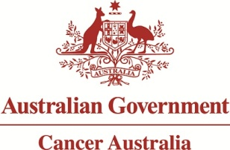

*Cancer Research in Australia: an overview of funding to cancer research projects and research programs in Australia 2006 to 2011* was prepared and produced by:

Cancer Australia  
Locked Bag 3 Strawberry Hills NSW 2012 Australia  
Tel: +61 2 9357 9400 Fax: +61 2 9357 9477  
Website: [canceraustralia.gov.au](http://www.canceraustralia.gov.au)

©Cancer Australia 2014

ISBN Print: 978-1-74127-277-2 ISBN Online: 978-1-74127-278-9

**Copyright statements**

**Paper-based publications**

This work is copyright. You may reproduce the whole or part of this work in unaltered form for your own personal use or, if you are part of an organisation, for internal use within your organisation, but only if you or your organisation do not use the reproduction for any commercial purpose and retain this copyright notice and all disclaimer notices as part of that reproduction. Apart from rights to use as permitted by the Copyright Act 1968 or allowed by this copyright notice, all other rights are reserved and you are not allowed to reproduce the whole or any part of this work in any way (electronic or otherwise) without first being given the specific written permission from Cancer Australia to do so. Requests and inquiries concerning reproduction and rights are to be sent to the Publications and Copyright contact officer, Cancer Australia, Locked Bag 3, Strawberry Hills NSW 2012.

**Internet sites**

This work is copyright. You may download, display, print and reproduce the whole or part of this work in unaltered form for your own personal use or, if you are part of an organisation, for internal use within your organisation, but only if you or your organisation do not use the reproduction for any commercial purpose and retain this copyright notice and all disclaimer notices as part of that reproduction. Apart from these rights to use as permitted by the Copyright Act 1968 or allowed by this copyright notice, all other rights are reserved and you are not allowed to reproduce the whole or any part of this work in any way (electronic or otherwise) without first being given the specific written permission from Cancer Australia to do so. Requests and inquiries concerning reproduction and rights are to be sent to the Publications and Copyright contact officer, Cancer Australia, Locked Bag 3, Strawberry Hills NSW 2012.

**Disclaimer**

Cancer Australia does not accept any liability for any injury, loss or damage incurred by use of or reliance on the information. Cancer Australia develops material based on the best available evidence, however it cannot guarantee and assumes no legal liability or responsibility for the currency or completeness of the information.

**Recommended citation**

Cancer Australia 2014. *Cancer Research in Australia: an overview of funding to cancer research projects and research programs in Australia 2006 to 2011*, Cancer Australia, Surry Hills, NSW.

*Cancer Research in Australia: an overview of funding to cancer research projects and research programs in Australia 2006 to 2011* can be downloaded from the Cancer Australia website: [canceraustralia.gov.au](http://canceraustralia.gov.au) or ordered by telephone: 1800 624 973.

## Acknowledgements

We sincerely thank all funding organisations that participated in this audit for the investment of time and effort in providing information, and Medicines Australia for contacting pharmaceutical companies for information on their extra-mural funding of cancer research.

All aspects of data collection, analysis and report preparation were overseen by the Audit Working Group. The Audit Working Group was comprised of members of Cancer Australia's national Research and Data Advisory Group, cancer researchers and representatives from the Chairs of the National Cooperative Cancer Clinical Trials Groups and the National Health and Medical Research Council. Cancer Australia extends its thanks to the Audit Working Group for its oversight and input.

Cancer Australia would like to thank Mr Nathan Smyth, First Assistant Secretary, Population Health Division, Australian Government Department of Health; Professor Warwick Anderson AM, CEO, National Health and Medical Research Council; Ms Casey Windrum, Manager of Research Grants & Development, Cancer Institute NSW; Ms Suzanne Byers, Manager, Victorian Cancer Agency; and the members of the Research and Data Advisory Group for their review and feedback.

Cancer Australia also extends its thanks to Professor Jim Bishop AO, Chair of Cancer Australia's Advisory Council, and members of the Advisory Council, for their valuable input.

This audit was conducted and the resultant report prepared by staff in the Knowledge Management section of Cancer Australia. The main author was Dr Alan Woods, with assistance from Dr Paul Jackson and Dr Cleola Anderiesz. Guidance and review was provided by the Executive Director, Associate Professor Christine Giles, and the Chief Executive Officer, Professor Helen Zorbas. Coding and categorisation of funding data was a critical part of this audit and was performed by Dr Christopher Poon, Ms Natasha Dodge and Dr Alan Woods.

## Members of the Audit Working Group

| Table 1 | Group Name |
| --- | --- |
| Dr Greg Ash | National Health and Medical Research Council |
| Professor Bryan Burmeister | Australia and New Zealand Melanoma Trials Group |
| Professor David Roder AM | Consultant, Cancer Australia |
| Dr Ian Roos | Consumer Representative  Research and Data Advisory Group (Cancer Australia) |
| Professor Erik (Rik) Thompson | School of Biomedical Sciences, Queensland University of Technology |
| Professor Patsy Yates | Centre for Palliative Care Research and Education, Royal Brisbane and Women's Hospital  Research and Data Advisory Group (Cancer Australia) |
| Dr Paul Jackson | Manager, research and Clinical Trials, Cancer Australia Chair of Audit Working Group |

## Members of Cancer Australia's Research and Data Advisory Group

| Table 2 | Group Name |
| --- | --- |
| Professor Robyn Ward (Chair) | Clinical Associate Dean and Head, Prince of Wales Clinical School, University of New South Wales |
| Mr Neville Board | Australian Commission on Safety and Quality in Healthcare |
| Professor Phyllis Butow | Medical Psychology Research Unit, University of Sydney |
| Mr David Kalisch | Australian Institute of Health and Welfare |
| Mr John Newsom | Consumer Representative |
| Dr Timothy Dyke Dr Marcus Nicol | National Health and Medical Research Council |
| Professor Kerin O'Dea | Sansom Institute for Health Research, University of South Australia |
| Dr Ian Roos | Consumer Representative |
| Laureate Professor Robert Sanson-Fisher | School of Medicine and Public Health, University of Newcastle |
| Dr Vicki White | Centre for Behavioural Research in Cancer, Cancer Council Victoria |
| Professor Patsy Yates | Centre for Palliative Care Research and Education, Royal Brisbane and Women's Hospital |
| Professor Doris Young | Chair of General Practice, University of Melbourne |
| Professor Penelope Webb | Population Health Department, QIMR Berghofer Medical Research Institute |
| Associate Professor Nik Zeps | Director of Research, St John of God Subiaco Hospital |

Contents

Acknowledgements ii

Members of the Audit Working Group iii

Members of Cancer Australia's Research and Data Advisory Group iii

Acronyms xi

List of figures and tables xiii

List of appendices xvii

Foreword I

Synopsis II

Audit methodology II

Key findings II

Optimising investment in cancer research -considerations for the future IV

Chapter 1 - Introduction 1

1.1 Background 1

1.2 Objective of the new National Audit of funding to cancer research projects and research programs 4

1.3 Scope of the new National Audit 4

Chapter 2 - Methodology 6

2.1 Approach to the National Audit of the period 2006 to 2011 6

2.2 Sources of data 6

2.3 Data collection 6

2.4 Coding, classification and analysis of cancer research projects and research programs 7

2.5 Ownership and access to data 8

2.6 Which data are not included in the National Audit 8

2.7 Oversight of the National Audit 9

2.8 Review of the National Audit 9

Chapter 3 - Identified direct funding to cancer research projects and research programs 10

3.1 Response to the National Audit 10

3.2 National research investment 10

3.3 State and territory distribution of the national research funding 12

3.4 Discussion 15

Chapter 4 - Sources of funding to cancer research projects and research programs 18

4.1 Sources of direct funding to cancer research projects and research programs in Australia 18

4.2 Co-funding of cancer research projects and research programs 21

4.3 Pharmaceutical industry funding 22

4.4 Discussion 23

Chapter 5 - Classification of funded cancer research by Common Scientific Outline 25

5.1 National pattern of funding to CSO categories 25

5.2 Funding to CSO categories by the NHMRC 30

5.3 Funding to CSO categories from other funding sources 32

5.4 Analysis of direct funding to CSO sub-categories 35

5.5 Discussion 44

Chapter 6 - Tumour stream focus of cancer research projects and research programs 47

6.1 Analysing cancer research by tumour stream focus 47

6.2 CSO focus of direct funding to cancer research that was not tumour stream-specific 49

6.3 CSO focus of direct funding to single and multiple tumour streams research 54

6.4 Discussion 58

Chapter 7 - Funding to research in tumour streams 60

7.1 Single tumour stream focus 60

7.2 Multiple tumour stream focus 63

7.3 Discussion 66

Chapter 8 - Funding to research in single tumour types 68

8.1 Funding to tumour types 68

8.2 Direct funding to cancer research from organisations that fund specific tumour types 72

8.3 Direct funding to tumour type research compared to measures of disease impact and burden 74

8.4 Discussion 77

Chapter 9 - Pattern of funding to specific tumour types 79

9.1 Breast cancer 80

9.2 Colon and rectum cancer 81

9.3 Prostate cancer 82

9.4 Leukaemia 83

9.5 Melanoma 84

9.6 Lung cancer and mesothelioma 85

9.7 Gynaecological cancers 86

9.8 Discussion 89

Chapter 10 - Cancer clinical trials - tumour type focus and health disciplines 91

10.1 Cancer clinical trials 92

10.2 Tumour type focus of clinical trials 94

10.3 Health discipline focus of cancer clinical trials 97

10.4 Discussion 98

Chapter 11 - Research collaborations 100

11.1 Collaborations 100

11.2 Location of collaborators 104

11.3 Interstate and international collaborators 105

11.4 Discussion 107

Chapter 12 - Patterns of funding to cancer research projects and research programs: national and international comparisons 109

12.1 Analysis of the patterns of funding to Australia's states and territories 110

12.2 Comparison between the national pattern of funding to cancer research projects and research programs in Australia with international patterns of funding 119

12.3 Discussion 128

Appendix A - Organisations invited to provide details of their direct funding to cancer research projects and research programs in Australia, 2006 to 2011 130

Appendix B - Email Introduction to the Audit 137

Appendix C - Invitation from CEO of Cancer Australia to cancer research funding organisation 139

Appendix D - Common Scientific Outline (CSO) classification of cancer research 141

Biology 141

Aetiology 142

Prevention 143

Early Detection, Diagnosis, and Prognosis 145

Treatment 146

Cancer Control, Survivorship, and Outcomes Research 148

Scientific Model Systems 152

Appendix E - Tumour streams and tumour types 153

Tumour streams 153

Tumour types 153

Appendix F - Definitions of health disciplines 156

Allied health 156

Medical oncology 156

Palliative care 156

Psycho-oncology 156

Nursing 156

Radiation oncology 156

Surgical oncology 156

References 157

List of Figures

Figure 1.1: The estimated ten most commonly diagnosed cancers in Australia, 2012, and the percentage contribution of each cancer type to total incidence 1

Figure 1.2: The estimated ten most common causes of cancer death in Australia, 2012, and the percentage contribution of each cancer type to total mortality 2

Figure 1.3: Changes in 5-year relative survival over time for selected cancers 3

Figure 3.1: Annual direct funding to cancer research projects and research programs in Australia, 2006 to 2011 11

Figure 3.2: Distribution to states and territories of direct funding to cancer research projects and research programs in Australia, 2006 to 2011 13

Figure 4.1: Proportion of funding to cancer research projects and research programs by funding source in the period 2006 to 2011 20

Figure 5.1: The pattern of funding to each CSO category and percentage of total direct funding to each CSO category in the period 2006 to 2011 26

Figure 5.2: The pattern of funding to each CSO category and the percentage of proportional funding in 2003-2005, 2006-2008 and 2009-2011 29

Figure 5.3: The pattern of funding to each CSO category and the percentage of proportional funding from the NHMRC in 2003-2005, 2006-2008 and 2009-2011 31

Figure 5.4: The pattern of funding to each CSO category and the percentage of proportional funding from other (non-NHMRC) funding sources in 2003-2005, 2006-2008 and 2009-2011 34

Figure 5.5: Pattern of direct funding to CSO sub-categories in 2003-2005, 2006-2008 and 2009-2011 41

Figure 6.1: Proportional distribution of direct funding to Not tumour stream-specific, Single stream, or Multiple stream research categories in 2003-2005, 2006-2008 and 2009-2011 48

Figure 6.2: The pattern of funding to each CSO category for research that was not tumour stream-specific in 2003-2005, 2006-2008 and 2009-2011 53

Figure 6.3: The pattern of funding to each CSO category for cancer research that was specific to a tumour stream(s) in 2003-2005, 2006-2008 and 2009-2011 57

Figure 7.1: Proportional funding to single tumour stream cancer research projects and research programs in 2003-2005, 2006-2008 and 2009-2011 63

Figure 7.2: Tumour stream combinations in multiple tumour stream research projects and research programs in the period 2006 to 2011 66

Figure 8.1: Proportional funding to single tumour type cancer research projects and research programs in 2003-2005, 2006-2008 and 2009-2011 71

Figure 8.2: Direct and proportional funding contribution by tumour type-specific funders and non tumour type-specific funders to direct funding to tumour type-specific cancer research projects and research programs in the period 2006 to 2011 73

Figure 8.3: Direct funding to tumour type-specific cancer research projects and research programs in Australia 2006 to 2011, compared with the top 20 cancers by incidence in Australia, 2009 74

Figure 8.4: Direct funding to tumour type-specific cancer research projects and research programs in Australia 2006 to 2011, compared with the top 20 cancers by mortality in Australia, 2010 75

Figure 8.5: Direct funding to single tumour type-specific cancer research projects and research programs in Australia 2006 to 2011, compared with the top 20 cancers by DALYs in Australia, 2012 76

Figure 8.6: Direct funding to single tumour type-specific cancer research projects and research programs in Australia (2006-2011), compared with the improvement in 5-year relative survival since 1982-1987 and the overall 5-year relative survival (2006-2010) for selected cancers 77

Figure 9.1: Breast cancer research projects and research programs: pattern of proportional funding to each CSO category in 2003-2005, 2006-2008 and 2009-2011 80

Figure 9.2: Colon and rectum cancer research projects and research programs: pattern of proportional funding to each CSO category in 2003-2005, 2006-2008 and 2009-2011 81

Figure 9.3: Prostate cancer research projects and research programs: pattern of proportional funding to each CSO category in 2003-2005, 2006-2008 and 2009-2011 82

Figure 9.4: Leukaemia research projects and research programs: pattern of proportional funding to each CSO category in 2003-2005, 2006-2008 and 2009-2011 83

Figure 9.5: Melanoma research projects and research programs: pattern of proportional funding to each CSO category in 2003-2005, 2006-2008 and 2009-2011 84

Figure 9.6: Lung cancer and mesothelioma research projects and research programs: pattern of proportional funding to each CSO category in 2003-2005, 2006-2008 and 2009-2011 85

Figure 9.7: Gynaecological cancer research projects and research programs: pattern of proportional funding to each CSO category in 2003-2005, 2006-2008 and 2009-2011 86

Figure 9.8: Ovarian cancer research projects and research programs: pattern of proportional funding to each CSO category in 2003-2005, 2006-2008 and 2009-2011 87

Figure 9.9: Cervical cancer research projects and research programs: pattern of proportional funding to each CSO category in 2003-2005, 2006-2008 and 2009-2011 88

Figure 9.10: Endometrial cancer research projects and research programs: pattern of proportional funding to each CSO category in 2003-2005, 2006-2008 and 2009-2011 89

Figure 10.1: Direct funding to and number of cancer clinical trial research projects and research programs in 2003-2005, 2006-2008 and 2009-2011 93

Figure 10.2: The number of cancer clinical trials with a specific tumour type focus in the period 2006 to 2011 96

Figure 10.3: The number of cancer clinical trials with a health discipline focus in the period 2006 to 2011 97

Figure 11.1: The proportion of cancer research projects and research programs in each collaboration category in 2003−2005, 2006−2008 and 2009−2011 102

Figure 11.2: The proportional split of direct funding to cancer research projects and research programs in each collaboration category in the period 2006 to 2011 104

Figure 11.3: The proportion of cancer research projects and research programs in each collaboration location category in the period 2006 to 2011 105

Figure 11.4: Interstate and international collaborations: number of cancer research projects and research programs and location of collaborator(s) in the period 2006 to 2011 107

Figure 12.1: Cancer research projects and research programs in NSW: pattern of proportional funding to each CSO category in 2003-2005, 2006-2008 and 2009-2011 110

Figure 12.2: Cancer research projects and research programs in Victoria: pattern of proportional funding to each CSO category in 2003-2005, 2006-2008 and 2009-2011 111

Figure 12.3: Cancer research projects and research programs in Queensland: pattern of proportional funding to each CSO category in 2003-2005, 2006-2008 and 2009-2011 112

Figure 12.4: Cancer research projects and research programs in South Australia: pattern of proportional funding to each CSO category in 2003-2005, 2006-2008 and 2009-2011 113

Figure 12.5: Cancer research projects and research programs in Western Australia: pattern of proportional funding to each CSO category in 2003-2005, 2006-2008 and 2009-2011 114

Figure 12.6: Cancer research projects and research programs in Tasmania, Australian Capital Territory and Northern Territory: pattern of proportional funding to each CSO category in 2003-2005, 2006-2008 and 2009-2011 116

Figure 12.7: Comparison of the pattern of funding to cancer research in Australia with Canada and the United Kingdom (2006-2011) 120

Figure 12.8: Pattern of funding in international cancer research (2008) 121

Figure 12.9: International comparisons of the changes in the patterns of funding to cancer research 123

List of Tables

Table 3.1: Direct funding to and number of cancer research projects and research programs in Australia in 2003-2005, 2006-2008 and 2009-2011 11

Table 3.2: Distribution to states and territories of direct funding to cancer research projects and research programs from NHMRC and non-NHMRC funding sources in the period 2006 to 2011 13

Table 3.3: Distribution to states and territories of direct funding to cancer research projects and research programs in 2003-2005, 2006-2008 and 2009-2011 14

Table 4.1: Major sources of funding - total direct funding, percentage of total direct funding and number of cancer research projects and research programs funded in 2003-2005, 2006-2008 and 2009-2011 20

Table 5.1: Research sub-categories in each CSO category 27

Table 5.2: Direct funding to and number of cancer research projects and research programs in each CSO category in 2003-2005, 2006-2008 and 2009-2011 29

Table 5.3: Direct funding to and number of research projects and research programs funded by the NHMRC in 2003-2005, 2006-2008 and 2009-2011 31

Table 5.4: Direct funding to and number of research projects and research programs in each CSO category funded by other (non-NHMRC) sources in 2003-2005, 2006-2008 and 2009-2011 34

Table 6.1: Direct funding to and number of research projects and research programs in Not tumour stream-specific, Single stream or Multiple streams research categories in 2003-2005, 2006-2008 and 2009-2011 48

Table 6.2: Direct funding to and number of research projects and research programs in each CSO category for research that was not tumour stream-specific in 2003-2005, 2006-2008 and 2009-2011 52

Table 6.3: Direct funding to and number of research projects and research programs in each CSO category for research that was specific to single or multiple tumour stream(s) in 2003-2005, 2006-2008 and 2009-2011 56

Table 7.1: Direct funding to and number of single tumour stream research projects and research programs in 2003-2005, 2006-2008 and 2009-2011 61

Table 8.1: Direct funding to and number of single tumour type research projects and research programs in 2003-2005, 2006-2008 and 2009-2011 69

Table 10.1: Direct funding to and number of cancer clinical trial research projects and research programs in 2003-2005, 2006-2008 and 2009-2011 94

Table 11.1: Direct funding to and number of cancer research projects and research programs, and average funding per project/program, in each collaboration category in 2003-2005, 2006-2008 and 2009-2011 102

## Acronyms

| Acronym | Description |
| --- | --- |
| AACR | Australian Association of Cancer Registries |
| ABS | Australian Bureau of Statistics |
| ACIM | Australian Cancer Incidence and Mortality |
| AIHW | Australian Institute of Health and Welfare |
| ANZ | Australia and New Zealand |
| AUD | Australian dollars |
| B | Billion |
| CAD | Canadian dollars |
| CCRA | Canadian Cancer Research Alliance |
| CI NSW | Cancer Institute New South Wales |
| CNS | Central nervous system |
| CRC | Cooperative Research Centre |
| CSO | Common Scientific Outline |
| CUP | Cancer of unknown primary site |
| DALY | Disability-Adjusted Life Year |
| EU | European Union |
| GBP | British pounds |
| GI | Gastrointestinal |
| ICRP | International Cancer Research Partnership |
| M | Million |
| NCI | National Cancer Institute |
| NCRI | National Cancer Research Institute |
| NHMRC | National Health and Medical Research Council |
| NIH | National Institutes of Health |
| PdCCRS | Priority-driven Collaborative Cancer Research Scheme |
| RDAG | Research and Data Advisory Group |
| UK | United Kingdom |
| US | United States of America |
| USD | US Dollar |
| YLD | Years Lost due to Disability |
| YLL | Years of Life Lost (due to premature mortality) |

## List of figures and tables

| Figure | Description |
| --- | --- |
| Figure 1.1 | The estimated ten most commonly diagnosed cancers in Australia, 2012, and the percentage contribution of each cancer type to total incidence |
| Figure 1.2 | The estimated ten most common causes of cancer death in Australia, 2012, and the percentage contribution of each cancer type to total mortality |
| Figure 1.3 | Changes in 5-year relative survival over time for selected cancers |
| Figure 3.1 | Annual direct funding to cancer research projects and research programs in Australia, 2006 to 2011 |
| Figure 3.2 | Distribution to states and territories of direct funding to cancer research projects and research programs in Australia, 2006 to 2011 |
| Figure 4.1 | Proportion of funding to cancer research projects and research programs by funding source in the period 2006 to 2011 |
| Figure 5.1 | The pattern of funding to each CSO category and percentage of total direct funding to each CSO category in the period 2006 to 2011 |
| Figure 5.2 | Direct funding to and number of cancer research projects and research programs in each CSO category in 2003-2005, 2006-2008 and 2009-2011 |
| Figure 5.3 | Direct funding to and number of research projects and research programs funded by the NHMRC in 2003-2005, 2006-2008 and 2009-2011 |
| Figure 5.4 | Direct funding to and number of research projects and research programs in each CSO category funded by other (non-NHMRC) sources in 2003-2005, 2006-2008 and 2009-2011 |
| Figure 5.5 | Pattern of direct funding to CSO sub-categories in 2003-2005, 2006-2008 and 2009-2011 |
| Figure 6.1 | Direct funding to and number of research projects and research programs in Not tumour stream-specific, Single stream or Multiple streams research categories in 2003-2005, 2006-2008 and 2009-2011 |
| Figure 6.2 | The pattern of funding to each CSO category for research that was not tumour stream-specific in 2003-2005, 2006-2008 and 2009-2011 |
| Figure 6.3 | The pattern of funding to each CSO category for cancer research that was specific to a tumour stream(s) in 2003-2005, 2006-2008 and 2009-2011 |
| Figure 7.1 | Proportional funding to single tumour stream cancer research projects and research programs in 2003-2005, 2006-2008 and 2009-2011 |
| Figure 7.2 | Tumour stream combinations in multiple tumour stream research projects and research programs in the period 2006 to 2011 |
| Figure 8.1 | Direct funding to single tumour type research projects and research programs in 2003-2005, 2006-2008 and 2009-2011 |
| Figure 8.2 | Direct and proportional funding contribution by tumour type-specific funders and non tumour type-specific funders to direct funding to tumour type-specific cancer research projects and research programs in the period 2006 to 2011 |
| Figure 8.3 | Direct funding to tumour type-specific cancer research projects and research programs in Australia 2006 to 2011, compared with the top 20 cancers by incidence in Australia, 2009 |
| Figure 8.4 | Direct funding to tumour type-specific cancer research projects and research programs in Australia 2006 to 2011, compared with the top 20 cancers by mortality in Australia, 2010 |
| Figure 8.5 | Direct funding to single tumour type-specific cancer research projects and research programs in Australia 2006 to 2011, compared with the top 20 cancers by DALYs in Australia, 2012 |
| Figure 8.6 | Direct funding to single tumour type-specific cancer research projects and research programs in Australia (2006-2011), compared with the improvement in 5-year relative survival since 1982-1987 and the overall 5-year relative survival (2006-2010) for selected cancers |
| Figure 9.1 | Breast cancer research projects and research programs: pattern of proportional funding to each CSO category in 2003-2005, 2006-2008 and 2009-2011 |
| Figure 9.2 | Colon and rectum cancer research projects and research programs: pattern of proportional funding to each CSO category in 2003-2005, 2006-2008 and 2009-2011 |
| Figure 9.3 | Prostate cancer research projects and research programs: pattern of proportional funding to each CSO category in 2003-2005, 2006-2008 and 2009-2011 |
| Figure 9.4 | Leukaemia research projects and research programs: pattern of proportional funding to each CSO category in 2003-2005, 2006-2008 and 2009-2011 |
| Figure 9.5 | Melanoma research projects and research programs: pattern of proportional funding to each CSO category in 2003-2005, 2006-2008 and 2009-2011 |
| Figure 9.6 | Lung cancer and mesothelioma research projects and research programs: pattern of proportional funding to each CSO category in 2003-2005, 2006-2008 and 2009-2011 |
| Figure 9.7 | Gynaecological cancer research projects and research programs: pattern of proportional funding to each CSO category in 2003-2005, 2006-2008 and 2009-2011 |
| Figure 9.8 | Ovarian cancer research projects and research programs: pattern of proportional funding to each CSO category in 2003-2005, 2006-2008 and 2009-2011 |
| Figure 9.9 | Cervical cancer research projects and research programs: pattern of proportional funding to each CSO category in 2003-2005, 2006-2008 and 2009-2011 |
| Figure 9.10 | Endometrial cancer research projects and research programs: pattern of proportional funding to each CSO category in 2003-2005, 2006-2008 and 2009-2011 |
| Figure 10.1 | Direct funding, proportional funding and number of cancer clinical trial research projects and research programs, in 2003-2005, 2006-2008 and 2009-2011 |
| Figure 10.2 | The number of cancer clinical trials with a specific tumour type focus in the period 2006 to 2011 |
| Figure 10.3 | The number of cancer clinical trials with a health discipline focus in the period 2006 to 2011 |
| Figure 11.1 | The proportion of cancer research projects and research programs in each collaboration category in 2003-2005, 2006-2008 and 2009-2011 |
| Figure 11.2 | The proportional split of direct funding to cancer research projects and research programs in each collaboration category in the period 2006 to 2011 |
| Figure 11.3 | The proportion of cancer research projects and research programs in each collaboration location category in the period 2006 to 2011 |
| Figure 11.4 | Interstate and international collaborations: number of cancer research projects and research programs and location of collaborator(s) in the period 2006 to 2011 |
| Figure 12.1 | Cancer research projects and research programs in NSW: pattern of proportional funding to each CSO category in 2003-2005, 2006-2008 and 2009-2011 |
| Figure 12.2 | Cancer research projects and research programs in Victoria: pattern of proportional funding to each CSO category in 2003-2005, 2006-2008 and 2009-2011 |
| Figure 12.3 | Cancer research projects and research programs in Queensland: pattern of proportional funding to each CSO category in 2003-2005, 2006-2008 and 2009-2011 |
| Figure 12.4 | Cancer research projects and research programs in South Australia: pattern of proportional funding to each CSO category in 2003-2005, 2006-2008 and 2009-2011 |
| Figure 12.5 | Cancer research projects and research programs in Western Australia: pattern of proportional funding to each CSO category in 2003-2005, 2006-2008 and 2009-2011 |
| Figure 12.6 | Cancer research projects and research programs in Tasmania, Australian Capital Territory and Northern Territory: pattern of proportional funding to each CSO category in 2003-2005, 2006-2008 and 2009-2011 |
| Figure 12.7 | Comparison of the pattern of funding to cancer research in Australia with Canada and the United Kingdom (2006-2011) |
| Figure 12.8 | Pattern of funding in international cancer research (2008) |
| Figure 12.9 | International comparisons of the changes in the patterns of funding to cancer research |

| Table | Description |
| --- | --- |
| Table 3.1 | Direct funding to cancer research projects and research programs in Australia in 2003-2005, 2006-2008 and 2009-2011 |
| Table 3.2 | Distribution to states and territories of direct funding to cancer research projects and research programs from NHMRC and non-NHMRC funding sources in the period 2006 to 2011 |
| Table 3.3 | Distribution to states and territories of direct funding to cancer research projects and research programs in 2003-2005, 2006-2008 and 2009-2011 |
| Table 4.1 | Major sources of funding - total direct funding, percentage of total direct funding and number of cancer research projects and research programs funded in 2003-2005, 2006-2008 and 2009-2011 |
| Table 5.1 | Research sub-categories in each CSO category |
| Table 5.2 | Direct funding to research projects and research programs in each CSO category in 2003-2005, 2006-2008 and 2009-2011 |
| Table 5.3 | The direct funding and number of research projects and research programs funded by the NHMRC in 2003-2005, 2006-2008 and 2009-2011 |
| Table 5.4 | Direct funding and number of research projects and research programs in each CSO category funded by other (non-NHMRC) sources in 2003-2005, 2006-2008 and 2009-2011 |
| Table 6.1 | Direct funding and number of research projects and research programs in Not tumour stream-specific, Single stream or Multiple streams research categories in 2003-2005, 2006-2008 and 2009-2011 |
| Table 6.2 | Direct funding and number of research projects and research programs in each CSO category for research that was not tumour stream-specific in 2003-2005, 2006-2008 and 2009-2011 |
| Table 6.3 | Direct funding and number of research projects and research programs in each CSO category for research that was specific to single or multiple tumour stream(s) in 2003-2005, 2006-2008 and 2009-2011 |
| Table 7.1 | Direct funding and number of single tumour stream research projects and research programs in 2003-2005, 2006-2008 and 2009-2011 |
| Table 8.1 | Direct funding to single tumour types in 2003-2005, 2006-2008 and 2009-2011 |
| Table 10.1 | Direct funding to and number of cancer clinical trial research projects and research programs in 2003-2005, 2006-2008 and 2009-2011 |
| Table 11.1 | Direct funding and number of cancer research projects and research programs in each collaboration category in 2003-2005, 2006-2008 and 2009-2011 |

## List of appendices

Appendix A - Organisations invited to provide details of their direct funding to cancer research projects and research programs in Australia, 2006 to 2011

Appendix B - Email 'Introduction to the Audit' sent to cancer funding organisations

Appendix C - Invitation from CEO of Cancer Australia to cancer research funding organisations

Appendix D - Common Scientific Outline (CSO) classification of cancer research

Appendix E - Tumour streams and tumour types

Appendix F - Health disciplines

## Foreword

Cancer places a significant burden on the Australian population. In Australia, one in two men and one in three women will be diagnosed with cancer in their lifetime.

Cancer Australia was established by the Australian Government in 2006 to provide national leadership in cancer control to improve outcomes for Australians affected by cancer, their families and carers. Cancer Australia's functions, specified in its Act, include overseeing a dedicated budget for research into cancer and guiding scientific improvements in cancer prevention, treatment and care. The research budget is administered through Cancer Australia's Priority-driven Collaborative Cancer Research Scheme (PdCCRS). This scheme provides a national approach to funding identified priority areas.

Cancer research is the foundation on which improvements in cancer outcomes can be realised. To strengthen the evidence base to inform future research priorities in the PdCCRS, Cancer Australia has undertaken a national audit of cancer research projects and research programs.

*Cancer Research in Australia: an overview of funding to cancer research projects and research programs in Australia 2006 to 2011* presents the findings of an audit of funding to cancer research projects and programs in Australia. The report also provides a comparison of the direct funding to cancer research internationally and across three trienniums nationally; 2003-2005, 2006-2008 and 2009-2011.

This audit builds upon Cancer Australia's report published in 2008, *Cancer research in Australia: an overview of cancer research projects and research programs in Australia 2003 to 2005*, which identified, for the first time, the national pattern of investment in cancer research projects and programs.

The findings from this recent audit will provide Cancer Australia with the opportunity to analyse our national efforts and the information on which to inform future cancer research investment and focus.

The report will also be of interest and relevance to all funders of cancer research, policy makers, and researchers, as it includes information about cancer research investments made to date, provides the evidence base to inform future cancer research funding investments, and lays the foundation for maximising the benefit and impact of cancer research funding efforts through national and international collaborations.

Cancer research is a dynamic and rapidly changing field and the challenge for funders is to support research which improves outcomes and care in a changing national and international research and funding landscape.

Australian cancer research is of international standing and recognition. A strategic and coordinated approach to research investment is critical to ensuring that cancer research continues to achieve improved outcomes for Australians affected by this disease.



Professor Helen Zorbas AO CEO  
Cancer Australia

## Synopsis

### Audit methodology

#### National Audit of cancer research projects and research programs

*Cancer Research in Australia: an overview of funding to cancer research projects and research programs in Australia 2006 to 2011* is a descriptive analysis of the extent and pattern of direct funding to cancer research projects and research programs at a national level. The report includes a description of investment versus burden of disease, investment across the cancer research continuum and investment in specific tumour streams. The report also describes the extent of research collaborations, the sources of funding to cancer research in Australia, and international comparisons of funding patterns.

It should be noted that this audit does not capture funding of:

* Cancer clinical trials funded partly or wholly by industry;
* Infrastructure and equipment;
* Fellowships or individual scholarships; or
* In-kind support provided by health and other institutions in the form of staff, support services, or data collections.

### Key findings

#### Direct funding to and number of cancer research projects and research programs

In the period 2006 to 2011, 3,106 cancer research projects and research programs were funded across Australia, with a total value identified of more than $1 billion.

From 2003 to 2011, the total direct funding provided to cancer research projects and research programs was $1.3 billion.

Across the three trienniums 2003-2005, 2006-2008 and 2009-2011, the total direct funding to cancer research projects and research programs progressively increased in all states and territories, with the exception of the Australian Capital Territory. From 2003-2005 to 2009-2011, the number of cancer research projects and research programs increased in all states and territories.

#### Sources of funding to cancer research

In the period 2006 to 2011, 90% (2,790) of cancer research projects and research programs were supported by a single identified funding source.

The Australian Government provided 66% of all direct funding (totalling $856 million) across the three trienniums 2003-2005, 2006-2008 and 2009-2011.

#### Pattern of funding to cancer research areas - the Common Scientific Outline

In the period 2006 to 2011, over half the direct funding for cancer research projects and research programs was provided to the Common Scientific Outline (CSO) categories of Biology (35%; which includes basic laboratory research) and Treatment (28%).

From 2003-2005 to 2009-2011, the number of funded cancer research projects and research programs increased across all CSO categories and direct funding increased to all CSO categorises other than Prevention. The largest increases in direct funding over this time were to the CSO categories of Treatment and Early Detection, Diagnosis and Prognosis.

#### Pattern of funding to cancer research areas - tumour streams

##### A 'tumour stream' comprises a collective group of like cancer types.

In the period 2006 to 2011, $610 million (61%) of direct funding was provided to cancer research projects and research programs which focused on the study of single or multiple tumour streams, with the remaining $398 million (39%) in broader areas of cancer research.

From 2003-2005 to 2009-2011, the proportion of funding to cancer research projects and research programs which focused on one or more specific tumour streams increased from 40% to 63%, and the number of cancer research projects and research programs focusing on single or multiple tumour streams more than doubled from 675 to 1,421.

From 2003-2005 to 2009-2011, both the amount of direct funding and the number of cancer research projects and research programs increased for each tumour stream except cancer of unknown primary.

#### Pattern of funding to cancer research areas - tumour types

In the period 2006 to 2011, 1,892 cancer research projects and research programs only focused on a single tumour type.

From 2003-2005 to 2009-2011, direct funding and the number of funded cancer research projects and research programs increased for all tumour types compared, with the notable exception being cancer of unknown primary. However, research spending directed at specific types of cancer does not always correlate well with burden of disease.

#### Cancer clinical trials

This report identified 240 cancer clinical trials, with a total value of $76 million, directly funded through cancer research projects and research programs in the period 2006 to 2011, with the Australian Government providing approximately 74% ($56.4 million) of this funding.

From 2003-2005 to 2009-2011, direct funding to cancer clinical trials through cancer research projects and research programs increased from $23.3 million to $44.1 million. Funding to Phase 3 clinical trials increased almost 9-fold, from $1.9 million in 2003-2005 to $16.8 million in 2009-2011.

#### Research collaborations

From 2003-2005 to 2009-2011, the proportion of cancer research projects and research programs which involved named collaborators increased from 58% to 65%.

In the six-year period 2006 to 2011, of the total 3,106 cancer research projects and research programs analysed in this audit, 61% (1,907) involved one or more named collaborators. Of the cancer research projects and research programs which provided location details of collaborators, 75% had named collaborators at the same institution.

From 2003-2005 to 2009-2011, total funding to research projects or research programs with one or more collaborators increased markedly from $174 million to $466 million, and the average funding per research project or research program with single or multiple named collaborators increased by 54%.

#### Interstate and international comparisons of the pattern of funding

Across the three trienniums 2003-2005, 2006-2008 and 2009-2011, both the pattern of funding and changes in pattern of funding across the CSO categories in New South Wales, Queensland and Victoria were broadly similar to the overall national pattern of funding.

The national CSO pattern of funding in Australia was broadly similar to the patterns for the United Kingdom (UK) and Canada.

### Optimising investment in cancer research -considerations for the future

Data provided in this report informs funders and policymakers of cancer research investments to date, provides the evidence-base to inform future cancer research funding investments, and lays the foundation for maximising the benefit and impact of cancer research funding efforts through national and international collaborations. Specific considerations for the future include:

#### Co-funding

This audit identified that, of the funding identified, 90% of the cancer research projects and research programs which met the criteria for inclusion were funded by a single funding source.

Opportunities to partner and leverage investments will be important in ensuring future sustainability of cancer research funding. A well-developed model of co-funding, which engages additional funders, could increase the impact and delivery timelines of a range of cancer research.

Co-funding could also impact on increasing the investment capability building in areas such as prevention research, which was low and remained unchanged across the period 2006 to 2011. It is estimated that, world-wide, more than 50% of cancers can be prevented1 and many preventable risk factors for cancer are common to other chronic diseases such as cardiovascular disease and diabetes. Development of joint prevention or health services research funding initiatives by funders of different chronic diseases would build the evidence base to support strategies to reduced risk of cancer and other chronic diseases, and provide more cost-effective models of care.

#### Targeted research investment

The proportional funding to research in many cancers was low compared with their burden on the Australian population. Research funding investment could be prioritised for cancers which have a high impact (incidence and mortality) and burden of disease - Disability-adjusted life years (DALYs). Given the increasing research focus on genetic and epigenetic factors which are common across tumour types this also presents an opportunity to foster funding which supports research activity across tumour streams.

National cancer data shows that several population groups in Australia experience significantly poorer cancer outcomes.2,3 However, funding to cancer research in these population groups was not specified in the data provided for this audit by funders. Understanding and targeting funding to support cancer research for these population groups will be critical to informing strategies to improve the disparate cancer outcomes.

#### Research collaborations

Funders of cancer research could foster research collaboration by developing and implementing funding models which value and reward national and international collaborations. To link researchers across institutions and facilitate collaborations across Australian states and territories and internationally, it is proposed that Australian data on successfully funded cancer research be included in international databases such as the International Cancer Research Partnership (ICRP) database.

#### International funding

The pattern of funding across the research continuum in Australia was broadly similar to the UK and Canada. This funding pattern identifies areas of common research endeavour and need, providing an opportunity to collaborate, direct and co-fund future research funding investments, and to create opportunities to establish an international collaborative which funds priority research across different countries.

##### References

1. Stewart BW, Wild CP (eds) 2014. World cancer report. Lyon: International Agency for Research on Cancer, WHO.

2. Australian Institute of Health and Welfare, Cancer Australia 2013. Cancer in Aboriginal and Torres Strait Islander peoples of Australia: an overview. Cancer series 78. Cat. no. CAN 75. Canberra: AIHW.

3. Australian Institute of Health and Welfare 2011. Cancer in adolescents and young adults in Australia. Cancer series no. 62. Cat. no. CAN 59. Canberra: AIHW.

## Chapter 1 - Introduction

### 1.1 Background

#### Cancer in Australia

Approximately one in two Australian men and one in three Australian women will be diagnosed with cancer in their lifetime. In 2012, it was estimated that there would be 120,710 new cases of cancer diagnosed in Australia and 45,520 deaths due to this disease.1 Cancer accounts for 29% of deaths from all causes in Australia and is second only to cardiovascular disease as a cause of death.2 The estimated ten most common cancers in Australia by incidence and mortality are shown in Figures 1.1 and 1.2.

Figure 1.1: The estimated ten most commonly diagnosed cancers in Australia, 2012, and the percentage contribution of each cancer type to total incidence

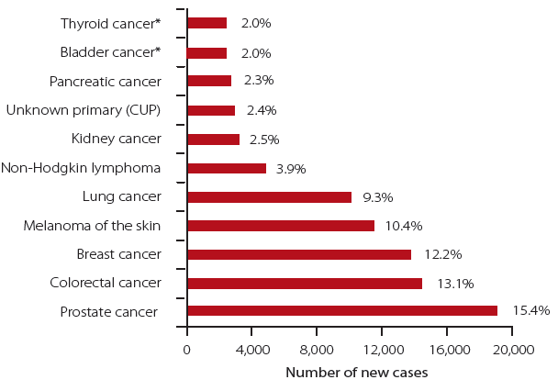

*Note: The data in Figure 1.1 was sourced from: Australian Institute of Health and Welfare & Australasian Association of Cancer Registries 2012. Cancer in Australia: an overview 2012. Cancer series no. 74. Cat. no. CAN 70. Canberra: AIHW.*

*\*The same number of new diagnoses of bladder cancer and thyroid cancer were estimated in 2012.*

Figure 1.2: The estimated ten most common causes of cancer death in Australia, 2012, and the percentage contribution of each cancer type to total mortality

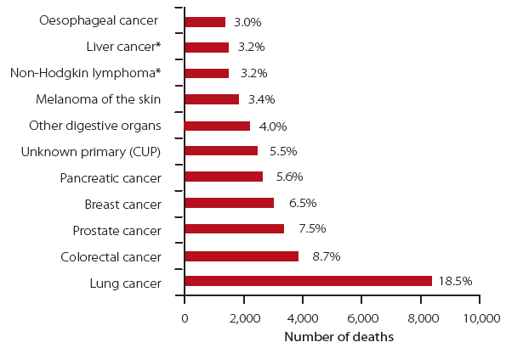

*Note: The data in Figure 1.2 was sourced from: Australian Institute of Health and Welfare & Australasian Association of Cancer Registries 2012. Cancer in Australia: an overview 2012. Cancer series no. 74. Cat. no. CAN 70. Canberra: AIHW.*

*\*Non-Hodgkin lymphoma and liver cancer were estimated to cause an equal number of deaths in 2012.*

Between 1982 and 2009, the actual number of new cancer cases in Australia more than doubled and the number of deaths from cancer increased by more than 70% from 1982 to 2010.3 When changes in the size and average age of Australia's population are taken into consideration (the age-standardised rate), this translates to a change in incidence rate from 384 to 486 persons per 100,000 from 1982 to 2009. The number of deaths from cancer increased from 24,922 in 1982 to 42,844 in 2010; however, the age-standardised mortality rate decreased from 209 to 174 deaths per 100,000 from 1982 to 2010.1,3

At the end of 2007, there were approximately 774,700 people living in Australia who had been diagnosed with cancer in the previous 26 years. This figure included 339,000 people diagnosed with cancer in the previous 5 years.

#### Survival

Relative survival compares the survival of a group of people diagnosed with cancer to the expected survival of similarly aged people in the general population. Survival rates provide information on the likelihood that a person will be alive at a specified point in time (such as five years) following a diagnosis of cancer.

For the 2006-2010 period, the 5-year relative survival rate for all cancers combined was 66%, compared with 47% in 1982-1987 (Figure 1.3).4 Five-year relative survival rates from the 1982-1987 to the 2006-2010 periods have increased markedly for some cancers, for example, colorectal cancer (48.0% to 66.2%). By contrast, other cancers have shown a smaller absolute increase, albeit a larger proportional increase, in 5-year relative survival rate over the same period, such as lung cancer (8.7% to 14.1%; 62% proportional increase), cancer of unknown primary (CUP, 5.6% to 15.7%; 180% proportional increase) and pancreatic cancer (3.0% to 5.2%; 73% proportional increase).4

Figure 1.3: Changes in 5-year relative survival over time for selected cancers

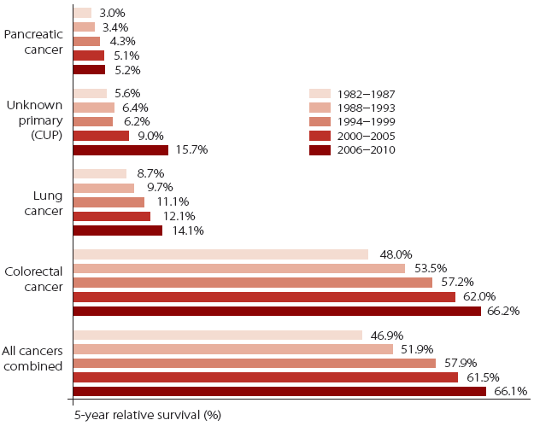

*Note: The data in Figure 1.3 was sourced from: Australian Institute of Health and Welfare 2012. Cancer survival and prevalence in Australia: period estimates from 1982 to 2010. Cancer Series no. 69. Cat. no. CAN 65. Canberra: AIHW.*

Cancer has a major impact on the Australian community and is the leading contributor to the burden of disease.5 The 'disability-adjusted life year' (DALY) is a measure of disease burden and combines data on the extent of premature death and non-fatal health impacts of disease. It is estimated that in 2012, cancer caused 551,300 DALYs to be lost, representing 19% of the burden of all diseases in Australia.1 By comparison, cardiovascular disease contributed to 16% of the burden of disease, whilst nervous system and sense organ disorders accounted for 14% of the burden of disease and mental disorders accounted for 13% of the burden of disease.2 In terms of health care expenditure, in 2008-09, cancer and other neoplasms accounted for $5 billion or 7% of total recurrent health spending.2

#### Cancer Australia

Cancer Australia was established by the Australian Government in 2006 to benefit all Australians affected by cancer, and their families and carers. Cancer Australia works to reduce the impact of cancer and improve the wellbeing of those diagnosed by ensuring that evidence informs cancer prevention, screening, diagnosis, treatment and supportive care.

In 2008, Cancer Australia published results from the first National Audit of cancer research funding. *Cancer research in Australia: an overview of cancer research projects and research programs in Australia 2003 to 2005* identified, for the first time, the national pattern of investment in cancer research projects and research programs. This first audit documented the direct funding provided to research on different tumour types, and provided valuable data on the areas of cancer research being funded and the extent of collaboration between investigators in the cancer research projects and research programs identified.

### 1.2 Objective of the new National Audit of funding to cancer research projects and research programs

An evidence base is essential for enabling the identification of priority areas for cancer research investment. Results from the first National Audit published in 2008 were used to inform Cancer Australia's cancer research priorities for the 2009-2012 rounds of the Priority-driven Collaborative Cancer Research Scheme (PdCCRS); an innovative research funding scheme, which brings together government and other funders of cancer research across Australia to collaboratively fund research in identified priority areas. From the 2007 to the 2012 rounds of the scheme, the PdCCRS funded 210 grants with a total value of $72.1 million, and at least 78% of this funding was for grants with a direct focus on research which can influence clinical practice, policy or patient outcomes.

The objective of the new National Audit of funding to cancer research projects and research programs was to provide the evidence base to inform Cancer Australia's future research priorities for the PdCCRS. The data captured in this audit, however, may also be of interest and relevance to other funders of cancer research, policy makers, researchers and consumers.

### 1.3 Scope of the new National Audit

This new National Audit identified direct funding provided to cancer research projects and research programs in Australia in the period 2006 to 2011, and compared the pattern of investment with the previous audit of 2003 to 2005. This new audit therefore allows a direct comparison of the pattern of investment in cancer research in the trienniums 2003-2005, 2006-2008 and 2009-2011. This audit also:

* Describes the amount of funding provided to cancer research projects and research programs in Australia and the number of research projects and research programs funded;
* Identifies the government and non-government sources of funding;
* Categorises the funded research using the internationally-recognised system for classifying cancer research: the Common Scientific Outline (CSO) and presents the proportional distribution of funding across the seven CSO categories of Biology; Aetiology; Prevention; Early Detection, Diagnosis and Prognosis; Treatment; Cancer Control, Survivorship and Outcomes Research; and Scientific Model Systems and presents the CSO pattern of funding nationally and in each of the states and territories;
* Identifies the amount of funding and CSO pattern of funding to different tumour streams and tumour types;
* Outlines the funding provided to cancer clinical trials research;
* Describes the extent of planned research collaborations; and
* Compares the national CSO patterns of direct research funding for Australia, Canada and the United Kingdom (UK), as well as international patterns of research funded by the National Institutes of Health and by members of the International Cancer Research Partnership.

Whilst this audit does capture some clinical trials activity funded in the period 2006 to 2011, specifically clinical trials-based research that was directly funded through research project and research program grant funding; the audit does not capture trials activity that did not receive specific grant funding, nor does it capture cancer clinical trials funded by industry.

Cancer research funding provided by the pharmaceutical industry was also not a primary focus of this present audit; however, an estimate of the investment by the pharmaceutical industry to cancer research in Australia was obtained directly from individual companies.

While other areas of research funding, such as infrastructure support and fellowships, contribute significantly to supporting and undertaking cancer research, the present audit did not directly seek information on funding for these areas of research. Specifically, this audit did not seek information on funding intended for:

* Infrastructure;
* Equipment;
* Fellowships or scholarships awarded to individuals;
* In-kind support provided by staff in cancer research; and
* Routine clinical care, support services, data collection and ongoing monitoring of service delivery and outcomes.

Direct funding to infrastructure, equipment, fellowships and scholarships in the period 2006 to 2011 is the subject of an additional research audit being conducted by Cancer Australia.

The audit did not capture or measure outputs, findings or the impact of the funded research. Information on funding specifically allocated to policy initiatives or practice imperatives is also not included in this audit.

## Chapter 2 - Methodology

### 2.1 Approach to the National Audit of the period 2006 to 2011

The approach of this audit was to update funding data collected in the audit of 2003 to 2005 and to compare the patterns of investment in the trienniums 2003-2005, 2006-2008 and 2009-2011. Given the approach was to compare patterns of investment over separate time periods, it was decided to, as far as possible, follow the same methodology in accessing information on cancer research projects and research programs as was used for the audit of 2003 to 2005.

A 'top-down' approach was used in this and the first audit - requesting information from organisations likely to directly fund cancer-related research projects and research programs rather than approaching the grantees themselves. This approach has also previously been used by other international organisations, including the National Cancer Research Institute of the United Kingdom and the Canadian Cancer Research Alliance.7,8 By using a consistent approach to collecting cancer funding data, we maximise our ability to make comparisons between this and other audits of cancer research funding. This approach has resulted in response rates ranging from 62-96%.6,7,9 In comparison, surveys using the 'bottom-up' approach have reported lower response rates of 32-42%.10,11

### 2.2 Sources of data

It is not known exactly how many organisations and groups provide funding for cancer research in Australia. In identifying funding organisations to approach for this audit, we first referred to the organisations invited to provide details of their funding to cancer research for the previous audit and then undertook a comprehensive search for other funders of cancer research, using the internet to research cancer funding websites and annual reports of organisations undertaking cancer research. In this way, we identified 161 Australian organisations, including the National Health and Medical Research Council (NHMRC) and the Australian Research Council (ARC), and non-government organisations (including Cancer Councils), cancer charities, foundations and medical research institutes that provided funding support to Australian researchers. In addition, 23 international funding agencies and organisations were identified as directly funding cancer researchers in Australia.

To gauge investment by the pharmaceutical industry in cancer research in Australia, an approach was made to Medicines Australia to contact its members, and request that they contact Cancer Australia and provide information on any extramural funding of cancer research projects and research programs. Medicines Australia contacted 35 of its members on behalf of Cancer Australia.

### 2.3 Data collection

From May to August 2012, Cancer Australia contacted a total of 184 organisations and invited them to provide details of their direct funding to cancer research projects and programs (Appendix A). The email and letter sent to each organisation is shown in Appendices B and C.

Information was requested to be supplied in the form of an electronic spread sheet or text document which would include:

* Details of the Chief Investigator and named collaborators (where available),
* A summary or abstract of the research funded, and
* Amount of funding granted in each calendar year to each funded cancer research project or research program in 2006, 2007, 2008, 2009, 2010 and 2011.

Approximately four weeks after the initial invitation, follow-up emails were sent to funding organisations which had not responded, in order to verify that the request had reached an appropriate organisational contact and to answer any questions arising from the request.

Following submission to Cancer Australia, data were checked to ensure that the data provided were appropriate for inclusion in the audit. Details of funding provided that did not fit the scope of the audit (e.g. scholarships, fellowships, special research initiatives) were removed from the final file. All data received were entered into a Microsoft Excel™ (2010) database for analysis.

### 2.4 Coding, classification and analysis of cancer research projects and research programs

All cancer research projects and research programs entered into the Cancer Australia database were classified according to the International Cancer Research Partnership's (ICRP) internationally recognised coding system for cancer research: the Common Scientific Outline12, and a standard cancer type coding scheme.13

#### Common Scientific Outline

The Common Scientific Outline (CSO) is a classification system specific to cancer research which uses easily applied cancer-related research terminology. The CSO was developed by the ICRP which includes the United State's (US) National Cancer Institute, other USA cancer research funding agencies and the UK's National Cancer Research Institute. The ICRP maintains the CSO classifications system as well as a database of funded research classified by CSO categories.

The CSO system classifies individual research projects or research programs into seven broad areas of cancer research:

1. Biology;
2. Aetiology;
3. Prevention;
4. Early Detection, Diagnosis, and Prognosis;
5. Treatment;
6. Cancer Control, Survival and Outcomes Research; and
7. Scientific Model Systems.

Each of these codes is then subdivided into more specific areas of cancer research giving a final figure of 38 individual CSO codes (listed in Appendix D). It should be noted that some CSO codes which relate primarily to infrastructure and person support (i.e. the CSO codes: 1.5, 2.4, 3.6, 4.4, 5.7, 6.9, 7.3) will be under-represented in this Audit because these data were not specifically requested or collected.

#### Tumour stream and tumour type

Following allocation to a CSO code, individual cancer research projects and research programs were classified by tumour stream of focus (i.e. breast cancer, central nervous system cancers (including brain cancer), colorectal cancer, genitourinary cancers, gynaecological cancers, haematological cancers, head and neck cancers, lung cancer (including mesothelioma), musculo-skeletal cancer, skin cancers, cancer of unknown primary (CUP) and upper gastrointestinal cancers), and tumour type or types (Appendix E). Grants for research activities which were not specific to any tumour stream(s) were classified as "Not tumour stream-specific".

#### Location of research, collaborations and co-funding

Each cancer research project and research program was allocated to the state or territory location of the Chief Investigator's institution or Administering Institution. If there were named collaborators, the number and location of these collaborators were also noted. It was also recorded whether the research project or research program was co-funded and the names of the organisation/s involved in co-funding the research.

#### Clinical trials and health disciplines

Cancer research projects and research programs that were clinical trials were recorded, as was the trial phase, where applicable. Each clinical trial was also categorised by tumour type and one or more health disciplines which were a focus of the research undertaken (see Appendix F.)

#### Coding and analysis

In the majority of cases, the description of the cancer research projects and research programs provided to Cancer Australia consisted of a media or lay summary, rather than a scientific abstract. An analysis of the title, keywords and the project or program summary was used to classify the research to an appropriate CSO code.[1]

Following entry of details of cancer research projects and research programs by coders, approximately 50% of entries were cross-checked by the team leader. Where discrepancies occurred in coding (in approximately 10% of cases), consensus was sought through discussions with the project team and executive to allow re-classification. Analysis of audit data was undertaken using Microsoft Excel™ (2010).

### 2.5 Ownership and access to data

The data supplied by participants are held in confidence by Cancer Australia. Access to identifiable information is limited to Cancer Australia staff involved in the audit. Details of individual research projects and research programs, and individual levels of funding, will not be published or accessible unless agreement is obtained in advance from the organisation(s) supplying the data.

### 2.6 Which data are not included in the National Audit

This audit captures and reports on the amount and pattern of direct funding provided to cancer research projects and research programs in Australia from 2006 to 2011. The data used for analysis focuses on cancer research where funding could be directly attributed to specific cancer research projects and research programs, including clinical trials research. It should be noted that this audit should not be regarded as a record of all types of cancer research funding in Australia.

The audit does not include funding assigned to infrastructure, equipment, person support, fellowships or scholarships, in-kind support, routine clinical care, support services, data collection and ongoing monitoring of service delivery and outcomes. In addition, the audit does not include direct funding from organisations to cancer research where allocations to specific cancer research projects could not be identified. Funding within these categories includes: funding of in-house research by some Cancer Councils, funds provided to research institutes by their internal foundations which was not in the form of a specific award or grant, and funds towards the establishment of Centres conducting cancer research.

### 2.7 Oversight of the National Audit

The initial scope and methodology of the audit were determined after discussions with members of Cancer Australia's Research and Data Advisory Group (RDAG). This group is composed of members with extensive expertise across the cancer research, data, policy and the cancer control spectrum and includes consumer representation.

Through the data collection, analysis and report drafting stages, advice was sought from an expert Working Group (Table 1). This Working Group advised on specific data items to be collected, potential funding sources to be approached, data to be included or excluded from analysis, and specific analyses of the final data set.

### 2.8 Review of the National Audit

The Working Group and members of RDAG reviewed and provided input on drafts of the audit report.

Specific chapters containing data from the NHMRC, Cancer Institute NSW and the Victorian Cancer Agency were provided to the respective organisations for review and comment. Review and feedback of the organisation's data and its interpretation were specifically requested. The full audit report was also reviewed by the Australian Government Department of Health.

## Chapter 3 - Identified direct funding to cancer research projects and research programs

**KEY FINDINGS**

* In the period 2006 to 2011:
* There was more than $1 billion in direct funding to 3,106 cancer research projects and research programs
* From 2003-2005 to 2009-2011:
* The total direct funding to cancer research projects and research programs was $1.3 billion and increased from:
* $292 million in 2003-2005, to
* $413 million in 2006-2008, to
* $596 million in 2009-2011
* The total direct funding to cancer research projects and research programs increased for all states and territories, with the exception of the Australian Capital Territory
* The number of cancer research projects and research programs funded increased for all states and territories

### 3.1 Response to the National Audit

Cancer Australia contacted 161 Australian and 23 international organisations that were identified as potentially providing funds for cancer research projects and/or research programs in the period 2006 to 2011. Fourteen of these organisations informed us that they didn't fund research projects or research programs in the period 2006 to 2011. Of the remaining 170 organisations, 10 advised that they were unable to provide data due to lack of staffing or difficulty in identifying records of funding. In total, we received data from 148 of these 170 organisations (128 Australian and 20 international), which represented a response rate of 87% (i.e. 148/170). The remaining 22 organisations which didn't provide data to the audit tended to be smaller medical research institutes, hospitals and foundations, or some universities whose databases could not report on funded cancer research projects and research programs. Of the 148 respondents, some organisations reported funding only for infrastructure, equipment or people support. As this was outside the scope of this audit, these data were not included. In addition, some respondents provided data on behalf of other funders. This audit contains data from 134 individual funders of cancer research projects and research programs. All major funders of cancer research projects and research programs identified in the previous audit of 2003 to 2005 responded with data for this audit of the period 2006 to 2011.

### 3.2 National research investment

This audit identified 3,106 cancer research projects and research programs that were directly funded during the period 2006 to 2011. Total direct funding of $1.01 billion was provided to these research projects and research programs.

From 2003-2005 to 2009-2011, a total of $1.3 billion was provided to cancer research projects and research programs in Australia. A breakdown of funding in each of the trienniums 2003-2005, 2006-2008 and 2009-2011 is shown in Table 3.1.

Table 3.1: Direct funding to and number of cancer research projects and research programs in Australia in 2003-2005, 2006-2008 and 2009-2011

| Triennium | Funding | No. projects/programs* |
| --- | --- | --- |
| 2003-2005 | $292 million | 1,332 |
| 2006-2008 | $413 million | 1,596 |
| 2009-2011 | $596 million | 2,100 |

* some projects/programs overlap trienniums

The annual direct funding to cancer research projects and research programs (i.e. funds allocated in each year of a research project or research program for the period 2006 to 2011) is shown in Figure 3.1.

In 2011, the annual direct funding to cancer research projects and research programs was 86% higher than in 2006. The annual increase in direct funding exceeded the increase which would have been expected due to the impact of inflation alone.14

Figure 3.1: Annual direct funding to cancer research projects and research programs in Australia, 2006 to 2011

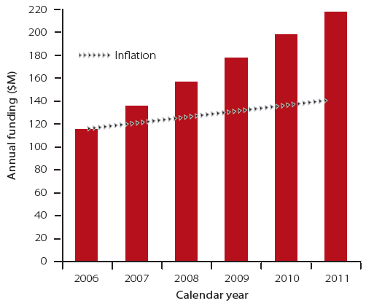

#### Increase in direct funding to cancer research projects and research programs since 2003-2005

In the triennium 2006-2008, the direct funding to cancer research projects and research programs was 42% higher than for the period 2003-2005. In the triennium 2009-2011, the direct funding was 44% higher than for 2006-2008. The number of cancer research projects and research programs funded in each triennium increased by 20% from 2003-2005 to 2006-2008, and by 32% from 2006-2008 to 2009-2011; however, it should be noted that some cancer research projects and research programs were funded in more than one triennium.

### 3.3 State and territory distribution of the national research funding

Figure 3.2 shows the state and territory distribution of direct funding to cancer research projects and research programs in the period 2006 to 2011. The amount of funding awarded by the NHMRC and other funders to cancer research projects and research programs in each state and territory is shown in Table 3.2. Distribution of funding was allocated by the location of the Chief Investigator's Institution or Administering Institution.

Figure 3.2: Distribution to states and territories of direct funding to cancer research projects and research programs in Australia, 2006 to 2011

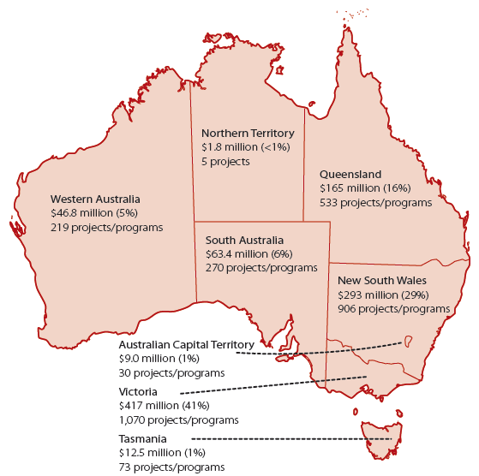

Table 3.2: Distribution to states and territories of direct funding to cancer research projects and research programs from NHMRC and non-NHMRC funding sources in the period 2006 to 2011

| State or territory | NHMRC | Non-NHMRC | Total |
| --- | --- | --- | --- |
| New South Wales | $151 M | $142 M | $293 M |
| New South Wales projects/programs | 249 | 657 | 906 |
| Queensland | $89.8 M | $75.2 M | $165 M |
| Queensland projects/programs | 185 | 348 | 533 |
| South Australia | $33.5 M | $29.9 M | $63.4 M |
| South Australia projects/programs | 94 | 176 | 270 |
| Tasmania | $9.4 M | $3.1 M | $12.5 M |
| Tasmania projects/programs | 6 | 67 | 73 |
| Victoria | $245 M | $172 M | $417 M |
| Victoria projects/programs | 429 | 641 | 1,070 |
| Western Australia | $30.8 M | $16.0 M | $46.8 M |
| Western Australia projects/programs | 74 | 145 | 219 |
| Australian Capital Territory | $6.8 M | $2.2 M | $9.0 M |
|
| Australian Capital Territory projects/programs | 18 | 12 | 30 |
| Northern Territory | $1.8 M | N/A | $1.8 M |
| Northern Territory projects/programs | 5 | – | 5 |

In the period 2006 to 2011, Victoria, New South Wales and Queensland together received 87% of identified direct funding to cancer research projects and research programs in Australia. For all states and territories the NHMRC provided the majority of funding.

Direct funding per capita15 (i.e. expressed as funding to every person) for each State and Territory in the period 2006 to 2011 was as follows:

* Australian Capital Territory, $25 per person;
* New South Wales, $42 per person;
* Northern Territory, $8.50 per person;
* Queensland, $38 per person;
* South Australia, $40 per person;
* Tasmania, $25 per person;
* Victoria, $78 per person; and
* Western Australia, $21 per person.

Table 3.3: Distribution to states and territories of direct funding to cancer research projects and research programs in 2003-2005, 2006-2008 and 2009-2011

| State or territory | 2003-2005 | 2006-2008 | 2009-2011 |
| --- | --- | --- | --- |
| New South Wales | $72.6 M (25%) | $118 M (29%) | $175 M (29%) |
| New South Wales projects/programs | 379 | 445 | 627 |
| Queensland | $56.8 M (19%) | $69.6 M (17%) | $95.1 M (16%) |
| Queensland projects/programs | 264 | 285 | 359 |
| South Australia | $24.4 M (8%) | $27.7 M (7%) | $35.7 M (6%) |
| South Australia projects/programs | 135 | 129 | 179 |
| Tasmania | $3.6 M (1%) | $4.8 M (1%) | $7.8 M (1%) |
| Tasmania projects/programs | 28 | 37 | 40 |
| Victoria | $114 M (39%) | $168 M (41%) | $249 M (42%) |
| Victoria projects/programs | 413 | 566 | 721 |
| Western Australia | $16.3 M (6%) | $18.7 M (5%) | $28.0 M (5%) |
| Western Australia projects/programs | 91 | 113 | 151 |
| Australian Capital Territory | $3.4 M (1%) | $5.2 M (1%) | $3.9 M (<1%) |
| Australian Capital Territory projects/programs | 18 | 19 | 19 |
| Northern Territory | $0.1 M (<1%) | $0.6 M (<1%) | $1.2 M (<1%) |
| Northern Territory projects/programs | 3 | 2 | 4 |

*N.B. Some projects/programs overlap trienniums, thus the total number of projects/programs from 2003 to 2011 does not equal the sum of projects/programs for 2003-2005, 2006-2008 and 2009-2011.*

A detailed comparison of the direct funding provided to each state and territory over three trienniums, 2003-2005, 2006-2008 and 2009-2011, is shown in Table 3.3. The total funding to cancer research projects and programs increased from one triennium to the next in all states and territories. The exception was the Australian Capital Territory, where the funding increased from the 2003-2005 to 2006-2008 trienniums but then decreased in the 2009-2011 triennium. The number of cancer research projects or research programs funded increased in all states and territories from the first (2003-2005) to the last (2009-2011) trienniums.

### 3.4 Discussion

This audit of the period 2006 to 2011 has identified direct funding of $1.01 billion to 3,106 cancer research projects and research programs in Australia. Including the data from the audit of 2003 to 2005, the total direct funding to cancer research projects and research programs across three trienniums (2003-2005, 2006-2008 and 2009-2011) was $1.3 billion. It should be noted that this figure includes funding from both competitive and non-competitive granting processes.

A sustained annual increase in direct funding to cancer research projects and research programs was observed in the period 2006 to 2011. When comparing across the two trienniums covered in this audit and the triennium covered in the previous audit, an increase in direct funding to cancer research projects and research programs from one triennium to the next of more than 40% was observed. Cancer is one of the Australian Government's National Health Priority Areas and, since 2003, government agencies such as Cancer Australia, Cancer Institute NSW and the Victorian Cancer Agency have been established to fund research and initiatives which reduce the impact of cancer on Australians.

#### Future funding to cancer research projects and research programs

Further sustained increases in direct funding to cancer research projects and research programs in future years should not be assumed on the basis of the findings in this audit. The principal funder of cancer research in Australia is the NHMRC, and the average annual increase in its funding to cancer research was 13% over the triennium 2003-2005 and 11% over the triennium 2009-2011.16 However in 2012, NHMRC funding to cancer increased by 4% from the previous year;16 a rate that is lower than the annual increases observed for all funding to cancer research projects and research programs in the period 2006 to 2011 (see Figure 3.1).

The impact of a difficult global economic environment on future investment by government and non-government sources to cancer research is unknown. It is possible that in future years, direct funding to cancer research projects and programs may not continue to increase at the rates observed in this audit of the period 2006 to 2011. Therefore, it is important to ensure that the provision of funding for cancer research is well co-ordinated, and strategies that increase the national cancer research funding pool are developed and implemented collaboratively by government and non-government funders of cancer research. Furthermore, in a future environment of potentially limited research funding, assessment of the impact of research funding will guide strategic research investment to support evidence-based cancer care and policy.

#### Distribution of funding to Australia's states and territories

From 2003-2005 to 2009-2011, the total direct funding to cancer research projects and research programs increased for all states and territories, with the exception of the Australian Capital Territory. However, the number of cancer research projects and research programs funded increased for all states and territories during the same period. It was observed that, from 2003-2005 to 2009-2011, the relative proportion of funding to each state and territory remained broadly similar and that 87% of direct funding went to the eastern mainland states; a reflection of the geographical location of Australia's health and medical research workforce.

New South Wales has Australia's largest population and a large health and medical research workforce which receives support from Cancer Institute NSW. New South Wales's proportional share of direct funding to cancer research projects and research programs in the period 2006 to 2011 was 29%. However, a significant portion of Cancer Institute NSW's funding to cancer research has been awarded in areas such as people support, building research capacity and infrastructure17, areas that are not in the scope of this audit of funding to cancer research projects and research programs. As such, New South Wales's share of the national investment in cancer research is likely to be significantly more than is captured in this current audit. Historically, despite Victoria's smaller population than New South Wales, it is the location of a higher number of medical research institutes18 and thus a large workforce base. This is reflected in Victoria receiving 42% of proportional funds in the period 2006 to 2011. The Victorian Cancer Agency has also contributed significantly to the amount of funding and number of cancer research projects and research programs in Victoria (see Chapter 4).

State and territories where funding to cancer research projects and research programs was proportionally lower are more prone to fluctuations in direct funding per triennium, such as might be caused by funding of a single, large research program or clinical trial. An example of this was in the Australian Capital Territory, where a single clinical trial accounted for 15% of the direct funding to the Territory for cancer research projects and research programs in 2006-2008.

## Chapter 4 - Sources of funding to cancer research projects and research programs

**KEY FINDINGS**

* The Australian Government* is the largest funder, providing 66% of direct funding to cancer research projects and research programs across the three trienniums
* From 2003-2005 to 2009-2011:
* All the funding sources , except international funders and universities, increased the amount of direct funding to Australian cancer research projects and research programs
* The number of cancer research projects and research programs funded by all the funding sources increased, with the exception of international funders, universities and philanthropic funders
* Both state and territory governments and cancer foundations more than doubled their proportional funding to cancer research
* In the period 2006 to 2011:
* 90% of funded cancer research projects and research programs (2,790) were supported by a single funding source
* 10% of funded cancer research projects or research programs (316) were supported by co-funding from two or more funding sources
* The Australian Government and cancer foundations co-funded more than half of all co-funded cancer research projects and research programs
* Cancer Australia alone funded 28% of all co-funded cancer research projects and research programs

*Australian Government includes the NHMRC and other Australian Government departments and agencies.

### 4.1 Sources of direct funding to cancer research projects and research programs in Australia

In section 4.1 of this chapter and in subsequent chapters, where a cancer research project or research program was co-funded, the total funding amount was allocated to the funding partner that provided the majority of funds. For co-funded cancer research projects and research programs where the majority funder was not identified, the total funding was allocated to the funder that had submitted the funding data to Cancer Australia.

Cancer research projects and research programs were categorised by source/s of funding support. Figure 4.1 shows the proportion of funding provided by different funding sectors to cancer research projects and research programs in Australia. In the period 2006 to 2011, the major funders of cancer research projects and research programs in Australia, the total funding amounts provided, and the number of cancer research projects or research programs funded, were as follows:

* NHMRC - $568 million (56% of total funding), 1,060 research projects and research programs;
* Other Australian Government sources[2] - $96.9 million (10% of total funding), 279 research projects and research programs;
* Cancer Councils - $95.7 million (9% of total funding), 616 research projects and research programs;
* State and territory governments -$75.6 million (8% of total funding), 187 research projects and research programs;
* Cancer foundations[3] - $74.0 million (7% of total funding), 419 research projects and research programs;
* International funders -$42.3 million (4% of total funding), 116 research projects and research programs;
* Other sources[4] - $29.1 million (3% of total funding), 21 research projects and research programs;
* Medical research institutes, hospitals and foundations[5] - $19.2 million (2% of total funding), 211 research projects and research programs;
* Universities - $5.7 million (1% of total funding),164 research projects and research programs; and
* Philanthropic sources[6] - $2.6 million (<1% total funding), 33 research projects and research programs.

Figure 4.1: Proportion of funding to cancer research projects and research programs by funding source in the period 2006 to 2011

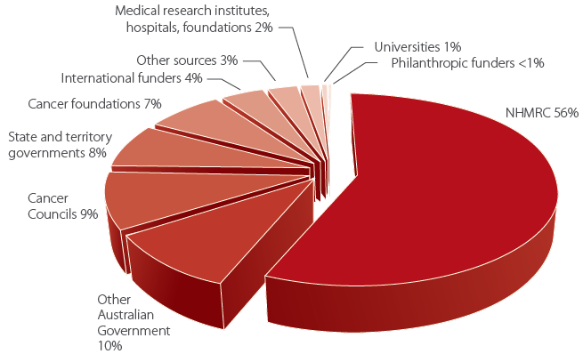

Table 4.1 compares the amounts of funding provided and the number of cancer research projects and research programs funded in each of the trienniums 2003-2005, 2006-2008 and 2009-2011 by the funding source.

From 2003-2005 to 2009-2011, all funding sources increased their direct funding to cancer research projects and research programs with the exception of international funders and universities. The direct funding provided by international funding sources progressively decreased, whilst funding reported by universities decreased from 2003-2005 to 2006-2008 but increased in 2009-2011. All funding sources except international funders, universities and philanthropic funders increased the number of cancer research projects and research programs funded from 2003-2005 to 2009-2011.

Table 4.1: Major sources of funding - total direct funding, percentage of total direct funding and number of cancer research projects and research programs funded in 2003-2005, 2006-2008 and 2009-2011

| Funding source | 2003-2005 | 2006-2008 | 2009-2011 |
| --- | --- | --- | --- |
| NHMRC | $166 M (58%) | $241 M (58%) | $327 M (55%) |
| NHMRC | 454 | 602 | 755 |
| Other Australian Government | $24.6 M (8%) | $44.3 M (11%) | $52.6 M (9%) |
| Other Australian Government | 118 | 139 | 213 |
| Cancer Councils | $24.2 M (8%) | $41.7 M (10%) | $54.0 M (9%) |
| Cancer Councils projects/programs | 257 | 340 | 371 |
| State and territory governments | $9.2 M (3%) | $23.1 M (6%) | $52.5 M (9%) |
| State and territory governments projects/programs | 13 | 62 | 147 |
| Cancer foundations | $10.5 M (4%) | $20.5 M (5\%) | $53.5 M (9%) |
| Cancer foundations projects/programs | 97 | 185 | 292 |
| International funders | $37.6 M (13%) | $25.4 M (6%) | $16.9 M (3%) |
| International funders projects/programs | 157 | 89 | 51 |
| Other sources | $7.6 M (3%) | $6.4 M (2%) | $22.7 M (4%) |
| Other sources projects/programs | 6 | 10 | 21 |
| Medical research institutes, hospitals and foundations | $6.8 M (2%) | $6.8 M (2%) | $12.4 M (2%) |
| Medical research institutes, hospitals and foundations projects/programs | 118 | 79 | 141 |
| Universities | $4.2 M (1%) | $2.3 M (<1%) | $3.3 M (<1%) |
| Universities projects/programs | 96 | 71 | 94 |
| Philanthropic funders | $1.3 M (<1%) | $1.1 M (<1%) | $1.5 M (<1%) |
| Philanthropic funders projects/programs | 15 | 19 | 15 |

*N.B. Some projects/programs overlap trienniums, thus the total number of projects/programs from 2003 to 2011 does not equal the sum of projects/programs for 2003-2005, 2006-2008 and 2009-2011.*

### 4.2 Co-funding of cancer research projects and research programs

In the period 2006 to 2011, 90% of funded cancer research projects and research programs (2,790) were supported by a single funding source. The remaining 10% of funded cancer research projects or research programs (316) were supported by co-funding from two or more funding sources.

Of these 316 cancer research projects and research programs that were co-funded:

* 256 (81%) were funded by two sources;
* 41 (13%) were funded by three sources; and
* 19 (6%) were funded by four or more sources.

The funding sources that were involved in the co-funding of cancer research projects and research programs were as follows:

* All Australian government sources (including NHMRC and Cancer Australia) co-funded 176 (56%) cancer research projects and research programs;
* Cancer foundations co-funded 160 (51%) cancer research projects and research programs;
* Medical research institutes, hospitals and foundations co-funded 91 (29%) cancer research projects and research programs;
* Cancer Councils co-funded 62 (19%) cancer research projects and research programs;
* Industry co-funded 35 (11%) cancer research projects and research programs; and
* State and territory governments co-funded 26 (8%) cancer research projects and research programs.

#### Cancer Australia's involvement in co-funding cancer research projects and research programs

In 2007, Cancer Australia commenced its Priority-driven Collaborative Cancer Research Scheme (PdCCRS). In this scheme, Cancer Australia collaborates with other funding organisations to jointly fund peer-reviewed cancer research projects which are in areas of identified priority. The first projects funded under this scheme commenced in 2008.

In the period covered by this Audit of 2006 to 2011, the PdCCRS funded 141 cancer research projects and research programs, 90 (64%) of which were co-funded. These 90 cancer research projects and research programs funded by Cancer Australia accounted for 28% of the total national co-funded cancer research projects and research programs in the period 2006 to 2011.

### 4.3 Pharmaceutical industry funding

The pharmaceutical industry in Australia provides significant funds to cancer research activities. Cancer Australia invited Medicines Australia, the peak body representing the pharmaceutical industry in Australia, to contact its members and request that they provide Cancer Australia with details of their external funding to cancer research projects and research programs. Medicines Australia's members received an invitation from Cancer Australia.

Information was received from six companies, which reported a combined funding total to cancer research projects and research programs in Australia of approximately $82 million for the period 2006 to 2011. It should be cautioned that:

* The level of detail provided to Cancer Australia varied greatly between the six companies which responded to the request; and
* Of the funding provided, the proportional contribution to extramural research projects and research programs could not always be readily identified.

The funding identified by this audit is likely to be an underestimate of the total research funding to Australian cancer research from the pharmaceutical industry. Due to the difficulty in obtaining complete data from the pharmaceutical industry and for consistency with the previous audit of 2003-2005, extramural funding from pharmaceutical companies was not counted in this audit.

### 4.4 Discussion

From 2003-2005, to 2006-2008 to 2009-2011, direct funding to cancer research projects and research programs more than doubled (i.e. from $292 million to $596 million). Despite this marked increase in funding, the relative proportion of direct funding from each funding source category was similar across the trienniums 2003-2005, 2006-2008 and 2009-2011, with the following notable exceptions:

* International funders showed a proportional decrease in funding from 13% ($37.6 million) of total identified funding in 2003-2005 to 3% ($16.9 million) of total identified funding in 2009-2011. This decrease was largely a result of reduced funding to Australian researchers by US government agencies (Congressionally Directed Medical Research Programs and the National Institutes of Health (NIH), including the National Cancer Institute) from whom funding to cancer research projects and research programs in Australia decreased from $22.1 million in 2003-2005 to $10.0 million in 2009-2011. This reduction in investment may have reflected a combination of the following: the impact of a challenging global economic climate; international currency exchange rates moving towards a stronger Australian dollar; and/or changing priorities in funding. Despite direct funding from international sources decreasing over the trienniums, the average level of international funding to individual cancer research projects or research programs increased from each triennium to the next.
* State and territory government funders showed a proportional increase in funding from 3% ($9.2 million) in 2003-2005 to 9% ($52.5 million) in 2009-2011. The largest contributors to this increase in funding were the Victorian Government (including the Victorian Cancer Agency which was established in 2006) whose funding to cancer research projects and research programs increased from $6.8 million in 2003-2005 to $33.6 million in 2009-2011, and the New South Wales Government (including Cancer Institute NSW) whose funding to cancer research projects and research programs increased from $2.4 million in 2003-2005 to $15.8 million in 2009-2011.
* Cancer foundations showed a proportional increase in funding from 4% ($10.5 million) in 2003-2005 to 9% ($53.5 million) in 2009-2011. The increase in proportional funding by Cancer foundations over this period may have reflected an increased public investment in cancer research through a growing recognition of the impact of cancer, and high-profile fundraising campaigns.

It should also be noted that the level of direct funding attributed to university sources and medical research institutes, hospitals and their associated foundations is likely to be an underestimation of the level of support that these sectors provide to cancer research projects and research programs. Some universities and smaller institutions were not able to provide data for the audit. It should be noted, however, that universities and medical research institutes (and hospitals and their associated foundations) provide valuable support to funded research in areas such as laboratory infrastructure and staffing that isn't captured as formal research grants. Similarly, the direct funding attributed to philanthropic funders may also be an underestimation because only 8 philanthropic funders provided information to Cancer Australia. In addition, support for cancer research by philanthropy may occur through other funding mechanisms such as people support awards and equipment grants, and these elements were not the focus of this audit.

In total, across all three trienniums, the Australian Government was the primary funder of cancer research projects and research programs. Approximately two-thirds of the total identified funding to cancer research projects and research programs was ascribed to the Australian Government (66% in 2003-2005, 69% in 2006-2008 and 64% in 2009-2011). The NHMRC provided approximately 58% of the total identified direct funding in 2003-2005 and 2006-2008, and 55%

in 2009-2011. The level of NHMRC funding to cancer research projects and research programs recorded in this audit are different from those published by the NHMRC.16 The figures published on the NHMRC's website include funding to research projects and research programs where cancer research was a component of the project or program but not necessarily the major focus of the funded study. Furthermore, funding areas such as people support, infrastructure and special research initiatives in the area of cancer were not included in this audit.

#### Co-funding of cancer research projects and research programs

Ten per cent of cancer research projects and research programs in the period 2006 to 2011 were identified as being co-funded. The largest identified co-funders of cancer research projects and research programs were the Australian Government (including NHMRC and Cancer Australia) and cancer foundations. These funders were involved in the co-funding of more than half of all identified co-funded cancer research projects and research programs. The relatively large amount of co-funding undertaken by these sectors may relate to the national focus of these funders, and a greater emphasis on the national coordination of research funding.

Cancer Australia's PdCCRS was involved in co-funding over a quarter of all co-funded research projects and research programs identified in this audit. Given that funding to the first PdCCRS grants commenced in 2008, this program appears to be making a notable impact on the co-funding of cancer research in Australia; however, with only 10% of cancer research projects and research programs co-funded in Australia, opportunities still exist to partner and leverage research funding investments.

Cancer Australia's PdCCRS is a demonstrated model for bringing together government and non-government funders of cancer research. The scheme provides an existing mechanism through which organisations can co-fund national cancer research in shared priority areas and has encouraged investment from organisations that have not previously funded research. The advantages of this centralised and coordinated approach include reduced grant administration and management costs, and the ability to fund more research through the co-funding of grants.

## Chapter 5 - Classification of funded cancer research by Common Scientific Outline

**KEY FINDINGS**

* In the period 2006 to 2011:
* Nearly two-thirds of the direct finding for cancer research projects and research programs was provided to the CSO categories of Biology (35%) and Treatment (28%)
* Cancer prevention research received 2% of the total direct funding to cancer research projects and research programs
* From 2003-2005 to 2009-2011:
* The number of funded cancer research projects and research programs increased for all CSO categories
* The direct funding increased to all CSO categories other than Prevention
* The largest decrease in proportional funding was to the CSO category of Biology (51% to 32%)
* The largest increases in direct and proportional funding were to the CSO categories of Treatment ($55.1 M to $168 M, 19% to 28%) and Early Detection, Diagnosis and Prognosis ($21.9 M to $94.5 M, 8% to 16%)

### 5.1 National pattern of funding to CSO categories

#### Analysis of the funding pattern in the period 2006 to 2011

Each cancer research project or research program was classified using the Common Scientific Outline12 (CSO) category that best reflected the primary focus of the research being undertaken.[7] These CSO categories are:

1. Biology;
2. Aetiology;
3. Prevention;
4. Early Detection, Diagnosis and Prognosis;
5. Treatment;
6. Cancer Control, Survivorship and Outcomes Research; and
7. Scientific Model Systems.

Figure 5.1 shows the proportional distribution to each CSO category of the direct funding to cancer research projects and research programs in the period 2006 to 2011 and Table 5.1 lists the sub-categories of research in each CSO category. Over half of direct funding for cancer research projects and research programs was provided to two categories: Biology (35%) and Treatment (28%). Funding to Aetiology (9%), Prevention (2%), Early Detection, Diagnosis and Prognosis (15%), Cancer Control, Survivorship and Outcomes Research (8%) and Scientific Model Systems (4%) accounted for the balance of total funding.

Figure 5.1: The pattern of funding to each CSO category and percentage of total direct funding to each CSO category in the period 2006 to 2011

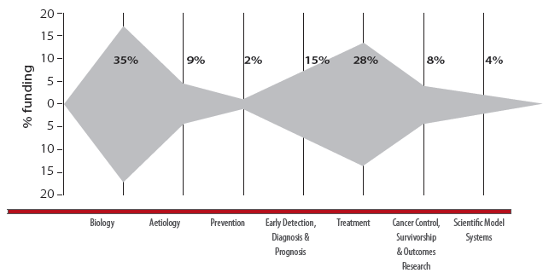

#### Comparison of funding patterns in 2003-2005, 2006-2008 and 2009-2011

The number of funded cancer research projects and research programs from 2003-2005 to 2009-2011 increased in all CSO categories. All CSO categories, other than Prevention, received an increase in direct funding from the first to the last trienniums. The largest increases in direct funding over this time were to the CSO categories of Treatment and Early Detection, Diagnosis and Prognosis, which increased by $113 million and $72.6 million, respectively (Table 5.2).

Changes in the pattern of proportional funding to each CSO category were analysed for each triennium from 2003-2005 to 2009-2011 (Figure 5.2).

The proportional distribution of funding across the CSO categories changed from the first to the last triennium. The largest change in proportional funding was to Biology which, as a percentage of total direct funding, decreased from 51% in 2003-2005 to 33% in 2009-2011. The second most funded category, Treatment, showed a proportional increase in funding from 19% (2003-2005) to 27% (2006-2008) and 28% (2009-2011). The proportional funding to cancer research projects or research programs in the area of Aetiology increased from 7% (2003-2005) to 10% (2006-2008) and then decreased to 8% (2009-2011), proportional funding to Prevention declined from 5% (2003-2005) to 2% (2006-2008 and 2009-2011) and proportional funding to Early Detection, Diagnosis and Prognosis progressively increased from 8% (2003-2005) to 16% (2009-2011). Proportional funding to Cancer Control, Survivorship and Outcomes Research was 9% (2003-2005), 7% (2006-2008) and then 9% (2009-2011) whilst proportional funding to Scientific Model Systems progressively increased from 1% (2003-2005) to 4% (2009-2011).

Table 5.1: Research sub-categories in each CSO category

**Table 5.1 CSO1-CSO4**

| CSO 1 Biology | CSO 2 Aetiology | CSO 3 Prevention | CSO 4 Early Detection, Diagnosis & Prognosis |
| --- | --- | --- | --- |
| Normal Functioning  Cancer Initiation: Alterations in Chromosomes  Cancer Initiation: Oncogenes and Tumour Suppressor Genes  Cancer Progression and Metastasis  Resources and Infrastructure | Exogenous Factors in the Origin and Cause of Cancer  Endogenous Factors in the Origin and Cause of Cancer  Interactions of Genes and/or Genetic Polymorphisms with Exogenous and/or Endogenous Factors  Polymorphisms with Exogenous and/or Endogenous Factors Resources and Infrastructure Related to Aetiology | Interventions to Prevent Cancer: Personal Behaviours That Affect Cancer Risk  Nutritional Science in Cancer Prevention  Chemo-prevention  Vaccines  Complementary and Alternative Prevention Approaches  Resources and Infrastructure Related to Prevention | Technology Development and/or Marker Discovery  Technology and/or Marker Evaluation With Respect to Fundamental Parameters of Method  Technology and/or Marker Testing in a Clinical Setting  Resources and Infrastructure Related to Detection, Diagnosis, or Prognosis |

**Table 5.1 CSO5-CSO7**

| CSO 5 Treatment | CSO 6 Cancer Control, Survivorship & Outcomes Research | CSO 7 Scientific Model Systems |
| --- | --- | --- |
| Localized Therapies - Discovery and Development  Localized Therapies - Clinical Applications  Systemic Therapies - Discovery and Development  Systemic Therapies - Clinical Applications  Combinations of Localized and Systemic Therapies  Complementary and Alternative Treatment Approaches  Resources and Infrastructure Related to Treatment and the prevention of recurrence | Patient Care and Survivorship Issues  Surveillance  Behaviour  Cost Analyses and Health Care Delivery Education and Communication End-of-Life Care  Ethics and Confidentiality in Cancer Research  Complementary and Alternative Approaches for Supportive Care of Patients and Survivors  Resources and Infrastructure Related to Cancer Control, Survivorship, and Outcomes Research | Development and Characterisation of Model Systems  Application of Model Systems  Resources and Infrastructure Related to Scientific Model Systems |

Figure 5.2: The pattern of funding to each CSO category and the percentage of proportional funding in 2003-2005, 2006-2008 and 2009-2011

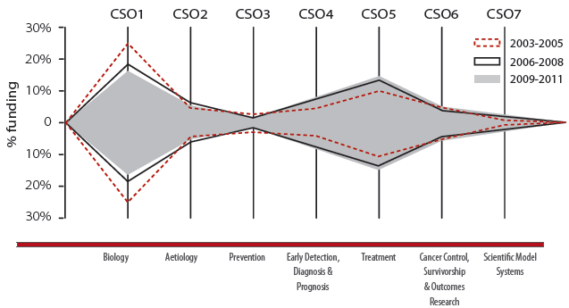

| Triennium | Biology | Aetiology | Prevention | Early Detection, Diagnosis & Prognosis | Treatment | Cancer Control, Survivorship & Outcomes Research | Scientific Model Systems |
| --- | --- | --- | --- | --- | --- | --- | --- |
| 2003-2005 | 51% | 7% | 5% | 8% | 19% | 9% | 1% |
| 2006-2008 | 38% | 10% | 2% | 13% | 27% | 7% | 3% |
| 2009-2011 | 32% | 8% | 2% | 16% | 28% | 9% | 4% |

Table 5.2: Direct funding to and number of cancer research projects and research programs in each CSO category in 2003-2005, 2006-2008 and 2009-2011

| CSO category | 2003-2005 | 2006-2008 | 2009-2011 |
| --- | --- | --- | --- |
| Biology | $148 M | $156 M | $194 M |
| Biology projects/programs | 602 | 557 | 689 |
| Aetiology | $19.9 M | $40.6 M | $48.4 M |
| Aetiology projects/programs | 80 | 146 | 143 |
| Prevention | $15.2 M | $8.7 M | $13.6 M |
| Prevention projects/programs | 42 | 42 | 52 |
| Early Detection, Diagnosis and Prognosis | $21.9 M | $54.6 M | $94.5 M |
| Early Detection, Diagnosis and Prognosis projects/programs | 120 | 199 | 296 |
| Treatment | $55.1 M | $110 M | $168 M |
| Treatment projects/programs | 290 | 414 | 558 |
| Cancer Control, Survivorship and Outcomes Research | $27.4 M | $29.6 M | $54.5 M |
| Cancer Control, Survivorship and Outcomes Research projects/programs | 176 | 175 | 261 |
| Scientific Model Systems | $4.3 M | $13.4 M | $22.7 M |
| Scientific Model Systems projects/programs | 22 | 63 | 101 |

### 5.2 Funding to CSO categories by the NHMRC

In the period 2006 to 2011, the NHMRC provided direct funding of $568 million (56% of the total direct funding to cancer research projects and research programs identified for the period). As the single largest funder of cancer research projects and research programs, a breakdown of the NHMRC's funding support was undertaken.

All CSO categories, except Cancer Control, Survivorship and Outcomes Research (CSO category 6), received a progressive increase in direct funding from the 2003-2005 to the 2009-2011 trienniums (Table 5.3). Direct funding to Cancer Control, Survivorship and Outcomes Research decreased slightly from the 2003-2005 ($16.3 million) to 2006-2008 ($14.8 million) trienniums but increased by the 2009-2011 triennium ($21.4 million).

The number of cancer research projects and research programs funded for all CSO categories increased progressively from the 2003-2005 to the 2009-2011 trienniums. The exception was Cancer Control, Survivorship and Outcomes Research, for which the number of cancer research projects and research programs funded varied slightly, decreasing from 60 (2003-2005) to 52 (2006-2008) and then increasing again to 61 (2009-2011). The proportional funding to each CSO category over the trienniums is shown in Figure 5.3.

The proportional distribution of funding across the CSO categories changed from the first to the last triennium. The largest change in proportional funding was to Biology which, as a percentage of the total direct funding to cancer research projects and research programs, decreased by 14% from 2003-2005 to 2009-2011. By contrast, the second-most funded category, Treatment, received a proportional funding increase of 9% from 2003-2005 to 2009-2011.

In summary, the proportional changes in NHMRC funding to cancer research projects or research programs across all CSO categories were as follows:

* The proportional funding to Biology decreased across the trienniums from 59% (2003-2005) to 53% (2006-2008) and then to 45% (2009-2011);
* The proportional funding to Aetiology fluctuated from 6% (2003-2005) to 10% (2006-2008) and then to 9% (2009-2011);
* The proportional funding to Prevention increased across the trienniums from 1% (2003-2005) to 2% (2006-2008) and then to 3% (2009-2011);
* The proportional funding to Early Detection, Diagnosis and Prognosis increased across the trienniums from 8% (2003-2005) to 10% (2006-2008 and 2009-2011);
* The proportional funding to Treatment increased across the trienniums from 14% (2003-2005) to 17% (2006-2008) and then to 23% (2009-2011);
* The proportional funding to Cancer Control, Survivorship and Outcomes Research decreased from 10% (2003-2005) to 6% (2006-2008) and then increased to 7% (2009-2011); and
* The proportional funding to Scientific Model Systems increased across the trienniums from 2% (2003-2005) to 3% (2006-2008) and then to 5% (2009-2011).

Figure 5.3: The pattern of funding to each CSO category and the percentage of proportional funding from the NHMRC in 2003-2005, 2006-2008 and 2009-2011

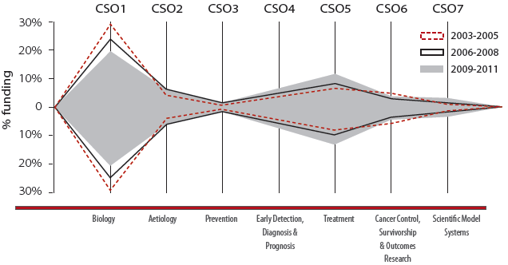

| Triennium | Biology | Aetiology | Prevention | Early Detection, Diagnosis & Prognosis | Treatment | Cancer Control, Survivorship & Outcomes Research | Scientific Model Systems |
| --- | --- | --- | --- | --- | --- | --- | --- |
| 2003-2005 | 59% | 6% | 1% | 8% | 14% | 10% | 2% |
| 2006-2008 | 53% | 10% | 2% | 10% | 17% | 6% | 3% |
| 2009-2011 | 45% | 9% | 3% | 10% | 23% | 7% | 5% |

Table 5.3: Direct funding to and number of research projects and research programs funded by the NHMRC in 2003-2005, 2006-2008 and 2009-2011

| CSO category | 2003-2005 | 2006-2008 | 2009-2011 |
| --- | --- | --- | --- |
| Biology | $98.3 M | $127 M | $146 M |
| Biology projects/programs | 249 | 293 | 331 |
| Aetiology | $10.3 M | $23.3 M | $29.4 M |
| Aetiology projects/programs | 20 | 61 | 67 |
| Prevention | $1.90 M | $4.7 M | $8.7 M |
| Prevention projects/programs | 8 | 15 | 23 |
| Early Detection, Diagnosis and Prognosis | $12.4 M | $23.2 M | $31.4 M |
| Early Detection, Diagnosis and Prognosis projects/programs | 30 | 56 | 70 |
| Treatment | $23.5 M | $42.0 M | $74.5 M |
| Treatment projects/programs | 76 | 112 | 161 |
| Cancer Control, Survivorship and Outcomes Research | $16.3 M | $14.8 M | $21.4 M |
| Cancer Control, Survivorship and Outcomes Research projects/programs | 60 | 52 | 61 |
| Scientific Model Systems | $3.1 M | $6.3 M | $15.2 M |
| Scientific Model Systems projects/programs | 11 | 13 | 42 |

*N.B. Some projects/programs overlap trienniums, thus the total number of projects/programs from 2003 to 2011 does not equal the sum of projects/programs for 2003-2005, 2006-2008 and 2009-2011.*

### 5.3 Funding to CSO categories from other funding sources

In the period 2006 to 2011, aside from the NHMRC, other funding sources across diverse funding sectors provided $440 million or 44% of direct funding to cancer research projects and research programs. The pattern of direct funding, changes in the proportional distribution of funding, and the number of cancer research projects or research programs funded in each CSO category over the trienniums was analysed. (Figure 5.4 and Table 5.4)

Taken together, the direct funding provided to cancer research projects and research programs by other (non-NHMRC) sources[8] increased over the three trienniums. Total direct funding progressively increased in the areas of Aetiology, Early Detection, Diagnosis and Prognosis, Treatment, Cancer Control, Survivorship and Outcomes Research, and Scientific Model Systems from the 2003-2005 to the 2009-2011 trienniums. The direct funding to Biology decreased from $49.3 million (2003-2005) to $29.4 million (2006-2008) but then increased to $47.8 million (2009-2011). The total direct funding in Prevention research decreased from $13.3 million (2003-2005) to $4.0 million (2006-2008) and then increased to $4.9 million (2009-2011).

Progressive increases in the number of cancer research projects and research programs funded across the three trienniums was seen in the CSO categories of Early Detection, Diagnosis and Prognosis, Treatment, Cancer Control, Survivorship and Outcomes, and Scientific Model Systems. The number of cancer research projects and research programs funded in the areas of Biology, Aetiology and Prevention varied from the 2003-2005 to the 2009-2011 trienniums.

The proportional distribution of funding across the CSO categories also varied from the first to the last triennium. The largest change in proportional funding was to Biology which, as a percentage of the total direct funding to cancer research projects and research programs, decreased by 21% from 2003-2005 to 2009-2011. By contrast, the second-most funded category, Treatment, received an increase in proportional funding of 10% from 2003-2005 to 2009-2011.

In summary, the proportional changes in funding from other (non-NHMRC) sources to cancer research projects or research programs across all CSO categories were as follows:

* The proportional funding to Biology decreased from 39% (2003-2005) to 17% (2006-2008) and then increased slightly to 18% (2009-2011);
* The proportional funding to Aetiology fluctuated from 8% (2003-2005) to 10% (2006-2008) and then to 7% (2009-2011);
* The proportional funding to Prevention decreased from 11% (2003-2005) to 2% (2006-2008 and 2009-2011);
* The proportional funding to Early Detection, Diagnosis and Prognosis increased across the trienniums from 8% (2003-2005) to 18% (2006-2008) and then to 23% (2009-2011);
* The proportional funding to Treatment increased from 25% (2003-2005) to 39% (2006-2008) and then decreased to 35% (2009-2011);
* The proportional funding to Cancer Control, Survivorship and Outcomes Research was 9% (2003-2005 and 2006-2008) and then increased to 12% (2009-2011); and
* The proportional funding to Scientific Model Systems increased from 1% (2003-2005) to 4% (2006-2008), before decreasing to 3% (2009-2011).

Figure 5.4: The pattern of funding to each CSO category and the percentage of proportional funding from other (non-NHMRC) funding sources in 2003-2005, 2006-2008 and 2009-2011

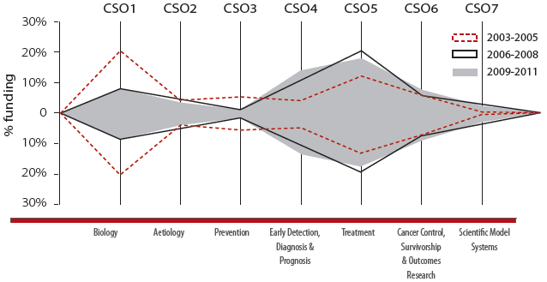

| Triennium | Biology | Aetiology | Prevention | Early Detection, Diagnosis & Prognosis | Treatment | Cancer Control, Survivorship & Outcomes Research | Scientific Model Systems |
| --- | --- | --- | --- | --- | --- | --- | --- |
| 2003-2005 | 39% | 8% | 11% | 8% | 25% | 9% | 1% |
| 2006-2008 | 17% | 10% | 2% | 18% | 39% | 9% | 4% |
| 2009-2011 | 18% | 7% | 2% | 23% | 35% | 12% | 3% |

Table 5.4: Direct funding to and number of research projects and research programs in each CSO category funded by other (non-NHMRC) sources in 2003-2005, 2006-2008 and 2009-2011

| CSO category | 2003-2005 | 2006-2008 | 2009-2011 |
| --- | --- | --- | --- |
| Biology | $49.3 M | $29.4 M | $47.8 M |
| Biology projects/programs | 353 | 264 | 358 |
| Aetiology | $9.6 M | $17.3 M | $19.0 M |
| Aetiology projects/programs | 60 | 85 | 76 |
| Prevention | $13.3 M | $4.0 M | $4.9 M |
| Prevention projects/programs | 34 | 27 | 29 |
| Early Detection, Diagnosis and Prognosis | $9.6 M | $31.5 M | $63.1 M |
| Early Detection, Diagnosis and Prognosis projects/programs | 90 | 143 | 226 |
| Treatment | $31.6 M | $67.5 M | $93.5 M |
| Treatment projects/programs | 214 | 302 | 397 |
| Cancer Control, Survivorship and Outcomes Research | $11.1 M | $14.7 M | $33.1 M |
| Cancer Control, Survivorship and Outcomes Research projects/programs | 116 | 123 | 200 |
| Scientific Model Systems | $1.3 M | $7.1 M | $7.5 M |
| Scientific Model Systems projects/programs | 11 | 50 | 59 |

*N.B. Some projects/programs overlap trienniums, thus the total number of projects/programs from 2003 to 2011 does not equal the sum of projects/programs for 2003-2005, 2006-2008 and 2009-2011.*

### 5.4 Analysis of direct funding to CSO sub-categories

Direct funding to all cancer research projects and research programs in the CSO categories of Biology, Aetiology, Prevention, Early Detection, Diagnosis and Prognosis, Treatment, Cancer Control, Survivorship and Outcomes Research and Scientific Model Systems was further analysed by CSO sub-categories.

**Biology (CSO category 1)**

There are five sub-categories within the main CSO Biology category:

1.1 Normal Functioning;

1.2 Cancer Initiation: Alterations in Chromosomes;

1.3 Cancer Initiation: Oncogenes and Tumour Suppressor Genes;

1.4 Cancer Progression and Metastasis; and

1.5 Resources and Infrastructure.

Figure 5.5A shows the pattern of direct funding across three trienniums in these sub-categories. In each of the three trienniums, in the CSO category of Biology, the sub-category of Normal Functioning received the highest level of funding.

The pattern of direct funding observed in each sub-category across the three trienniums was as follows:

* Direct funding to Normal Functioning decreased from $93.2 million (2003-2005) to $63.5 million (2006-2009) and then increased to $68.2 million (2009-2011);
* Direct funding to Cancer Initiation: Alterations in Chromosomes increased across the trienniums from $17.5 million (2003-2005) to $24.8 million (2006-2008) and then to $32.7 million (2009-2011);
* Direct funding to Cancer Initiation: Oncogenes and Tumour Suppressor Genes increased across the trienniums from $14.9 million (2003-2005) to $37.3 million (2006-2008) and then to $46.3 million (2009-2011);
* Direct funding to Cancer Progression and Metastasis increased across the trienniums from $22.0 million (2003-2005) to $37.3 million and then to $46.6 million (2009-2011); and
* Direct funding to Resources and Infrastructure remained below $1 million in each triennium.

The Resources and Infrastructure category deals with research support mechanisms and, as this audit focused on direct funding to cancer research projects and research programs, we would not expect spending in this category to be well represented for some CSO categories.

**Aetiology (CSO category 2)**

There are four sub-categories within the main CSO Aetiology category:

2.1 Exogenous Factors in the Origin and Cause of Cancer;

2.2 Endogenous Factors in the Origin and Cause of Cancer;

2.3 Interactions of Genes and/or Genetic Polymorphisms with Exogenous and/or Endogenous Factors; and

2.4 Resources and Infrastructure Related to Aetiology.

Figure 5.5B shows the pattern of direct funding across three trienniums in these categories.

The pattern of direct funding observed in each sub-category across the three trienniums was as follows:

* Direct funding to Exogenous Factors in the Origin and Cause of Cancer increased from $3.3 million (2003-2005) to $11.5 million (2006-2008) and $13.1 million (2009-2011);
* Direct funding to Endogenous Factors in the Origin and Cause of Cancer decreased from $8.5 million (2003-2005) to $7.6 million (2006-2008) and then increased to $12.4 million (2009-2011);
* Direct funding to Interactions of Genes and/or Genetic Polymorphisms with Exogenous and/ or Endogenous Factors increased from $4.9 million (2003-2005) to $12.2 million (2006-2008) and $14.4 million (2009-2011); and
* Direct funding to Resources and Infrastructure Related to Aetiology increased from $3.2 million (2003-2005) to $9.3 million (2006-2008) but then decreased to $8.4 million (2009-2011).

**Prevention (CSO category 3)**

There are six sub-categories within the main CSO Prevention category:

3.1 Interventions to Prevent Cancer: Personal Behaviours That Affect Cancer Risk;

3.2 Nutritional Science in Cancer Prevention;

3.3 Chemoprevention;

3.4 Vaccines;

3.5 Complementary and Alternative Prevention Approaches; and

3.6 Resources and Infrastructure Related to Prevention.

Figure 5.5C shows the pattern of direct funding across the three trienniums in these categories.

The pattern of direct funding observed in each sub-category across the three trienniums was as follows:

* Direct funding to Interventions to Prevent Cancer: Personal Behaviours That Affect Cancer Risk in each triennium increased from $0.7 million (2003-2005) to $3.3 million (2006-2008) and then to $4.6 million (2009-2011);
* Direct funding to Nutritional Science in Cancer Prevention increased from $0.2 million (2003-2005) to $0.4 million (2006-2008) and then increased further to $3.9 million (2009-2011);
* Direct funding to Chemoprevention research decreased from $3.5 million (2003-2005) to $0.5 million (2006-2008) but then increased in the last triennium to $1.8 million (2009-2011);
* Direct funding to Vaccines decreased from $10 million[9] (2003-2005) to approximately $1.5 million (2006-2008 and 2009-2011);
* No direct funding to projects and programs in the sub-category Complementary and Alternative Prevention Approaches was recorded in the triennium 2003-2005, and the direct funding for this CSO sub-category was $2.6 million (2006-2008) and then decreased to $1.6 million (2009-2011); and
* Direct funding to Resources and Infrastructure Related to Prevention decreased overall from approximately $0.7 million (2003-2005 and 2006-2008) to $0.2 million (2009-2011).

**Early Detection, Diagnosis and Prognosis (CSO category 4)**

There are four sub-categories within the main CSO Early Detection, Diagnosis and Prognosis category:

4.1 Technology Development and/or Marker Discovery;

4.2 Technology and/or Marker Evaluation With Respect to Fundamental Parameters of Method;

4.3 Technology and/or Marker Testing in a Clinical Setting; and

4.4 Resources and Infrastructure Related to Detection, Diagnosis, or Prognosis.

Figure 5.5D shows the pattern of direct funding across the three trienniums in these categories. In each of the three trienniums, in the CSO category of Early Detection, Diagnosis and Prognosis, the sub-category of Technology Development and/or Marker Discovery research received the highest level of funding.

The pattern of direct funding observed in each sub-category across the three trienniums was as follows:

* Direct funding to Technology Development and/or Marker Discovery increased across the three trienniums from $12.0 million (2003-2005) to $32.0 million (2006-2008) and then to $60.6 million (2009-2011);
* Direct funding to Technology and/or Marker Evaluation With Respect to Fundamental Parameters of Method increased across the trienniums from $3.1 million (2003-2005) to $4.3 million (2006-2008) and then to $9.1 million (2009-2011);
* Direct funding to Technology and/or Marker Testing in a Clinical Setting research varied across the trienniums, decreasing from $6.6 million (2003-2005) to $3.9 million (2006-2008) and then increasing to $6.0 million (2009-2011); and
* Direct funding to Resources and Infrastructure Related to Detection, Diagnosis, or Prognosis increased from $0.2 million (2003-2005) to $14.3 million (2006-2008) and $18.7 million (2009-2011).

**Treatment (CSO category 5)**

There are seven sub-categories within the main CSO Treatment category:

5.1 Localized Therapies - Discovery and Development;

5.2 Localized Therapies - Clinical Applications;

5.3 Systemic Therapies - Discovery and Development;

5.4 Systemic Therapies - Clinical Applications;

5.5 Combinations of Localized and Systemic Therapies;

5.6 Complementary and Alternative Treatment Approaches; and

5.7 Resources and Infrastructure Related to Treatment and the prevention of recurrence.

Figure 5.5E shows the pattern of direct funding across the three trienniums in these categories. In each of the three trienniums, in the CSO category of Treatment, the sub-category of Systemic Therapies - Discovery and Development received the highest level of funding.

The pattern of direct funding observed in each sub-category across the trienniums was as follows:

* Direct funding to Localized Therapies - Discovery and Development varied across the trienniums, decreasing from $4.6 million (2003-2005) to $4.1 million (2006-2008) and then increasing to $6.5 million (2009-2011)
* Direct funding to Localized Therapies - Clinical Applications increased across the trienniums from $3.8 million (2003-2005) to $6.4 million (2006-2008) and then to $9.9 million (2009-2011);
* Direct funding to Systemic Therapies - Discovery and Development increased across each triennium from $36.2 million (2003-2005) to $71.4 million (2006-2008) and then to $121 million (2009-2011);
* Direct funding to Systemic Therapies - Clinical Applications varied across the trienniums, increasing from $7.9 million (2003-2005) to $21.5 million (2006-2008) and then decreasing to $17.2 million (2009-2011);
* Direct funding to Combinations of Localized and Systemic Therapies increased across the trienniums from $2.2 million (2003-2005) to $4.8 million and then to $7.2 million (2009-2011);
* Direct funding to Complementary and Alternative Treatment Approaches remained at less than $1 million for each of the trienniums; and
* No direct funding to projects and programs in the sub-category Resources and Infrastructure Related to Treatment was recorded in the triennium 2003-2005, and the direct funding for this CSO sub-category was $0.8 million (2006-2008) and increased to $5.5 million (2009-2011).

**Cancer Control, Survivorship and Outcomes Research (CSO category 6)**

There are nine sub-categories within the main CSO Cancer Control, Survivorship and Outcomes Research category:

6.1 Patient Care and Survivorship Issues;

6.2 Surveillance;

6.3 Behaviour;

6.4 Cost Analyses and Health Care Delivery;

6.5 Education and Communication;

6.6 End-of-Life Care;

6.7 Ethics and Confidentiality in Cancer Research;

6.8 Complementary and Alternative Approaches for Supportive Care of Patients and Survivors; and

6.9 Resources and Infrastructure Related to Cancer Control, Survivorship, and Outcomes Research.

Figure 5.5F shows the pattern of direct funding across the three trienniums in these categories. In each of the three trienniums, in the CSO category of Cancer Control, Survivorship and Outcomes, the sub-category of Patient Care and Survivorship Issues research received the highest level of funding.

The pattern of direct funding observed in each sub-category across the trienniums was as follows:

* Direct funding to Patient Care and Survivorship Issues increased across the trienniums from $7.2 million (2003-2005) to $9.7 million (2006-2008) and then to $18.7 million (2009-2011);
* Direct funding to Surveillance varied over the trienniums decreasing $6.4 million (2003-2005) to $0.8 million (2006-2008) and increasing to $4.9 million (2009-2011);
* Direct funding to Behaviour similarly varied across the trienniums, decreasing from $4.9 million (2003-2005) to $3.1 million (2006-2008) and then increasing to $4.1 million (2009-2011);
* Direct funding to Cost Analyses and Health Care Delivery increased across the three trienniums from $3.1 million (2003-2005) to $7.4 million (2006-2008) and then to $12.1 million (2009-2011);
* Direct funding to Education and Communication increased from $2.3 million (2003-2005 and 2006-2008) to $4.9 million (2009-2011);
* Direct funding to End-of-Life Care also displayed a variation in the amount of direct funding decreasing from $1.7 million (2003-2005) to $0.5 million (2006-2008) and then increasing to $2.2 million (2009-2011);
* Direct funding to Ethics and Confidentiality in Cancer Research remained constant across the trienniums at less than $1 million;
* No direct funding to projects and programs in the sub-category Complementary and Alternative Approaches for Supportive Care of Patients and Survivors was recorded in the triennium 2003-2005, and the direct funding for this CSO subcategory increased from $0.2 million (2006-2008) to $1.1 million (2009-2011); and
* Resources and Infrastructure Related to Cancer Control, Survivorship, and Outcomes Research increased from $1.6 million (2003-2005) to $5.3 million (2006-2008) and then to $6.1 million (2009-2011).

**Scientific Model Systems (CSO category 7)**

There are three sub-categories within the main CSO Scientific Model Systems category:

7.1 Development and Characterization of Model Systems;

7.2 Application of Model Systems; and

7.3 Resources and Infrastructure Related to Scientific Model Systems.

As funding was only observed in two sub-categories, the results are not illustrated; however, the pattern of direct funding observed in each sub-category across the trienniums was as follows:

* Direct funding to Development and Characterization of Model Systems increased across the trienniums from $3.6 million (2003-2005) to $6.9 million (2006-2008) and then to $14.3 million (2009-2011);
* Direct funding to Application of Model Systems also increased across the trienniums from $0.7 million (2003-2005) to $6.4 million (2006-2008) and to $8.5 million (2009-2011); and
* No direct funding to projects and research programs in the sub-category Resources and Infrastructure Related to Scientific Model Systems was recorded in any of the trienniums.

Figure 5.5: Pattern of direct funding to CSO sub-categories in 2003-2005, 2006-2008 and 2009-2011

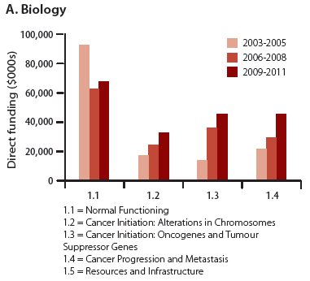

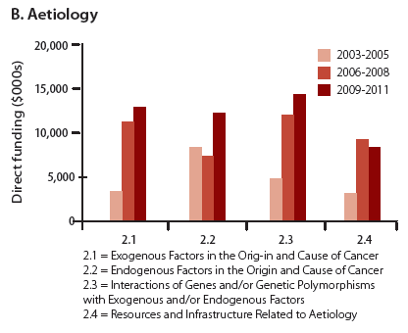

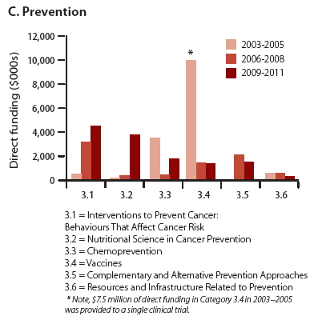

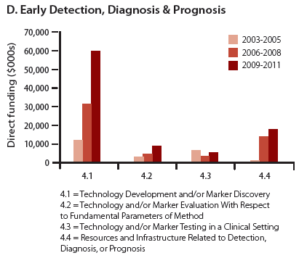

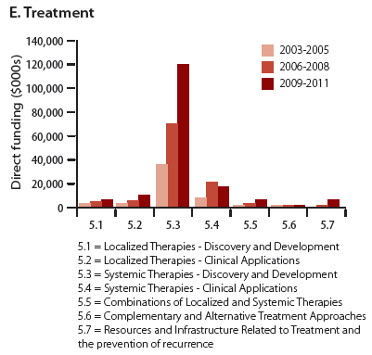

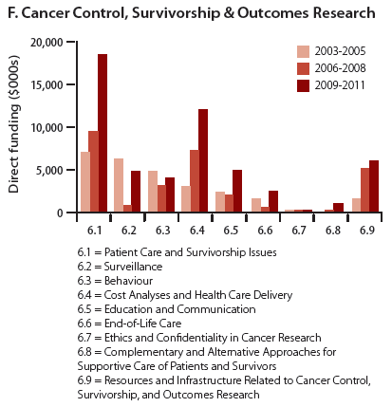

### 5.5 Discussion

The pattern of funding[10] to CSO categories reflected the dominant areas of cancer research in Australia. In the period 2006 to 2011, the CSO categories of Biology and Treatment together accounted for nearly two-thirds (63%) of the identified direct funding to cancer research projects and research programs. However it is interesting to note that, from 2003-2005 to 2009-2011, proportional funding to Biology decreased from 51% to 32% and proportional funding to Treatment increased from 19% to 28%. Funding to Early Detection, Diagnosis and Prognosis also increased, from 8% to 16%.

#### Direct funding to CSO categories

Despite the decreasing proportional funding to some CSO categories, direct funding to all CSO categories (except Prevention) increased from 2003-2005 to 2009-2011. Notable findings for each CSO category are discussed below.

##### Biology

Direct funding to Biology increased from $148 million to $194 million across the trienniums. While Biology's proportional share of direct funding to all CSO categories decreased across the trienniums, research in this area is still a growing area of cancer research. Indeed, research in Biology underpins a large component of cancer research across different tumour streams and tumour types. Direct funding to the Biology CSO sub-categories 1.1, 1.2, 1.3 and 1.4 was relatively evenly spread in 2009-2011 compared to 2003-2005. This was largely due to a reduction in funding to CSO 1.1 (Normal Functioning) whereas the other subcategories all experienced marked increases in direct funding. This change in funding to the CSO subcategories of Biology may relate to an overall changing focus of research within Biology as well as a focus towards more applied biological research.

##### Aetiology

Direct funding to Aetiology increased from $19.9 million to $48.4 million across the trienniums, with a relatively even spread of funding across all CSO sub-categories. A smaller workforce of researchers working in the CSO category of Aetiology may in part explain the lower level of funding to this CSO category.

##### Prevention

Direct funding to Prevention research decreased from $15.2 million in 2003-2005 to $13.6 million in 2009-2011. However, a single clinical trial recorded only in 2003-2005 accounted for almost 50% of funding in this triennium. If this single grant is not counted, direct funding to Prevention research would have increased over the three trienniums and the proportional funding would have remained steady at 2-3% over the same period. However, direct funding to Prevention research was lower relative to the levels of funding to other CSO categories.

##### Early Detection, Diagnosis and Prognosis

Direct funding to Early Detection, Diagnosis and Prognosis increased from $21.9 million to $93.5 million across the trienniums. The increase in direct funding to this CSO category was particularly apparent in the CSO sub-category 4.1 (Technology Development and/or Marker Discovery), to which funding increased 5-fold. Funding to CSO 4.1 was relatively well-funded compared to CSO 4.3 (Technology and/or Marker Testing in a Clinical Setting), with CSO 4.1 being more than 6-fold higher than CSO 4.3 in 2009-2011. This finding may relate to the time required to progress research into a clinical setting and/or the different research associated with the development and then the testing of clinical markers.

##### Treatment

Direct funding to Treatment increased from $55.1 million to $168 million across the trienniums. A feature of the increased funding to Treatment was the 5-fold increase in direct funding to CSO sub-category 5.3 (Systemic Therapies - Discovery and Development) which is discussed above. The large observed increase in funding in CSO 5.3 may also be explained by the translation of biological research, well-funded in 2003-2005, into the discovery and development of systemic therapies. The increase in direct funding to Treatment as a whole, however, was marked and is indicative of the observed shift towards funding applied clinical research in Australia.

##### Cancer Control, Survivorship and Outcomes Research

Direct funding to Cancer Control, Survivorship and Outcomes Research increased from $27.4 million to $54.5 million across the trienniums. The most notable CSO sub-category which received an increase in direct funding was CSO 6.1 (Patient Care and Survivorship Issues) which indicates a growing emphasis on research in the areas of psychosocial care, quality-of-life, survivorship and pain and symptom management. Relatively lower levels of funding were provided to: CSO 6.2 (Surveillance), which involves end results reporting and reporting of incidence and mortality. These activities are conducted in Australia through regular reporting of cancer registry data; and CSO 6.3 (Behaviour), which may relate to a relatively small relevant workforce in Australia. CSO 6.4 (Cost Analysis and Health Care Delivery) received increases in direct funding over the trienniums but funding was still relatively low. This finding may relate to the involved nature of accessing national datasets such as Medicare and the Medicare Benefits Schedule, and the Pharmaceutical Benefits Scheme. CSO 6.6 (End of Life Care) also received lower levels of direct funding, which may relate to a small workforce and the fact that some end-of-life care issues may not be cancer-specific.

##### Scientific Model Systems

Direct funding to Scientific Model Systems increased from $4.3 million to $22.7 million across the trienniums. Whilst funding to this CSO category was low relative to other CSO categories, the development and application of model systems may often be undertaken as the minor component of cancer research projects or research programs. Therefore, with the CSO coding strategy used in this audit, direct funding in the area may be under-estimated.

These data on the distribution of funding across the research continuum can assist to guide future research investment.

#### Changes in proportional funding towards Treatment and Early Detection, Diagnosis and Prognosis

The observed change in the pattern of funding towards Treatment and Early Detection, Diagnosis and Prognosis may reflect a combination of several factors. The majority of the direct funding to the CSO categories of Treatment and Early Detection, Diagnosis and Prognosis was directed towards two CSO sub-categories: 5.3 (Systemic Therapies - Discovery and Development) and 4.1 (Technology Development and/or Marker Discovery). These CSO sub-categories include areas that can be considered as applied biological research (see Appendix D for further detail on the types of research included in these CSO sub-categories) and from 2003-2005 to 2009-2011, the direct funding to these sub-categories increased by 3.4-fold and 5-fold, respectively. Thus, the observed change in proportional funding away from Biology and towards Treatment and Early Detection, Diagnosis and Prognosis may, in part, reflect the translation of basic biological research towards application of the research.

The proportional change in funding from Biology to Treatment and Early Detection, Diagnosis and Prognosis was most pronounced for funding that was from non-NHMRC sources. There are some important factors to bear in mind when considering this shift. Firstly, the funders represented in this category (and the proportional contribution from each single funder) changed across the trienniums. Thus for the audit of 2003 to 2005, there were 83 organisations (not including the NHMRC) that directly funded cancer research projects and research programs, whereas for this audit of 2006 to 2011, 133 organisations (not including the NHMRC) funded cancer research projects and research programs. In addition to the increase in the number of funders captured in this audit, it is possible that changes in funding policies have occurred towards supporting more applied research. This change may have been driven, in part, by increasing consumer involvement in setting research priorities and growing consumer engagement in research design and conduct.

Cancer Australia's PdCCRS has strategically sought to fund applied research. Cancer Australia directs the funding of applied research to research priorities which are likely to impact on cancer care and policy. Research project grants were first funded through the PdCCRS in 2008. Between 2008 and 2011, Cancer Australia has funded or co-funded 121 project grants totalling $31.8 million. Of these grants, 68% supported research in Early Detection, Diagnosis and Prognosis, Treatment and Cancer Control, Survivorship and Outcomes Research.

#### Proportional funding to Prevention research

Cancer research in the CSO category of Prevention decreased in proportional and direct funding across the trienniums. A single clinical trial recorded only in 2003-2005 accounted for approximately half of the 5% of proportional funding to Prevention in the first triennium and proportional funding to this CSO category remained low at 2% of proportional funding in the subsequent trienniums of 2006-2008 and 2009-2011.

The lower level of funding to Prevention research may be explained in part by cancer sharing common preventable risk factors with other chronic diseases, such as cardiovascular disease and diabetes. Thus, research projects and research programs which investigate prevention of several chronic diseases through risk mitigation may not have been captured in this audit of direct funding to cancer research projects and research programs.

Another important consideration is that whilst the Prevention CSO sub-category of 3.4 (Vaccines) is the appropriate classification for the development of vaccines for the prevention of cancer, a considerable amount of vaccine research occurs for the treatment of cancer (including prevention of recurrence) and thus is coded to the Treatment sub-categories of 5.3 (Systemic Therapies -Discovery and Development) and 5.4 (Systemic Therapies - Clinical Applications). Nonetheless, proportional investment in Prevention research was 2% in Australia in the period 2006 to 2011 and the proportional investment in Prevention research in other countries was similar. It is estimated that, world-wide, more than 50% of cancer can be prevented19, and many preventable risk factors for cancer are common with other chronic diseases such as cardiovascular disease and diabetes.

Development of international initiatives to fund cancer prevention research, and initiatives which bring together funders of chronic diseases to co-fund prevention research, could help to reduce the burden of disease of cancers and other chronic diseases.

## Chapter 6 - Tumour stream focus of cancer research projects and research programs

**KEY FINDINGS**

* In the period 2006 to 2011:
* $610 million (61%) of direct funding was provided to cancer research projects and research programs with a single or multiple tumour stream focus
* $398 million (39%) of direct funding was provided to cancer research projects and research programs which did not have a focus in any particular tumour stream
* From 2003-2005 to 2009-2011:
* The proportional funding to cancer research projects and research programs with a focus on single or multiple tumour streams increased from 40% to 63%
* The number of cancer research projects and research programs focusing on single or multiple tumour streams increased from 675 to 1,421

### 6.1 Analysing cancer research by tumour stream focus

A "tumour stream" comprises a collective group of cancer types. The tumour streams used in this audit are listed in Appendix E.

Each cancer research project and research program was allocated to one of three categories according to whether the research undertaken was:

* not specific to any tumour stream (Not tumour stream-specific);
* specific to a single tumour stream (Single stream); or
* directly addressed multiple tumour streams (Multiple streams).

Figure 6.1 shows the proportional distribution of direct funding in the trienniums 2003-2005, 2006-2008 and 2009-2011 in each of these three tumour stream categories. Table 6.1 lists the number of cancer research projects and research programs funded in each category, and details the direct funding to the research projects and research programs.

In each of the three categories identified above, there was a progressive increase in direct funding from the 2003-2005 to the 2009-2011 trienniums. In the Single stream and Multiple streams categories, the number of cancer research projects and research programs increased from the 2003-2005 to the 2009-2011 trienniums. The number of cancer research projects and research programs in the Not tumour stream-specific category decreased from 657 (2003-2005) to 566 (2006-2008) and then increased to 679 (2009-2011).

In terms of proportional distribution of funding, in the first triennium (2003-2005), cancer research projects and research programs in the Not tumour stream-specific category received the majority of direct funding (60%) but in the last triennium (2009-2011), Single stream research received the majority of funding (59%).

In summary, the proportional distribution of funding to cancer research projects or research programs was as follows:

* The proportional funding to research that was Not tumour stream-specific decreased from 60% (2003-2005) to 44% (2006-2008) and then to 37% (2009-2011);
* The proportional funding to research that was specific to a Single stream increased from 38% (2003-2005) to 53% (2006-2008) and then to 59% (2009-2011); and
* The proportional funding to research that was specific to Multiple streams increased from 3% (2003-2005) to 4% in 2006-2008 and 2009-2011.

Figure 6.1: Proportional distribution of direct funding to Not tumour stream-specific, Single stream, or Multiple stream research categories in 2003-2005, 2006-2008 and 2009-2011

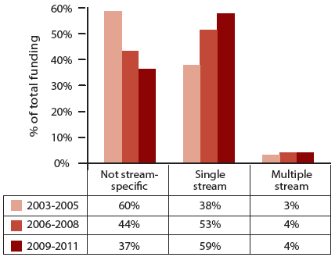

*Due to rounding, each row may not add up to exactly 100%.*

Table 6.1: Direct funding to and number of research projects and research programs in Not tumour stream-specific, Single stream or Multiple streams research categories in 2003-2005, 2006-2008 and 2009-2011

| Stream focus | 2003-2005 | 2006-2008 | 2009-2011 |
| --- | --- | --- | --- |
| Not tumour stream-specific | $174 M | $180 M | $218 M |
| Not tumour stream-specific projects/programs | 657 | 566 | 679 |
| Single stream | $110 M | $217 M | $351 M |
| Single stream projects/programs | 651 | 980 | 1362 |
| Multiple streams | $7.4 M | $15.5 M | $26.6 M |
| Multiple streams projects/programs | 24 | 49 | 59 |

*N.B. Some projects/programs overlap trienniums, thus the total number of projects/programs from 2003 to 2011 does not equal the sum of projects/programs for 2003-2005, 2006-2008 and 2009-2011.*

### 6.2 CSO focus of direct funding to cancer research that was not tumour stream-specific

From 2006 to 2011, $398 million or 39% of the identified direct funding to cancer research projects and research programs went to research that was not specific to any particular tumour stream.

For cancer research projects and research programs that were not tumour specific,

* the pattern of direct funding,
* changes in the proportional distribution of funding, and
* the number of cancer research projects or research programs

supported in each CSO category for the trienniums 2006-2008 and 2009-2011 were analysed and compared with 2003-2005 for two funding source categories: NHMRC and other sources of funding (Table 6.2 and Figure 6.2).

#### NHMRC funding

In the period 2006 to 2011, the NHMRC provided $267 million of direct funding to cancer research projects and research programs which were not tumour stream-specific. From 2003-2005 to 2009-2011, direct funding from the NHMRC to this category of research increased from $116 million to $142 million.

In summary, direct funding from the NHMRC to research that was not tumour stream-specific in each CSO category was as follows:

* Direct funding to Aetiology, Prevention and Treatment increased from 2003-2005 to 2009-2011;
* Direct funding to Early Detection, Diagnosis and Prognosis, Cancer Control, Survivorship and Outcomes Research and Scientific Model Systems decreased from the 2003-2005 to the 2006-2008 trienniums but increased by the 2009-2011 triennium; and
* Direct funding to Biology increased from the 2003-2005 to the 2006-2008 trienniums but decreased by the 2009-2011 triennium.

Cancer research projects and research programs which were funded in each CSO category were as follows:

* The number of cancer research projects and research programs funded in Aetiology, Prevention, Early Detection, Diagnosis and Prognosis and Treatment increased progressively from the 2003-2005 to the 2009-2011 trienniums;
* The number of cancer research projects and research programs funded in Cancer Control, Survivorship and Outcomes Research and Scientific Model Systems decreased from the 2003-2005 to the 2006-2008 trienniums but increased by the 2009-2011 triennium; and
* The number of cancer research projects and research programs funded in Biology increased from the 2003-2005 to the 2006-2008 trienniums but decreased by the 2009-2011 triennium.

The proportional distribution of funding across the CSO categories changed from the first to the last triennium. The largest change in proportional funding was to Biology which, as a percentage of the total direct funding decreased by 15% from 2003-2005 to 2009-2011. By contrast, the second-most funded category, Treatment, received a proportional increase in funding of 12% from 2003-2005 to 2009-2011.

In summary, the proportional NHMRC funding to cancer research projects or research programs was as follows:

* The proportional funding to Biology decreased from 70% (2003-2005 and 2006-2008) to 55% (2009-2011);
* The proportional funding to Aetiology increased across the trienniums from 2% (2003-2005) to 5% (2006-2008) and then to 7% (2009-2011);
* The proportional funding to Prevention increased across the trienniums from 0% (2003-2005) to 1% (2006-2008) and then to 2% (2009-2011);
* The proportional funding to Early Detection, Diagnosis and Prognosis decreased from 4% (2003-2005) to 2% (2006-2008 and 2009-2011);
* The proportional funding to Treatment increased across the trienniums from 10% (2003-2005) to 13% (2006-2008) and then to 22% (2009-2011);
* The proportional funding to Cancer Control, Survivorship and Outcomes Research decreased from 11% (2003-2005) to 8% (2006-2008) and then increased to 9% (2009-2011); and
* The proportional funding to Scientific Model Systems decreased from 2% (2003-2005) to 1% (2006-2008) and then increased to 3% (2009-2011).

#### Other sources of funding

In the period 2006 to 2011, aside from the NHMRC, other funding sources across diverse funding sectors[11] provided $131 million of direct funding to cancer research projects and research programs for which the research undertaken was not tumour stream-specific. From 2003-2005 to 2009-2011, funding from these other sources to this category of research increased from $57.6 million to $75.5 million.

In summary, direct funding from these other sources to CSO categories was as follows:

* Direct funding to Early Detection, Diagnosis and Prognosis and Treatment increased from 2003-2005 to 2009-2011;
* Direct funding to Biology, Prevention and Cancer Control, Survivorship and Outcomes Research decreased from the 2003-2005 to the 2006-2008 trienniums but increased by the 2009-2011 triennium;
* Direct funding to Scientific Model Systems increased from the 2003-2005 to the 2006-2008 trienniums but decreased by the 2009-2011 triennium; and
* Direct funding to Aetiology decreased from the 2003-2005 to the 2009-2011 trienniums.

Cancer research projects and research programs funded in each CSO category were as follows:

* The number of cancer research projects and research programs in Scientific Model Systems increased from the 2003-2005 to the 2006-2008 trienniums but decreased by the 2009-2011 triennium;
* The number of cancer research projects and research programs funded in Biology, Prevention, Treatment and Cancer Control, Survivorship and Outcomes Research decreased from the 2003-2005 to the 2006-2008 trienniums but increased by the 2009-2011 triennium;
* The number of cancer research projects and research programs funded in Early Detection, Diagnosis and Prognosis remained steady in the 2003-2005 to the 2006-2008 trienniums and then increased by the 2009-2011 triennium; and
* The number of cancer research projects and research programs funded in Aetiology decreased from the 2003-2005 to the 2009-2011 trienniums.

The proportional distribution of funding across the CSO categories changed from the first to the last triennium. The largest change in proportional funding was to Biology which, as a percentage of the total direct funding decreased by 15% from 2003-2005 to 2009-2011. By contrast, the second-most funded category, Treatment, received a proportional increase in funding of 19% from 2003-2005 to 2009-2011.

In summary, the proportional funding from other sources to cancer research projects or research programs was as follows:

* The proportional funding to Biology decreased from 35% (2003-2005) to 18% (2006-2008) and then increased slightly to 20% (2009-2011);
* The proportional funding to Aetiology decreased across the trienniums from 4% (2003-2005) to 2% (2006-2008) and then to 1% (2009-2011);
* The proportional funding to Prevention decreased across the trienniums from 19% (2003-2005) to 2% (2006-2008) and then to 1% (2009-2011);
* The proportional funding to Early Detection, Diagnosis and Prognosis increased across the trienniums from 3% (2003-2005) to 6% (2006-2008) and then to 13% (2009-2011);
* The proportional funding to Treatment increased from 31% (2003-2005) to 59% (2006-2008) and then decreased to 50% (2009-2011);
* The proportional funding to Cancer Control, Survivorship and Outcomes Research increased across the trienniums from 7% (2003-2005) to 8% (2006-2008) and then to 11% (2009-2011); and
* The proportional funding to Scientific Model Systems increased from 0% (2003-2005) to 7% (2006-2008) and then decreased to 4% (2009-2011).

Table 6.2: Direct funding to and number of research projects and research programs in each CSO category for research that was not tumour stream-specific in 2003-2005, 2006-2008 and 2009-2011

| CSO category | 2003-2005 NHMRC | 2003-2005 Other sources | 2006-2008 NHMRC | 2006-2008 Other sources | 2009-2011 NHMRC | 2009-2011 Other sources |
| --- | --- | --- | --- | --- | --- | --- |
| Biology | $81.9 M | $20.2 M | $87.2 M | $10.0 M | $78.6 M | $15.0 M |
| Biology projects/programs | 174 | 179 | 200 | 83 | 172 | 110 |
| Aetiology | $2.8 M | $2.3 M | $6.2 M | $0.9 M | $9.7 M | $0.7 M |
| Aetiology projects/programs | 3 | 14 | 11 | 10 | 13 | 8 |
| Prevention | $0.1 M | $11.1 M* | $1.7 M | $0.9 M | $2.9 M | $1.1 M |
| Prevention projects/programs | 1 | 15 | 5 | 7 | 10 | 8 |
| Early Detection, Diagnosis & Prognosis | $5.0 M | $2.0 M | $2.4 M | $3.0 M | $2.9 M | $10.0 M |
| Early Detection, Diagnosis & Prognosis projects/programs | 7 | 18 | 9 | 18 | 11 | 36 |
| Treatment | $12.0 M | $17.7 M | $16.7 M | $32.4 M | $31.0 M | $37.6 M |
| Treatment projects/programs | 36 | 96 | 42 | 91 | 62 | 120 |
| Cancer Control, Survivorship & Outcomes Research | $12.6 M | $4.3 M | $9.5 M | $4.2 M | $13.5 M | $8.4 M |
| Cancer Control, Survivorship & Outcomes Research projects/programs | 42 | 66 | 30 | 33 | 34 | 61 |
| Scientific Model Systems | $1.7 M | $0.02 M | $1.6 M | $3.7 M | $3.9 M | $2.7 M |
| Scientific Model Systems projects/programs | 6 | 1 | 5 | 22 | 14 | 20 |
| All categories | $116 M | $57.6 M | $125 M | $55.2 M | $142 M | $75.5 M |
| All categories projects/programs | 269 | 389 | 302 | 264 | 316 | 363 |

*\* Note, $7.5 million of direct funding to Prevention in 2003-2005 was provided to a single clinical trial.*

*N.B. Some projects/programs overlap trienniums, thus the total number of projects/programs in the period 2006 to 2011 does not equal the sum of projects/programs in 2006-2008 and 2009-2011.*

Figure 6.2: The pattern of funding to each CSO category for research that was not tumour stream-specific in 2003-2005, 2006-2008 and 2009-2011

**A. Proportional distribution of funding from the NHMRC**

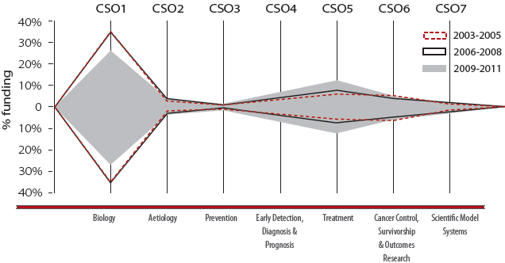

| Triennium | Biology | Aetiology | Prevention | Early Detection, Diagnosis & Prognosis | Treatment | Cancer Control, Survivorship & Outcomes Research | Scientific Model Systems |
| --- | --- | --- | --- | --- | --- | --- | --- |
| 2003-2005 | 70% | 2% | 0% | 4% | 10% | 11% | 2% |
| 2006-2008 | 70% | 5% | 1% | 2% | 13% | 8% | 1% |
| 2009-2011 | 55% | 7% | 2% | 2% | 22% | 9% | 3% |

**B. Proportional distribution of funding from other sources (non-NHMRC)**

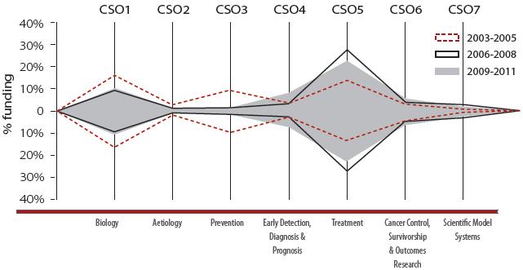

| Triennium | Biology | Aetiology | Prevention | Early Detection, Diagnosis & Prognosis | Treatment | Cancer Control, Survivorship & Outcomes Research | Scientific Model Systems |
| --- | --- | --- | --- | --- | --- | --- | --- |
| 2003-2005 | 35% | 4% | 19% | 3% | 31% | 7% | 0% |
| 2006-2008 | 18% | 2% | 2% | 6% | 59% | 8% | 7% |
| 2009-2011 | 20% | 1% | 1% | 13% | 50% | 11% | 4% |

### 6.3 CSO focus of direct funding to single and multiple tumour streams research

From 2006 to 2011, $568 million or 56% of the direct funding to cancer research projects and research programs was for single tumour stream-specific research and a further $42.1 million or 4% of the direct funding was for research addressing multiple tumour streams. The two categories have been combined for this analysis. The pattern of direct funding, changes in the proportional distribution of funding, and the number of cancer research projects or research programs supported in each CSO category for the trienniums 2006-2008 and 2009-2011 were analysed and compared to 2003-2005 for each of two funding source categories: NHMRC and other sources of funding (Table 6.3 and Figure 6.3).

#### NHMRC funding

In the period 2006 to 2011, the NHMRC provided $301 million of direct funding to cancer research projects and research programs that were specific to a tumour stream(s). From 2003-2005 to 2009-2011, funding from the NHMRC increased from $49.8 million to $185 million. In summary:

* Direct funding to each CSO category progressively increased from 2003-2005 to 2009-2011; and
* The number of cancer research projects and research programs funded in each CSO category also progressively increased from 2003-2005 to 2009-2011.

The proportional distribution of funding across the CSO categories changed slightly from the first to the last triennium. The largest changes in proportional funding were to Biology and Early Detection, Diagnosis and Prognosis which, as a percentage of total direct funding, both increased by 5% from 2003-2005 to 2009-2011.

In summary, the proportional NHMRC funding to cancer research projects and research programs was as follows:

* The proportional funding to Biology increased across the trienniums from 32% (2003-2005) to 34% (2006-2008) and then to 37% (2009-2011);
* The proportional funding to Aetiology decreased from 15% (2003-2005 and 2006-2008) to 11% (2009-2011);
* The proportional funding to Prevention remained at 3% across the trienniums;
* The proportional funding to Early Detection, Diagnosis and Prognosis increased from 10% (2003-2005) to 18% (2006-2008) and then decreased to 15% (2009-2011);
* The proportional funding to Treatment decreased slightly from 23% (2003-2005) to 22% (2006-2008) and then increased to 24% (2009-2011);
* The proportional funding to Cancer Control, Survivorship and Outcomes Research decreased across the trienniums from 7% (2003-2005) to 5% (2006-2008) and then to 4% (2009-2011); and
* The proportional funding to Scientific Model Systems increased across the trienniums from 3% (2003-2005) to 4% (2006-2008) and then to 6% (2009-2011).

#### Other sources of funding

In the period 2006 to 2011, aside from the NHMRC, other funding sources across diverse funding sectors[12] provided $309 million of direct funding to cancer research projects and research programs that were specific to a tumour stream(s). From 2003-2005 to 2009-2011, funding increased from $68.2 million to $193 million, and each CSO category except Biology received a progressive increase in direct funding. Direct funding to Biology decreased from 2003-2005 to 2006-2008, but increased to 2009-2011. Each CSO category except Aetiology also received a progressive increase in the number of cancer research projects and research programs funded. In the CSO category Aetiology, 46 research projects and research programs were funded in 2003-2005, 75 in 2006-2008 and 68 in 2009-2011.

The proportional distribution of funding across the CSO categories changed from the first to the last triennium. The largest change in proportional funding was to Biology which, as a percentage of total direct funding decreased by 28% from 2003-2005 to 2009-2011.

In summary, the proportional funding to cancer research projects and research programs from other sources (non-NHMRC) was as follows:

* The proportional funding to Biology decreased from 45% (2003-2005) to 17% (2006-2008 and 2009-2011);
* The proportional funding to Aetiology increased from 12% (2003-2005) to 14% (2006-2008) and then decreased to 9% (2009-2011);
* The proportional funding to Prevention decreased slightly from 3% (2003-2005 and 2006-2008) to 2% (2009-2011);
* The proportional funding to Early Detection, Diagnosis and Prognosis increased across the trienniums from 12% (2003-2005) to 24% (2006-2008) and then to 28% (2009-2011);
* The proportional funding to Treatment increased from 21% (2003-2005) to 30% (2006-2008) and then decreased slightly to 29% (2009-2011);
* The proportional funding to Cancer Control, Survivorship and Outcomes Research decreased from 10% (2003-2005) to 9% (2006-2008) and then increased to 13% (2009-2011); and
* The proportional funding to Scientific Model Systems fluctuated from 2% (2003-2005) to 3% (2006-2008) and then back to 2% (2009-2011).

Table 6.3: Direct funding to and number of research projects and research programs in each CSO category for research that was specific to single or multiple tumour stream(s) in 2003-2005, 2006-2008 and 2009-2011

| CSO category | 2003-2005 NHMRC | 2003-2005 Other sources | 2006-2008 NHMRC | 2006-2008 Other sources | 2009-2011 NHMRC | 2009-2011 Other sources |
| --- | --- | --- | --- | --- | --- | --- |
| Biology | $16.5 M | $29.1 M | $39.7 M | $19.4 M | $67.9 M | $32.8 M |
| Biology projects/programs | 75 | 175 | 93 | 181 | 159 | 248 |
| Aetiology | $7.6 M | $7.3 M | $17.1 M | $16.3 M | $19.7 M | $18.3 M |
| Aetiology projects/programs | 17 | 46 | 50 | 75 | 54 | 68 |
| Prevention | $1.8 M | $2.2 M | $3.0 M | $3.1 M | $5.8 M | $3.7 M |
| Prevention projects/programs | 7 | 19 | 10 | 20 | 13 | 21 |
| Early Detection, Diagnosis & Prognosis | $7.3 M | $7.6 M | $20.8 M | $28.4 M | $28.5 M | $53.2 M |
| Early Detection, Diagnosis & Prognosis projects/programs | 23 | 72 | 47 | 125 | 59 | 190 |
| Treatment | $11.6 M | $13.9 M | $25.3 M | $35.1 M | $43.5 M | $55.8 M |
| Treatment projects/programs | 40 | 118 | 70 | 211 | 99 | 277 |
| Cancer Control, Survivorship & Outcomes Research | $3.7 M | $6.8 M | $5.4 M | $10.6 M | $7.9 M | $24.7 M |
| Cancer Control, Survivorship & Outcomes Research projects/programs | 18 | 50 | 22 | 90 | 27 | 139 |
| Scientific Model Systems | $1.3 M | $1.2 M | $4.7 M | $3.4 M | $11.3 M | $4.8 M |
| Scientific Model Systems projects/programs | 5 | 10 | 8 | 28 | 28 | 39 |
| All categories | $49.8 M | $68.2 M | $116 M | $116 M | $185 M | $193 M |
| All categories projects/programs | 185 | 490 | 300 | 730 | 439 | 982 |

*N.B. Some projects/programs overlap trienniums, thus the total number of projects/programs in the period 2006 to 2011 does not equal the sum of projects/programs in 2006-2008 and 2009-2011.*

Figure 6.3: The pattern of funding to each CSO category for cancer research that was specific to a tumour stream(s) in 2003-2005, 2006-2008 and 2009-2011

**A. Proportional distribution of funding from the NHMRC**

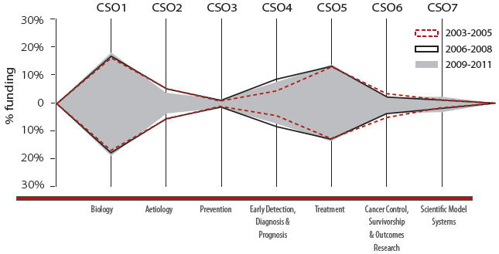

| Triennium | Biology | Aetiology | Prevention | Early Detection, Diagnosis & Prognosis | Treatment | Cancer Control, Survivorship & Outcomes Research | Scientific Model Systems |
| --- | --- | --- | --- | --- | --- | --- | --- |
| 2003-2005 | 32% | 15% | 3% | 10% | 23% | 7% | 3% |
| 2006-2008 | 34% | 15% | 3% | 18% | 22% | 5% | 4% |
| 2009-2011 | 37% | 11% | 3% | 15% | 24% | 4% | 6% |

**B. Proportional distribution of funding from other sources (non-NHMRC)**

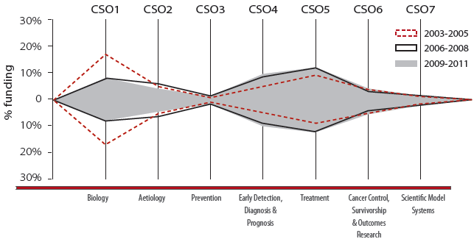

| Triennium | Biology | Aetiology | Prevention | Early Detection, Diagnosis & Prognosis | Treatment | Cancer Control, Survivorship & Outcomes Research | Scientific Model Systems |
| --- | --- | --- | --- | --- | --- | --- | --- |
| 2003-2005 | 45% | 12% | 3% | 12% | 21% | 10% | 2% |
| 2006-2008 | 17% | 14% | 3% | 24% | 30% | 9% | 3% |
| 2009-2011 | 17% | 9% | 2% | 28% | 29% | 13% | 2% |

### 6.4 Discussion

From 2003-2005 to 2009-2011, a clear shift in proportional funding was observed away from research that was not specific to any tumour stream towards research that was specific to one or multiple tumour streams. These observed shifts in direct and proportional funding towards single and multiple tumour stream-specific research shown in Figure 6.1 and Table 6.1 may be due to several factors. For example, an increase in direct and proportional funding to cancer research projects and research programs was observed for Cancer foundations (see Chapter 4) and this funding sector included many tumour-specific funders.

From 2003-2005 to 2009-2011, direct funding to single and multiple tumour stream-specific research from NHMRC increased 3.7-fold and from other sources of funding increased 2.8-fold (see Table 6.3), indicating that the shift towards funding research that was tumour stream-specific was driven by both the NHMRC and other funding sources. This observation may in part reflect the changing pattern of funding described in Chapter 5, i.e. towards more applied research in the CSO categories of Treatment and Early Detection, Diagnosis and Prognosis, areas which would tend to be more tumour-specific. This explanation is supported by the finding in this Chapter (see Tables 6.3 and 6.4) that the combined direct funding to Treatment and Early Detection, Diagnosis and Prognosis in the period 2006 to 2011 was higher to tumour stream-specific research ($291 million) than to not tumour stream-specific research ($134 million). In the same period, direct funding to Biology was lower to tumour stream-specific research ($160 million) than to not tumour stream-specific research ($191 million).

#### Pattern of proportional funding to CSO categories

For research that was not tumour stream-specific, proportional funding to cancer research projects and research programs funded from NHMRC and other sources of funding both showed a proportional decrease in Biology and an increase in Treatment from the first to the last triennium. In addition, research funded by other sources of funding showed a proportional decrease in Prevention (although an important caveat to consider is that $7.5 million of funding went to a single clinical prevention trial that was not tumour-specific in 2003-2005) and an increase in Early Detection, Diagnosis and Prognosis. The observed proportional increases to the CSO categories of Treatment and Early Detection, Diagnosis and Prognosis, may reflect increased funding to applied research such as in discovering new drug targets in tumour angiogenesis (an area that is coded to the CSO sub-category of 5.3 (Systemic Therapies - Discovery and Development).

For research that was specific to single or multiple tumour streams, NHMRC funding remained relatively stable across the trienniums and did not exhibit any major pattern shifts. However, a proportional decrease in funding to Biology and a proportional increase in funding to Treatment and Early Detection, Diagnosis and Prognosis was observed for research funded from other sources. When considering this shift, it is important to remember the change in the pool of other funders of cancer research (i.e. there were 67 non-NHMRC funding sources in the audit of 2003 to 2005 and 133 in the audit of 2006 to 2011) and the two-fold increase in funding from Cancer foundations from 2006-2008 to 2009-2011 observed in Chapter 4. Thus, it is likely that an increase in funding from Cancer Foundations, combined with changing priorities for funding towards applied and patient-centred research are being reflected in the observed change in the pattern of funding towards the CSO categories of Treatment and Early Detection, Diagnosis and Prognosis from other sources of funding than the NHMRC.

## Chapter 7 - Funding to research in tumour streams

**KEY FINDINGS**

* In the period 2006 to 2011:
* 2,006m cancer research projects and research programs focused on a single tumour stream
* 93 cancer research projects and research programs focused on multiple tumour streams
* 40% of these multiple tumour stream cancer research projects and research programs included a focus on breast cancer research
* From 2003-2005 to 2009-2011:
* Direct funding and number of cancer research projects and research programs increased for each tumour stream except cancer of unknown primary (CUP)
* Direct funding to breast cancer research increased 2.6-fold, however proportional funding decreased by 6%
* Direct funding to lung cancer research increased 6.5-fold and proportional funding increased by 3%
* Direct funding to upper gastrointestinal cancers increased 4.3-fold and proportional funding increased by 2%

### 7.1 Single tumour stream focus

In the period 2006 to 2011, there were 2,006[13] directly funded cancer research projects and research programs which focused on a single tumour stream. (A tumour stream comprises a collective group of cancer types. The tumour streams used in this audit are listed in Appendix E). The specific tumour stream focus for each cancer research project and research program was recorded for each of the trienniums 2006-2008 and 2009-2011, and compared with data for 2003-2005.

Table 7.1 details the direct funding to each tumour stream, and provides the number of cancer research projects and research programs funded in each stream in each of the trienniums 2003-2005, 2006-2008 and 2009-2011. Figure 7.1 shows the proportional distribution of funding to cancer research projects and research programs in each tumour stream in the three trienniums.

Direct funding increased from one triennium to the next for all tumour streams except cancer of unknown primary (CUP). The number of funded cancer research projects and research programs increased from the first to the last triennium for all tumour streams, except for cancer of unknown primary (CUP).

The largest change in proportional funding was to breast cancer research, which as a percentage of the direct funding to single tumour stream research, decreased by 6% from 2003-2005 to 2009-2011.

In summary, the proportional change in funding to cancer research projects and research programs which focused on a single tumour stream was as follows:

* The proportional funding to breast cancer decreased from 30% (2003-2005) to 27% (2006-2008) and then to 24% (2009-2011);
* The proportional funding to haematological cancers was similar across the trienniums at 17% (2003-2005) and 16% (2006-2008 and 2009-2011);
* The proportional funding to colorectal cancer was steady at approximately 12% (2003-2005 and 2006-2008) and then increased to 14% (2009-2011);
* The proportional funding to genitourinary cancers was similar across the trienniums at 13% (2003-2005), 12% (2006-2008) and 13% (2009-2011);
* The proportional funding to skin cancers was similar across the trienniums at 10% (2003-2005), 12% (2006-2008) and 10% (2009-2011);
* The proportional funding to upper gastrointestinal cancers increased across the trienniums from 5% (2003-2005) to 6% (2006-2008) and then to 7% (2009-2011);
* The proportional funding to gynaecological cancers was similar across the trienniums at 5% (2003-2005) and 6% (2006-2008 and 2009-2011);
* The proportional funding to lung cancers increased across the trienniums from 2% (2003-2005) to 4% (2006-2008) and then to 5% (2009-2011);
* The proportional funding to central nervous system cancers increased across the trienniums from 3% (2003-2005) to 4% (2006-2008) and then to 5% (2009-2011);
* The proportional funding to head and neck cancers decreased from 2% to (2003-2005) to approximately 1% (2006-2008 and 2009-2011);
* The proportional funding to musculo-skeletal cancers remained at approximately 1% in each triennium; and
* The proportional funding to cancer of unknown primary (CUP) remained at less than 1% in each triennium.

Table 7.1: Direct funding to and number of single tumour stream research projects and research programs in 2003-2005, 2006-2008 and 2009-2011

| Tumour stream | 2003-2005 | 2006-2008 | 2009-2011 |
| --- | --- | --- | --- |
| Breast cancer | $33.4 M | $57.4 M | $85.9 M |
| Breast cancer projects/programs | 167 | 309 | 317 |
| Haematological cancers | $18.5 M | $33.6 M | $55.4 M |
| Haematological cancers projects/programs | 112 | 126 | 218 |
| Colorectal cancer | $13.6 M | $27.0 M | $47.8 M |
| Colorectal cancer projects/programs | 76 | 82 | 125 |
| Genitourinary cancers | $13.9 M | $26.7 M | $44.4 M |
| Genitourinary cancers projects/programs | 87 | 131 | 209 |
| Skin cancers | $11.1 M | $25.6 M | $33.5 M |
| Skin cancers projects/programs | 59 | 88 | 120 |
| Upper gastrointestinal cancers | $5.6 M | $12.1 M | $24.1 M |
| Upper gastrointestinal cancers projects/programs | 36 | 73 | 103 |
| Gynaecological cancers | $5.2 M | $13.5 M | $19.3 M |
| Gynaecological cancers projects/programs | 38 | 60 | 75 |
| Lung cancers | $2.5 M | $7.8 M | $16.3 M |
| Lung cancers projects/programs | 22 | 48 | 78 |
| Central nervous system cancers | $3.5 M | $8.8 M | $16.0 M |
| Central nervous system cancers projects/programs | 21 | 38 | 77 |
| Head and neck cancers | $2.2 M | $2.8 M | $3.8 M |
| Head and neck cancers projects/programs | 21 | 17 | 23 |
| Musculo-skeletal cancers | $0.9 M | $1.2 M | $4.6 M |
| Musculo-skeletal cancers projects/programs | 10 | 9 | 16 |
| Cancer of unknown primary (CUP) | $0.1 M | No identified funding | $0.1 M |
| Cancer of unknown primary (CUP) projects/programs | 1 | – | 1 |

*N.B. Some projects/programs overlap trienniums, thus the total number of projects/programs from 2003 to 2011 does not equal the sum of projects/programs for 2003-2005, 2006-2008 and 2009-2011.*

Figure 7.1: Proportional funding to single tumour stream cancer research projects and research programs in 2003-2005, 2006-2008 and 2009-2011

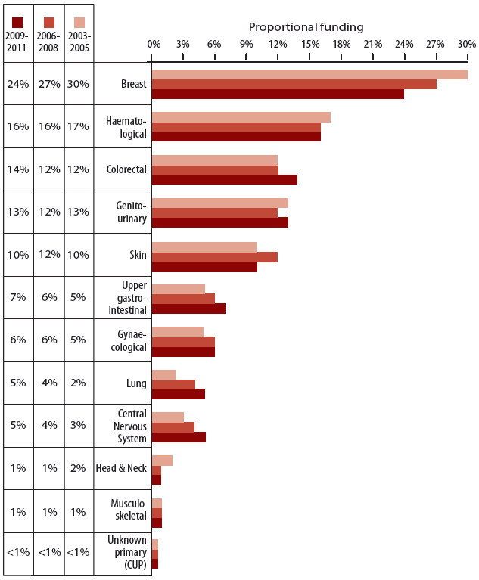

### 7.2 Multiple tumour stream focus

In the period 2006 to 2011, there were 93[14] cancer research projects and research programs which focused on multiple tumour streams (multiple stream research projects and research programs). For these research projects and research programs, both the primary tumour stream of focus and the secondary and (if applicable) tertiary tumour streams foci were determined from the research abstract or summary and key words. Where a hierarchy of tumour streams for a particular cancer research project or research program was not apparent, tumour streams were recorded in the order that they were listed in the abstract or summary and key words (i.e. the first named tumour stream was deemed to be the primary tumour stream).

Figure 7.2 shows the stratification of multiple tumour stream cancer research projects and research programs in each combination of primary tumour stream, and secondary and tertiary tumour streams.

Of the 93n cancer research projects and research programs in the period 2006 to 2011 that focused on multiple tumour streams, one-third (31) had breast cancer as the primary tumour stream and approximately half of these (16) also involved genitourinary cancers as the secondary or tertiary tumour stream. In total, 37 (40%) multiple tumour stream research projects and research programs included a focus on breast cancer research. A summary of the most common multiple tumour stream combinations for each primary tumour stream is provided below:

* Breast cancer was the primary tumour stream in 31 multiple tumour stream cancer research projects or research programs, of which:
* 16 also focused on genitourinary cancers as a secondary or tertiary stream;
* 10 also focused on gynaecological cancers as a secondary or tertiary stream; and
* 7 also focused on colorectal cancer as a secondary or tertiary stream.
* Genitourinary cancers was the primary tumour stream in 13 multiple tumour stream cancer research projects or research programs, of which:
* 9 also focused on gynaecological cancers as a secondary or tertiary stream.
* Gynaecological cancers was the primary tumour stream in 8 multiple tumour stream cancer research projects or research programs, of which:
* 3 also focused on colorectal cancer as a secondary or tertiary stream; and
* 3 also focused on genitourinary cancers as a secondary or tertiary stream.
* Central nervous system cancers was the primary tumour stream in 8 multiple tumour stream cancer research projects or research programs, of which:
* 6 also focused on colorectal cancer as a secondary or tertiary stream; and
* 3 also focused on head and neck cancers as a secondary or tertiary stream.
* Colorectal cancers was the primary tumour stream in 8 multiple tumour stream cancer research projects or research programs, of which:
* 5 also focused on upper gastrointestinal cancers as a secondary or tertiary stream.
* Upper gastrointestinal cancers was the primary tumour stream in 8 multiple tumour stream cancer research projects or research programs, of which:
* 3 also focused on colorectal cancer as a secondary or tertiary stream; and
* 3 also focused on genitourinary cancers as a secondary or tertiary stream.
* Haematological cancers was the primary tumour stream in 6 multiple tumour stream cancer research projects or research programs, of which:
* 3 also focused on central nervous system cancers as a secondary or tertiary stream.
* Lung cancer was the primary stream in 5 multiple tumour stream cancer research projects or research programs, of which:
* 2 also focused on breast cancer as a secondary or tertiary stream.
* Skin cancers was the primary stream in 5 multiple tumour stream cancer research projects or research programs, of which:
* 2 also focused on central nervous system cancers as a secondary or tertiary stream; and
* 2 also focused on head and neck cancers as a secondary or tertiary stream.

Figure 7.2: Tumour stream combinations in multiple tumour stream research projects and research programs in the period 2006 to 2011

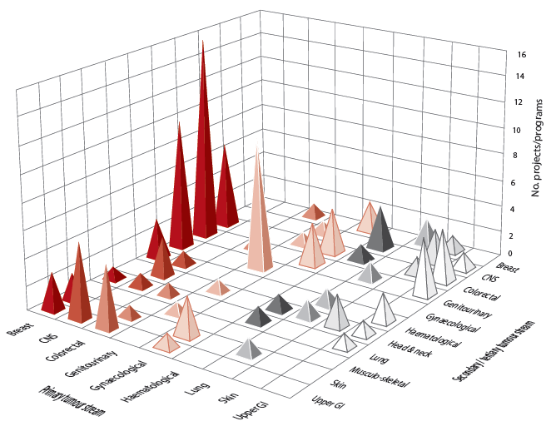

### 7.3 Discussion

From 2003-2005 to 2009-2011, the identified direct funding to single tumour stream research projects and research programs increased for all tumour streams except cancer of unknown primary (CUP).

Proportional funding to specific tumour streams changed across the trienniums, with a 6% decrease in proportional funding to breast cancer research projects and research programs from 2003-2005 to 2009-2011 contrasting with a 3% increase to lung cancer and a 2% increase to upper gastrointestinal cancer research projects and research programs. These relative changes in proportional funding occurred as direct funding to breast cancer research projects and research programs increased 2.6-fold from 2003-2005 to 2009-2011, whilst direct funding to lung and upper gastrointestinal cancer research projects and research programs increased 6.5-fold and 4.3-fold respectively over the same period. These differences were largely driven by the impact of a reduction in international funding to breast cancer research in Australia, as well as asbestos disease-related initiatives providing increased funding to lung cancer and mesothelioma research, and a large NHMRC program grant and significant Cancer Council research project grant funding to upper gastrointestinal cancers.

Direct funding to cancer research projects and research programs which focused on multiple tumour streams increased more than three-fold from 2003-2005 to 2009-2011 (see Chapter 6) and analysis of the combinations of tumour streams investigated from 2006 to 2011 revealed that the tumour streams most commonly researched together (i.e. breast cancer, gynaecological cancers and genitourinary cancers) were cancers for which common gene mutations have recently been identified. For example, having the genes BRCA1 and BRCA2 in mutated form increases a person's risk of developing breast, ovarian or prostate cancer.20 Indeed, the focus on these combinations of tumour streams suggests a growing recognition of the importance of the specific molecular make-up of cancers, over the traditional approach of studying cancers of a single tumour stream or site. More broadly, there is an increasing research focus on genetic and epigenetic factors which are common across different tumour types, and opportunities exist for research funding to be directed to research which extends across tumour types.

## Chapter 8 - Funding to research in single tumour types

**KEY FINDINGS**

* In the period 2006 to 2011:
* 1,892 cancer research projects and research programs focused on a single tumour type
* 17% of the direct funding to the 21 tumour types analysed was provided by tumour-specific funders
* From 2003-2005 to 2009-2011:
* Direct funding and the number of cancer research projects and research programs funded increased to 19 of the 21 tumour types analysed. The exceptions were:
* Thyroid cancer
* Cancer of unknown primary (CUP)

### 8.1 Funding to tumour types

Cancer research projects and research programs from 2006 to 2011 which focused on a single tumour stream were further analysed to identify the specific tumour type on which the research focused.[15] Due to the large number of tumour types (see Appendix E), only the top 20 funded tumour types from 2003-2005 were analysed in this section, as well as cancer of unknown primary (CUP).

In the period 2006 to 2011, 61% of all cancer research projects and research programs (1,892[16]) focused on a single tumour type. Table 8.1 details the direct funding to 21 tumour types and provides the number of cancer research projects and research programs funded for each tumour type in each of the trienniums 2003-2005, 2006-2008 and 2009-2011. Figure 8.1 shows the proportional distribution of funding to each tumour type in the three trienniums.

From the first (2003-2005) to last (2009-2011) trienniums, the direct funding increased to 19 of the 21 tumour types. However, funding to thyroid cancer decreased over this period while funding to cancer of unknown primary (CUP) remained unchanged. In addition, all tumour types except for thyroid cancer and cancer of unknown primary (CUP) showed an increase in the number of cancer research projects and research programs funded from the first to the last triennium.

The largest change in proportional funding was in breast cancer research which, as a percentage of the direct funding to single tumour type research, decreased by 6% from 2003-2005 to 2009-2011. In summary, the proportional funding to cancer research projects or research programs which focused on a single tumour type was as follows:

* The proportional funding to breast cancer decreased across the trienniums from 32% (2003-2005) to 28% (2006-2008) and then to 26% (2009-2011);
* The proportional funding to colon and rectum cancer was similar across the trienniums at 13% (2003-2005 and 2006-2008) and 14% (2009-2011);
* The proportional funding to leukaemia fluctuated from 15% (2003-2005) to 10% (2006-2008) and then to 12% (2009-2011);
* The proportional funding to melanoma was similar across the trienniums at 8% (2003-2005), 9% (2006-2008) and 7% (2009-2011);
* The proportional funding to lung cancer (including mesothelioma) progressively increased across the trienniums from 2% (2003-2005) to 4% (2006-2008) and then to 5% (2009-2011);
* The proportional funding to cancers of the ovary, brain, liver, stomach, oesophagus, pancreas, skin (not melanoma), neuroblastoma, cervix, endometrium, myeloma, bone, lymphoma, thyroid and cancer of unknown primary (CUP) were each at 4% or less.

Table 8.1: Direct funding to and number of single tumour type research projects and research programs in 2003-2005, 2006-2008 and 2009-2011

| Tumour type | 2003-2005 | 2006-2008 | 2009-2011 |
| --- | --- | --- | --- |
| Breast | $33.4 M | $57.4 M | $85.9 M |
| Breast projects/programs | 167 | 309 | 317 |
| Colon and rectum | $13.6 M | $26.7 M | $47.2 M |
| Colon and rectum projects/programs | 76 | 79 | 120 |
| Leukaemia | $15.3 M | $20.8 M | $39.7 M |
| Leukaemia projects/programs | 81 | 78 | 141 |
| Prostate | $13.2 M | $25.8 M | $41.6 M |
| Prostate projects/programs | 82 | 122 | 195 |
| Melanoma | $8.5 M | $19.1 M | $24.6 M |
| Melanoma projects/programs | 40 | 55 | 89 |
| Lung and mesothelioma | $2.5 M | $7.8 M | $16.3 M |
| Lung and mesothelioma projects/programs | 22 | 48 | 78 |
| Ovary | $2.2 M | $7.2 M | $11.7 M |
| Ovary projects/programs | 20 | 31 | 42 |
| Brain | $1.5 M | $4.9 M | $11.3 M |
| Brain projects/programs | 10 | 32 | 61 |
| Liver | $1.1 M | $2.5 M | $7.2 M |
| Liver projects/programs | 10 | 15 | 29 |
| Stomach | $1.5 M | $3.9 M | $5.6 M |
| Stomach projects/programs | 8 | 17 | 26 |
| Oesophagus | $1.7 M | $3.1 M | $5.3 M |
| Oesophagus projects/programs | 5 | 16 | 23 |
| Pancreas | $0.8 M | $1.9 M | $5.3 M |
| Pancreas projects/programs | 7 | 19 | 22 |
| Skin (not melanoma) | $1.3 M | $2.7 M | $4.8 M |
| Skin (not melanoma) projects/programs | 13 | 9 | 15 |
| Neuroblastoma | $1.9 M | $3.9 M | $4.7 M |
| Neuroblastoma projects/programs | 10 | 6 | 16 |
| Cervix | $2.1 M | $2.5 M | $2.7 M |
| Cervix projects/programs | 12 | 13 | 14 |
| Endometrium | $0.8 M | $3.0 M | $3.0 M |
| Endometrium projects/programs | 3 | 12 | 8 |
| Myeloma | $1.3 M | $3.2 M | $3.0 M |
| Myeloma projects/programs | 12 | 9 | 17 |
| Lymphoma* | $0.7 M | $2.9 M | $3.4 M |
| Lymphoma* projects/programs | 11 | 17 | 20 |
| Bone | $0.7 M | $0.6 M | $2.7 M |
| Bone projects/programs | 8 | 5 | 12 |
| Thyroid | $0.9 M | $0.6 M | $0.5 M |
| Thyroid projects/programs | 6 | 4 | 5 |
| Cancer of unknown primary (CUP) | $0.1 M | No identified spend | $0.1 M |
| Cancer of unknown primary (CUP) projects/programs | 1 | – | 1 |

*N.B. Some projects/programs overlap trienniums, thus the total number of projects/programs from 2003 to 2011 does not equal the sum of projects/programs for 2003-2005, 2006-2008 and 2009-2011.*

*\*Lymphoma represents the sum of funding to cancer research projects or research programs which focused on either Hodgkin's disease or non-Hodgkin lymphoma or both.*

Figure 8.1: Proportional funding to single tumour type cancer research projects and research programs in 2003-2005, 2006-2008 and 2009-2011

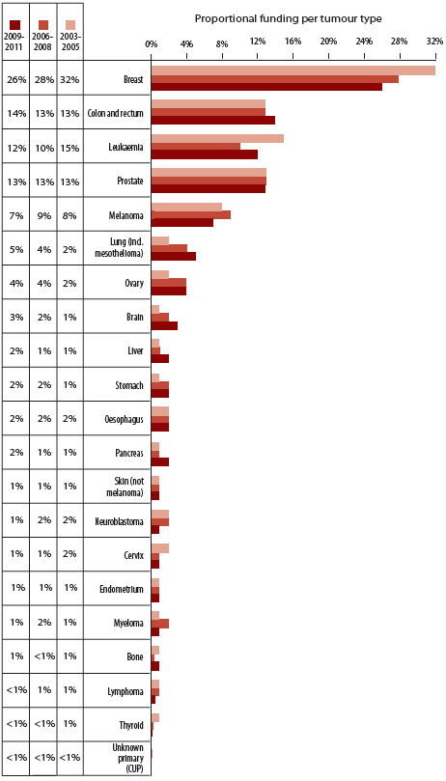

### 8.2 Direct funding to cancer research from organisations that fund specific tumour types

Many non-government and community-based organisations raise funds for research in specific tumour types (for example, the National Breast Cancer Foundation and the Prostate Cancer Foundation of Australia). In the period 2006 to 2011, 16 organisations that only fund specific tumour types were identified in this audit.

Figure 8.2 shows the proportional contribution of direct funding from organisations to the cancer research projects and research programs in each of the 21 tumour types analysed. In the period 2006 to 2011, 17% of the direct funding to the 21 tumour types analysed was provided by tumour-specific funders. Direct funding from these tumour type-specific funders accounted for nearly half of all direct funding to breast cancer research projects and research programs.

In summary, the proportion of direct funding from organisations that fund specific tumour types was as follows:

* The proportion of funding to breast cancer research projects and research programs was 46%;
* The proportion of funding to prostate cancer research projects and research programs was 24%;
* The proportion of funding to ovarian cancer research projects and research programs was 9%;
* The proportion of funding to brain cancer research projects and research programs was 9%;
* The proportion of funding to leukaemia research projects and research programs was 8%;
* The proportion of funding to lung cancer and mesothelioma research projects and research programs was 3%;
* The proportion of funding to myeloma research projects and research programs was 3%; and
* The proportion of funding to colon and rectum cancer, melanoma, cancers of the liver and stomach, neuroblastoma, oesophagus, skin (not melanoma), pancreas, lymphoma, endometrium, cervix, bone, thyroid and cancer of unknown primary (CUP) was 0.3% or less to each.

Figure 8.2: Direct and proportional funding contribution by tumour type-specific funders and non tumour type-specific funders to direct funding to tumour type-specific cancer research projects and research programs in the period 2006 to 2011

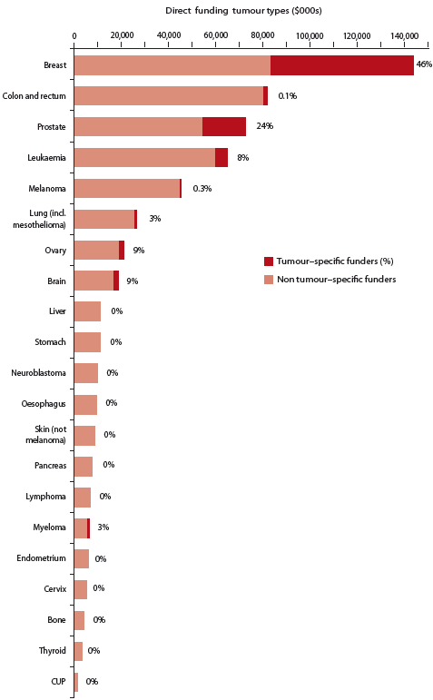

### 8.3 Direct funding to tumour type research compared to measures of disease impact and burden

The direct funding to 1,892 cancer research projects and research programs which focused on a specific tumour type was compared to different measures of disease impact and burden for these tumour types. These measures included incidence, mortality, disability adjusted life years (DALYs) and change in 5-year relative survival.

#### Incidence

Figure 8.3 shows the direct funding to single tumour types (2006 to 2011) for the top 20 cancers by incidence in 2009.1 Relative to incidence, there were proportionally lower levels of funding to prostate cancer, colon and rectum cancer, melanoma, lung cancer and mesothelioma, lymphoma, cancer of unknown primary (CUP), kidney, pancreas, bladder, uterus, thyroid, stomach and lip cancers.

Figure 8.3: Direct funding to tumour type-specific cancer research projects and research programs in Australia 2006 to 2011, compared with the top 20 cancers by incidence in Australia, 2009

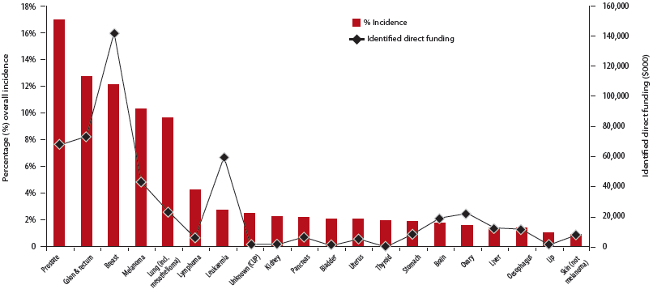

*Notes:*

*1. The AIHW lung and mesothelioma data for incidence has been summed to allow comparison with our collection of direct funding to lung cancer and mesothelioma.*

*2. Leukaemia incidence data has been obtained by summing AIHW data for cancer types C91-C95,*

*3. Lymphoma incidence has been obtained by summing AIHW data for cancer sites C81-C85 & C96.*

*4. Direct funding to lymphoma represents the summed direct funding to the tumour types Hodgkin's disease and non-Hodgkin's lymphoma.*

*5. Direct funding to endometrial cancer is allocated to cancer of the uterus for consistency with AIHW data.*

#### Mortality

Figure 8.4 shows the direct funding to single tumour types (2006 to 2011) for the top 20 cancers by mortality in 2010.1 Relative to mortality, there were proportionally lower levels of funding to lung cancer and mesothelioma and cancer of the pancreas, cancer of unknown primary (CUP), lymphoma, other digestive organs, liver, brain, oesophagus, stomach, bladder, kidney and myeloma.

Figure 8.4: Direct funding to tumour type-specific cancer research projects and research programs in Australia 2006 to 2011, compared with the top 20 cancers by mortality in Australia, 2010

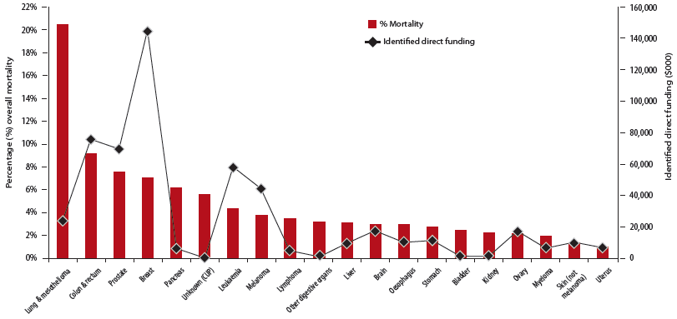

*Notes:*

*1. The AIHW lung and mesothelioma data for mortality has been summed to allow for comparability with our collection of direct funding to lung cancer and mesothelioma.*

*2. Leukaemia mortality data has been obtained by summing AIHW data for cancer sites C91-C95.*

*3. Lymphoma incidence has been obtained by summing AIHW data for cancer sites C81-C85 & C96.*

*4. Direct funding to lymphoma represents the summed direct funding to the tumour types Hodgkin's disease and non-Hodgkin's lymphoma.*

*5. Direct funding to endometrial cancer is allocated to cancer of the uterus for consistency with AIHW data.*

#### Disability-adjusted life years

Figure 8.5 shows the direct funding to single tumour types (2006 to 2011) for the top 20 cancers by Disability-adjusted life years lost (DALYs).1 DALYs represent the summed estimated years of life lost due to premature death (YLL) and years of healthy life lost to disability (YLD). When direct funding was compared to each tumour type's burden of disease, funding for lung cancer, colon and rectum cancer, lymphoma and cancers of the pancreas, brain, oesophagus, mouth and oropharynx, kidney, stomach, bladder, myeloma, and bone and connective tissue was proportionally lower relative to the burden of disease caused by these cancers.

Figure 8.5: Direct funding to single tumour type-specific cancer research projects and research programs in Australia 2006 to 2011, compared with the top 20 cancers by DALYs in Australia, 2012

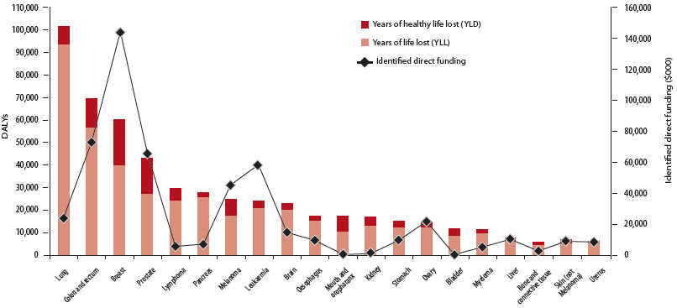

*Notes:*

*1. AIHW mesothelioma data is not available for DALYs. As such DALYs are only presented for lung cancer.*

*2. In Cancer Australia's audit, mouth and oropharynx tumour site funding is obtained by summing the direct spend for oral cavity and lip and pharyngeal tumour types.*

*3. Statistics on the burden of disease for persons diagnosed with cancer of unknown primary (CUP) in Australia are not available.*

*4. Direct funding to lymphoma represents the summed direct funding to the tumour types Hodgkin's disease and non-Hodgkin's lymphoma.*

*5. Direct funding to endometrial cancer is allocated to cancer of the uterus for consistency with AIHW data.*

#### Improvement in relative survival

Figure 8.6 shows the direct funding to single tumour types (2006 to 2011) compared with the improvement in 5-year relative survival from 1982-1987 to 2006-2010 for selected cancers.4 The 5-year relative survival for 2006-2010 is also shown for each cancer; this statistic is a measure of the probability of a patient with this cancer surviving for at least five years after diagnosis, compared with the general population. A notable improvement in 5-year relative survival has been observed for prostate cancer, kidney cancer, colon and rectum cancer, breast cancer, myeloma and non-Hodgkin lymphoma. Of these breast cancer, colon and rectum cancer and prostate cancer have received the highest levels of direct funding to cancer research projects and research programs in the period 2006 to 2011.

Figure 8.6: Direct funding to single tumour type-specific cancer research projects and research programs in Australia (2006-2011), compared with the improvement in 5-year relative survival since 1982-1987 and the overall 5-year relative survival (2006-2010) for selected cancers

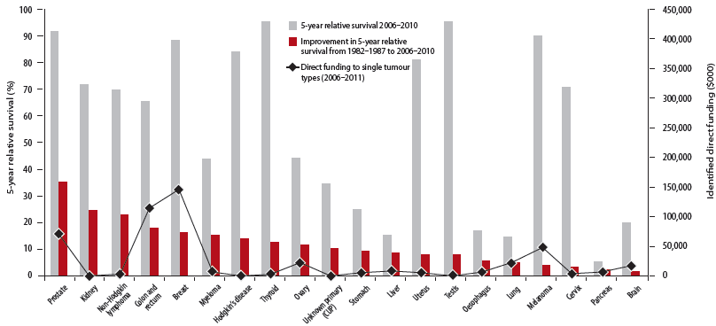

*Notes:*

*1. For consistency with the AIHW 5-year relative survival data, the change in 5-year relative survival for non-Hodgkin lymphoma is presented here rather than non-Hodgkin lymphoma and Hodgkin's disease combined. Direct funding to non-Hodgkin lymphoma is shown here rather than the combined direct funding for non-Hodgkin lymphoma and Hodgkin's disease.*

*2. Direct funding to endometrial cancer is allocated to cancer of the uterus for consistency with AIHW data.*

*3. Change in 5-year relative survival for liver cancer was calculated from 1988-1993 to 2006-2010, as no data is available for 1982-1987.*

*4. Leukaemia was not included in this analysis as survival data is only available for some individual leukaemias.*

### 8.4 Discussion

The direct funding to single tumour type cancer research projects and research programs was analysed for 21 tumour types. Each tumour type, except thyroid cancer and cancer of unknown primary (CUP), received an increase in direct funding from 2003-2005 to 2009-2011, and only thyroid cancer had fewer funded research projects or research programs in 2009-2011 than in 2003-2005.

Reasons for the changes in proportional funding to breast cancer and lung cancer (including mesothelioma) have been previously discussed (see discussion in Chapter 7). Across the trienniums, proportional funding to leukaemia fluctuated markedly, from 15% (2003-2005) to 10% (2006-2008) to 12% (2009-2011), despite total direct funding increasing in each triennium. It should be noted however that approximately $8.7 million (or 9% of total direct funding in the period 2006 to 2011) was provided to general haematological cancer research projects and research programs (i.e. a specific haematological tumour type was not given for the research projects and research programs). Taken together, the total funding to haematological cancers remained stable over the three trienniums.

Research into some tumour types benefited from non-government and community organisations which funded tumour type-specific research. Across the 21 tumour types analysed, tumour-specific funders provided 17% of direct funding, and cancers of the breast, prostate, ovary, brain and leukaemia each received 46%, 24%, 9%, 9% and 8%, respectively of proportional funding in the period 2006 to 2011 from such funding organisations.

#### Impact and burden of disease

The level of direct funding to cancer research projects and research programs which focused on specific tumour types was further analysed by comparing the direct funding to selected tumour types against incidence, mortality and DALYs for the Australian population.

The indicators of incidence, mortality and DALYs each represent different measurements of the burden of disease. Cancers which received proportionally lower levels of funding when compared to at least two of these measures of burden were lung cancer and mesothelioma, colon and rectum cancer, lymphoma, cancers of the pancreas, brain, oesophagus, kidney, stomach and bladder, myeloma and cancer of unknown primary (CUP). That some tumour types received lower levels of direct funding despite their observed burden of disease may reflect a small research workforce for these tumours. Low incidence cancers and cancers with a relatively small research workforce may benefit from an international collaborative research approach to ensure that improvements in outcomes can be realised for these tumour types.

The level of funding to cancer research projects and research programs was also compared to the improvement in relative survival observed from 1982-1987 to 2006-2010, for selected tumour types. Some cancers that have seen an improvement in 5-year relative survival rates from 1982-1987 to 2006-2010 of greater than 10% were observed to receive proportionally higher levels of direct funding in the period 2006 to 2011, specifically: prostate cancer, colon and rectum cancer, breast and ovarian cancer. Other cancer types experienced improvements in 5-year relative survival of greater than 10% without similar levels of direct funding e.g. kidney cancer, non-Hodgkin lymphoma, myeloma and thyroid cancer. Due to a lack of available data on relative survival for some types of leukaemia, this analysis could not be performed for all leukaemias combined.

Nonetheless, there appears to be some relationship between levels of direct research investment and improvements in 5-year relative survival. This was noted for some cancers which receive larger amounts of direct funding to research projects and research programs and have shown greater improvements in 5-year relative survival.

Research funding investment could be prioritised for cancers which have a high impact and burden of disease to deliver improvements in cancer care and outcomes.

## Chapter 9 - Pattern of funding to specific tumour types

**KEY FINDINGS**

* From 2003-2005 to 2009-2011:
* The pattern of proportional funding across the CSO categories for breast and prostate cancer was similar to the overall pattern for all cancer research projects and research programs
* The pattern of proportional funding across the CSO categories varied for different tumour types and reflects the predominant areas of research focus for individual tumours

For a selection of tumour types, the pattern of proportional funding by CSO category was examined.

In this chapter we have analysed the pattern of proportional funding across the CSO categories for the top five tumour types by total direct funding (2006 to 2011), as well as lung and gynaecological cancers which are a focus of Cancer Australia's program of work.

The changes in the pattern of proportional funding to these five tumour types and lung and gynaecological cancers, over the trienniums 2003-2005, 2006-2008 and 2009-2011, are presented below.

### 9.1 Breast cancer

The total funding to breast cancer research projects and research programs increased from $33.4 million (2003-2005) to $85.9 million (2009-2011). Figure 9.1 depicts the pattern of proportional funding for breast cancer research projects and research programs in the trienniums 2003-2005, 2006-2008 and 2009-2011, classified by main CSO category. In 2003-2005, Biology received half (51%) of all funding but by 2009-2011, funding to this category had reduced to 27%. The pattern of funding to breast cancer research across the other CSOs also changed over the trienniums; the largest increases in proportional funding between 2003-2005 and 2009-2011 occurred in Early Detection, Diagnosis and Prognosis and Treatment, which both increased by 16%.

Figure 9.1: Breast cancer research projects and research programs: pattern of proportional funding to each CSO category in 2003-2005, 2006-2008 and 2009-2011

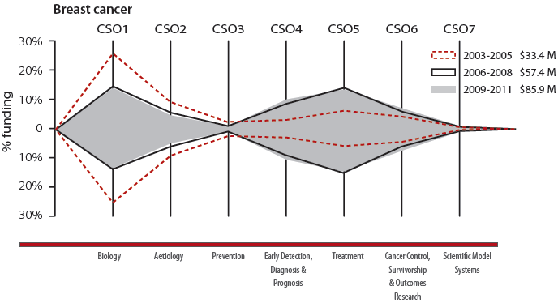

| Triennium | Biology | Aetiology | Prevention | Early Detection, Diagnosis & Prognosis | Treatment | Cancer Control, Survivorship & Outcomes Research | Scientific Model Systems |
| --- | --- | --- | --- | --- | --- | --- | --- |
| 2003-2005 | 51% | 18% | 5% | 6% | 11% | 7% | 1% |
| 2006-2008 | 29% | 10% | 2% | 19% | 28% | 11% | 1% |
| 2009-2011 | 27% | 7% | 3% | 22% | 27% | 13% | 1% |

### 9.2 Colon and rectum cancer

The total funding to colon and rectum cancer research projects and research programs increased from $13.6 million (2003-2005) to $47.2 million (2009-2011). Figure 9.2 depicts the pattern of proportional funding for colon and rectum cancer research projects and research programs in the trienniums 2003-2005, 2006-2008 and 2009-2011, classified by main CSO category. In 2003-2005, Biology and Treatment each received nearly a third (31% and 32%, respectively) of all direct funding. However, by 2009-2011 proportional funding to Biology had reduced by more than half to 15%. Proportional funding to Treatment remained virtually the same in the first and last trienniums whilst proportional funding to Aetiology and Early Detection, Diagnosis and Prognosis fluctuated but was 12% and 6% higher, respectively, in the last triennium than the first.

Figure 9.2: Colon and rectum cancer research projects and research programs: pattern of proportional funding to each CSO category in 2003-2005, 2006-2008 and 2009-2011

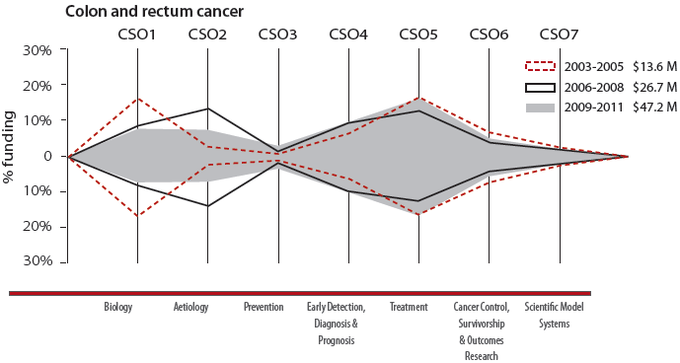

| Triennium | Biology | Aetiology | Prevention | Early Detection, Diagnosis & Prognosis | Treatment | Cancer Control, Survivorship & Outcomes Research | Scientific Model Systems |
| --- | --- | --- | --- | --- | --- | --- | --- |
| 2003-2005 | 31% | 4% | 1% | 12% | 32% | 15% | 5% |
| 2006-2008 | 16% | 28% | 3% | 20% | 23% | 7% | 4% |
| 2009-2011 | 15% | 16% | 6% | 18% | 32% | 11% | 2% |

### 9.3 Prostate cancer

The total funding to prostate cancer research projects and research programs increased from $13.2 million (2003-2005) to $41.6 million (2009-2011). Figure 9.3 depicts the pattern of proportional for prostate cancer research projects and research programs in the trienniums 2003-2005, 2006-2008 and 2009-2011, classified by main CSO category. In 2003-2005, Biology received 50% of all direct funding, decreasing to 25% by 2009-2011. Proportional funding to Early Detection, Diagnosis and Prognosis and Treatment both fluctuated across the trienniums, but were 5-6% higher in the last triennium than the first, and together in 2009-2011 accounted for over 50% of direct funding to cancer research projects and research programs.

Figure 9.3: Prostate cancer research projects and research programs: pattern of proportional funding to each CSO category in 2003-2005, 2006-2008 and 2009-2011

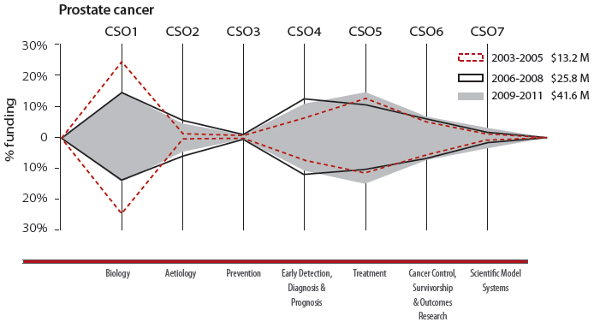

| Triennium | Biology | Aetiology | Prevention | Early Detection, Diagnosis & Prognosis | Treatment | Cancer Control, Survivorship & Outcomes Research | Scientific Model Systems |
| --- | --- | --- | --- | --- | --- | --- | --- |
| 2003-2005 | 50% | 0% | 1% | 15% | 25% | 9% | 0% |
| 2006-2008 | 28% | 10% | 2% | 24% | 22% | 12% | 2% |
| 2009-2011 | 25% | 7% | 1% | 21% | 30% | 11% | 5% |

### 9.4 Leukaemia

The total funding to leukaemia research projects and research programs increased from $15.3 million (2003-2005) to $39.7 million (2009-2011). Figure 9.4 depicts the pattern of proportional funding for leukaemia research projects and research programs in the trienniums 2003-2005, 2006-2008 and 2009-2011, classified by main CSO category. In 2003-2005, Biology received nearly half (44%) of all funding, increasing to nearly two-thirds (61%) by 2009-2011. Proportional funding to Treatment fluctuated across the trienniums but was 5% higher in the last triennium than the first and accounted for approximately one quarter of all funding to leukaemia research in 2009-2011.

Figure 9.4: Leukaemia research projects and research programs: pattern of proportional funding to each CSO category in 2003-2005, 2006-2008 and 2009-2011

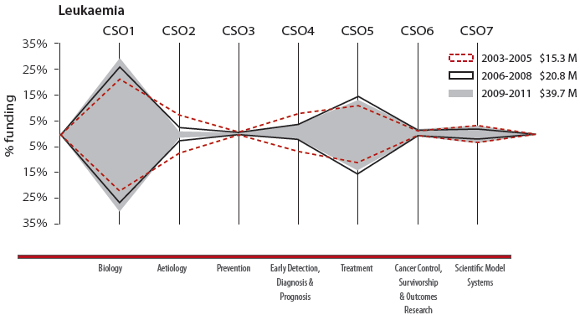

| Triennium | Biology | Aetiology | Prevention | Early Detection, Diagnosis & Prognosis | Treatment | Cancer Control, Survivorship & Outcomes Research | Scientific Model Systems |
| --- | --- | --- | --- | --- | --- | --- | --- |
| 2003-2005 | 44% | 14% | 1% | 14% | 21% | 1% | 6% |
| 2006-2008 | 57% | 5% | 0% | 4% | 30% | 1% | 3% |
| 2009-2011 | 61% | 1% | 0% | 5% | 26% | 1% | 6% |

### 9.5 Melanoma

The total funding to melanoma research projects and research programs increased from $8.5 million (2003-2005) to $24.6 million (2009-2011). Figure 9.5 depicts the pattern of proportional funding for melanoma research projects and research programs in the trienniums 2003-2005, 2006-2008 and 2009-2011, classified by main CSO category. In 2003-2005, Treatment received 39% of all funding, decreasing to 16% by 2009-2011. Proportional funding to Early Detection, Diagnosis and Prognosis increased markedly from 7% (2003-2005) to nearly half of all funding (47%) in 2006-2008 and 2009-2011. Biology increased from one-tenth (9-10%) to one-fifth (21%) from 2003-2005 and 2006-2008 to 2009-2011.

Figure 9.5: Melanoma research projects and research programs: pattern of proportional funding to each CSO category in 2003-2005, 2006-2008 and 2009-2011

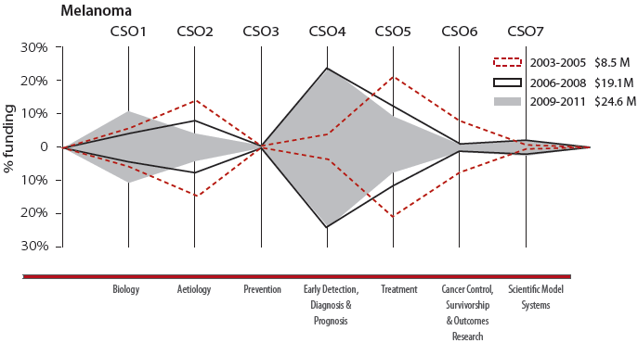

| Triennium | Biology | Aetiology | Prevention | Early Detection, Diagnosis & Prognosis | Treatment | Cancer Control, Survivorship & Outcomes Research | Scientific Model Systems |
| --- | --- | --- | --- | --- | --- | --- | --- |
| 2003-2005 | 10% | 28% | 2% | 7% | 39% | 13% | 1% |
| 2006-2008 | 9% | 14% | 0% | 47% | 24% | 2% | 4% |
| 2009-2011 | 21% | 7% | 2% | 47% | 16% | 1% | 4% |

### 9.6 Lung cancer and mesothelioma

The total funding to lung cancer and mesothelioma research projects and research programs increased from $2.5 million (2003-2005) to $16.3 million (2009-2011). Figure 9.6 depicts the pattern of proportional funding for lung cancer research projects and research programs in the trienniums 2003-2005, 2006-2008 and 2009-2011, classified by main CSO category. In 2003-2005, Early Detection, Diagnosis and Prognosis received nearly half of all funding (44%), reducing to one-third (33%) by 2009-2011. Proportional funding for Treatment almost doubled (15% to 28%) from the first to the last trienniums whilst Biology varied but was about one sixth (17%) of direct funding in the first and last trienniums.

Figure 9.6: Lung cancer and mesothelioma research projects and research programs: pattern of proportional funding to each CSO category in 2003-2005, 2006-2008 and 2009-2011

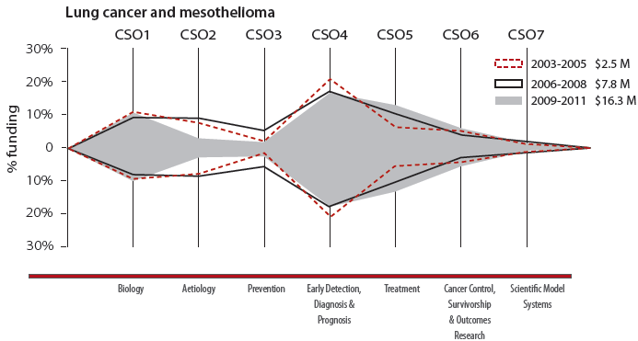

| Triennium | Biology | Aetiology | Prevention | Early Detection, Diagnosis & Prognosis | Treatment | Cancer Control, Survivorship & Outcomes Research | Scientific Model Systems |
| --- | --- | --- | --- | --- | --- | --- | --- |
| 2003-2005 | 17% | 12% | 2% | 44% | 15% | 10% | 0% |
| 2006-2008 | 13% | 15% | 8% | 34% | 24% | 6% | 1% |
| 2009-2011 | 17% | 4% | 4% | 33% | 28% | 9% | 4% |

### 9.7 Gynaecological cancers

The total funding to gynaecological cancer research projects and research programs increased from $5.2 million (2003-2005) to $19.3 million (2009-2011). Figure 9.7 depicts the pattern of proportional funding for gynaecological cancer research projects and research programs in the trienniums 2003-2005, 2006-2008 and 2009-2011, classified by main CSO category. In 2003-2005, Biology and Early Detection, Diagnosis and Prognosis together accounted for half (52%) of all direct funding. Fluctuations in proportional funding were observed over the subsequent trienniums, with the major overall changes being in proportional funding to Biology, which decreased from 31% (2003-2005) to 20% (2009-2011), Prevention which decreased from 8% (2003-2005) to 0% (2009-2011) and Scientific Model Systems which increased from 0% (2003-2005) to 5% (2009-2011).

Figure 9.7: Gynaecological cancer research projects and research programs: pattern of proportional funding to each CSO category in 2003-2005, 2006-2008 and 2009-2011

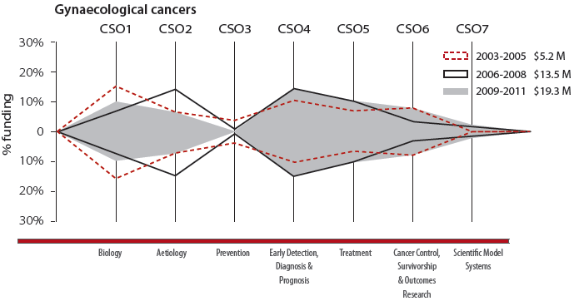

| Triennium | Biology | Aetiology | Prevention | Early Detection, Diagnosis & Prognosis | Treatment | Cancer Control, Survivorship & Outcomes Research | Scientific Model Systems |
| --- | --- | --- | --- | --- | --- | --- | --- |
| 2003-2005 | 31% | 13% | 8% | 21% | 13% | 15% | 0% |
| 2006-2008 | 16% | 28% | 1% | 27% | 19% | 7% | 3% |
| 2009-2011 | 20% | 14% | 0% | 27% | 18% | 15% | 5% |

#### Gynaecological tumour types

In the period 2006 to 2011, gynaecological cancers, as a single tumour stream, received direct funding of $32.8 million to 120 cancer research projects and research programs. The direct funding for the period 2006 to 2011 for the three major tumour types in this stream (when measured by incidence) were:

* Ovarian cancer, $18.9 million to 66 cancer research projects and research programs;
* Cervical cancer, $5.2 million to 22 cancer research projects and research programs; and
* Endometrial cancer, $6.0 million for 19 cancer research projects and research programs.

#### Ovarian cancer

The total funding to ovarian cancer research projects and research programs increased from $2.2 million (2003-2005) to $11.7 million (2009-2011). Figure 9.8 depicts the pattern of proportional funding for ovarian cancer research projects and research programs in the trienniums 2003-2005, 2006-2008 and 2009-2011, classified by main CSO category. In 2003-2005, Biology, Early Detection, Diagnosis and Prognosis and Cancer Control, Survivorship and Outcomes Research together accounted for nearly 90% of all direct funding. The pattern remained broadly similar for the two subsequent trienniums, except that Cancer Control, Survivorship and Outcomes Research decreased from 22% to 7%.

Figure 9.8: Ovarian cancer research projects and research programs: pattern of proportional funding to each CSO category in 2003-2005, 2006-2008 and 2009-2011

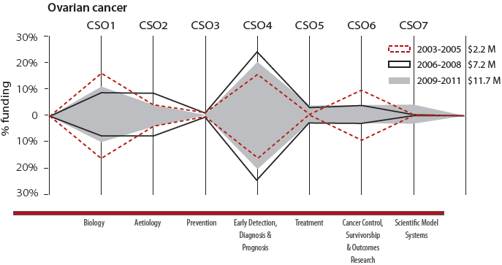

| Triennium | Biology | Aetiology | Prevention | Early Detection, Diagnosis & Prognosis | Treatment | Cancer Control, Survivorship & Outcomes Research | Scientific Model Systems |
| --- | --- | --- | --- | --- | --- | --- | --- |
| 2003-2005 | 33% | 9% | 3% | 33% | 0% | 22% | 0% |
| 2006-2008 | 18% | 16% | 2% | 49% | 7% | 8% | 0% |
| 2009-2011 | 23% | 10% | 0% | 43% | 9% | 7% | 8% |

#### Cervical cancer

The total funding to cervical cancer research projects and research programs increased from $2.1 million (2003-2005) to $2.7 million (2009-2011). Figure 9.9 depicts the pattern of proportional funding for cervical cancer research projects and research programs in the trienniums 2003-2005, 2006-2008 and 2009-2011, classified by main CSO category. From the first to the last triennium, proportional funding to Treatment decreased slightly from 33% to 28%. Proportional funding for Biology, Prevention and Early Detection, Diagnosis and Prognosis decreased to 0% in the last triennium.

Figure 9.9: Cervical cancer research projects and research programs: pattern of proportional funding to each CSO category in 2003-2005, 2006-2008 and 2009-2011

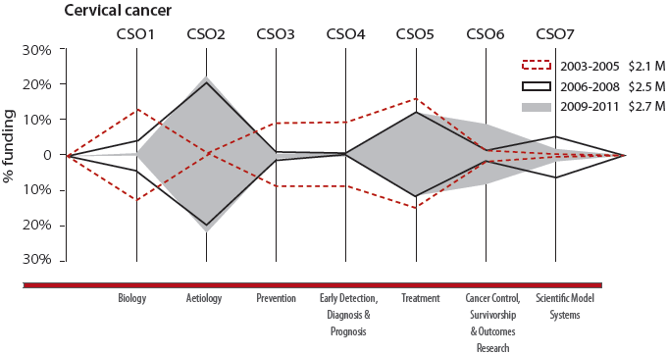

| Triennium | Biology | Aetiology | Prevention | Early Detection, Diagnosis & Prognosis | Treatment | Cancer Control, Survivorship & Outcomes Research | Scientific Model Systems |
| --- | --- | --- | --- | --- | --- | --- | --- |
| 2003-2005 | 28% | 0% | 17% | 18% | 33% | 5% | 0% |
| 2006-2008 | 10% | 42% | 2% | 0% | 28% | 4% | 15% |
| 2009-2011 | 0% | 46% | 0% | 0% | 28% | 23% | 4% |

#### Endometrial cancer

The total funding to endometrial cancer research projects and research programs increased from $0.8 million (2003-2005) to $3.0 million (2009-2011). Figure 9.10 depicts the pattern of proportional funding for endometrial cancer research projects and research programs in the trienniums 2003-2005, 2006-2008 and 2009-2011, classified by main CSO category. In 2003-2005, Biology and Aetiology accounted for all of the direct funding to endometrial cancer research projects and research programs. By 2009-2011, Aetiology had decreased to 0% whilst Cancer Control, Survivorship and Outcomes Research increased from 0% to 20%.

Figure 9.10: Endometrial cancer research projects and research programs: pattern of proportional funding to each CSO category in 2003-2005, 2006-2008 and 2009-2011

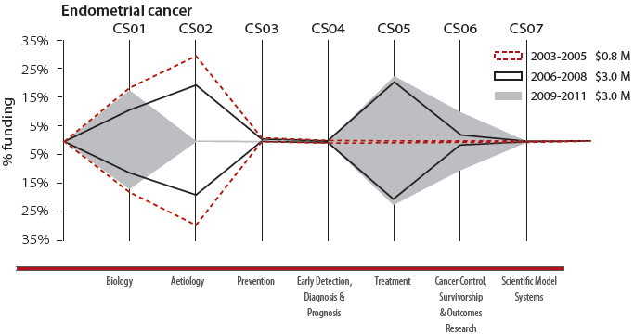

| Triennium | Biology | Aetiology | Prevention | Early Detection, Diagnosis & Prognosis | Treatment | Cancer Control, Survivorship & Outcomes Research | Scientific Model Systems |
| --- | --- | --- | --- | --- | --- | --- | --- |
| 2003-2005 | 37% | 63% | 0% | 0% | 0% | 0% | 0% |
| 2006-2008 | 21% | 37% | 0% | 0% | 40% | 2% | 0% |
| 2009-2011 | 35% | 0% | 0% | 0% | 45% | 20% | 0% |

### 9.8 Discussion

The pattern of proportional funding and changes in the pattern of proportional funding to CSO categories for breast and prostate cancer were similar to the overall national patterns observed in the trienniums 2003-2005, 2006-2008 and 2009-2011 (see Chapter 5). For breast and prostate cancer, the CSO categories receiving the highest proportional funding were Biology, Treatment and Early Detection, Diagnosis and Prognosis. By contrast, the pattern of proportional funding to CSO categories for colon and rectum cancer was somewhat different, with a large proportional increase in 2006-2008 in Aetiology research; driven largely by an international grant from the US National Institutes of Health (NIH). The pattern of proportional funding to CSO categories for lung cancer and mesothelioma also differed, with Early Detection, Diagnosis and Prognosis and Treatment together receiving the majority of proportional funding over the trienniums, indicating a different research focus for these cancers. Direct funding to leukaemia research showed an opposite trend, with proportional funding to Biology showing an increase across the trienniums. This can be attributed in part to a large program grant funded by the NHMRC.

These results demonstrate that the pattern of proportional funding to cancer research projects and research programs vary by tumour type and the pattern of proportional funding within each tumour type is also subject to change over the years. Caution, however, is advised when analysing the pattern of proportional funding to tumour types with a relatively small pool of funding, due to the influence that a single large grant can have on the overall pattern. This effect was particularly apparent when analysing individual gynaecological cancers compared to the pattern of proportional funding to gynaecological cancers as a whole. A more even spread of proportional funding is observed for gynaecological cancers as a whole compared to the individual tumour types of ovarian, cervical and endometrial cancers. In the case of ovarian cancer, the proportional funding to Early Detection, Diagnosis and Prognosis dominated the pattern of funding and varied between one-third and one-half of all funding across the trienniums. This observation may relate to targeted research initiatives in this area of ovarian cancer research.

## Chapter 10 - Cancer clinical trials - tumour type focus and health disciplines

**KEY FINDINGS**

* In the period 2006 to 2011:
* 240 cancer clinical trials were funded through cancer research projects and research programs, totalling $76 million
* The Australian Government was the primary funder of cancer clinical trials, providing approximately 74% of direct funding
* Through the PdCCRS, Cancer Australia and funding partners funded 16% of the clinical trials
* The ten most common tumour types investigated in clinical trials were:
* Breast
* Prostate
* Colon and rectum
* Ovary
* Lung cancer and mesothelioma
* Melanoma
* Leukaemia
* Endometrium
* Oesophagus
* Pancreas
* The most common health disciplines involved in clinical trials were:
* Medical oncology
* Radiation oncology
* Psycho-oncology
* Surgery
* Palliative care
* From 2003-2005 to 2009-2011:
* Funding to cancer clinical trials research increased from $23.3 million to $44.1 million; however, the proportional funding remained similar at 8-9%
* Funding to Phase 3 clinical trials increased almost 9-fold, from $1.9 million to $16.8 million

Cancer clinical trials that were funded through cancer research projects and research programs in the period 2006 to 2011 were identified and classified by tumour type and health discipline. The health disciplines used for classifying cancer clinical trials in the period 2006 to 2011 were: allied health, epidemiology, medical oncology, nursing, palliative care, primary care, psycho-oncology, radiation oncology and surgery. The definitions for each of these disciplines are provided in Appendix F.

### 10.1 Cancer clinical trials

In the period 2006 to 2011, 240 (8%) cancer research projects and research programs were clinical trials. These cancer clinical trials received direct funding of $76.0 million. The Australian Government was the primary funder, accounting for approximately 74% of the identified direct funding to cancer clinical trials. These figures do not include cancer clinical trials funded by the pharmaceutical industry.

In summary, the sources of funding for cancer clinical trials in Australia[17], the total funding provided, and the number of cancer clinical trials funded, were as follows:

* NHMRC - $36.7 million (48% of total funding), 74 clinical trials;
* Other Australian Government sources - $19.7 million (26% of total funding), 40 clinical trials;
* Cancer Councils - $6.0 million (8% of total funding), 58 clinical trials;
* International funders -$4.6 million (6% of total funding), 13 clinical trials;
* Medical research institutes, hospitals and foundations - $3.0 million (4% of total funding), 23 clinical trials;
* Cancer foundations - $3.0 million (4% of total funding), 18 clinical trials;
* State and territory governments -$3.0 million (4% of total funding), 11 clinical trials; and
* Universities - $0.2 million (<1% of total funding), 3 clinical trials.

Figure 10.1 shows the direct funding and number of cancer clinical trials in the trienniums 2006-2008 and 2009-2011, compared with data collected for the audit of 2003 to 2005.

Direct funding to cancer clinical trials funded through cancer research projects and research programs progressively increased from $23.3 million (2003-2005) to $31.9 million (2006-2008) and then to $44.1 million (2009-2011). The number of cancer clinical trials funded increased progressively from 99 (2003-2005) to 132 (2006-2008) and then to 159 (2009-2011).

The funding of cancer clinical trials, as a proportion of the total funding to all cancer research projects and research programs, remained fairly constant at 8% (2003-2005 and 2006-2008) and 7% (2009-2011). Similarly, the proportion of cancer research projects and research programs which were a clinical trial also remained fairly constant, at 7% (2003-2005) and 8% (2006-2008 and 2009-2011).

Figure 10.1: Direct funding to and number of cancer clinical trial research projects and research programs in 2003-2005, 2006-2008 and 2009-2011

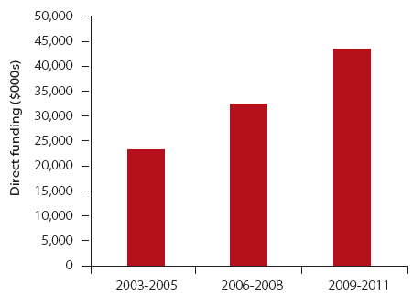

| Direct Funding and Clinical Trial Research | 2003-2005 | 2006-2008 | 2009-2011 |
| --- | --- | --- | --- |
| Proportion of direct funding | 8% | 8% | 7% |
| Number of clinical trials (%) | 99 (7%) | 132 (8%) | 159 (8%) |

Funding to cancer clinical trials was further subdivided into the trial phase being undertaken (where applicable) for each triennium (see Table 10.1). The largest change in direct funding was to Phase 3 cancer clinical trials, which increased from less than 10% ($1.9 million) of total direct clinical trials funding in 2003-2005 to more than one-third ($16.8 million) of total direct clinical trials funding in 2009-2011. In summary, the direct funding to cancer clinical trials research was as follows:

* Direct funding to Phase 1 only cancer clinical trials research decreased across the trienniums from $9.0 million (2003-2005) to $3.2 million (2006-2008) and then to $2.4 million (2009-2011);
* Direct funding to Phase 1/2 cancer clinical trials research increased from $0.2 million (2003-2005) to $4.2 million (2006-2008) and then decreased to $0.8 million (2009-2011);
* Direct funding to Phase 2 only cancer clinical trials research, increased from $2.5 million (2003-2005) to $4.1 million (2006-2008) and then decreased to $3.4 million (2009-2011);
* Direct funding to Phase 3 only cancer clinical trials research increased progressively from $1.9 million (2003-2005) to $8.6 million (2006-2008) and then to $16.8 million (2009-2011);
* Direct funding to Phase 3/4 cancer clinical trials research was not identified in 2003-2005 and 2006-2008, and was $0.1 million in 2009-2011;
* Direct funding to cancer clinical trials research that was not phase specific decreased from $5.5 million (2003-2005) to $4.7 million (2006-2008) and then increased to $11.7 million (2009-2011); and
* Direct funding to cancer clinical trials research in which the phase of research was unclear or undefined, increased progressively from $4.3 million (2003-2005) to $7.1 million (2006-2008) and then to $9.0 million (2009-2011).

Table 10.1: Direct funding to and number of cancer clinical trial research projects and research programs in 2003-2005, 2006-2008 and 2009-2011

| Clinical trial phase | 2003-2005 | 2006-2008 | 2009-2011 |
| --- | --- | --- | --- |
| Phase 1 | $9.0 M | $3.2 M | $2.4 M |
| Phase 1 projects/programs | 11 | 11 | 10 |
| Phase 1/2 | $0.2 M | $4.2 M | $0.8 M |
| Phase 1/2 projects/programs | 1 | 4 | 1 |
| Phase 2 | $2.5 M | $4.1 M | $3.4 M |
| Phase 2 projects/programs | 7 | 11 | 17 |
| Phase 3 | $1.9 M | $8.6 M | $16.8 M |
| Phase 3 projects/programs | 8 | 37 | 48 |
| Phase 3/4 | None identified | None identified | $0.1M |
| Phase 3/4 projects/programs | - | - | 1 |
| Not phase specific | $5.5 M | $4.7 M | $11.7 M |
| Not phase specific projects/programs | 39 | 28 | 43 |
| Unclear or undefined | $4.3 M | $7.1 M | $9.0 M |
| Unclear or undefined projects/programs | 33 | 41 | 39 |

*N.B. Some projects/programs overlap trienniums, thus the total number of projects/programs from 2003 to 2011 does not equal the sum of projects/programs for 2003-2005, 2006-2008 and 2009-2011*

### 10.2 Tumour type focus of clinical trials

The cancer clinical trials recorded in this audit were further analysed for the tumour type(s) on which the studies focused. In the period 2006 to 2011, there were 214 (89%) cancer clinical trials that were relevant to one or more tumour types. Please note that in this analysis, each clinical trial may focus on more than one tumour type. Similar data were not available for 2003-2005. The number of cancer clinical trials with a focus in a tumour type is shown in Figure 10.2.

In summary, the number of cancer clinical trials with a focus in a tumour type was as follows:

* Breast cancer, 51 clinical trials;
* Prostate cancer, 33 clinical trials;
* Colon and rectum cancer, 24 clinical trials;
* Ovarian cancer, 18 clinical trials;
* Lung cancer and mesothelioma, 14 clinical trials;
* Melanoma of the skin, 14 clinical trials;
* Leukaemia, 11 clinical trials;
* Endometrial cancer, 10 clinical trials;
* Oesophageal cancer, 9 clinical trials;
* Pancreatic cancer, 9 clinical trials;
* Brain cancer, 7 clinical trials;
* Lymphoma, 6 clinical trials;
* Testicular cancer, 5 clinical trials;
* Cervical cancer, 3 clinical trials;
* Myeloma, 3 clinical trials;
* Skin cancer (not melanoma), 3 clinical trials;
* Stomach cancer; 3 clinical trials; and
* Liver cancer, 3 clinical trials; and
* Other[18] tumour types, 11 clinical trials.

Figure 10.2: The number of cancer clinical trials with a specific tumour type focus in the period 2006 to 2011

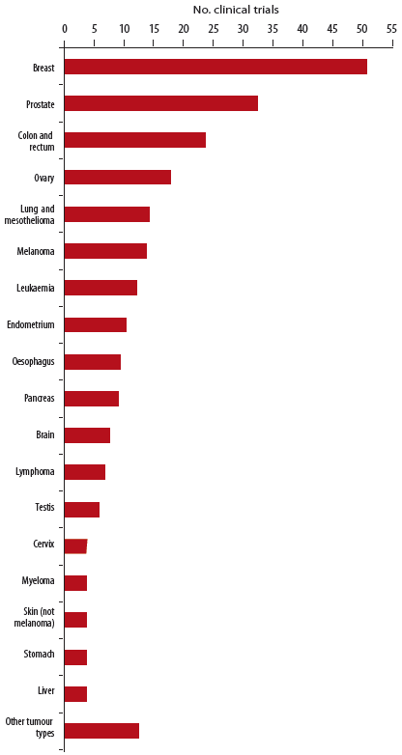

*Note: Each clinical trial may have a focus in more than one tumour type.*

### 10.3 Health discipline focus of cancer clinical trials

Cancer research projects and research programs in the period 2006 to 2011 which were clinical trials were further analysed for the area(s) of health discipline focus of the trial. Health disciplines were assigned to all 240 clinical trials and were determined from the project summary/abstract and keywords. Please note that in this analysis, each clinical trial may have a focus in more than one health discipline. The number of cancer clinical trials with a focus in each health discipline is shown in Figure 10.3.

In summary, the number of cancer clinical trials with a focus in each health discipline was as follows:

* Medical oncology, 93 cancer clinical trials;
* Radiation oncology, 52 cancer clinical trials;
* Psycho-oncology, 48 cancer clinical trials;
* Surgery, 35 cancer clinical trials;
* Palliative care, 18 cancer clinical trials;
* Primary care, 9 cancer clinical trials;
* Nursing, 8 cancer clinical trials;
* Allied health, 6 cancer clinical trials;
* Multi-disciplinary research, 5 cancer clinical trials; and
* Others[19] clinical research, 7 cancer clinical trials.

Figure 10.3: The number of cancer clinical trials with a health discipline focus in the period 2006 to 2011

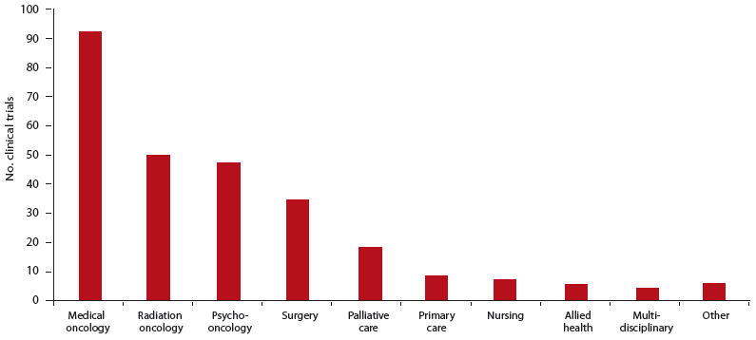

*Note: Each clinical trial may have a focus in more than one health discipline.*

### 10.4 Discussion

Of the 3,106 cancer research projects and research programs identified in the period 2006 to 2011, only 240 (8%) were identified as clinical trials, a figure which may be an under-representation as it was not always possible to determine if a research project was a clinical trial from the information provided to Cancer Australia. In addition, it should be noted that the data presented in this report do not represent the sum of all cancer clinical trials research conducted in the trienniums 2003-2005, 2006-2008 and 2009-2011, as it does not include funding of clinical trials conducted by the pharmaceutical industry.

Of the cancer clinical trials identified in the period 2006 to 2011, the Australian Government was the primary funder, providing approximately 74% of direct funding. The single largest funder was the NHMRC, which provided approximately 48% of direct funds to cancer clinical trials. Through the PdCCRS, Cancer Australia and funding partners funded 16% of clinical trials funded in the period 2006 to 2011.

Clinical trials can require large financial investments and a co-funding model which engages new funders could bring new money to fund more cancer clinical trials research.

#### Cancer clinical trials in 2003-2005, 2006-2008 and 2009-2011

Identified direct funding to cancer clinical trials and the number of clinical trials funded both increased across the trienniums, from $23.3 million for 99 clinical trials in 2003-2005 to $44.1 million for 159 clinical trials in 2009-2011. However, both the proportion of direct funding to clinical trials and the proportion of research projects and research programs which were clinical trials was similar across the trienniums, at approximately 7-8%.

When the direct funding to cancer clinical trials was allocated to the identified clinical trial phase, it was observed that direct funding to each phase increased from 2003-2005 to 2009-2011, except for Phase 1 trials. However, a single Phase 1 trial in 2003-2005 accounted for $7.5 million and without this study, funding to Phase 1 trials would have increased across the trienniums.

The increase in direct funding to clinical trials was largely driven by the increase in funding to Phase 3 studies, which increased almost 9-fold from 2003-2005 to 2009-2011. The two largest funders were the NHMRC and Cancer Australia (including Cancer Australia's funding partners through the PdCCRS), which in the period 2006 to 2011 provided approximately 63% and 19% respectively of direct funding to Phase 3 trials. The increase in direct funding to and number of Phase 3 trials is consistent with the observation that funding to cancer research across the trienniums has shifted towards applied and patient-centred research.

#### Tumour type focus of clinical trials

The ten tumour types which received the greatest direct funding in the period 2006 to 2011 were also amongst the most commonly investigated tumour types in cancer clinical trials in the same period, specifically cancers of the breast, prostate, colon and rectum, lung (including mesothelioma), endometrium, oesophagus, pancreas, melanoma and leukaemia. These ten tumour types are also amongst the cancers with the greatest burden of disease on the Australian population (see Chapter 8).

#### Health discipline focus of clinical trials

The capture of all health disciplines involved in a clinical trial was difficult. It is likely that some disciplines may be under-represented as it was not always possible to determine what disciplines were involved from the data provided to Cancer Australia. In order to ensure that all health disciplines involved in a clinical trial were accurately reflected, surveying the Chief Investigators involved in the trial would be necessary.

Examination of the health discipline focus of cancer clinical trials in the period 2006 to 2011 showed that most cancer clinical trials had a focus in medical oncology, radiation oncology and/ or surgery, interventions involved in the treatment of cancer. This focus is consistent with the observed CSO pattern of cancer research projects and research programs in the period 2006 to 2011 (see Chapter 5) being dominated by categories most relevant to cancer treatment, i.e. the CSO category of Treatment. A focus in psycho-oncology and palliative care was also prevalent, areas which are largely included in the CSO category of Cancer Control, Survivorship and Outcomes Research.

## Chapter 11 - Research collaborations

**KEY FINDINGS**

* In the period 2006 to 2011:
* 1907 (61%) research projects and research programs involved one or more named collaborators
* The proportion of cancer research projects and research programs that received more than $600,000 was two-fold higher for research with multiple named collaborators
* 75% of cancer research projects and research programs which provided details of collaborators locations had named collaborators at the same institution
* Most interstate collaborations involved New South Wales, Queensland and/or Victoria
* Only 9% of cancer research projects and research programs had an international, named collaborator
* Almost half (46%) of international collaborations involved the US
* From 2003-2005 to 2009-2011:
* The proportion of funding to cancer research projects and research programs which involved named collaborators increased from 58% to 65%
* Average funding per cancer research project or research program decreased for projects and programs with No named collaborators
* Average funding per cancer research project or research program increased for projects and programs with Single or Multiple named collaborators

### 11.1 Collaborations

Details of named collaborators on cancer research projects and research programs directly funded in the period 2006 to 2011 were requested from funding organisations. It should be noted that:

* Where funding organisations made a distinction between Chief and Associate Investigators, only the details of the Chief Investigators were recorded in the database;
* Named collaborators provided by funders may or may not have been co-investigators on the original applications for research funding; and
* An absence of a named collaborator did not necessarily equate with a lack of collaboration in the conduct of the research.

Each cancer research project and research program in the period 2006 to 2011 was categorised by the number of named collaborators and allocated to one of the following categories:

* No named collaborators;
* A single named collaborator; or
* Multiple named collaborators.

The direct funding to each category of collaborators, and the number and proportion of cancer research projects and research programs in each category for the trienniums 2003-2005, 2006-2008 and 2009-2011 are shown in Figure 11.1 and Table 11.1.

#### Collaboration categories

In the period 2006 to 2011, of the 3,106 identified cancer research projects and research programs, 61% (1,907) involved one or more named collaborators. In 2003-2005, of the 1,332 identified cancer research projects and research programs, 58% (774) had named collaborators. By the last triennium (2009-2011), of the 2,100 identified cancer research projects and research programs, 65% (1,356) had named collaborators.

In summary, from 2003-2005 to 2009-2011, the proportion of cancer research projects or programs in each collaboration category was as follows:

* The proportion of cancer research projects and research programs with no named collaborator/s decreased across the trienniums from 42% (2003-2005) to 40% (2006-2008) and then to 35% (2009-2011);
* The proportion of cancer research projects and research programs with a single named collaborator fluctuated from approximately 25% (2003-2005) to 21% (2006-2008) and then to 23% (2009-2011);
* The proportion of cancer research projects and research programs with multiple named collaborators increased across the trienniums from 33% (2003-2005) to 39% (2006-2008) and then to 42% (2009-2011).

Direct funding to each collaboration category and the number of cancer research projects and research programs funded increased across the trienniums, except for research projects and research programs with no named collaborators, which remained about the same at approximately $130 million in 2006-2008 and 2009-2011. From 2003-2005 to 2009-2011, the direct funding to cancer research projects and research programs with single or multiple named collaborators increased from $174 million to $466 million.

The average funding per research project or research program with single or multiple named collaborators increased by 54%, from $224,000 for the 774 research projects and research programs with named collaborators in 2003-2005, to $344,000 for the 1,356 research projects and research programs with named collaborators in 2009-2011.

The average funding for each collaboration category was as follows:

* The average funding to cancer research projects, and research programs with no named collaborator/s decreased across the trienniums from $211,000 (2003-2005) to $205,000 (2006-2008) and then to $174,000 (2009-2011);
* The average funding to cancer research projects and research programs with a single named collaborator increased across the trienniums from $163,000 (2003-2005) to $233,000 (2006-2008) and then to $263,000 (2009-2011); and
* The average funding to cancer research projects and research programs with multiple named collaborators increased across the trienniums from $268,000 (2003-2005) to $327,000 (2006-2008) and then to $388,000 (2009-2011).

For cancer research projects and research programs with multiple named collaborators, the average number of collaborators increased across the trienniums from 3.2 (2003-2005) to 3.4 (2006-2008) and then to 3.6 (2009-2011).

Figure 11.1: The proportion of cancer research projects and research programs in each collaboration category in 2003−2005, 2006−2008 and 2009−2011

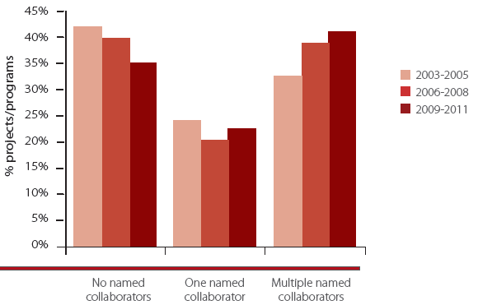

| Triennium | No named collaborators | One named collaborator | Multiple named collaborators |
| --- | --- | --- | --- |
| 2003-2005 | 42% | 25% | 33% |
| 2006-2008 | 40% | 21% | 39% |
| 2009-2011 | 35% | 23% | 42% |

Table 11.1: Direct funding to and number of cancer research projects and research programs, and average funding per project/program, in each collaboration category in 2003-2005, 2006-2008 and 2009-2011

| Collaboration category | 2003-2005 | 2006-2008 | 2009-2011 |
| --- | --- | --- | --- |
| No named collaborators | $118 M | $130 M | $129 M |
| (average funding per project/program) | ($211,000) | ($205,000) | ($174,000) |
| No named collaborators projects/programs | 558 | 635 | 742 |
| Single named collaborator | $53.5 M | $77.0 M | $126 M |
| (average funding per project/program) | ($163,000) | ($233,000) | ($263,000) |
| Single named collaborator projects/programs | 328 | 331 | 480 |
| Multiple named collaborators | $120 M | $206 M | $340 M |
| (average funding per project/program) | ($268,000) | ($327,000) | ($388,000) |
| (average no. collaborators) | (3.2) | (3.4) | (3.6) |
| Multiple named collaborators projects/programs | 446 | 630 | 876 |

*N.B. Some projects/programs overlap trienniums, thus the total number of projects/programs from 2003 to 2011 does not equal the sum of projects/programs for 2003-2005, 2006-2008 and 2009-2011.*

#### Proportional split of direct funding in each collaboration category

Each cancer research project and research program was further analysed for the level of direct funding that they received in the period 2006 to 2011 and subsequently allocated to one of three categories:

* Direct funding from $1 to $150,000;
* Direct funding from $151,000 to $600,000; or
* Direct funding of more than $600,000.

Figure 11.2 shows the proportional split of cancer research projects and research programs in each category of funding amount in the period 2006 to 2011. For cancer research projects and research programs with no named collaborators, most (61%) received $150,000 or less. However, for cancer research projects and research programs with one or multiple named collaborators, most (56% and 53% respectively) received between $150,000 and $600,000. In addition, the proportion of cancer research projects and research programs that received more than $600,000 was about two-fold higher for research projects or research programs with multiple named collaborators than for those with no named collaborators or a single collaborator.

Figure 11.2: The proportional split of direct funding to cancer research projects and research programs in each collaboration category in the period 2006 to 2011

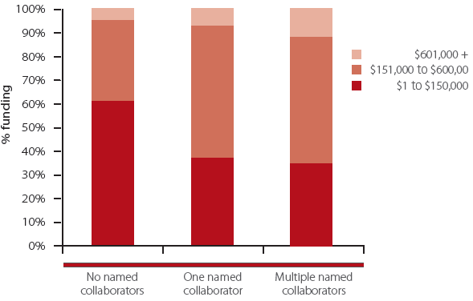

| Fund | No named collaborators | One named collaborator | Multiple named collaborators |
| --- | --- | --- | --- |
| $601,000 + | 5% | 6% | 11% |
| $151,000 to $600,00 | 34% | 56% | 53% |
| $1 to $150,000 | 61% | 38% | 36% |

### 11.2 Location of collaborators

In the period 2006 to 2011, of the 1907 cancer research projects and research programs which had one or more named collaborators, 1066 contained details of the named collaborator(s) geographical location. These 1066 cancer research projects and research programs were categorised by the following location categories for the named collaborator(s):

* Same Institution;
* Same State;
* Interstate; and/or
* International.

Due to differences in the way that collaborations were reported to Cancer Australia by some funding organisations, we were unable to make a comparison with the audit of 2003 to 2005. Figure 11.3 shows the percentage of cancer research projects and research programs in the period 2006 to 2011 with named collaborators in each location category.

In summary, of the 1066 cancer research projects and research programs with collaborator(s) location details, the percentage of research projects and research programs in each location category was as follows[20]:

* 75% of cancer research projects and research programs had a named collaborator at the same institution;
* 31% of cancer research projects and research programs had a named collaborator that were located in the same state;
* 25% of cancer research projects and research programs had a named collaborator that were located interstate; and
* 9% of cancer research projects and research programs had a named collaborator that was located internationally.

Figure 11.3: The proportion of cancer research projects and research programs in each collaboration location category in the period 2006 to 2011

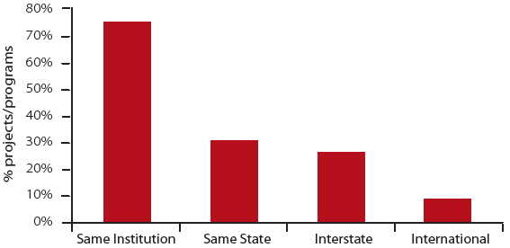

### 11.3 Interstate and international collaborators

This section analysed the location of collaborators where they were listed as being in a different state or territory or country to the host or administering institution of a cancer research project or research program (2006 to 2011). In total there were 290 cancer research projects and research programs with locations provided for interstate and/or international collaborators. For each state or territory location of the host or administering institution, the number of cancer research projects and research programs which had one or more collaborators in each state or territory or international location is provided in Figure 11.4.

In summary, for each State and Territory, the most common collaboration locations[21] were as follows:

* For the 80 cancer research projects or research programs where New South Wales was the host state:
* 41 had collaborators in Victoria;
* 29 had international collaborators;
* 27 had collaborators in Queensland;
* 16 had collaborators in Western Australia; and
* 14 had collaborators in South Australia.
* For the 48 cancer research projects or research programs where Queensland was the host state:
* 22 had collaborators in Victoria;
* 20 had collaborators in New South Wales; and
* 17 had international collaborators.
* For the 26 cancer research projects or research programs where South Australia was the host state:
* 9 had collaborators in Victoria;
* 9 had collaborators in Queensland; and
* 5 had international collaborators.
* For the 5 cancer research projects or research programs where Tasmania was the host state:
* 3 had international collaborators.
* For the 94 cancer research projects or research programs where Victoria was the host state:
* 28 had international collaborators;
* 25 had collaborators in New South Wales;
* 21 had collaborators in Queensland;
* 12 had collaborators in South Australia; and
* 10 had collaborators in Western Australia.
* For the 36 cancer research projects or research programs where Western Australia was the host state:
* 14 had collaborators in Victoria;
* 12 had collaborators in New South Wales; and
* 9 had international collaborators.
* The Australian Capital Territory and the Northern Territory together had 3 cancer research projects and research programs with collaborator location information provided. Given the small numbers an analysis of location of collaborators may not be meaningful. However, Figure 11.4 shows the collaborator location breakdown for these research projects and research programs.

For the 91 cancer research projects and research programs which had one or more international collaborators, 42 (46%) had one or more collaborators in the US, 17 (19%) had one or more in the UK, 16 (18%) had one or more in European Union nations, 9 (10%) had one or more in New Zealand, 9 (10%) had one or more in Canada and 6 (8%) had one or more in other nations.[22]

Figure 11.4: Interstate and international collaborations: number of cancer research projects and research programs and location of collaborator(s) in the period 2006 to 2011

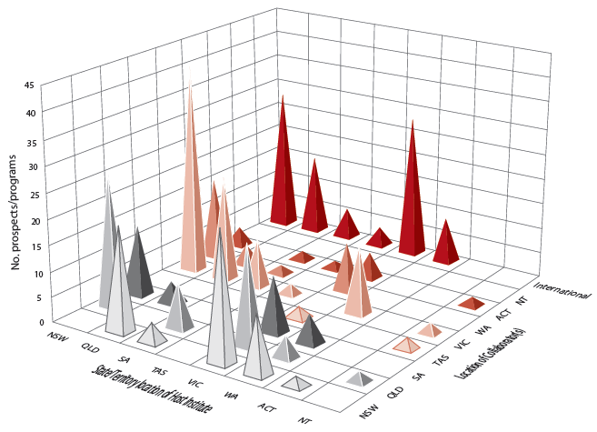

### 11.4 Discussion

The analysis in this Chapter is limited by the fact that not all funders were able to provide data on the level of collaboration and/or location of collaborators for cancer research projects and research programs. While the proportion of cancer research projects and research programs with named collaborators increased from 58% to 65%, due to differences in the way that collaborations were reported by some funding organisations, we were unable to make a comparison with the audit of 2003 to 2005 for the location of named collaborators. For those research projects and research programs which did provide details of the location of collaborators in the period 2006 to 2011, 75% of cancer research projects and research programs had collaborators in the same institution. A smaller proportion of cancer research projects and research programs involved collaborations outside the host institution, be it in the same State or Territory, interstate or internationally, highlighting the opportunities available to researchers to collaborate outside their host institution. Most of the interstate collaborations were with researchers in New South Wales, Queensland and Victoria. International collaborators were most commonly from the US, which is a major funder of cancer research (see Chapter 12).

From 2003-2005 to 2009-2011, the number and proportion of funded cancer research projects or research programs with multiple named collaborators increased, whilst the proportion with no named collaborators decreased. In addition, the average funding to cancer research projects or research programs decreased for those research projects and research programs with no named collaborators and increased markedly for those with a single or multiple named collaborators. These findings demonstrate a trend towards more collaborations in funded cancer research.

The proportional split of the level of funding in each collaboration category in the period 2006 to 2011 demonstrated that for research projects and research programs with no named collaborators, most research projects and programs received funding of $150,000 or less, whereas for those with one or more named collaborators, most research projects and programs received more than $150,000. In addition, the proportion of cancer research projects and research programs with multiple named collaborators that received more than $600,000 was two-fold higher than for those with a single or no named collaborators.

Collaboration in research supports the sharing of knowledge and skills, as well as enhancing the efficient use of available infrastructure and resources. Research collaborations can build research capacity and critical mass and bring together the best minds to expedite research and accelerate the achievement of improved cancer outcomes. National and international collaborations can limit the duplication of research effort, and funders of cancer research could foster collaboration by developing and implementing funding models which value and reward research collaborations. However, establishing collaborations is, in part, dependent on identifying researchers who work in similar research areas. International databases such as the International Cancer Research Partnership (ICRP) database provide information on cancer research projects funded by over 80 international organisations. The addition of information on Australian cancer research funding to this database and promulgation of awareness and use of this database amongst researchers will support the identification of research collaborators.

## Chapter 12 - Patterns of funding to cancer research projects and research programs: national and international comparisons

**KEY FINDINGS**

* From 2003-2005 to 2009-2011:
* both the pattern of funding and changes in the pattern of funding across CSO categories to New South Wales, Queensland and Victoria were broadly similar to the overall national pattern and to changes in the national pattern of funding
* The pattern of funding in Australia was broadly similar to the pattern of funding for the UK and Canada
* The change in the pattern of funding over time for Australia was more pronounced than for other national and international funders of cancer research, but similar features were a reduction in proportional funding to Biology and an increase in proportional funding to Treatment
* Australia, Canada and the UK all have proportionally lower levels of funding to CSO Prevention

Section 3.3 detailed the different levels of funding to cancer research projects and research programs in Australia's states and territories. In Chapter 12, the pattern of funding to each state and territory by CSO classification was analysed. A comparison of the national pattern of funding to cancer research projects and research programs in Australia with international funding patterns of cancer research was also conducted.

### 12.1 Analysis of the patterns of funding to Australia's states and territories

#### New South Wales

The total direct funding to cancer research projects and research programs in New South Wales increased from $72.6 million (2003-2005) to $175 million (2009-2011). Figure 12.1 depicts the proportional distribution of funding to cancer research projects and research programs in New South Wales in the trienniums 2003-2005, 2006-2008 and 2009-2011, by main CSO category. In 2003-2005, Biology received nearly half of all funding (44%), reducing to almost one-quarter (26%) by 2009-2011. Proportional funding increased to Treatment (20% to 31%) and Early Detection, Diagnosis and Prognosis (12% to 19%) from the first to the last triennium.

Figure 12.1: Cancer research projects and research programs in NSW: pattern of proportional funding to each CSO category in 2003-2005, 2006-2008 and 2009-2011

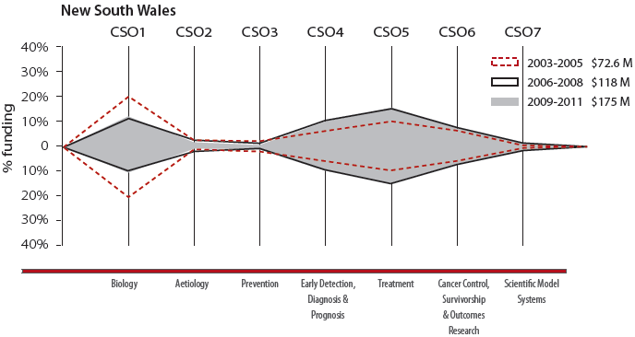

| Triennium | Biology | Aetiology | Prevention | Early Detection, Diagnosis & Prognosis | Treatment | Cancer Control, Survivorship & Outcomes Research | Scientific Model Systems |
| --- | --- | --- | --- | --- | --- | --- | --- |
| 2003-2005 | 44% | 4% | 5% | 12% | 20% | 14% | 1% |
| 2006-2008 | 24% | 5% | 1% | 19% | 32% | 15% | 4% |
| 2009-2011 | 26% | 3% | 3% | 19% | 31% | 16% | 3% |

#### Victoria

The total direct funding to cancer research projects and research programs in Victoria increased from $114 million (2003-2005) to $249 million (2009-2011). Figure 12.2 depicts the proportional distribution of funding to cancer research projects and research programs in Victoria in the trienniums 2003-2005, 2006-2008 and 2009-2011, by main CSO category. In 2003-2005, Biology received the majority of funding (62%), reducing to 38% by 2009-2011. Proportional funding increased to Treatment (16% to 28%) and Early Detection, Diagnosis and Prognosis (4% to 14%) from the first to the last triennium.

Figure 12.2: Cancer research projects and research programs in Victoria: pattern of proportional funding to each CSO category in 2003-2005, 2006-2008 and 2009-2011

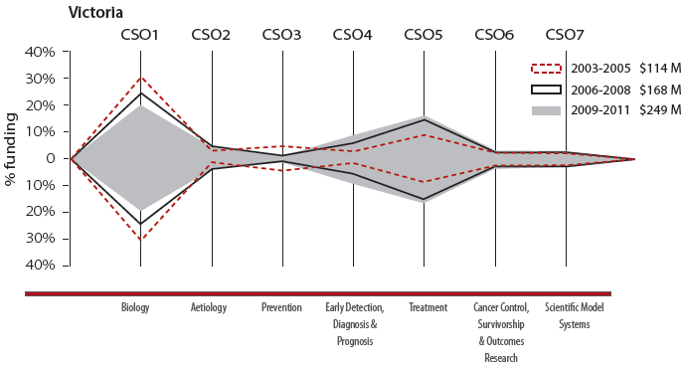

| Triennium | Biology | Aetiology | Prevention | Early Detection, Diagnosis & Prognosis | Treatment | Cancer Control, Survivorship & Outcomes Research | Scientific Model Systems |
| --- | --- | --- | --- | --- | --- | --- | --- |
| 2003-2005 | 62% | 3% | 8% | 4% | 16% | 5% | 2% |
| 2006-2008 | 50% | 9% | 2% | 9% | 24% | 3% | 3% |
| 2009-2011 | 38% | 9% | 1% | 14 % | 28% | 4% | 5% |

#### Queensland

The total direct funding to cancer research projects and research programs in Queensland increased from $56.8 million (2003-2005) to $95.1 million (2009-2011). Figure 12.3 depicts the proportional distribution of funding to cancer research projects and research programs in Queensland in the trienniums 2003-2005, 2006-2008 and 2009-2011, classified by main CSO category. Proportional distribution of funding changed little over the trienniums, with the largest change in proportional funding to Biology which received 38% in 2003-2005 and reduced to 30% in 2009-2011. Proportional funding increased to Early Detection, Diagnosis and Prognosis (10% to 15%) from the first to the last triennium.

Figure 12.3: Cancer research projects and research programs in Queensland: pattern of proportional funding to each CSO category in 2003-2005, 2006-2008 and 2009-2011

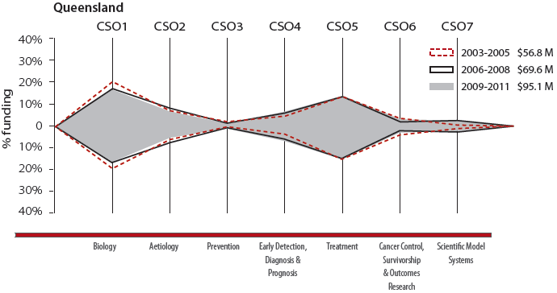

| Triennium | Biology | Aetiology | Prevention | Early Detection, Diagnosis & Prognosis | Treatment | Cancer Control, Survivorship & Outcomes Research | Scientific Model Systems |
| --- | --- | --- | --- | --- | --- | --- | --- |
| 2003-2005 | 38% | 14% | 3% | 10% | 26% | 9% | 1% |
| 2006-2008 | 31% | 17% | 3% | 14% | 26% | 5% | 4% |
| 2009-2011 | 30% | 12% | 2% | 15% | 28% | 9% | 4% |

#### South Australia

The total direct funding to cancer research projects and research programs in South Australia increased from $24.4 million (2003-2005) to $35.7 million (2009-2011). Figure 12.4 depicts the proportional distribution of funding to cancer research projects and research programs in South Australia in the trienniums 2003-2005, 2006-2008 and 2009-2011, classified by main CSO category. In 2003-2005, Biology received the majority of funding (64%), reducing to 37% in 2009-2011. Proportional funding increased to Early Detection, Diagnosis and Prognosis (6% to 27%) from the first to the last triennium.

Figure 12.4: Cancer research projects and research programs in South Australia: pattern of proportional funding to each CSO category in 2003-2005, 2006-2008 and 2009-2011

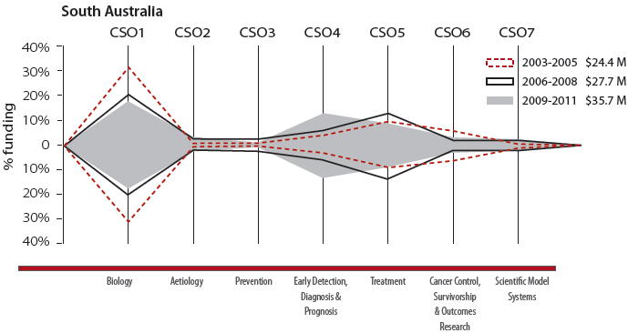

| Triennium | Biology | Aetiology | Prevention | Early Detection, Diagnosis & Prognosis | Treatment | Cancer Control, Survivorship & Outcomes Research | Scientific Model Systems |
| --- | --- | --- | --- | --- | --- | --- | --- |
| 2003-2005 | 64% | 1% | 1% | 6% | 17% | 11% | 0% |
| 2006-2008 | 42% | 4% | 5% | 17% | 24% | 5% | 4% |
| 2009-2011 | 37% | 5% | 2% | 27% | 19% | 8% | 3% |

#### Western Australia

The total direct funding to cancer research projects and research programs in Western Australia increased from $16.3 million (2003-2005) to $28.0 million (2009-2011). Figure 12.5 depicts the proportional distribution of funding to cancer research projects and research programs in Western Australia in the trienniums 2003-2005, 2006-2008 and 2009-2011, classified by main CSO category. In 2003-2005, Biology received one-third of all funding (34%), reducing to 27% in 2009-2011. Proportional funding also decreased from the first to the last triennium to Aetiology (15% to 8%) and Cancer Control, Survivorship and Outcomes Research (23% to 12%). Proportional funding to Treatment increased over the trienniums from 14% in 2003-2005 to 32% in 2009-2011.

Figure 12.5: Cancer research projects and research programs in Western Australia: pattern of proportional funding to each CSO category in 2003-2005, 2006-2008 and 2009-2011

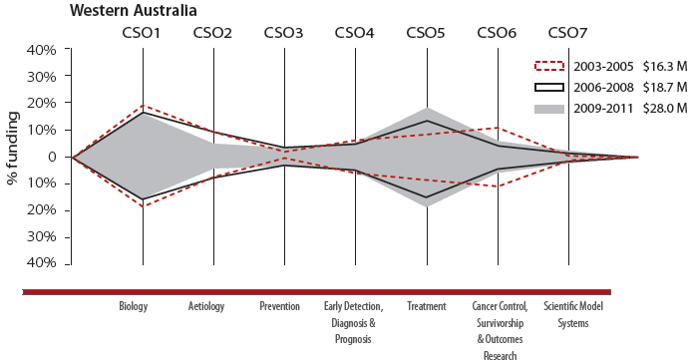

| Triennium | Biology | Aetiology | Prevention | Early Detection, Diagnosis & Prognosis | Treatment | Cancer Control, Survivorship & Outcomes Research | Scientific Model Systems |
| --- | --- | --- | --- | --- | --- | --- | --- |
| 2003-2005 | 34% | 15% | 2% | 13% | 14% | 23% | 1% |
| 2006-2008 | 28% | 17% | 6% | 10% | 27% | 9% | 2% |
| 2009-2011 | 27% | 8% | 8% | 11% | 32% | 12% | 2% |

#### Tasmania, Australian Capital Territory and Northern Territory

The total direct funding to cancer research projects and research programs in Tasmania increased from $3.6 million (2003-2005) to $7.8 million (2009-2011); in the Australian Capital Territory from $3.4 million (2003-2005) to $3.9 million (2009-2011); and in the Northern Territory from $0.1 million (2003-2005) to $1.2 million (2009-2011).

Figure 12.6 depicts the proportional distribution of funding to cancer research projects and research programs in Tasmania, Australian Capital Territory and Northern Territory in the trienniums 2003-2005, 2006-2008 and 2009-2011, classified by main CSO category.

In Tasmania, Aetiology received the majority of proportional funding at 80%, 51% and 84% of funding in 2003-2005, 2006-2008 and 2009-2011, respectively. Proportional funding to Biology varied notably over the trienniums: 11%, 44% and 8% of funding in 2003-2005, 2006-2008 and 2009-2011, respectively. Other CSO categories all received 3% or less of proportional funding per triennium. It should be noted that in Tasmania only 28, 37 and 40 cancer research projects and research programs were identified in the 2003-2005, 2006-2008 and 2009-2011 trienniums, respectively.

In the Australian Capital Territory, Biology received the majority of proportional funding at 56%, 61% and 68% of funding in 2003-2005, 2006-2008 and 2009-2011, respectively. Treatment also received a high proportion of overall funding, at 38%, 37% and 30% of funding in 2003-2005, 2006-2008 and 2009-2011, respectively. Other CSO categories all received 4% or less of proportional funding per triennium. It should be noted that in the Australian Capital Territory only 18, 19 and 19 cancer research projects and research programs were identified in the 2003-2005, 2006-2008 and 2009-2011 trienniums, respectively.

In the Northern Territory, proportional funding to CSO categories fluctuated across trienniums. Nonetheless, funding was identified in the CSO categories of Aetiology and Cancer Control Survivorship and Outcomes Research. It should be noted that in Northern Territory only 3, 2 and 4 cancer research projects and research programs were identified in this audit in the 2003-2005, 2006-2008 and 2009-2011 trienniums, respectively.

Figure 12.6: Cancer research projects and research programs in Tasmania, Australian Capital Territory and Northern Territory: pattern of proportional funding to each CSO category in 2003-2005, 2006-2008 and 2009-2011

**Tasmania**

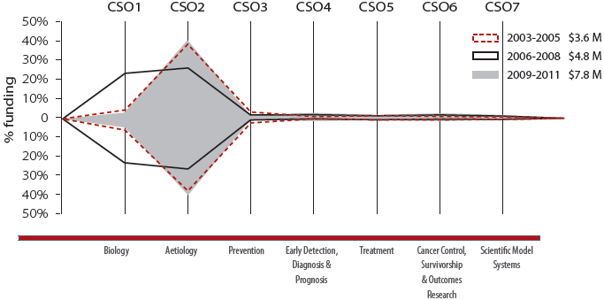

| Triennium | Biology | Aetiology | Prevention | Early Detection, Diagnosis & Prognosis | Treatment | Cancer Control, Survivorship & Outcomes Research | Scientific Model Systems |
| --- | --- | --- | --- | --- | --- | --- | --- |
| 2003-2005 | 11% | 80% | 3% | 2% | 1% | 3% | 0% |
| 2006-2008 | 44% | 51% | 0% | 2% | 0% | 2% | 0% |
| 2009-2011 | 8% | 84% | 2% | 2% | 1% | 3% | 0% |

**Australian Capital Territory**

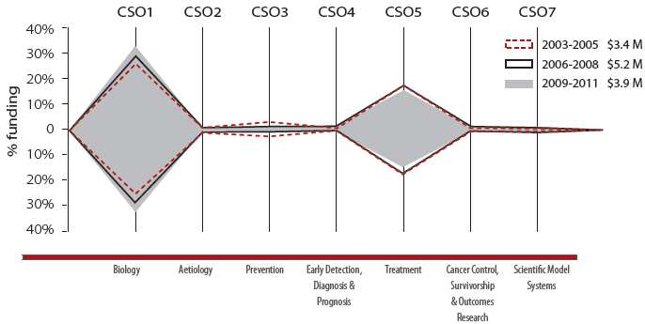

| Triennium | Biology | Aetiology | Prevention | Early Detection, Diagnosis & Prognosis | Treatment | Cancer Control, Survivorship & Outcomes Research | Scientific Model Systems |
| --- | --- | --- | --- | --- | --- | --- | --- |
| 2003-2005 | 56% | 1% | 4% | 0% | 38% | 1% | 0% |
| 2006-2008 | 61% | 0% | 0% | 2% | 37% | 0% | 0% |
| 2009-2011 | 68% | 0% | 0% | 1% | 30% | 0% | 0% |

**Northern Territory**

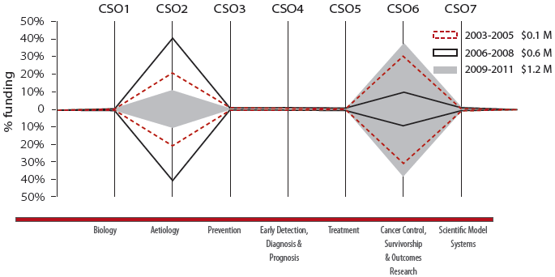

| Triennium | Biology | Aetiology | Prevention | Early Detection, Diagnosis & Prognosis | Treatment | Cancer Control, Survivorship & Outcomes Research | Scientific Model Systems |
| --- | --- | --- | --- | --- | --- | --- | --- |
| 2003-2005 | 0% | 43% | 0% | 0% | 0% | 57% | 0% |
| 2006-2008 | 0% | 83% | 0% | 0% | 0% | 17% | 0% |
| 2009-2011 | 0% | 23% | 0% | 0% | 0% | 77% | 0% |

### 12.2 Comparison between the national pattern of funding to cancer research projects and research programs in Australia with international patterns of funding

#### Analysis of the pattern of funding in Australia and abroad

This audit has identified direct funding to Australian cancer research projects and research programs of AUD$1.01 billion in the period 2006 to 2011. Recent international surveys by the Canadian Cancer Research Alliance (CCRA)21, the National Cancer Research Institute (NCRI)23 and the International Cancer Research Partnership (ICRP)22, have identified the following funding to cancer research:

* CAD$2.92 billion from 2006 to 2011 in Canada, by more than 40 organisations tracked by the CCRA;21
* GBP£2.81 billion from 2006 to 2011 in the UK, by 22 members of the NCRI;23 and
* USD$19.0 billion from 2005 to 2008 internationally, by 53 members of the ICRP.22

These surveys captured a mix of government and non-government funders, and certain members of both the CCRA and NCRI are included in the ICRP survey. Each of these surveys classified the funded research by CSO codes, and a comparison between the patterns of funding derived from the Canadian (CCRA) and UK (NCRI) surveys with the pattern of funding identified by the National Audit of cancer research funding in Australia (2006 to 2011) is shown in Figure 12.7.

The ICRP survey included data for cancer research funding provided by the US-based NIH. As the NIH funding comprised 71% of the ICRP funding from 2005 to 2008, these NIH data was disaggregated from the total ICRP data so that patterns of funding could be compared. The pattern of funding for research funded by the NIH and other ICRP members in 2008 is shown in Figure 12.8.

Some important caveats must be considered when comparing data from this Australian audit with the cited international surveys. Firstly, the methods of apportioning research expenditure to CSO codes differed between the surveys. The CCRA, NCRI and ICRP surveys apportioned budgets to more than one CSO code when a project was deemed to be of multi-CSO focus, whereas Cancer Australia allocated the research funds to the major CSO of focus. In addition, the type of funding data represented in each survey might differ. For example, the CCRA, NCRI and ICRP surveys included funding to people support schemes and infrastructure, whereas Cancer Australia's survey only includes funding to cancer research projects and research programs. Also, the CCRA survey apportioned budgets to projects based on the percentage by which each project was judged as being dedicated to cancer research, whereas Cancer Australia's audit only included research projects and research programs where the main research focus was on cancer.

Nonetheless, the patterns of funding for Australia, Canada (CCRA) and the UK (NCRI), were broadly similar, with the majority of proportional funding going to the CSO categories of Biology and Treatment, and lower levels of proportional funding going to Prevention and Scientific Model Systems. The pattern of funding for the ICRP was more evenly distributed across the CSO categories, and it is apparent that this effect was largely due to research funded by the NIH. When the ICRP data were analysed after removal of NIH funding data, it was observed that the pattern of funding was broadly similar to Australia, Canada (CCRA) and the UK (NCRI). It should also be noted that funding to cancer research by members of the NCRI and CCRA accounted for 74% of the remaining ICRP funding.

Figure 12.7: Comparison of the pattern of funding to cancer research in Australia with Canada and the United Kingdom (2006-2011)

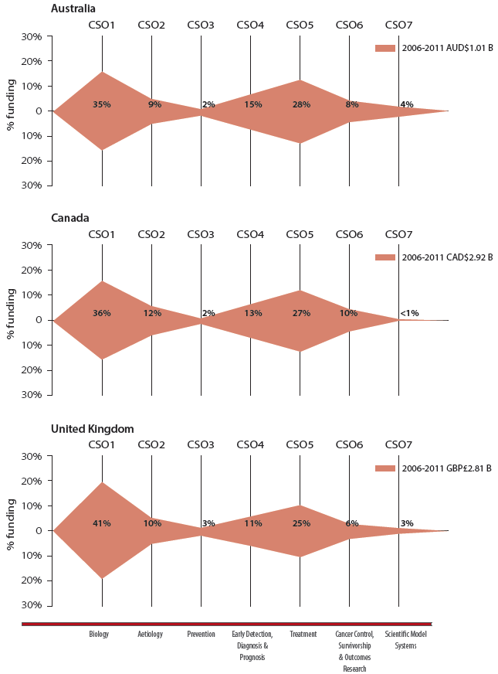

Figure 12.8: Pattern of funding in international cancer research (2008)

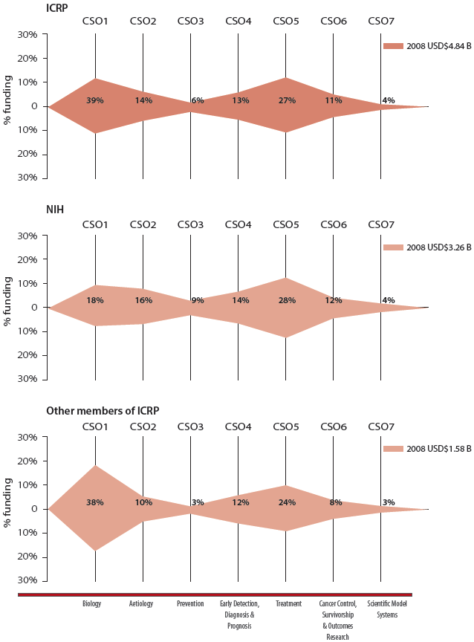

*Note: As proportional funding to CSO categories was only available for the years 2005 and 2008 for ICRP data, only the 2008 data is shown here.*

#### Analysis of the changes in the pattern of funding over time in Australia and abroad

Figure 12.7 compared the pattern of funding provided to cancer research in Canada, the UK and Australia in comparable timeframes.

This section compares changes in the pattern of funding over time for different international funders. Figure 12.9 compares the changes in pattern of cancer research funding:

* In Australia and the UK (NCRI) across the trienniums 2003-2005, 2006-2008 and 2009-2011;
* In Canada (CCRA) from 2006 to 2011 and the ICRP from 2005 to 2008; and
* From 2005 to 2008 for the disaggregated ICRP data: NIH and the rest of the ICRP membership.

The pattern of funding for Canada (CCRA) and the ICRP are presented for the first and last years of the available data and is consistent with the presentation of their data in their respective reports.

In summary:

* The total funding to Australian cancer research projects and research programs increased from $292 million (2003-2005) to $596 million (2009-2011). The pattern of proportional funding to CSO categories across the trienniums was discussed in detail in Section 5.1. In summary, the largest change in proportional funding was to Biology which, decreased from 51% (2003-2005) to 32% (2009-2011) whilst proportional funding to Treatment increased from 19% (2003-2005) to 28% (2009-2011);
* The total funding to cancer research in the UK increased from £0.9 billion (2003-2005) to £1.5 billion (2009-2011). In contrast to the changes in the patterns of funding to CSO categories observed for Australia, the patterns of funding to CSO categories for the UK remained relatively constant across the trienniums. The largest proportional changes in funding were to Aetiology, which decreased from 16% (2003-2005 and 2006-2008) to 9% (2009-2011) and Treatment, which increased from 20% (2003-2005 and 2006-2008) to 25% (2009-2011);
* The total funding to cancer research in Canada increased from CAD$390 million in 2006 to CAD$548 million in 2011. Similar to the change in the pattern of funding to CSO categories observed for Australia, the proportion of funding to Biology decreased from 45% (2006) to 30% (2011), whilst proportional funding to Treatment increased from 24% (2006) to 30% (2011);
* The total funding to cancer research by members of the ICRP increased from USD$4.76 billion in 2005 to USD$4.84 billion in 2008. In 2005 and 2008, the pattern of funding was more evenly distributed across the CSO categories, and the largest changes in proportional funding were to Aetiology, which decreased from 18% to 14%, and to Biology, which increased from 22% to 25%. The NIH provided almost three-quarters of the ICRP funding in the period 2005 to 2008:
* The total funding to cancer research by the NIH was USD$3.57 billion in 2005 and USD$3.26 billion in 2008. The patterns of funding in 2005 and 2008 for the NIH were more equally distributed across the CSO categories and remained relatively constant, with the largest change in proportional funding to Aetiology which decreased from 20% to 16%.
* The total funding to cancer research by other members of the ICRPP was USD$1.19 billion in 2005 and USD$1.58 billion in 2008. The patterns of funding in 2005 and 2008 were relatively constant, with the largest change in proportional funding to Aetiology which decreased from 13% to 10%.

When comparing these international surveys, it should be noted that the CCRA, ICRP and NCRI surveys may contain elements of cancer research funding not captured in Cancer Australia's 2003 to 2005 and 2006 to 2011 audits, such as infrastructure and person support schemes.

Figure 12.9: International comparisons of the changes in the patterns of funding to cancer research

**A. Australia and the United Kingdom in 2003-2005, 2006-2008 and 2009-2011**

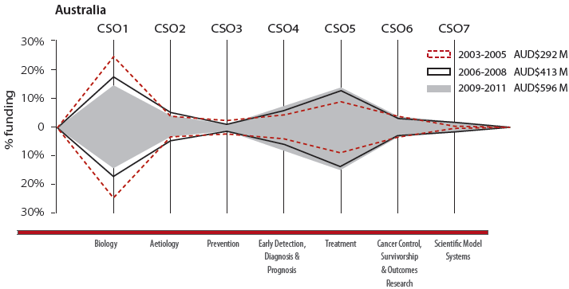

| Triennium | Biology | Aetiology | Prevention | Early Detection, Diagnosis & Prognosis | Treatment | Cancer Control, Survivorship & Outcomes Research | Scientific Model Systems |
| --- | --- | --- | --- | --- | --- | --- | --- |
| 2003-2005 | 51% | 7% | 5% | 8% | 19% | 9% | 1% |
| 2006-2008 | 38% | 10% | 2% | 13% | 27% | 7% | 3% |
| 2009-2011 | 32% | 8% | 2% | 16% | 28% | 9% | 4% |

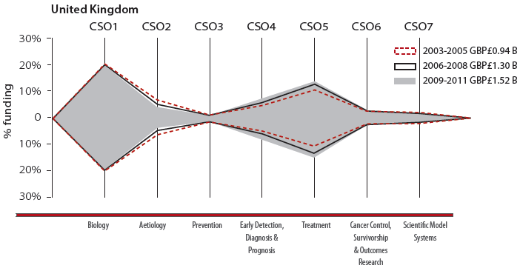

| Triennium | Biology | Aetiology | Prevention | Early Detection, Diagnosis & Prognosis | Treatment | Cancer Control, Survivorship & Outcomes Research | Scientific Model Systems |
| --- | --- | --- | --- | --- | --- | --- | --- |
| 2003-2005 | 42% | 16% | 3% | 9% | 20% | 6% | 4% |
| 2006-2008 | 42% | 12% | 3% | 10% | 24% | 6% | 3% |
| 2009-2011 | 41% | 9% | 3% | 12% | 25% | 6% | 3% |

**B. Canada in 2006 and 2011**

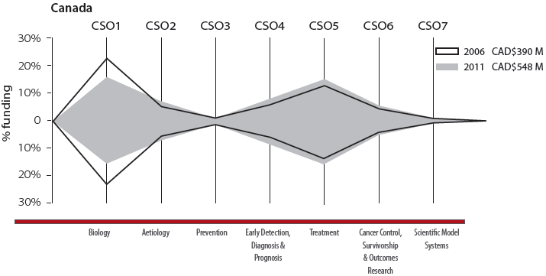

| Triennium | Biology | Aetiology | Prevention | Early Detection, Diagnosis & Prognosis | Treatment | Cancer Control, Survivorship & Outcomes Research | Scientific Model Systems |
| --- | --- | --- | --- | --- | --- | --- | --- |
| 2006 | 45% | 10% | 2% | 10% | 24% | 8% | 1% |
| 2011 | 30% | 14% | 2% | 13% | 30% | 10% | <1% |

**C. ICRP in 2005 and 2008**

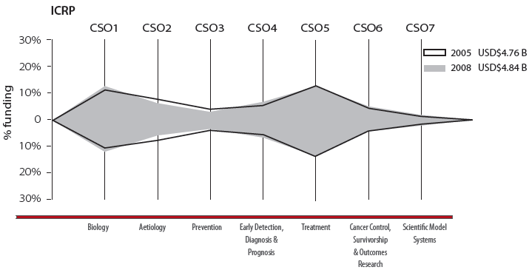

| Triennium | Biology | Aetiology | Prevention | Early Detection, Diagnosis & Prognosis | Treatment | Cancer Control, Survivorship & Outcomes Research | Scientific Model Systems |
| --- | --- | --- | --- | --- | --- | --- | --- |
| 2005 | 22% | 18% | 8% | 12% | 26% | 11% | 4% |
| 2008 | 25% | 14% | 7% | 13% | 27% | 11% | 4% |

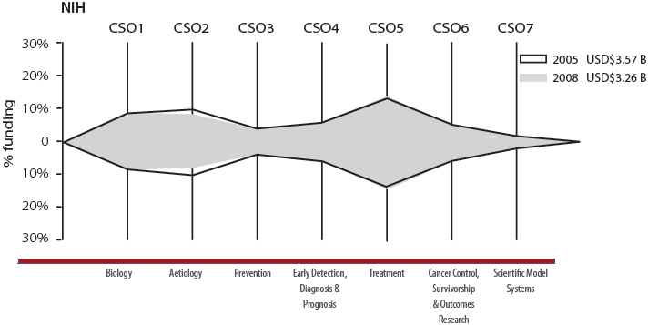

| Triennium | Biology | Aetiology | Prevention | Early Detection, Diagnosis & Prognosis | Treatment | Cancer Control, Survivorship & Outcomes Research | Scientific Model Systems |
| --- | --- | --- | --- | --- | --- | --- | --- |
| 2005 | 17% | 20% | 9% | 12% | 27% | 11% | 4% |
| 2008 | 18% | 16% | 9% | 14% | 28% | 12% | 4% |

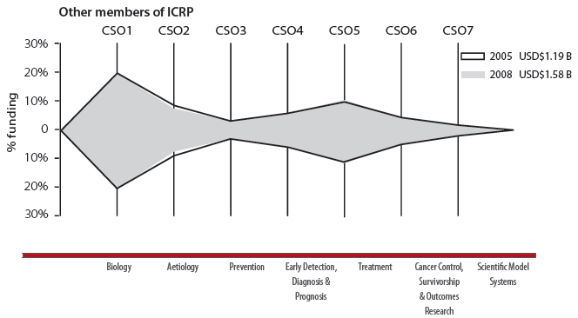

| Triennium | Biology | Aetiology | Prevention | Early Detection, Diagnosis & Prognosis | Treatment | Cancer Control, Survivorship & Outcomes Research | Scientific Model Systems |
| --- | --- | --- | --- | --- | --- | --- | --- |
| 2005 | 38% | 13% | 3% | 10% | 23% | 9% | 4% |
| 2008 | 39% | 10% | 3% | 12% | 24% | 8% | 3% |

### 12.3 Discussion

#### Funding to CSO categories in Australia's states and territories

The pattern of funding to CSO categories in each of Australia's states and territories is illustrated in Figures 12.1 to 12.6. The national pattern of funding shown in Figure 12.9 resembles the individual patterns of funding for New South Wales, Victoria and Queensland. These states together received 87% of funding to cancer research projects and research programs in the period 2006 to 2011. As such, it is expected that the national pattern of funding would reflect the average pattern of funding from these three states combined. In each of these states and in Australia as a whole, the CSO categories of Biology, Treatment and Early Detection, Diagnosis and Prognosis received the most funding.

The pattern of funding to CSO categories in South Australia and Western Australia revealed larger changes in proportional funding over the trienniums. This is due, in part, to the lower levels of funding to these states and the relative impact of single large grants in particular CSO categories. In South Australia, a marked increase in proportional funding to Aetiology was observed across the trienniums, from 6% to 27%. This was largely due to a NHMRC program grant and funding provided by a Co-operative Research Centre (CRC) which undertook research projects in the area of Aetiology. In Western Australia, a decrease in proportional funding to Cancer Control, Survivorship and Outcomes Research was observed after 2003-2005, due to the cessation of a NHMRC program grant that was active in the first triennium. The patterns of funding to CSO categories in Tasmania, the Australian Capital Territory and the Northern Territory were markedly different from the other states and this is due in part to a smaller cancer research base and the specific foci of the local research groups.

#### International comparisons of funding to CSO categories

A comparison between the national patterns of funding to CSO categories in Australia with international surveys of cancer research revealed both similarities and differences. In this analysis, it is important to note that the international surveys included categories such as people support and infrastructure funding. This audit of funding to cancer research projects and research programs in Australia, 2006 to 2011 and Cancer Australia's previous audit of 2003 to 2005 does not include direct funding to these categories. As such, comparison of the patterns of funding between Australia and other countries must be undertaken with caution. Nonetheless, a similar pattern of proportional funding to CSO categories in Australia, the UK and Canada was apparent, with the highest proportional funding to Biology, Treatment and Early Detection, Diagnosis and Prognosis, and similarly lower proportional funding to Aetiology, Prevention and Cancer Control, Survivorship and Outcomes Research. The pattern of funding by the ICRP to the CSO categories was similar to the pattern of funding in Australia, Canada and the UK, with the CSO categories of Treatment and Biology receiving the highest levels of funding.

The pattern of funding from the ICRP was notably influenced by funding from the NIH, which accounted for two-thirds of all ICRP funding in 2008. The pattern of funding for the NIH in 2008 was more evenly spread across the CSO categories than was observed for Australia, Canada, UK and the other members of the ICRP. The National Cancer Institute (NCI) is the NIH's principal funder of cancer research and supports research across the cancer continuum. The NCI assigns more than one CSO code to cancer grants which address multiple research themes; larger grants such as those to cancer centres and specialised programs of research excellence which work across the research continuum are typically assigned many CSO codes, leading to a more balanced CSO distribution.

The observed change in the pattern of funding over time for Australia was noted to be greater than for the UK and may be due, in part, to the change in the number of cancer funders reporting to Cancer Australia's audits, as discussed in Chapter 6. The change in pattern of funding in Canada from 2006 to 2011 was similar to that observed for Australia across the trienniums, whereas for the ICRP from 2005 to 2008, the pattern of funding only changed slightly, with a decrease in proportional funding to Aetiology. Nonetheless, the similar pattern of funding observed for Australia, the UK and Canada provides the opportunity to collaboratively fund research in areas of common research endeavour and need.

## Appendix A - Organisations invited to provide details of their direct funding to cancer research projects and research programs in Australia, 2006 to 2011

ACT Health Research Office

American Association for Cancer Research

American Cancer Society

American Institute for Cancer Research

AMP Foundation

ANZ Trustees

ANZAC Research Institute

Arrow Bone Marrow Transplant Foundation

Asbestos Diseases Research Institute

Association for International Cancer Research

auDA Foundation

Austin Medical Research Foundation

Australasian Gastro-Intestinal Trials Group

Australasian Leukaemia and Lymphoma Group

Australasian Sarcoma Study Group

Australia and New Zealand Breast Cancer Trials Group Ltd

Australia and New Zealand Children's Haematology / Oncology Group

Australia and New Zealand Gynaecological Oncology Group

Australia and New Zealand Melanoma Trials Group

Australia and New Zealand Urogenital and Prostate (ANZUP) Cancer Trials Group

Australian Breast Cancer Research

Australian Cancer Research Foundation

Australian Dental Research Foundation

Australian National University

Australian Nuclear Science and Technology Organisation

Australian Research Council

Australian Rotary Health

Australian Synchrotron

Avon Foundation for Women

beyondblue: Depression, Anxiety

Bowel Cancer Australia

Brain Foundation

Breast Cancer Institute of Australia

Breast Cancer Research Foundation

BUPA Foundation

Burnet Institute

Cabrini Institute

Canadian Institute for Health Research

Cancer Institute NSW

Cancer Nurses Society of Australia

Cancer Research Institute

CanTeen

CASS Foundation

Centenary Institute

Children's Cancer Institute Children's Leukaemia and Cancer Research Foundation

Children's Health Foundation Queensland

Children's Medical Research Institute

Clifford Craig Memorial Trust

Clinical Oncological Society of Australia

Colonial Foundation

Commonwealth Department of Health

Commonwealth Department of Industry

Commonwealth Department of Veterans' Affairs

Commonwealth Scientific and Industrial Research Organisation (CSIRO)

Conquer Cancer Foundation of the American Society of Clinical Oncology

Cooperative Research Centre for Aboriginal and Torres Strait Islander Health

Cooperative Research Centre for Biomarker Translation

Cooperative Research Centre for Biomedical Imaging Development

Cooperative Research Centre for Cancer Therapeutics

Cooperative Trials Group for Neuro-Oncology

Cure Brain Cancer Foundation

Cure Cancer Australia Foundation

Deakin University

Epworth Research Institute

European Organisation for Research and Treatment of Cancer

Fight Cancer Foundation

Flinders University

Garvan Research Foundation

Griffith University

Helen MacPherson Smith Trust

Human Frontier Science Program

Ian Potter Foundation

International Myeloma Foundation

James S. McDonnell Foundation

Kidney Health Australia

Kolling Institute of Medical Research

Latrobe University

Leukaemia Foundation

Leukemia and Lymphoma Society

Leukemia Research Foundation

Lions Medical Research Foundation

Ludwig Institute for Cancer Research

Macquarie Group Foundation

Macquarie University

Medical Oncology of Group of Australia

Melanoma Institute Australia

Menzies Research Institute

Menzies School of Health

Monash Institute of Medical Research

Monash University

Multiple Myeloma Research Foundation

Murdoch Children's Research Institute

Myeloma Foundation of Australia

National Breast Cancer Foundation

National Cancer Institute

National Health and Medical Research Council

National Institutes of Health

New South Wales Office for Health and Medical Research

Oral Health CRC

Ovarian Cancer Australia

Ovarian Cancer Research Foundation

Perpetual Trustees

Peter MacCallum Cancer Foundation

Petre Foundation

Pfizer Australia Cancer Research Grants

Primary Care Collaborative Cancer Clinical Trials Group (PC4)

Prince Henry's Institute

Princess Alexandra Hospital Research Foundation

Princess Margaret Hospital Foundation

Prostate Cancer Foundation of Australia

Pyscho-Oncology Co-operative Trials Group

QIMR Berghofer Institute of Medical Research

Queensland Children's Medical Research Institute

Queensland Office of Health and Medical Research

Queensland University of Technology

Raine Medical Research Foundation

Royal Adelaide Hospital Research Fund (incl. Hanson Institute)

Royal Australian and New Zealand College of Radiologists

Royal Australian College of Surgeons

Royal Brisbane and Women's Hospital Foundation

Royal Children's Hospital Foundation

Royal Hobart Hospital Foundation

Royal Melbourne Hospital Foundation

Royal North Shore Hospital Foundation

Royal Perth Hospital Foundation

Royal Women's Hospital Foundation

Sir Charles Gairdner Research Foundation

Sir Edward Dunlop Medical Research Foundation

Skin & Cancer Foundation Australia

Skin & Cancer Foundation Inc

South Australia Department of Health and Ageing

South Australian Health and Medical Research Institute

St Vincent's Health, Melbourne

St Vincent's Institute of Medical Research

Susan G. Komen for the Cure

Sydney Cancer Centre

Sydney Children's Hospital Foundation

Sydney Medical School Foundation

Telethon Institute for Child Health Research

Telstra Foundation

Terry Fox Foundation

The Alfred Foundation

The Atlantic Philanthropies

The Australian Lung Foundation

The Cancer Council Australia

The Cancer Council ACT

The Cancer Council Northern Territory

The Cancer Council NSW

The Cancer Council Queensland

The Cancer Council SA

The Cancer Council Tasmania

The Cancer Council Victoria

The Cancer Council Western Australia

The Children's Hospital at Westmead incl. Kids Research Institute

The Hospital Research Foundation

The John Curtin Medical Research Foundation

The Kids' Cancer Project (previously Oncology Children's Foundation)

The Kinghorn Cancer Centre

The Myer Foundation and Sydney Myer Fund

The West Australia Institute for Medical Research

Therapeutic Innovation Australia

Trans-Tasman Radiation Oncology Group

United States of America Department of Defense, Congressionally Directed Medical Research Programs

University of Adelaide University of Melbourne University of New South Wales

University of Newcastle (incl. Hunter Medical Research Institute)

University of Queensland

University of South Australia

University of Sydney

University of Tasmania

University of Western Australia

Val Lishman Health Research Foundation

Victorian Breast Cancer Research Consortium

Victorian Cancer Agency

Victorian Department of Business and Innovation

Victorian Prostate Cancer Research Consortium

Walter and Eliza Hall Institute of Medical Research

Wellcome Trust

Western Australia Department of Health

Western Australian Institute for Medical Research

Westmead Institute for Cancer Research

World Cancer Research Fund

## Appendix B - Email Introduction to the Audit

Dear

Cancer Australia invites your participation in informing research gaps and priorities for research funders. Cancer Australia is the Australian Government's national cancer agency established to reduce the impact of cancer and improve the wellbeing of people affected by cancer in Australia. Our mission is to strengthen and provide advice on the Australian Government's strategic focus on cancer control and care.

A priority of Cancer Australia is to fund cancer research in identified priority areas. To inform this priority, Cancer Australia is undertaking an audit of cancer research funding across Australia.

The attached letter from Dr Helen Zorbas, CEO of Cancer Australia, is an invitation for (name of funding organisation) to contribute to this audit, and requests assistance from you in providing details of cancer research activities directly funded by (name of funding organisation) in the calendar years 2006-2011.

To facilitate incorporation of this information into our database, we request that these details be provided in a spread sheet format (preferably using Microsoft Excel). We understand however, that this may not always be possible, in which case, information supplied in a Microsoft Word file format would be an acceptable alternative.

Your information can be provided as an attachment to an email addressed to me: [Alan.Woods@canceraustralia.gov.au](mailto:Alan.Woods@canceraustralia.gov.au)

If your data files are too large to be attached to electronic mail, we would be happy to accept the data on a CD or DVD. This can be mailed to:

Dr Alan Woods  
Cancer Australia  
GPO Box 4530  
Melbourne 3001  
Victoria  
Australia

We would appreciate receiving this information by C.O.B. July 6, 2012. If your organisation did not fund cancer research projects or programs between 2006 and 2011, please let us know so that we can update our records.

If you would like any further information, please do not hesitate to contact me using the details below.

We look forward to your contribution to informing cancer research priorities.

Kind regards,

Alan  
Dr Alan Woods  
Senior Project Officer  
Research Audits

Cancer Australia  
P: + 61 3 8866 0401 | M: 0425 819 356 | F: + 61 3 8866 0499  
[www.canceraustralia.gov.au](http://www.canceraustralia.gov.au)

## Appendix C - Invitation from CEO of Cancer Australia to cancer research funding organisation

Dear

Audits of Cancer Research in Australia, 2006-2011.

Cancer Australia invites your participation in informing research gaps and priorities for research funders. Cancer Australia is the Australian Government's national cancer agency established to reduce the impact of cancer and improve the wellbeing of people affected by cancer in Australia. Our mission is to strengthen and provide advice on the Australian Government's strategic focus on cancer control and care.

In 2008, Cancer Australia published the results from the first national audit of cancer research funding: Cancer research in Australia: An overview of cancer research projects and research programs in Australia 2003-2005. This report identified, for the first time, the national pattern of investment in the different areas of cancer research and the funding provided to different tumour types. The report also provided valuable data on the type of research being conducted and collaborations between researchers.

Having an evidence base is essential for identifying priority areas for cancer research. Results from the audit published in 2008 were used to inform Cancer Australia's cancer research priorities for the 2009-2012 rounds of the Priority-driven Collaborative Cancer Research Scheme (PdCCRS); an innovative research funding scheme, which brings together government and other funders of cancer research across Australia to collaboratively fund research in identified priority areas. The PdCCRS has, to date, funded 171 grants with a total value of $61.2M, and 70% of these grants have had a direct focus on influencing clinical practice, policy and patient outcomes.

In 2012, Cancer Australia will be undertaking two national audits of cancer research activities:

* Audit 1, updating the 2003-2005 audit to identify direct funding to cancer research projects and research programs in the period 2006-2011; and
* Audit 2, identifying the national investment in researcher and research team support, equipment, platform resources and special initiatives.

For Audit 1, we invite you to provide details of all cancer-related research project and program grants that were **directly** allocated funds by **(name of organisation)** in each of the calendar years from 2006 through to 2011 (inclusive). For this information to be most useful, we will require for each grant:

* Title of the Project/ Program
* Name of lead researcher and names of any collaborators (i.e. named co-investigators)
* Scientific abstract and any key words used to describe the planned Project or Program
* Host/Administering/Principal institution
* Amount of funding provided for each calendar year of the project/ program
* Total amount of funding for each project/ program grant (excluding GST)
* Any co-funder(s) of the project

(NB. Grants initially awarded funding prior to 2006 which may have a component of funding allocated in any of the calendar years from 2006 through to 2011, should be included).

Audit 1 also seeks to capture data on project/program grant funding announcements for each calendar year from 2006-2011 (inclusive). The above information listed above is also requested for projects/ program grants which were awarded funding in 2011, even if the project did not commence in 2011.

We would appreciate receiving the project/ program grant information for Audit 1 by C.O.B. Friday 6 July 2012.

Cancer Australia will commence Audit 2 in the latter half of 2012 and we will contact you again to seek your assistance in completing this second Audit.

If you would like clarification of the above, or would like to discuss any aspect of these audits further, please contact:

Dr Alan Woods, Senior Project Officer - Research Audits, Cancer Australia, by email at: [Alan.Woods@canceraustralia.gov.au](mailto:Alan.Woods@canceraustralia.gov.au) or by telephone on (03) 8866 0401.

Cancer Australia looks forward to your organisation's contribution to these Audits and thanks you for your support in helping to inform cancer research efforts which improve outcomes for people affected by cancer.

Yours sincerely,

Dr Helen Zorbas  
Chief Executive Officer

## Appendix D - Common Scientific Outline (CSO) classification of cancer research

### Biology

#### 1.1 Normal Functioning

Examples of science that would fit:

* Developmental biology (from conception to adulthood) and the biology of aging
* Normal functioning of genes, including their identification and expression, and the normal function of gene products, such as hormones and growth factors
* Normal formation of the extracellular matrix Normal cell-to-cell interactions
* Normal functioning of apoptotic pathways

#### 1.2 Cancer Initiation: Alterations in Chromosomes

Examples of science that would fit:

* Abnormal chromosome number
* Aberration in chromosomes and genes (e.g. in chronic myelogenous leukaemia)
* Damage to chromosomes and mutation in genes
* Failures in DNA repair
* Aberrant gene expression
* Epigenetics
* Genes and proteins involved in aberrant cell cycles

#### 1.3 Cancer Initiation: Oncogenes and Tumour Suppressor Genes

Examples of science that would fit:

* Genes and signals involved in growth stimulation or repression, including oncogenes (Ras, etc.), and tumour suppressor genes (p53, etc.)
* Effects of hormones and growth factors and their receptors such as oestrogens, androgens, TGF-beta, GM-CSF, etc.

#### 1.4 Cancer Progression and Metastasis

Examples of science that would fit:

* Latency, promotion, and regression
* Expansion of malignant cells
* Interaction of malignant cells with the immune system or extracellular matrix
* Cell mobility, including detachment, motility, and migration in the circulation Invasion
* Malignant cells in the circulation, including penetration of the vascular system and extravasation
* Systemic and cellular effects of malignancy
* Tumour angiogenesis and growth of metastases
* Role of hormone or growth factor dependence/independence in cancer progression

#### 1.5 Resources and Infrastructure

Examples of science that would fit:

* Informatics and informatics networks
* Specimen resources
* Epidemiological resources pertaining to biology
* Reagents, chemical standards
* Education and training of investigators at all levels (including clinicians), such as participation in training workshops, advanced research technique courses, and Master's course attendance. This does not include longer-term research-based training, such as Ph.D. or post-doctoral fellowships

### Aetiology

#### 2.1 Exogenous Factors in the Origin and Cause of Cancer

Examples of science that would fit:

* Lifestyle factors such as smoking, chewing tobacco, alcohol consumption, parity, diet, sunbathing, and exercise
* Environmental and occupational exposures such as radiation, second-hand smoke, radon, asbestos, organic vapours, pesticides, and other chemical or physical agents
* Infectious agents associated with cancer aetiology, including viruses (Human Papilloma Virus-HPV, etc.) and bacteria (helicobacter pylori, etc.)
* Viral oncogenes and viral regulatory genes associated with cancer causation

#### 2.2 Endogenous Factors in the Origin and Cause of Cancer

Examples of science that would fit:

* Free radicals such as superoxide and hydroxide radicals
* Genes known to be involved or suspected of being mechanistically involved in familial cancer syndromes; for example, BRCA1, Ataxia Telangiectasia, and APC
* Genes suspected or known to be involved in "sporadic" cancer events; for example, polymorphisms and/or mutations that may affect carcinogen metabolism (e.g., CYP, NAT, glutathione transferase, etc.)

#### 2.3 Interactions of Genes and/or Genetic Polymorphisms with Exogenous and/or Endogenous Factors

Examples of science that would fit:

* Gene-environment interactions
* Interactions of genes with lifestyle factors, environmental, and/or occupational exposures such as variations in carcinogen metabolism associated with genetic polymorphisms
* Interactions of genes and endogenous factors such as DNA repair deficiencies and endogenous DNA damaging agents such as oxygen radicals or exogenous radiation exposure

#### 2.4 Resources and Infrastructure Related to Aetiology

Examples of science that would fit:

* Informatics and informatics networks; for example, patient databanks
* Specimen resources (serum, tissue, etc.)
* Reagents and chemical standards
* Epidemiological resources pertaining to aetiology
* Statistical methodology or biostatistical methods
* Centres, consortia, and/or networks
* Education and training of investigators at all levels (including clinicians), such as participation in training workshops, advanced research technique courses, and Master's course attendance. This does not include longer term research based training, such as Ph.D. or post-doctoral fellowships

### Prevention

#### 3.1 Interventions to Prevent Cancer: Personal Behaviours That Affect Cancer Risk

Examples of science that would fit:

* Research on determinants of personal behaviours, such as diet, physical activity, sun exposure, and tobacco use, that affect cancer risk
* Interventions to change personal behaviours that affect cancer risk

#### 3.2 Nutritional Science in Cancer Prevention

Examples of science that would fit:

* Quantification of nutrients and micronutrients
* Studies on the effect(s) of nutrients or nutritional status on cancer incidence
* Dietary assessment efforts, including dietary questionnaires and surveys
* Development, characterization, and validation of dietary/nutritional assessment instruments

#### 3.3 Chemoprevention

Examples of science that would fit:

* Chemopreventive agents and their discovery, mechanism of action, development, testing in model systems, and clinical testing

#### 3.4 Vaccines

Examples of science that would fit:

* Vaccines for prevention, their discovery, mechanism of action, development, testing in model systems, and clinical testing

#### 3.5 Complementary and Alternative Prevention Approaches

Examples of science that would fit:

* Discovery, development, and testing of complementary/alternative prevention approaches such as diet, herbs, supplements, or other interventions that are not widely used in conventional medicine or are being applied in different ways as compared to conventional medical uses
* Hypnotherapy, relaxation, transcendental meditation, imagery, spiritual healing, massage, biofeedback, etc., used as a preventive measure

#### 3.6 Resources and Infrastructure Related to Prevention

Examples of science that would fit:

* Informatics and informatics networks; for example, patient databanks
* Specimen resources (serum, tissue, etc.)
* Epidemiological resources pertaining to prevention
* Clinical trials infrastructure
* Statistical methodology or biostatistical methods
* Centres, consortia, and/or networks
* Education and training of investigators at all levels (including clinicians), such as participation in training workshops, advanced research technique courses, and Master's course attendance. This does not include longer term research based training, such as Ph.D. or post-doctoral fellowships

### Early Detection, Diagnosis, and Prognosis

#### 4.1 Technology Development and/or Marker Discovery

Examples of science that would fit:

* Discovery of markers (e.g., proteins, genes), and/or technologies (such as fluorescence, nanotechnology, etc.) that are potential candidates for use in cancer detection, staging, diagnosis, and/or prognosis
* Use of proteomics, genomics, expression assays, or other technologies in the discovery of markers

#### 4.2 Technology and/or Marker Evaluation With Respect to Fundamental Parameters of Method

Examples of science that would fit:

* Development, refinement, and preliminary evaluation (e.g., animal trials and Phase I human trials)
* Preliminary evaluation with respect to laboratory sensitivity, laboratory specificity, reproducibility, and accuracy
* Research into mechanisms assessing tumour response to therapy at a molecular or cellular level

#### 4.3 Technology and/or Marker Testing in a Clinical Setting

Examples of science that would fit:

* Evaluation of clinical sensitivity, clinical specificity, and predictive value (Phase II or III clinical trials)
* Quality assurance and quality control
* Inter- and intra-laboratory reproducibility
* Testing of the method with respect to effects on morbidity and/or mortality
* Study of screening methods, including compliance, acceptability to potential screenees, and receiver-operator characteristics
* Research into improvements in techniques to assess clinical response to therapy

#### 4.4 Resources and Infrastructure Related to Detection, Diagnosis, or Prognosis

Examples of science that would fit:

* Informatics and informatics networks; for example, patient databanks
* Specimen resources (serum, tissue, images, etc.)
* Clinical trials infrastructure
* Epidemiological resources pertaining to risk assessment, detection, diagnosis, or prognosis
* Statistical methodology or biostatistical methods
* Centres, consortia, and/or networks
* Education and training of investigators at all levels (including clinicians), such as participation in training workshops, advanced research technique courses, and Master's course attendance. This does not include longer term research based training, such as Ph.D. or post-doctoral fellowships

### Treatment

#### 5.1 Localized Therapies - Discovery and Development

Examples of science that would fit:

* Discovery and development of treatments administered locally that target the organ and/ or neighbouring tissue directly, including but not limited to surgical interventions and radiotherapy
* Therapies with a component administered systemically but that act locally (e.g., photodynamic therapy, radioimmunotherapy and radiosensitizers)
* Development of methods of drug delivery
* Research into the development of localized therapies to prevent recurrence

#### 5.2 Localized Therapies - Clinical Applications

Examples of science that would fit:

* Clinical testing and application of treatments administered locally that target the organ and/or neighbouring tissue directly, including but not limited to surgical interventions and radiotherapy
* Clinical testing and application of therapies with a component administered systemically but that act locally (e.g., photodynamic therapy and radiosensitizers)
* Phase I, II, or III clinical trials of promising therapies that are administered locally
* Side effects, toxicity, and pharmacodynamics
* Clinical testing of localized therapies to prevent recurrence

#### 5.3 Systemic Therapies - Discovery and Development

Examples of science that would fit:

* Discovery and development of treatments administered systemically such as cytotoxic or hormonal agents, novel systemic therapies such as immunologically directed therapies (vaccines, antibodies), gene therapy, angiogenesis inhibitors, apoptosis inhibitors, and differentiating agents
* Defining molecular signatures of cancer cells
* Identifying molecular targets for drug discovery. Includes mechanistic studies of cellular metabolism, combinatorial chemical synthesis, drug screening, development of high-throughput assays, and testing in model systems
* Investigating the molecular mechanisms of drug resistance and pre-clinical evaluation of therapies to circumvent resistance
* Development of methods of drug delivery
* Research into the development of systemic therapies to prevent recurrence

#### 5.4 Systemic Therapies - Clinical Applications

Examples of science that would fit:

* Clinical testing and application of treatments administered systemically such as cytotoxic or hormonal agents, novel systemic therapies such as immunologically directed therapies (vaccines, antibodies), gene therapy, angiogenesis inhibitors, apoptosis inhibitors, and differentiating agents
* Phase I, II, or III clinical trials of promising therapies administered systemically
* Side effects, toxicity, and pharmacodynamics
* Clinical testing of systemic therapies to prevent recurrence

#### 5.5 Combinations of Localized and Systemic Therapies

Examples of science that would fit:

* Development and testing of combined approaches to treatment
* Clinical application of combined approaches to treatment such as systemic cytotoxic therapy and radiation therapy
* Development and clinical application of combined localized and systemic therapies to prevent recurrence

#### 5.6 Complementary and Alternative Treatment Approaches

Examples of science that would fit:

* Discovery, development, and clinical application of complementary/alternative treatment approaches such as diet, herbs, supplements, natural substances, or other interventions that are not widely used in conventional medicine or are being applied in different ways as compared to conventional medical uses
* Complementary/alternative approaches to the prevention of recurrence (please note that primary prevention using complementary or alternative approaches should be coded under 3.5)

#### 5.7 Resources and Infrastructure Related to Treatment and the prevention of recurrence

Examples of science that would fit:

* Informatics and informatics networks; for example, clinical trials networks and databanks
* Mathematical and computer simulations
* Specimen resources (serum, tissue, etc.)
* Clinical trial groups
* Epidemiological resources pertaining to treatment
* Statistical methodology or biostatistical methods
* Drugs and reagents for distribution and drug screening infrastructures
* Centres, consortia, and/or networks
* Education and training of investigators at all levels (including clinicians), such as participation in training workshops, advanced research technique courses, and Master's course attendance. This does not include longer-term research-based training, such as Ph.D. or post-doctoral fellowships

### Cancer Control, Survivorship, and Outcomes Research

#### 6.1 Patient Care and Survivorship Issues

Examples of science that would fit:

* Quality of life
* Pain management
* Psychological impacts of cancer survivorship
* Rehabilitation
* Reproductive issues
* Long-term morbidity
* Symptom management, including nausea, vomiting, lymphedema, neuropathies, etc.
* Prevention of treatment-related toxicities and sequelae, including symptom management, prevention of mucosities, prevention of cardiotoxicities, etc.

#### 6.2 Surveillance

Examples of science that would fit:

* Epidemiology and end results reporting (e.g., SEER)
* Surveillance of cancer risk factors such as diet, body weight, physical activity, sun exposure, and tobacco use
* Analysis of variations in risk factor exposure by demographic or other factors
* Registries that track incidence, morbidity, and/or mortality related to cancer
* Trends in use of interventional strategies
* Method development for risk factor surveillance

#### 6.3 Behaviour

Examples of science that would fit:

* Behavioural medicine research and interventions
* Influence of social factors such as community, policy, education, and legislation, on behaviours related to cancer control
* Attitudes and belief systems and their influence on psychological health and on behaviours related to cancer control. For example, how beliefs can alter attempts to seek screening, detection, and treatment
* Interventions to change attitudes and beliefs that affect behaviour related to cancer control and cancer outcomes
* Influences of attitudes and beliefs on compliance with treatment and prevention protocols
* Psychological or educational interventions to promote behaviours that lessen treatment-related morbidity and promote psychological adjustment to the diagnosis of cancer and to treatment effects
* Burdens of cancer on family members/caregivers and psychological/behaviour issues

#### 6.4 Cost Analyses and Health Care Delivery

Examples of science that would fit:

* Analyses of the cost effectiveness of methods used in cancer prevention, detection, diagnosis, prognosis, treatment, and survivor care/support
* Development and testing of health service delivery methods
* Interventions to increase the quality of health care delivery
* Impact of organisational, social, and cultural factors on access and quality of care
* Studies of providers such as geographical or care-setting variations in outcomes
* Effect of reimbursement and/or insurance on cancer control, outcomes, and survivorship support
* Access to care issues
* Health services research, including health policy and practice
* Analysis of health service provision, including the interaction of primary and secondary care; cost-effectiveness of treatments

#### 6.5 Education and Communication

Examples of science that would fit:

* Development of communication tools and methods
* Education of patients, health care providers, at-risk populations, and the general population about cancer
* Communication to patients regarding therapeutic options
* Educational interventions to promote self-care and symptom management
* Communicating cancer risk to underserved populations, at-risk populations, and the general public
* Alternative teaching methods to communicate therapeutic options and risk-reduction behaviour to patients and the general public
* Communication of lifestyle models that reduce cancer risk, such as communication of nutritional interventions
* Communicating smoking and tobacco cessation interventions
* Special approaches and considerations for underserved and at-risk populations
* Education, information, and prevention/screening/assessment systems for the general public, primary care professionals, or policy makers
* Training, predictive cancer models, pain management, and surveillance systems for primary care professionals, telehealth/telemedicine applications
* Communication regarding cancer genetics, managed oncology care, and communicating with survivors
* Barriers to successful health communication

#### 6.6 End-of-Life Care

Examples of science that would fit:

* End-of-life care issues, including palliative care, psychological interventions with families at end of life, hospice care, and pain management for terminally ill patients

#### 6.7 Ethics and Confidentiality in Cancer Research

Examples of science that would fit:

* Informed consent modeling and development
* Quality of Institutional Review Boards (IRBs)
* Protecting patient confidentiality and privacy
* Research ethics

#### 6.8 Complementary and Alternative Approaches for Supportive Care of Patients and Survivors

Examples of science that would fit:

* Hypnotherapy, relaxation, transcendental meditation, imagery, spiritual healing, massage, biofeedback, etc., as used for the supportive care of patients and survivors
* Discovery, development, and testing of complementary/alternative approaches such as diet, herbs, supplements, or other interventions that are not widely used in conventional medicine or are being applied in different ways as compared to conventional medical uses

#### 6.9 Resources and Infrastructure Related to Cancer Control, Survivorship, and Outcomes Research

Examples of science that would fit:

* Informatics and informatics networks
* Clinical trial groups related to cancer control, survivorship, and outcomes research
* Epidemiological resources pertaining to cancer control, survivorship, and outcomes research
* Statistical methodology or biostatistical methods
* Surveillance infrastructures
* Centres, consortia, and/or networks
* Psychosocial, economic, political and health services research frameworks and models
* Education and training of investigators at all levels (including clinicians), such as participation in training workshops, advanced research technique courses, and Master's course attendance. This does not include longer-term research-based training, such as Ph.D. or post-doctoral fellowships

### Scientific Model Systems

#### 7.1 Development and Characterization of Model Systems

Examples of science that would fit:

* Development and characterization of model systems, including but not limited to:
* Computer-simulation model systems and computer software development
* In vitro models systems
* Cell culture model systems
* Organ and tissue model systems
* Animal model systems such as drosophila and c. elegans, zebra fish, mouse, etc.

#### 7.2 Application of Model Systems

Examples of science that would fit:

* Research into new ways of applying model systems, including but not limited to:
* Computer simulation model systems and computer software development
* In vitro models systems
* Cell culture model systems
* Organ and tissue model systems
* Animal model systems such as drosophila and c. elegans, zebra fish, mouse, etc.

#### 7.3 Resources and Infrastructure Related to Scientific Model Systems

Examples of science that would fit:

* Models made available for distribution to the scientific community
* Centres, consortia, and/or networks
* Education and training of investigators at all levels (including clinicians), such as participation in training workshops, advanced research technique courses, and Master's course attendance. This does not include longer-term research-based training, such as Ph.D. or post-doctoral fellowships.

## Appendix E - Tumour streams and tumour types

### Tumour streams

Breast cancer

Cancer of unknown primary (CUP)

Central nervous system tumours

Colorectal cancer

Genitourinary (includes cancers of the prostate, bladder, kidney, and testis)

Gynaecological cancers

Head and neck cancers

Haematological (includes lymphomas, leukaemia, and myeloma)

Lung cancer

Musculoskeletal

Skin cancers including melanoma

Upper gastro-intestinal cancers (includes cancers of the oesophagus, stomach, pancreas, and hepato-biliary system)

### Tumour types

Specific tumour types used for coding cancer research projects and research programs

Adrenocortical cancer

Anal cancer

Bladder cancer

Blood cancer (other than Hodgkin's disease, leukaemia, myeloma, non-Hodgkin's lymphoma)

Bone cancer (including osteosarcoma and malignant fibrous histiocytoma)

Brain tumour (including chordoma) Breast cancer

Cancer of unknown primary (CUP)

Cervical cancer

Colon and rectal cancer

Ear cancer

Endometrial cancer

Eye cancer (not including retinoblastoma)

Gallbladder cancer

Gastrointestinal tract cancer (not including colon and rectal, oesophageal, gallbladder, liver, pancreatic, small intestine and stomach)

Genital System, Female (not including cervical, endometrial, ovarian, vaginal and vulva)

Genital System, Male (not including penile, prostate and testicular)

Head and neck cancer (not including laryngeal, nasal cavity and paranasal sinus, oral cavity and lip, parathyroid, pharyngeal, salivary gland and thyroid)

Heart cancer

Hodgkin's disease

Kaposi's sarcoma

Kidney cancer (including Wilm's tumour)

Laryngeal cancer

Leukaemia (including acute lymphoblastic leukaemia, acute myeloid leukaemia, chronic lymphocytic leukaemia, chronic myelogenous leukaemia, hairy cell leukaemia)

Liver cancer (including bile duct and hepatocellular)

Lung cancer (including pleural mesothelioma)

Melanoma

Myeloma (including multiple myeloma)

Nasal cavity and paranasal sinus cancer

Neuroblastoma

Non-Hodgkin lymphoma

Oesophageal cancer

Oral cavity and lip cancer

Ovarian cancer

Pancreatic cancer

Penile cancer

Pharyngeal cancer

Pituitary tumour

Prostate cancer

Retinoblastoma

Respiratory system cancer (not including lung, nasal cavity and paranasal sinus)

Salivary gland cancer

Sarcoma (including chondrosarcoma, Ewing's sarcoma, fibrosarcoma, osteosarcoma, rhabdomyosracoma, soft tissue sarcoma and uterine sarcoma)

Skin cancer (not melanoma)

Small intestine cancer

Stomach cancer

Testicular cancer

Thymoma (malignant)

Thyroid cancer

Urinary system (not including bladder, kidney and Wilm's)

Vaginal cancer

Vulva cancer

## Appendix F - Definitions of health disciplines

### Allied health

* Research involving non-medical health services such as psychologists or physiotherapists.
* Epidemiology
* Research that deals with the study of the causes, distribution, and control of disease in populations.

### Medical oncology

* Research into treatment primarily with drugs, (e.g. chemotherapy).
* Multi-disciplinary
* Research that involves a number of disciplines and not definable under any single category of care.

### Palliative care

* Research in an area of healthcare that focuses on relieving and preventing the suffering of patients.
* Primary care
* Research involving the first level of care provided by health services and systems.

### Psycho-oncology

* Research involving psycho-oncology, a field of interdisciplinary study and practice at the intersection of lifestyle, psychology and oncology.

### Nursing

* Research involving oncology nursing, which involves the provision and supervision of the care of patients with cancer. Nursing involves monitoring the patient's condition, administering medication, and developing care plans and symptom management protocols.

### Radiation oncology

* Research into the medical use of ionizing radiation, generally as part of cancer treatment to control or kill malignant cells.

### Surgical oncology

* Research involving the surgical treatment of cancer, including biopsy, staging, and surgical resection of tumours.

## References

1. Australian Institute of Health and Welfare, Australasian Association of Cancer Registries 2012. Cancer in Australia: an overview 2012. Cancer series no. 74. Cat. no. CAN 70. Canberra: AIHW.

2. Australian Institute of Health and Welfare 2012. Australia's health 2012. Australia's health series no. 13 Cat. no. AUS 156. Canberra: AIHW.

3. Australian Institute of Health and Welfare 2012. Australian cancer incidence and mortality (ACIM) books. Canberra: AIHW.

4. Australian Institute of Health and Welfare 2012. Cancer survival and prevalence in Australia: period estimates from 1982 to 2010. Cancer series no. 69. Cat. no. CAN 65. Canberra: AIHW.

5. Begg S, Vos T, Barker B, Stevenson C, Stanley L, Lopez AD 2007. The burden of disease and injury in Australia 2003. PHE 82. Canberra: AIHW.

6. Cancer Australia 2008. Cancer research in Australia: an overview of cancer research projects and research programs in Australia 2003-2005. Canberra: Cancer Australia.

7. National Cancer Research Institute 2008. Analysis of the national cancer research portfolio 2002­2006. NCRI: London.

8. Canadian Cancer Research Alliance 2012. Cancer research investment in Canada, 2005-2009: the Canadian Cancer Research Alliance's survey of government and voluntary sector investment in cancer research in 2009. Toronto: CCRA.

9. Ministerial Taskforce for Cancer 2007. Cancer research in Victoria. Report on cancer research activity in Victoria in 2005. Melbourne: Department of Human Services.

10. The Cancer and Palliative Care Research and Evaluation Unit 2011. Cancer research and funding in Western Australia: an overview from 2008 to 2010. Perth: CaPCREU, University of Western Australia.

11. National Cancer Control Initiative 2004. Cancer research in Australia - a survey of cancer researchers. NCCI: Melbourne.

12. International Cancer Research Partnership. Common Scientific Outline. Viewed June 2014, <https://www.icrpartnership.org/CSO.cfm>.

13. International Cancer Research Partnership. ICRP cancer type list. Viewed June 2014, <http://www.icrpartnership.org/CancerTypeList.cfm>.

14. Reserve Bank of Australia. Inflation calculator. 2006 spend adjusted for inflation. Viewed June 2014, <http://www.rba.gov.au/calculator/annualDecimal.html>.

15. Australian Bureau of Statistics 2011. Census data. Viewed June 2014, <http://www.abs.gov.au>.

16. National Health and Medical Research Council 2014. Research funding statistics and data: cancer. Viewed June 2014, <http://www.nhmrc.gov.au/grants/research-funding-statistics-and-data/funding-datasets/cancer-0>.

17. Cancer Institute NSW. Previous grants funded. Viewed June 2014, <http://www.cancerinstitute.org.au/research-grants-and-funding/grants/previous>.

18. NSW Department of Health 2011. NSW health and medical research strategic review: issues paper 1 - September 2011. Sydney: NSW Department of Health.

19. Stewart BW, Wild CP (eds) 2014. World cancer report. Lyon: International Agency for Research on Cancer, WHO.

20. National Cancer Institute 2014. Factsheet: BRCA1 and BRCA2 - cancer risk and genetic testing. Viewed June 2014, <http://www.cancer.gov/cancertopics/factsheet/Risk/BRCA>.

21. Canadian Cancer Research Alliance 2014. Cancer research investment in Canada, 2011. Toronto: CCRA.

22. International Cancer Research Partnership 2012. Cancer research funding from an international perspective. ICRP.

23. National Cancer Research Institute 2011. NCRI Cancer Research Database (CaRD). Viewed June 2014, <http://www.ncri.org.uk/146>.

1. *In a small minority of cases, a summary of the research undertaken could not be provided. In such cases, internet searches were conducted to confirm the focus of the research undertaken by the Chief Investigator.*
2. *Other Australian Government sources include many other Australian Government departments and agencies. The major sources of funding were the Department of Industry (including the Australian Research Council), Cancer Australia and the Department of Health.*
3. *Cancer foundations include foundations that provide funds specifically to cancer research (e.g. National Breast Cancer Foundation, Leukaemia Foundation, and Prostate Cancer Foundation of Australia).*
4. *Other sources of funding were Cancer Therapeutics CRC, CRC for Biomarker Translation and the Oral Health CRC.*
5. *This category includes medical research institutes and hospitals, their associated foundations and foundations dedicated to medical research.*
6. *Cancer Australia approached 13 philanthropic organisations for data on their cancer research funding. Seven organisations provided data for funded cancer research projects and research programs. As such, the contribution of this sector to funding of cancer research projects and research programs identified by this audit is likely to be under-represented.*
7.
8. *There were 83 major funding sources contributing to this category, across the following sectors: Other Australian government sources (not including NHMRC), Cancer Councils, Cancer foundations, State and territory governments, International funders, Medical research institutes, hospitals and their foundations, Other sources (CRCs), Universities and Philanthropic sources (refer Figure 4.1 in Chapter 4).*
9. *$7.5 million of direct funding in this category was for a single clinical trial.*
10. *Please note that cancer research projects and research programs were categorised by the principal focus of the research undertaken and that where a research project or research program was relevant to multiple CSO categories, the research was allocated to the main area of research focus.*
11. In the period 2006-2011 There were 75 funding sources contributing to this category, across the following sectors: Other Australian Government sources (not including NHMRC), Cancer Councils, Cancer foundations, State and Territory governments, International funders, Medical research institutes, hospitals and foundations, Other sources (CRCs), Universities and Philanthropic sources (refer Figure 4.1 in Chapter 4).
12. In the period 2006 to 2011, there were 110 funding sources contributing to this category, across the following sectors: Other Australian Government sources (not including NHMRC), Cancer Councils, Cancer foundations, State and Territory governments, International funders, Medical research institutes, hospitals and foundations, Other sources (CRCs), Universities and Philanthropic sources (refer Figure 4.1 in Chapter 4).
13. *Some cancer research projects and research programs overlap trienniums.*
14. *Some cancer research projects and research programs overlap trienniums.*
15. *Where a research project or research program focused on multiple tumour types, the funding was captured in the relevant tumour stream, or where the tumour types were in more than one tumour stream, in the multiple tumour stream categories (for both, see Chapter 7).*
16. *Some cancer research projects and research programs overlap trienniums.*
17. *Where a cancer clinical trial has been co-funded by two or more organisation, the funding has been ascribed to the major funder of the clinical trial.*
18. *Includes bladder, female genital system, blood (not lymphoma, leukaemia or myeloma), neuroblastoma, pharyngeal, small intestine and kidney, all with 2 clinical trials or less.*
19. *Other clinical research is for patient-centred activities which are not a good 'fit' with the other health disciplines. E.g. treatment of side-effects of medical oncology treatment.*
20. *Please note that a cancer research project or research program can be allocated to more than one collaboration category.*
21. *Please note that an individual research project or research program may have involved collaborations across multiple states and/or territories. As such, the number of collaborative states or territories does not equal the total number of cancer research projects and research programs in a host state or territory.*
22. *Other nations identified were Chile, China, India, Israel, South Africa, and Thailand.*