# Principles of shared care

Shared follow-up care

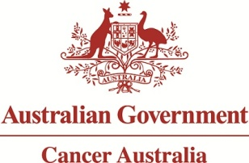

The 'Principles of shared care' are central to the objectives of the Shared follow-up care for early breast cancer.

The following Principles were developed in consultation with experts in the field and are based on key elements of a Cancer Australia literature review in 2008.

## Patient-centred

The patient and their whole person care is the focus for all care providers.

## Coordination, communication and continuity of care

Care of the patient requires coordination through timely and effective communication, and clarification of the roles and responsibilities of the care providers.

## Support for primary care providers

Primary care providers are supported in the delivery of shared follow-up care through early involvement, and through the provision of education, resources and protocols.

## Support for specialist treatment team

Specialist care providers are supported in the delivery of shared follow-up care through the provision of resources and protocols which improve efficiency and support data collection.

## Care is delivered according to best practice standards

Provision of care is in accordance with nationally agreed standards and is outcome-focused.